Grade 6
Unit 2Lesson 11CC BY NC Illustrative Mathematics, based on IM 6–8 Math, CC BY Open Up Resources.
Unit 2, Lesson 11

Representing Ratios with Tables
Let’s use tables to represent equivalent ratios.
Grade 6
Unit 2Lesson 11CC BY NC Illustrative Mathematics, based on IM 6–8 Math, CC BY Open Up Resources.

11.1Which Three Go Together: Very Dairy
Which three go together?
A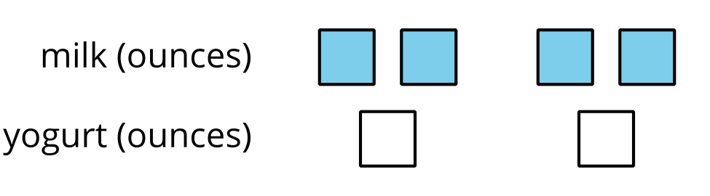
B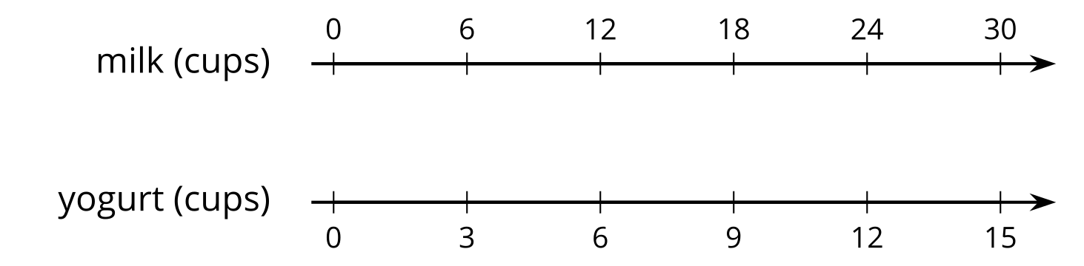
C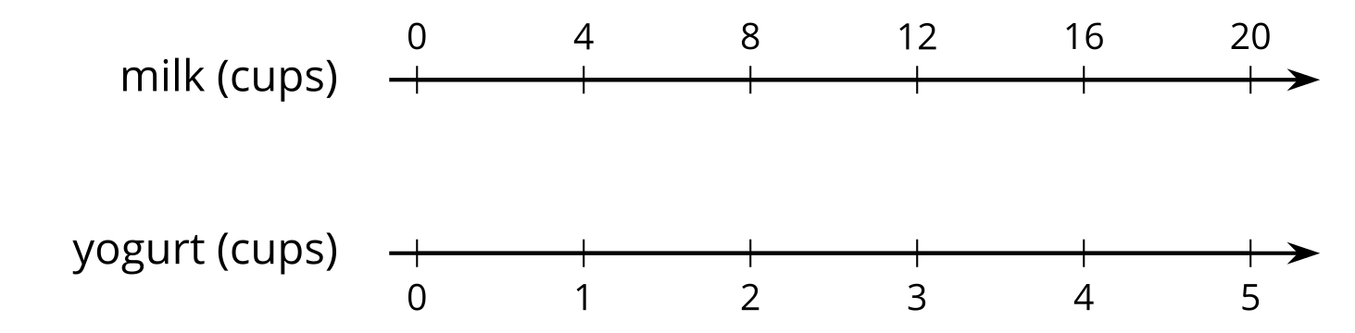
D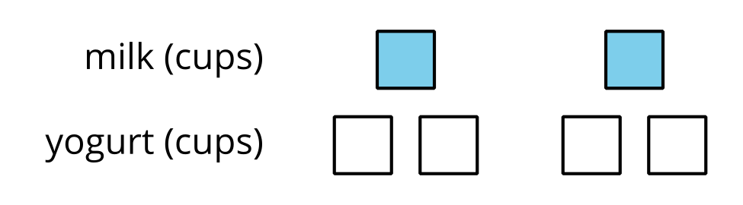
Grade 6
Unit 2Lesson 11CC BY NC Illustrative Mathematics, based on IM 6–8 Math, CC BY Open Up Resources.

11.2A Huge Amount of Sparkling Orange Juice
Noah’s recipe for one batch of sparkling orange juice uses 4 liters of orange juice and 5 liters of soda water.
- Use the double number line to show how many liters of each ingredient to use for different-sized batches of sparkling orange juice.
- 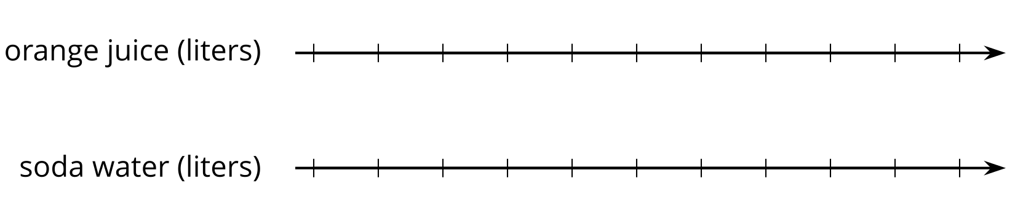
- If someone mixes 36 liters of orange juice and 45 liters of soda water, how many batches would they make?
- If someone uses 400 liters of orange juice, how much soda water would they need?
- If someone uses 455 liters of soda water, how much orange juice would they need?
- Explain the trouble with using a double number line diagram to answer the last two questions.
Grade 6
Unit 2Lesson 11CC BY NC Illustrative Mathematics, based on IM 6–8 Math, CC BY Open Up Resources.

11.3Batches of Nihaizu Sauce
Nihaizu (nee-HYE-zuu) is a sauce used with seafood or vegetables in Japanese cooking. A recipe for nihaizu uses 7 fluid ounces of vinegar and 5 fluid ounces of soy sauce.
The table shows amounts of vinegar and soy sauce that would be in different-sized batches of the recipe.
- Complete the table so that ratios represented by each row are equivalent. Explain or show your reasoning.
- How do you know that each row shows a ratio that is equivalent to $7:5$? Explain your reasoning.
vinegar  (fl oz) | soy sauce  (fl oz)
7 | 5
28
 | 10
3.5
 | 250
56

Are you ready for more?
Ponzu (pawn-ZUU) is another Japanese sauce. It uses rice wine and lemon juice in addition to soy sauce. In a ponzu recipe, the ratio of rice wine to lemon juice is $2:5$.
Create a table in which the values in each row represent amounts of rice wine to lemon juice that might be used to make different amounts of ponzu.
- One row should use less than 25 fluid ounces of lemon juice.
- One row should use between 20 and 30 fluid ounces of rice wine.
- One row should use more than 500 fluid ounces of lemon juice.

Lesson 11 Summary
A table is a way to organize information. Each horizontal set of entries is called a row, and each vertical set of entries is called a column. (The table shown has 2 columns and 5 rows.) A table can be used to represent a collection of equivalent ratios.
Here is a double number line diagram and a table that both represent the situation: “The price is $2 for every 3 mangos.”
