## Unit 7 Lesson 13: Describe Solid Shapes Around Us

### WU Notice and Wonder: At the Market (Warm up)

#### Student Task Statement

What do you notice?  
What do you wonder?

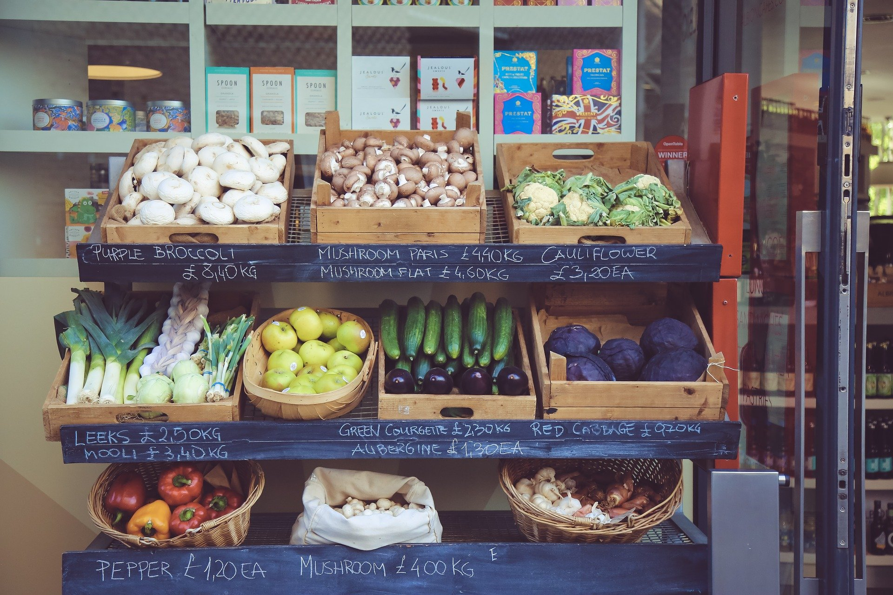

### 1 Solid Shape Walk

#### Student Task Statement

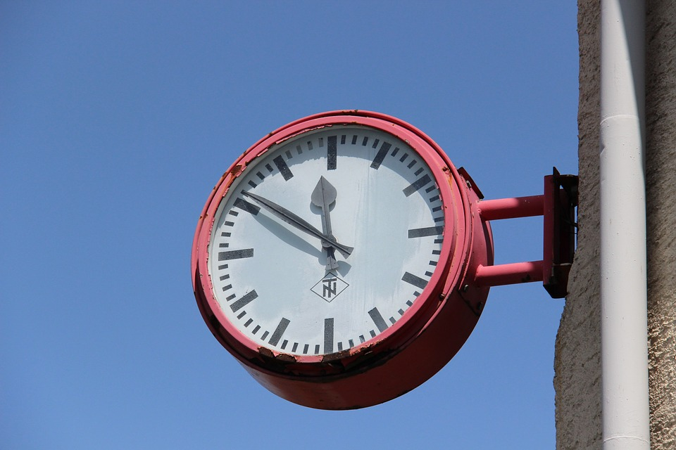

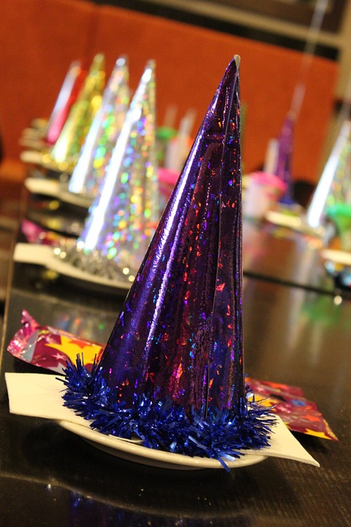

#### Activity Synthesis





### 2 Make Shapes in the World

#### Student Task Statement

### 3 Centers: Choice Time

#### Student Task Statement

Choose a center.

Build Shapes

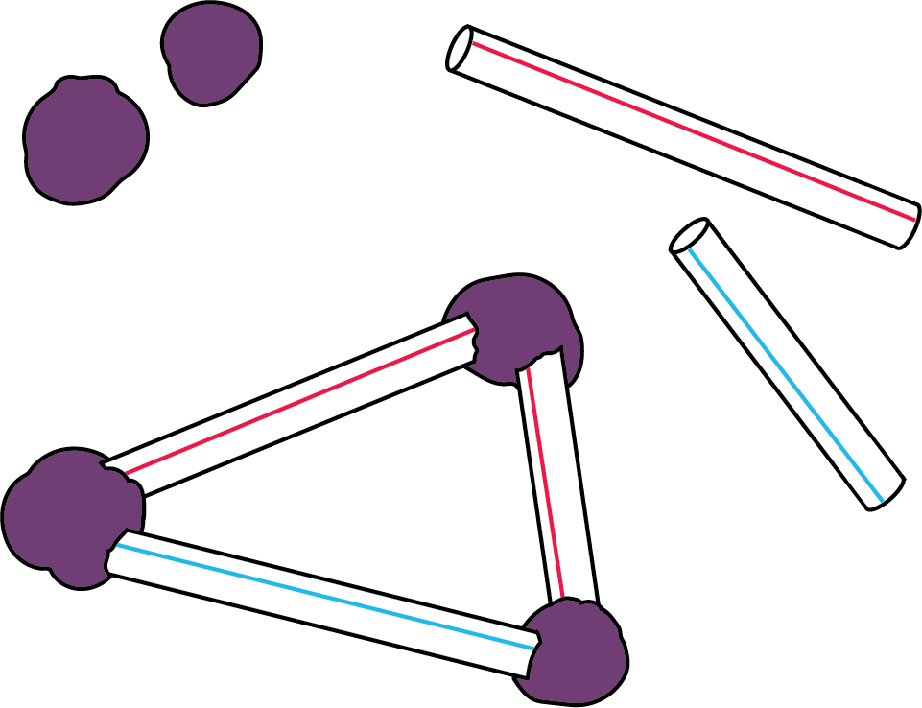

Geoblocks

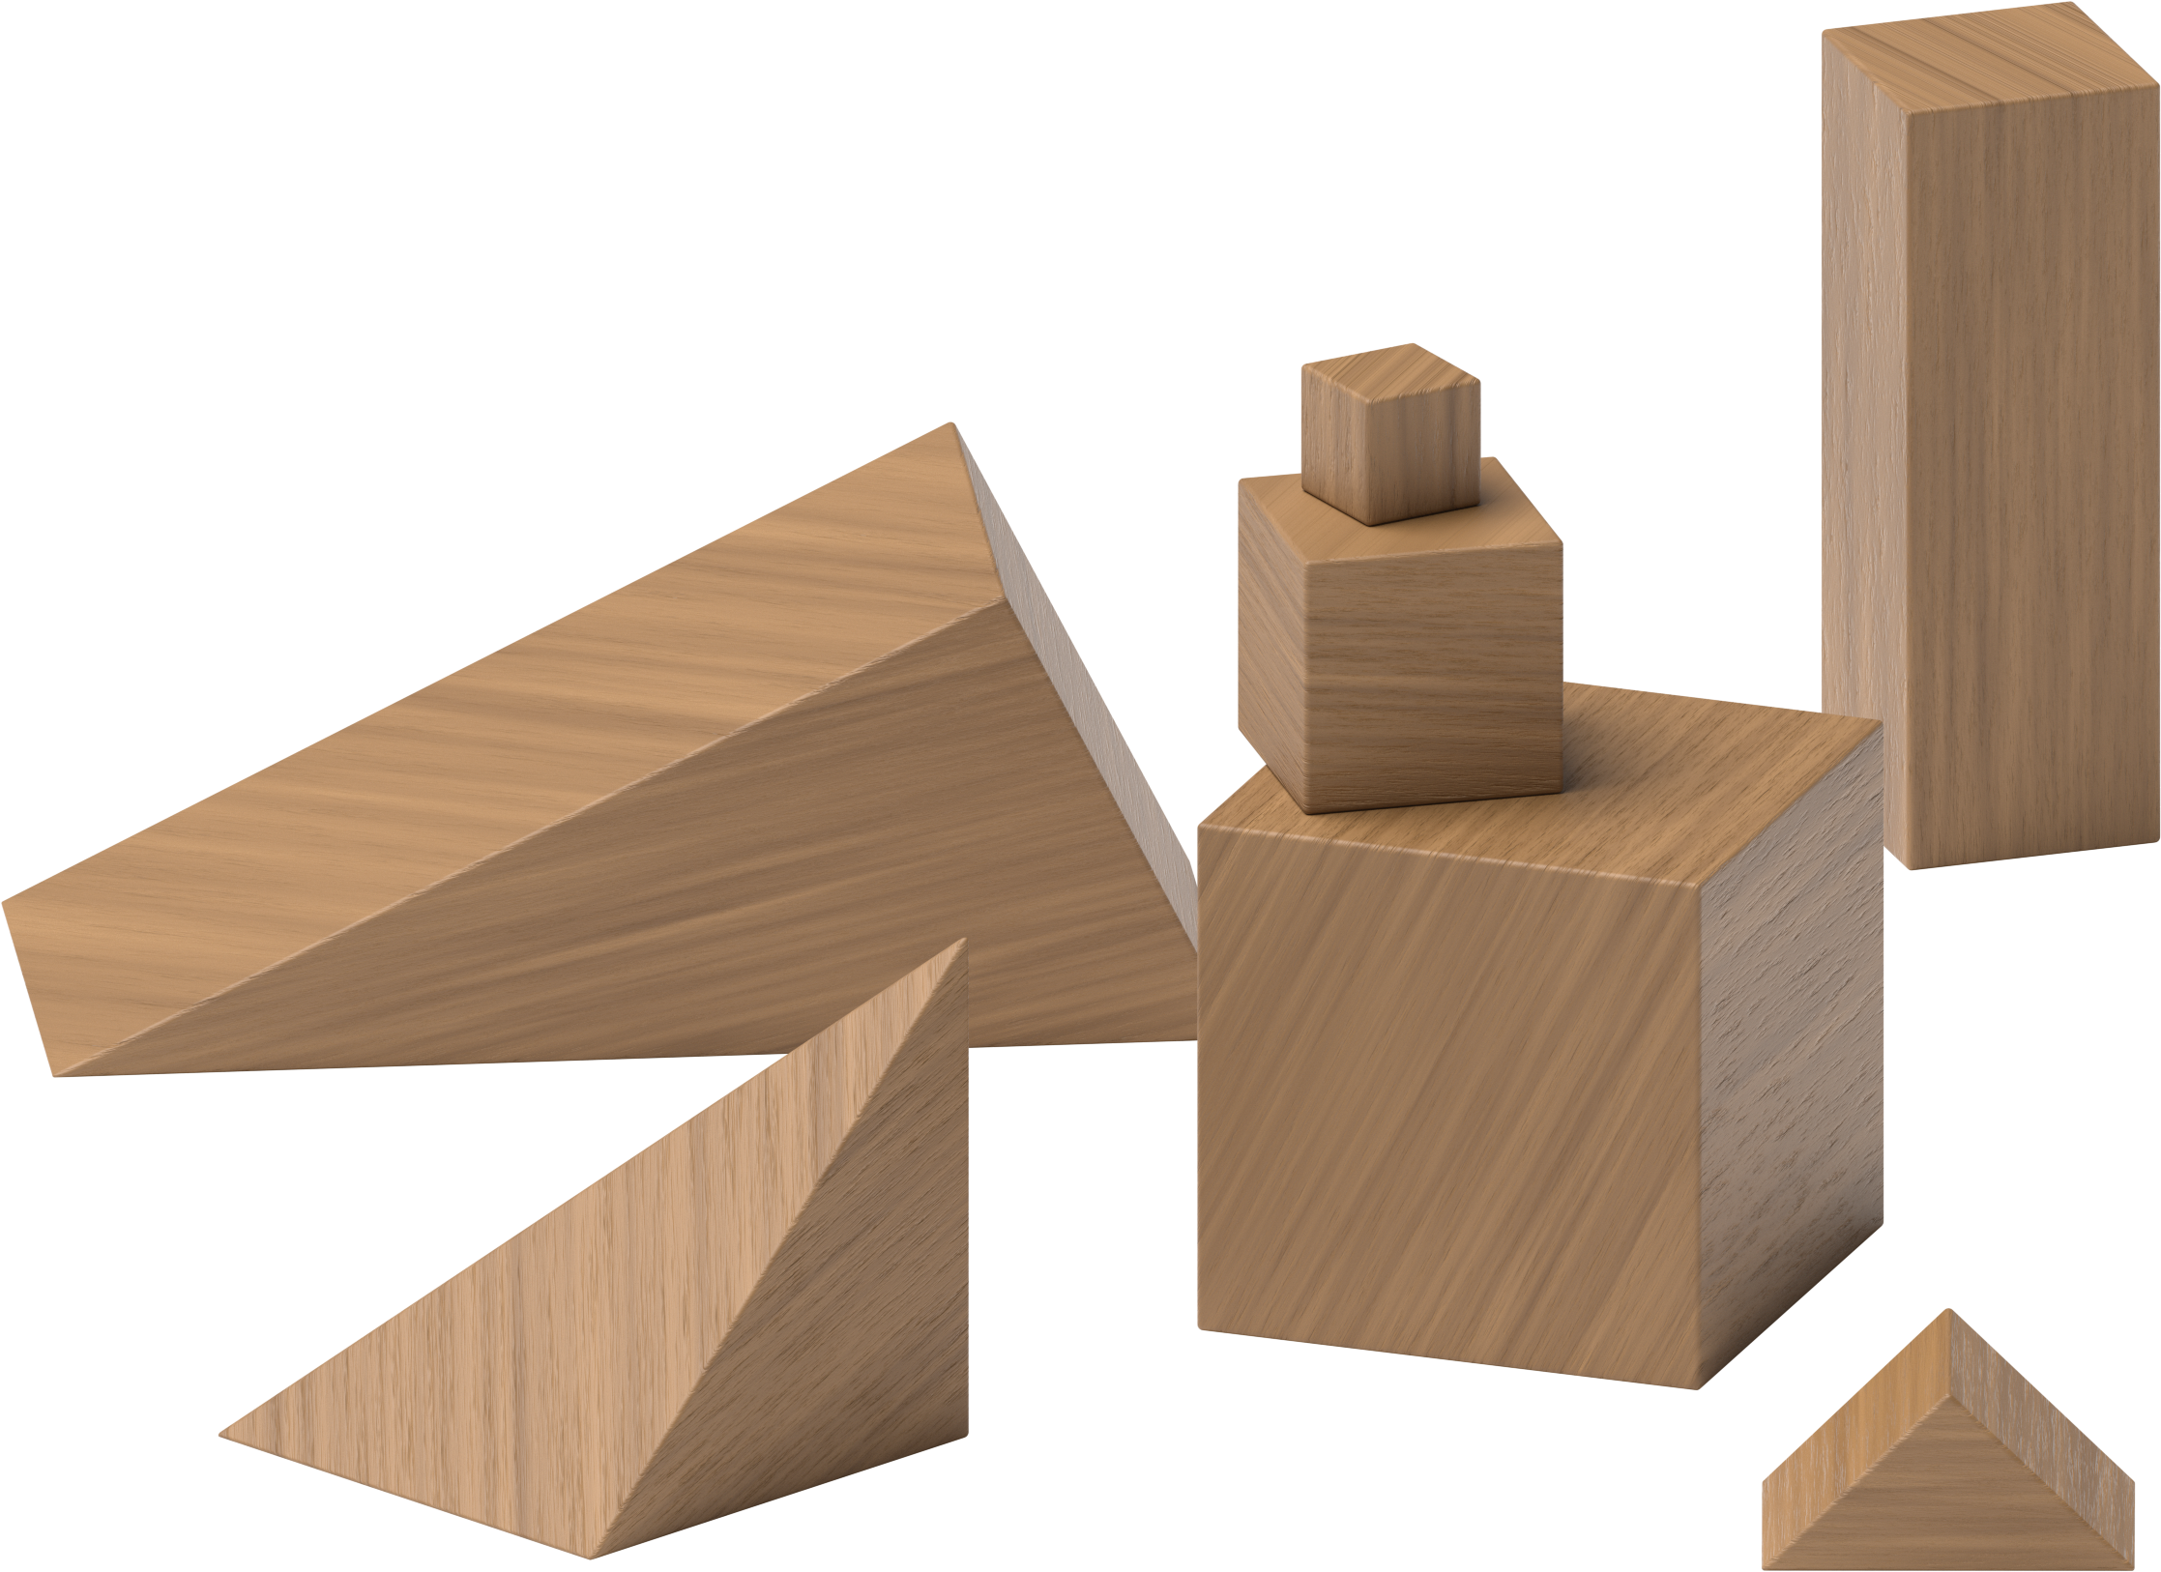

Counting Collections

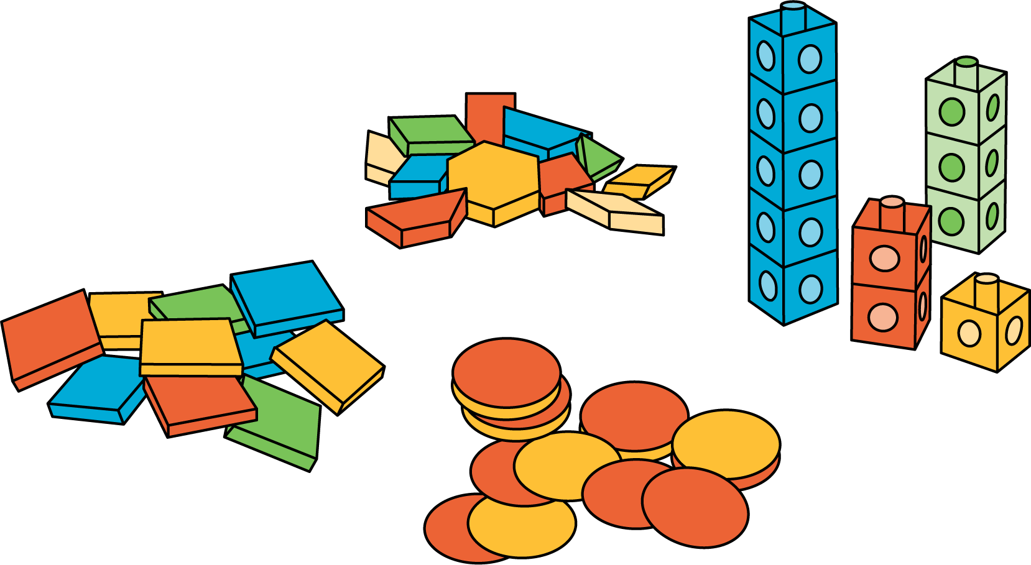

Match Mine

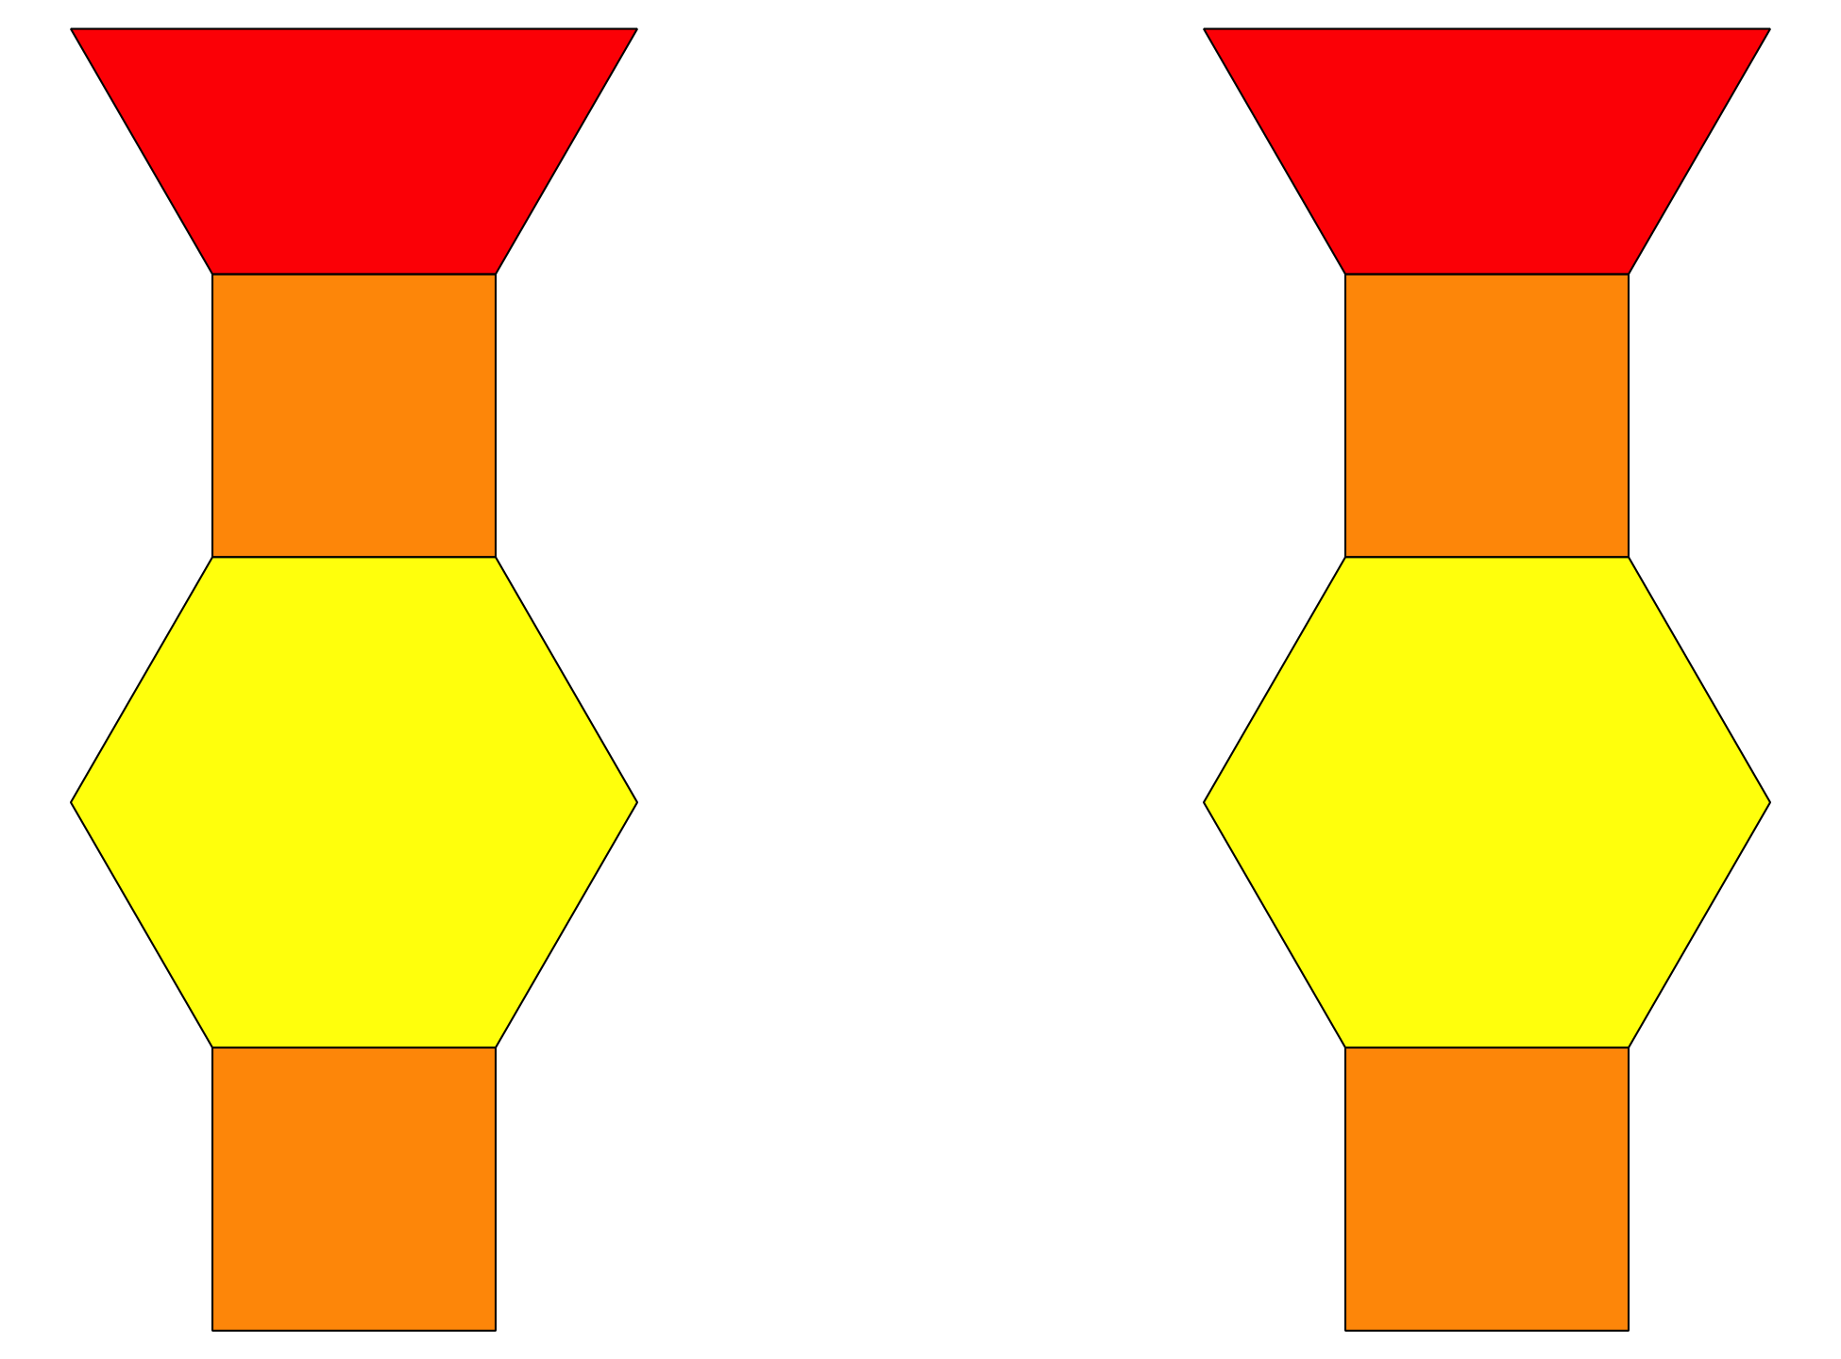

Shake and Spill

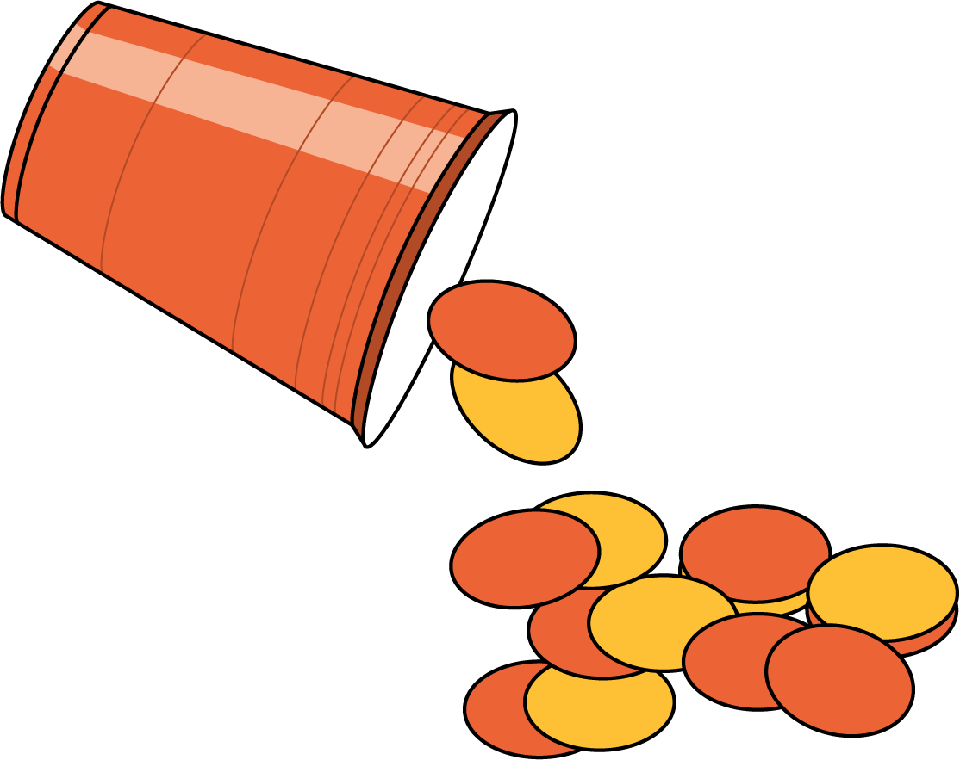



© CC BY 2021 Illustrative Mathematics®