Lesson 9: Expressions and Equations
- Let’s show numbers 11–19 in different ways.

9.2: Equations and 10-frames
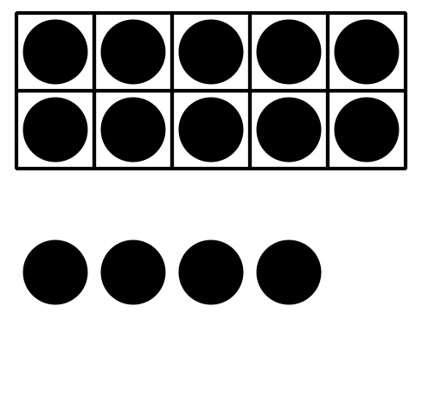
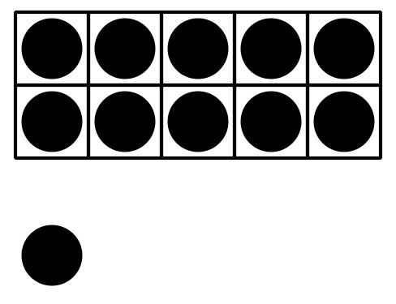
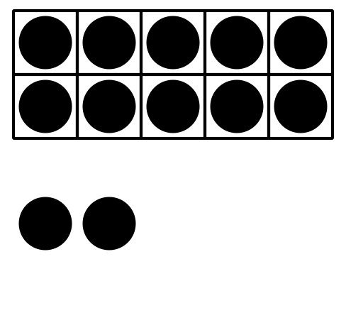
$10+9=19$
$10+1=11$
$10+4=14$
$10+8=18$
$10+5=15$
$10+2=12$
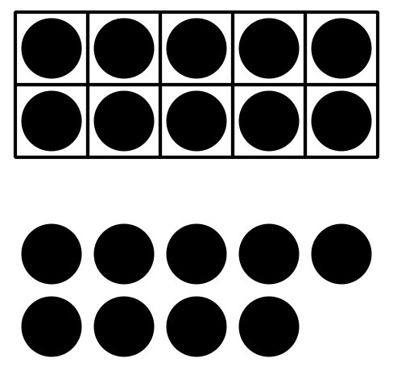
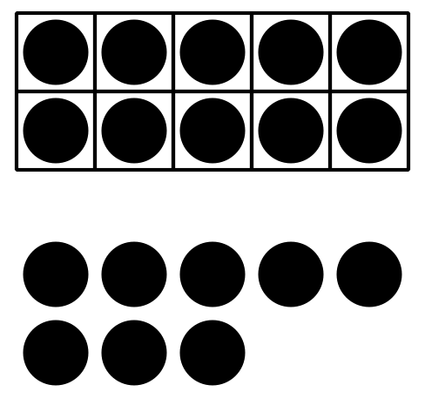
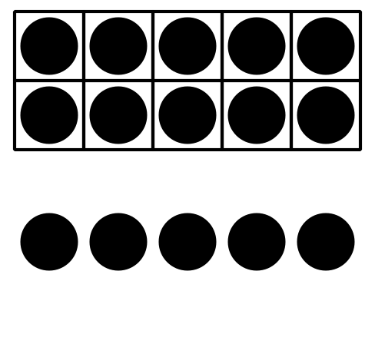

9.3: Introduce Make or Break Apart Numbers, Numbers 11–19
Choose a center.
Bingo
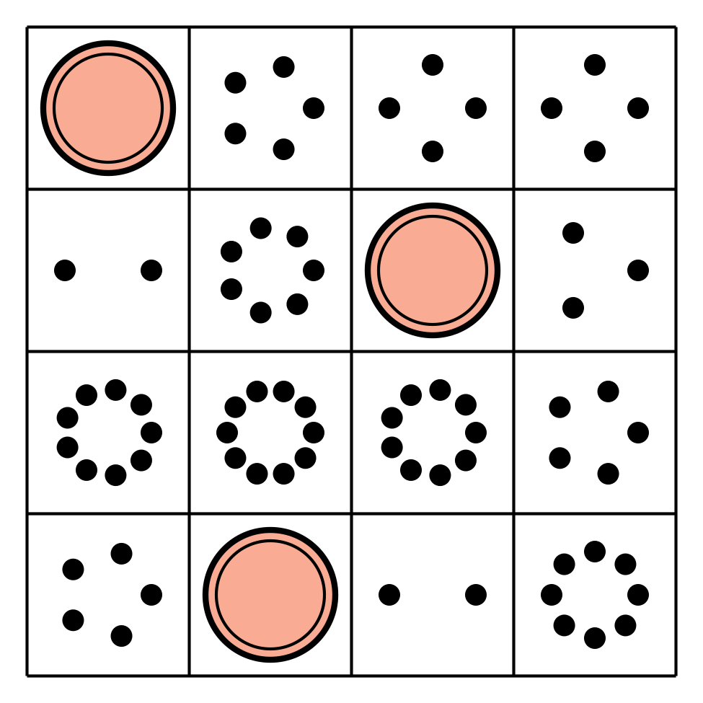
Number Race
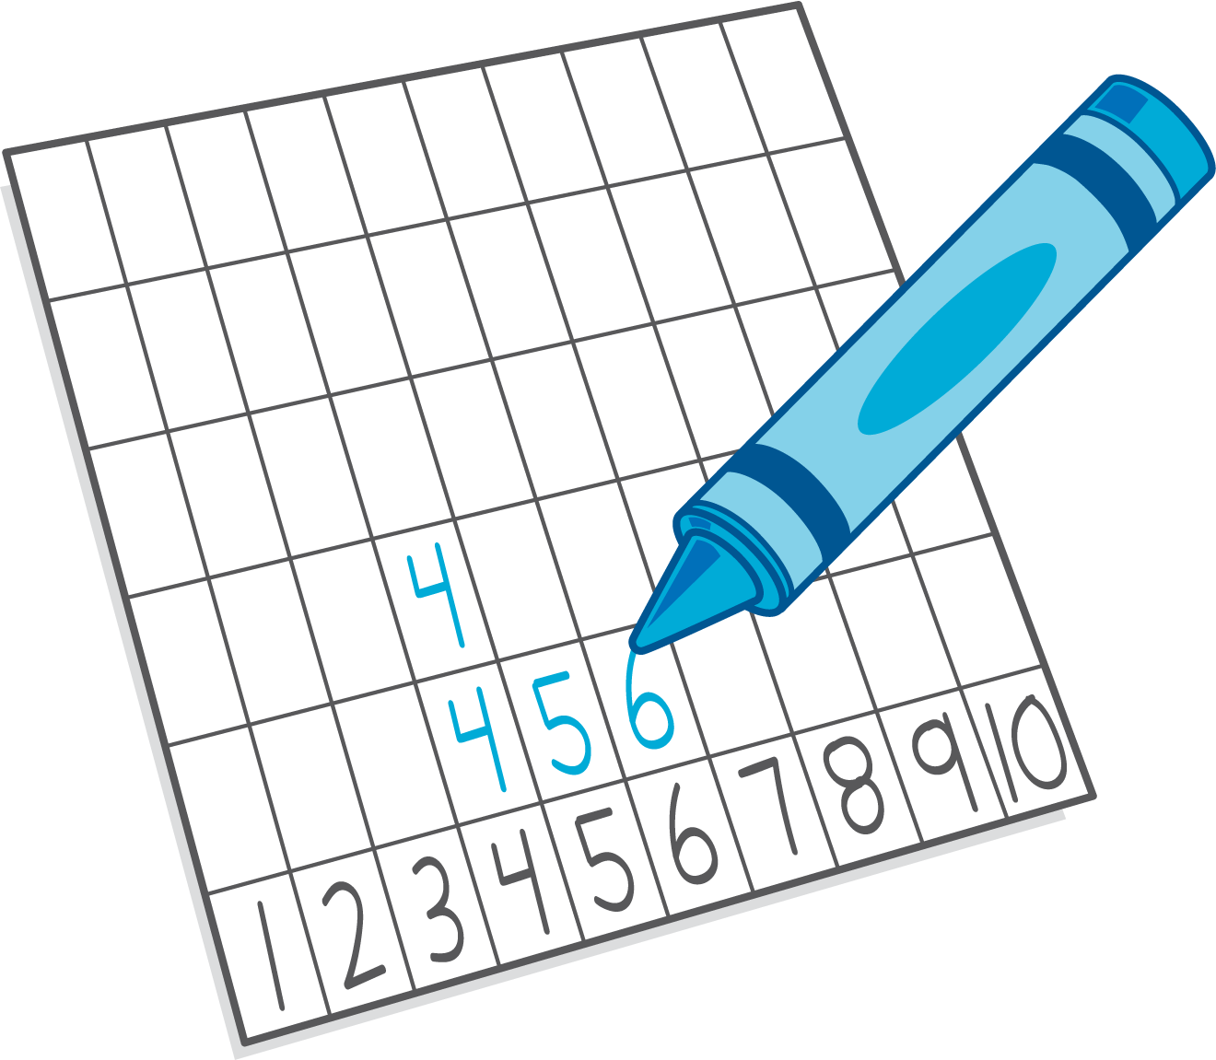
Grab and Count

Make or Break Apart Numbers
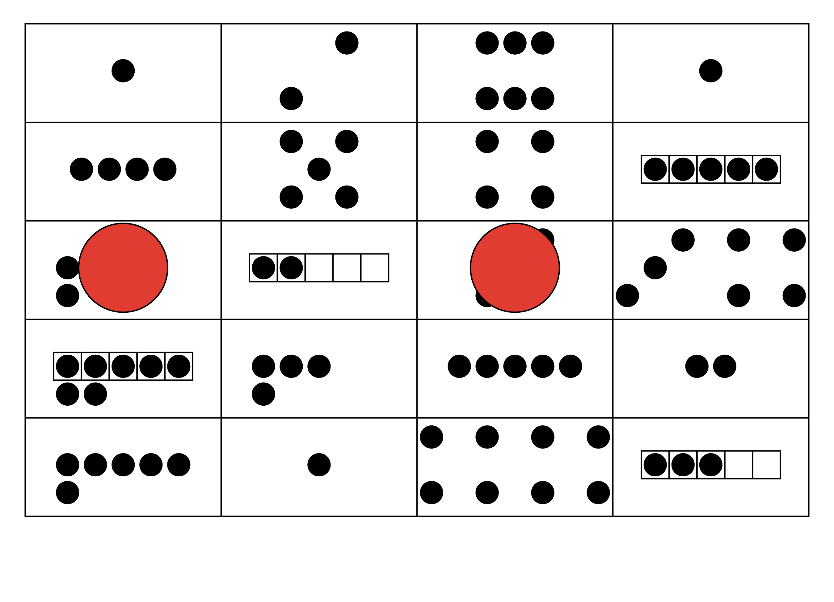
Tower Build
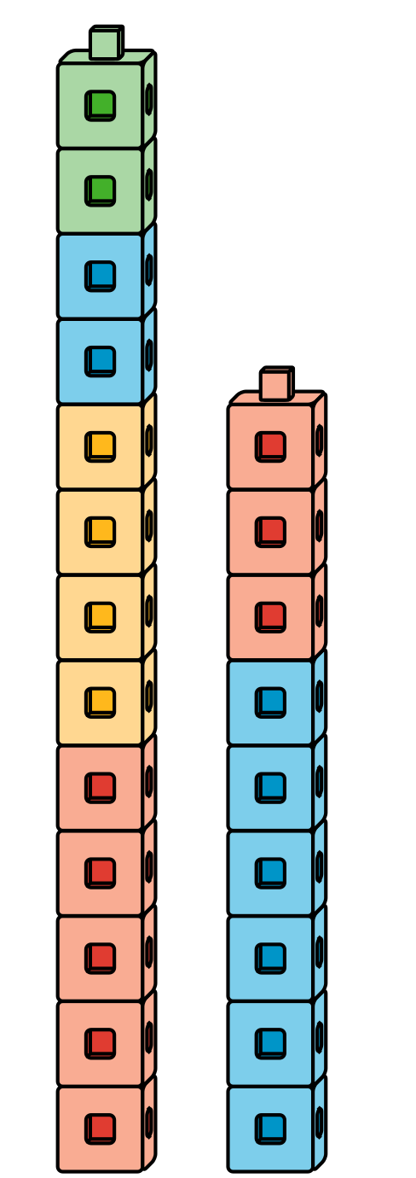
© CC BY 2021 Illustrative Mathematics®

