Grade 2
Unit 7Lesson 11CC BY NC 2024 Illustrative Mathematics®
Unit 7, Lesson 11

Center Day 2
- Let’s add numbers within 1,000.
Grade 2
Unit 7Lesson 11CC BY NC 2024 Illustrative Mathematics®

Warm-up Number Talk: Make 100
Find the value of each expression mentally.
- $80¢+20¢+37¢$
- $80¢+20¢+37¢+42¢$
- $75¢+37¢+25¢$
- $75¢+80¢+25¢+20¢$
Grade 2
Unit 7Lesson 11CC BY NC 2024 Illustrative Mathematics®

Activity 2Introduce Five in a Row—Add within 1,000, with Composing
Choose a center.
Five a Row: Addition and Subtraction
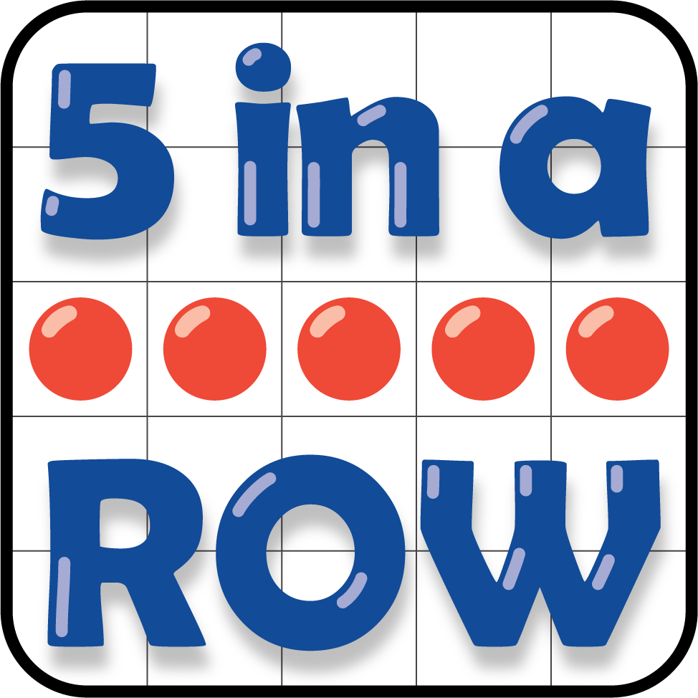
How Close?
