Lesson 8 Practice Problems
- The graphs show the distance, $d$, traveled by two cars, A and B, over time, $t$. Distance is measured in miles and time is measured in hours.
- Which car traveled slower? Explain how you know.
- 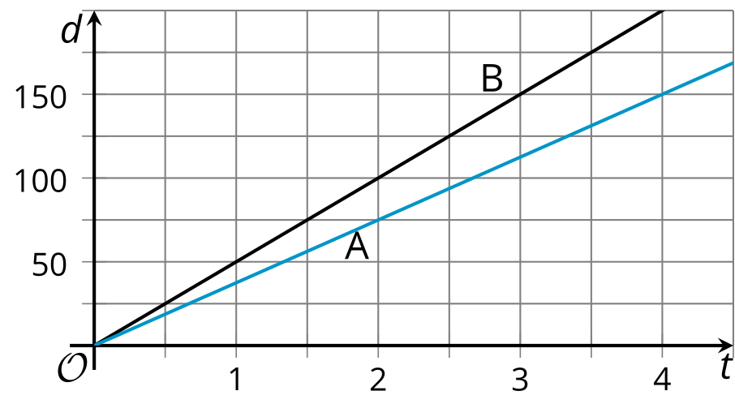
- Here are descriptions of four situations in which the volume of water in a tank is a function of time. Match each description to a corresponding graph.

- Graph 1
- 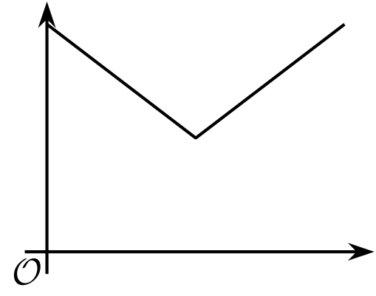

- Graph 2
- 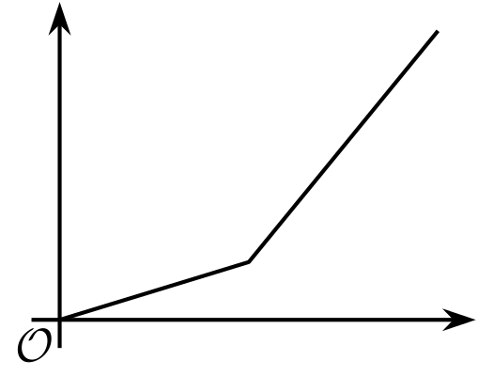

- Graph 3
- 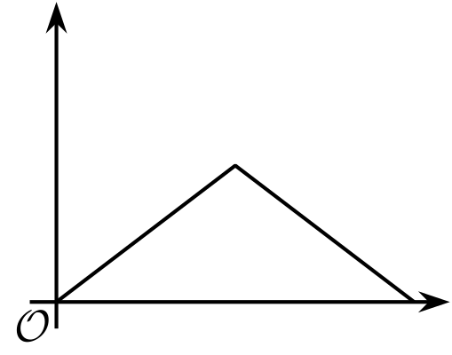

- Graph 4
- 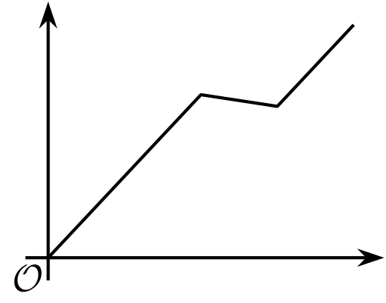
  - An empty 20-gallon water tank is filled at a constant rate for 3 minutes until it is half full. Then, it is emptied at a constant rate for 3 minutes.
  - A full 10-gallon water tank is drained for 30 seconds, until it is half full. Afterwards, it gets refilled.
  - A 2,000-gallon water tank starts out empty. It is being filled for 5 hours, slowly at first, and faster later.
  - An empty 100-gallon water tank is filled in 50 minutes. Then, a dog jumps in and splashes around for 10 minutes, letting 7 gallons of water out. The tank is refilled afterwards.
  - Graph 1
  - Graph 2
  - Graph 3
  - Graph 4
- Clare describes her morning at school yesterday: “I entered the school on the first floor, then walked up to the third floor and stayed for my class for an hour. Afterwards, I had an hour-long class in the basement, and after that I went back to the ground level and sat outside to eat my lunch."
- Sketch a possible graph of her height from the ground floor as a function of time.
- 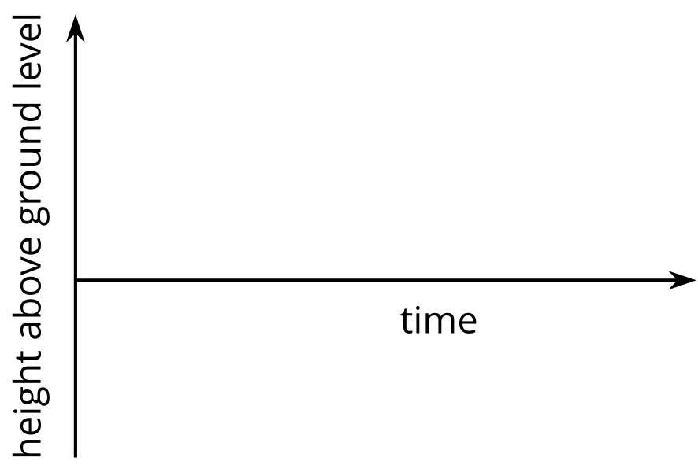
- Tyler filled up his bathtub, took a bath, and then drained the tub. The function gives the depth of the water, in inches, $t$ minutes after Tyler began to fill the bathtub.
- These statements describe how the water level in the tub was changing over time. Use the statements to sketch an approximate graph of function.
  - $B\left(0\right)=0$
  - $B\left(1\right)<B\left(7\right)$
  - $B\left(9\right)=11$
  - $B\left(10\right)=B\left(23\right)$
  - $B\left(20\right)>B\left(40\right)$
- 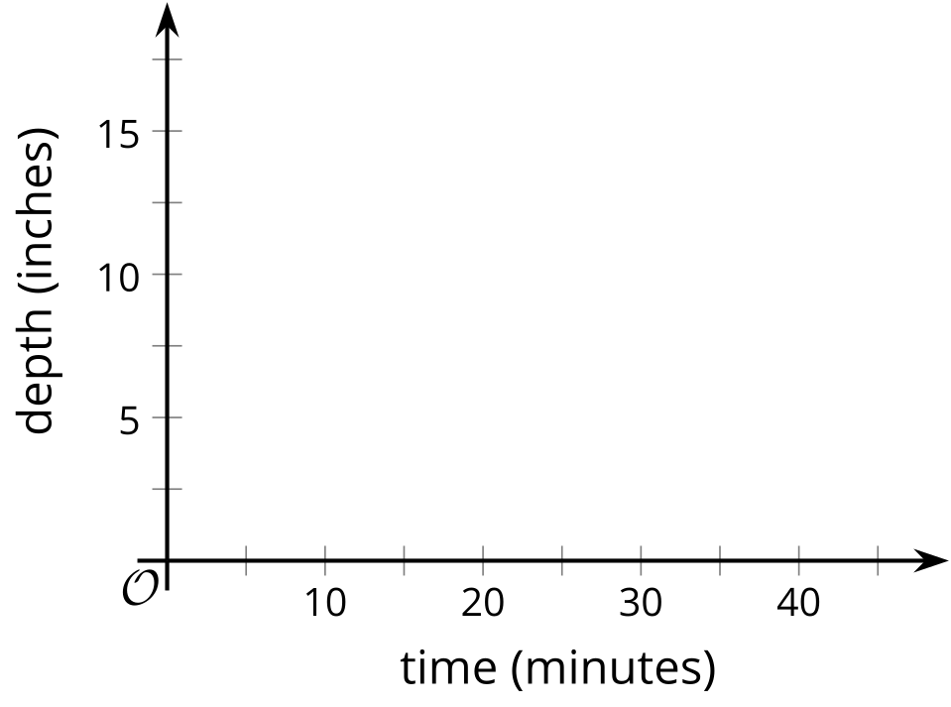
- Two functions are defined by these equations:
- $f\left(x\right)=5.1+0.8x$
- $g\left(x\right)=3.4+1.2x$
- Which function has a greater value when $x$ is 3.9? How much greater?
- (From Unit 4, Lesson 5.)
- Function $f$ is defined by the equation $f\left(x\right)=3x−7$. Find the value of $c$ so that $f\left(c\right)=20$ is true.
- (From Unit 4, Lesson 5.)
- Function $V$ gives the volume of water (liters) in a water cooler as a function of time, $t$ (minutes).
- This graph represents function $V$.
- 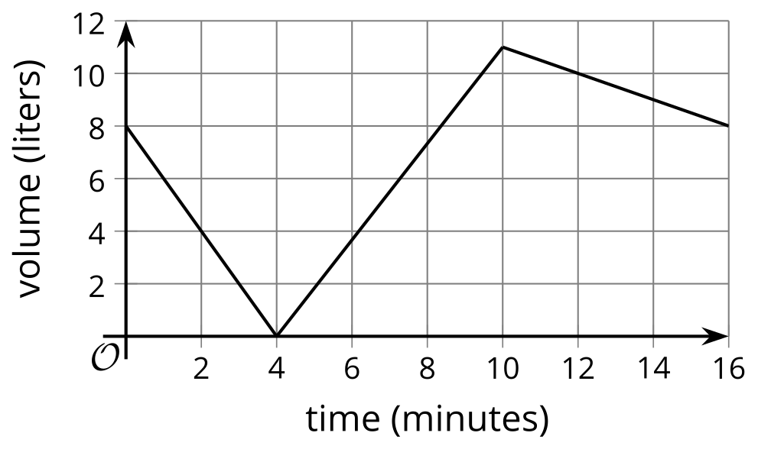
  - What is the greatest water volume in the cooler?
  - Find the value or values of $t$ that make $V\left(t\right)=4$ true. Explain what the value or values tell us about the volume of the water in the cooler.
  - Identify the horizontal intercept of the graph. What does it tell you about the situation?
- (From Unit 4, Lesson 6.)
- Noah draws this box plot for data that has measure of variability 0.
- 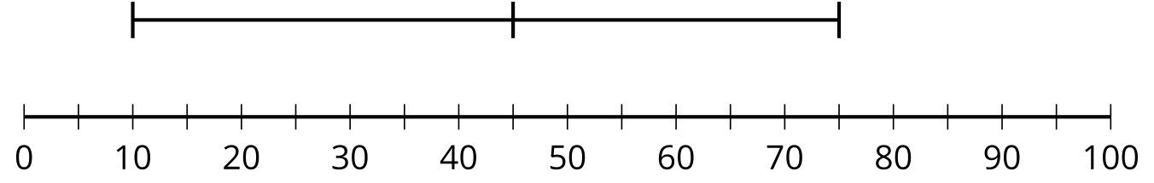
- Explain why the box plot is complete even though there do not appear to be any boxes.
- (From Unit 1, Lesson 15.)
© CC BY 2019 by Illustrative Mathematics®

