Algebra 1
Unit 2Lesson 8CC BY NC 2024 Illustrative Mathematics®
Unit 2, Lesson 8

Which Variable to Solve for? (Part 1)
- Let’s rearrange equations to pin down a certain quantity.
Algebra 1
Unit 2Lesson 8CC BY NC 2024 Illustrative Mathematics®

8.1Which Equations?
- The table shows the relationship between the base length, $b$, and the area, $A$, of some parallelograms. All the parallelograms have the same height. Base length is measured in inches, and area is measured in square inches. Complete the table.
- $b$ (inches) | - $A$ (square inches)
- 1 | - 3
- 2 | - 6
- 3 | - 9
- 4.5
- $\frac{11}{2}$
 | - 36
 | - 46.5
- Decide whether each equation could represent the relationship between $b$ and $A$. Be prepared to explain your reasoning.
  - $b=3A$
  - $b=\frac{A}{3}$
  - $A=\frac{b}{3}$
  - $A=3b$
Algebra 1
Unit 2Lesson 8CC BY NC 2024 Illustrative Mathematics®

8.2Post-Parade Clean-up
After a parade, a group of volunteers is helping to pick up the trash along a 2-mile stretch of a road.
The group decides to divide the length of the road so that each volunteer is responsible for cleaning up equal-length sections.

- Find the length of a road section for each volunteer if there are the following numbers of volunteers. Be prepared to explain or show your reasoning.
  - 8 volunteers
  - 10 volunteers
  - 25 volunteers
  - 36 volunteers
  - $n$ volunteers
- Find the number of volunteers in the group if each volunteer cleans up a section of the following lengths. Be prepared to explain or show your reasoning.
  - 0.4 mile
  - $\frac{2}{7}$ mile
  - 0.125 mile
  - $\frac{6}{45}$ mile
  - $ℓ$ miles

Are you ready for more?
Let's think about the graph of the equation $y=\frac{2}{x}$.
- Make a table of $\left(x,y\right)$ pairs that will help you graph the equation. Make sure to include some negative numbers for $x$ and some numbers that are not integers.
- Plot the graph on the coordinate axes. You may need to find a few more points to plot to make the graph look smooth.
- 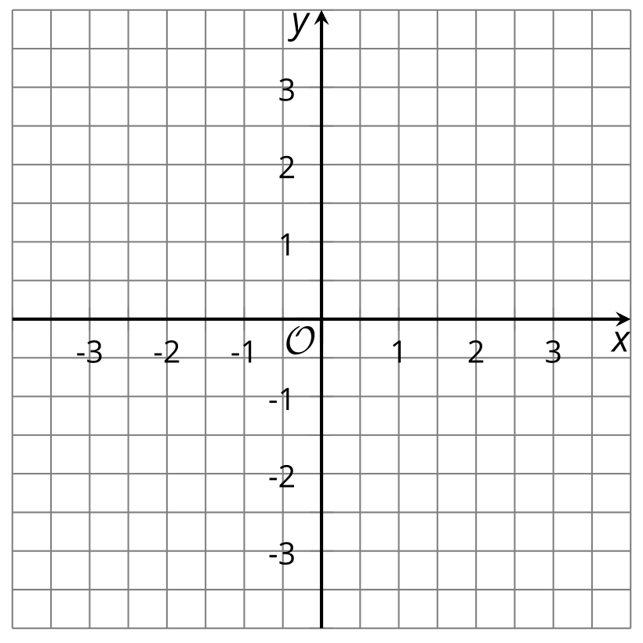
- ​​​​​​
- The coordinate plane provided is too small to show the whole graph. What do you think the graph looks like when $x$ is between 0 and $\frac{1}{2}$? Try some values of $x$ to test your idea.
- What is the largest value that $y$ can ever be?
Algebra 1
Unit 2Lesson 8CC BY NC 2024 Illustrative Mathematics®

8.3Filling and Emptying Tanks
- Tank A initially contained 124 liters of water. It is then filled with more water, at a constant rate of 9 liters per minute. How many liters of water are in Tank A after the following amounts of time have passed?
  - 4 minutes
  - 80 seconds
  - $m$ minutes
- How many minutes have passed, $m$, when Tank A contains the following amounts of water?
  - 151 liters
  - 191.5 liters
  - 270.25 liters
  - $p$ liters
- Tank B, which initially contained 80 liters of water, is being drained at a rate of 2.5 liters per minute. How many liters of water remain in the tank after the following amounts of time?
  - 30 seconds
  - 7 minutes
  - $t$ minutes
- For how many minutes, $t$, has the water been draining when Tank B contains the following amounts of water?
  - 75 liters
  - 32.5 liters
  - 18 liters
  - $v$ liters

Lesson 8 Summary
A relationship between quantities can be described in more than one way. Some ways are more helpful than others, depending on what we want to find out. Let’s look at the angles of an isosceles triangle, for example.
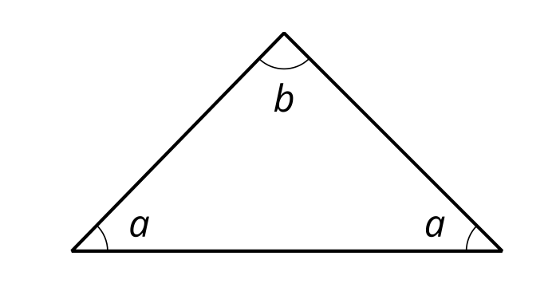
The two angles near the horizontal side have equal measurement in degrees, $a$.
The sum of angles in a triangle is ${180}^{∘}$, so the relationship between the angles can be expressed as:
$a+a+b=180$
Suppose we want to find $a$ when $b$ is ${20}^{∘}$.
Let's substitute 20 for $b$ and solve the equation.
$\begin{matrix}a+a+b & =180 \\ 2a+20 & =180 \\ 2a & =180−20 \\ 2a & =160 \\ a & =80\end{matrix}$
What is the value of $a$ if $b$ is ${45}^{∘}$?
$\begin{matrix}a+a+b & =180 \\ 2a+45 & =180 \\ 2a & =180−45 \\ 2a & =135 \\ a & =67.5\end{matrix}$
Now suppose the bottom two angles are ${34}^{∘}$ each. How many degrees is the top angle?
Let's substitute 34 for $a$ and solve the equation.
$\begin{matrix}a+a+b & =180 \\ 34+34+b & =180 \\ 68+b & =180 \\ b & =112\end{matrix}$
What is the value of $b$ if $a$ is ${72.5}^{∘}$?
$\begin{matrix}a+a+b & =180 \\ 72.5+72.5+b & =180 \\ 145+b & =180 \\ b & =35\end{matrix}$
Notice that when $b$ is given, we did the same calculation repeatedly to find $a$: We substituted $b$ into the first equation, subtracted $b$ from 180, and then divided the result by 2.
Instead of taking these steps over and over whenever we know $b$ and want to find $a$, we can rearrange the equation to isolate $a$:
$\begin{matrix}a+a+b & =180 \\ 2a+b & =180 \\ 2a & =180−b \\ a & =\frac{180−b}{2}\end{matrix}$
This equation is equivalent to the first one. To find $a$, we can now simply substitute any value of $b$ into this equation and evaluate the expression on the right side.
Likewise, we can write an equivalent equation to make it easier to find $b$ when we know $a$:
$\begin{matrix}a+a+b & =180 \\ 2a+b & =180 \\ b & =180−2a\end{matrix}$
Rearranging an equation to isolate one variable is called solving for a variable. In this example, we have solved for $a$ and for $b$. All three equations are equivalent. Depending on what information we have and what we are interested in, we can choose a particular equation to use.

