Grade 2
Unit 8CC BY NC 2024 Illustrative Mathematics®

Unit 8 Family Support Materials

Equal Groups
In this unit, students develop an understanding of equal groups as the foundation for multiplication and division, in grade 3 and beyond. This understanding builds on students’ experiences with skip-counting and finding the sums of equal addends.

Section A: Odd and Even
In this section, students build on their personal experiences with sharing equal groups of objects and making pairs to define the terms odd and even. They begin by noticing that some groups of objects can be made into two equal groups, without a “leftover,” and other groups can be made into two equal groups, with “1 left over.” They notice this same pattern when pairing objects. Students focus on justifying why a group has an even number or an odd number of members by showing whether the objects can be made into two equal groups, whether the objects can be paired without a leftover, or whether they can skip-count by 2 to find the total number of objects.
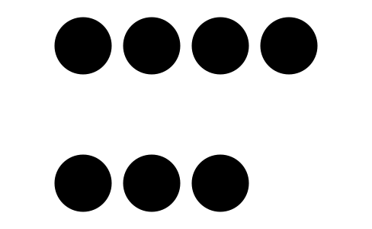
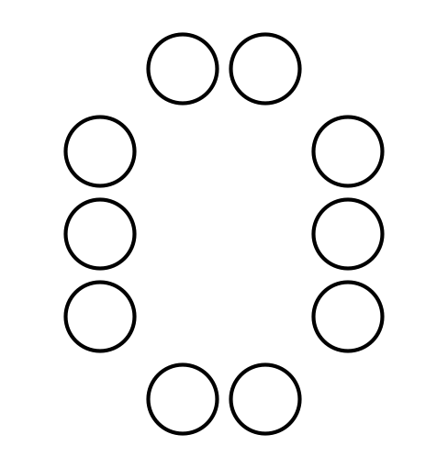

Section B: Rectangular Arrays
In this section, students are introduced to rectangular arrays. They learn that rectangular arrays contain objects arranged into rows and columns. They recognize that each row has the same number of objects and each column has the same number of objects. Using this structure, students can skip-count by the number in each row, or the number in each column, to find the total number of objects.
In addition to skip-counting, students learn that they can write equations with equal addends to represent the total number of objects in a rectangular array. Students connect these equations to the structure of the array and describe how equations can show the total number of objects as the sum of the objects in each row or the sum of the objects in each column.
Students also connect their work with arrays to their previous work with partitioning shapes into equal-size pieces. Starting with a rectangle, students partition them into equal-size squares by considering rows and columns. Rectangles in this section have up to 5 rows and 5 columns. Students use the structure of the rows and the columns created by the partitions in the rectangle to count the total number of equal-size squares.

Try it at home!
Near the end of the unit, ask your second grader to write two equations to represent the total number of squares.
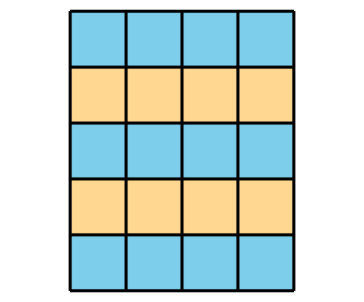
Questions that may be helpful as they work:
- How many rows?
- How many columns?
- How does each equation match the array?
Solution
- $4+4+4+4+4$
- $5+5+5+5$
Sample response:
- There are 5 rows.
- There are 4 columns.
- The first equation shows that there are 5 rows, each with 4 squares. The second equation shows that there are 4 columns, each with 5 squares.

