Lesson 10: Find More or Fewer
- Let’s compare groups of images using the words “more,” “fewer,” or “the same number.”

10.1: Circle More, Circle Fewer

- 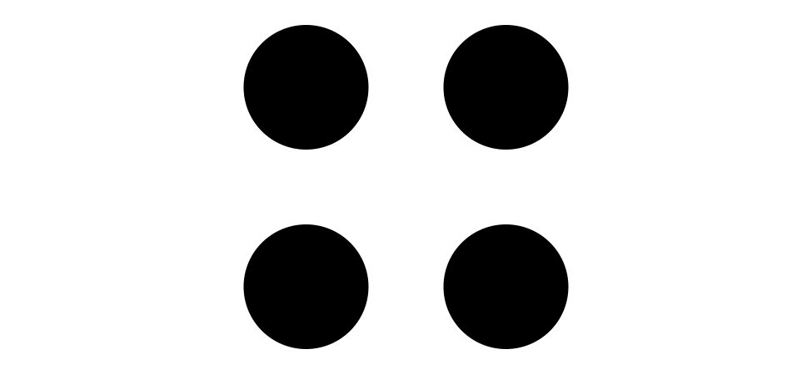

- 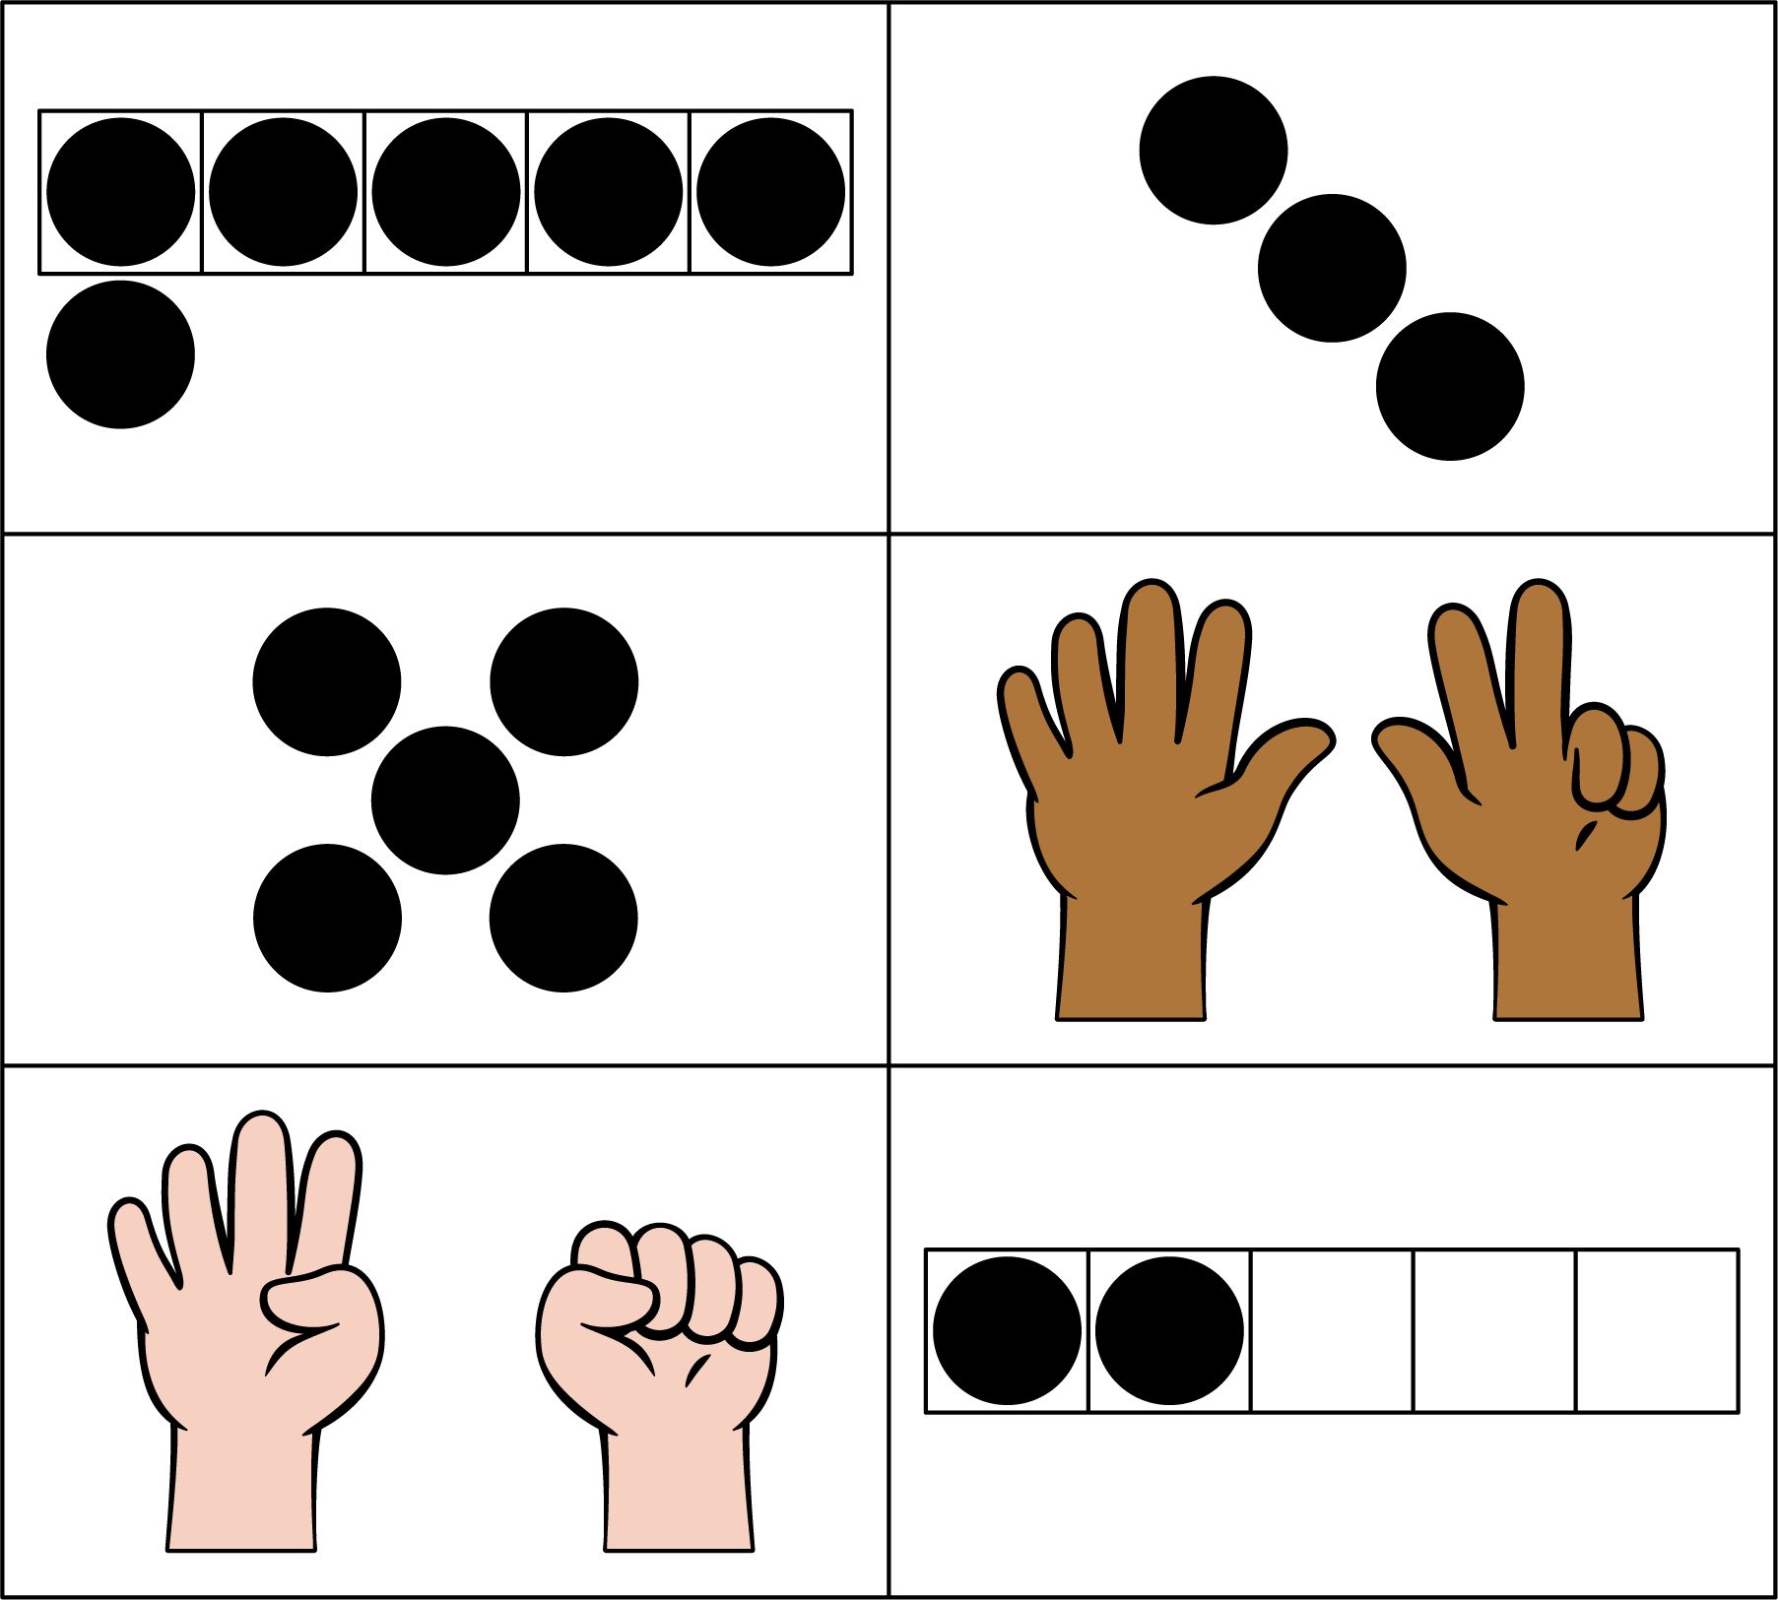

- 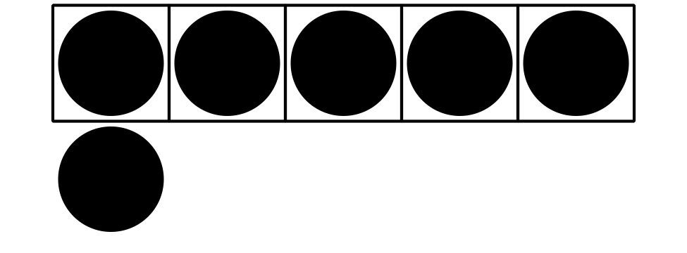

- 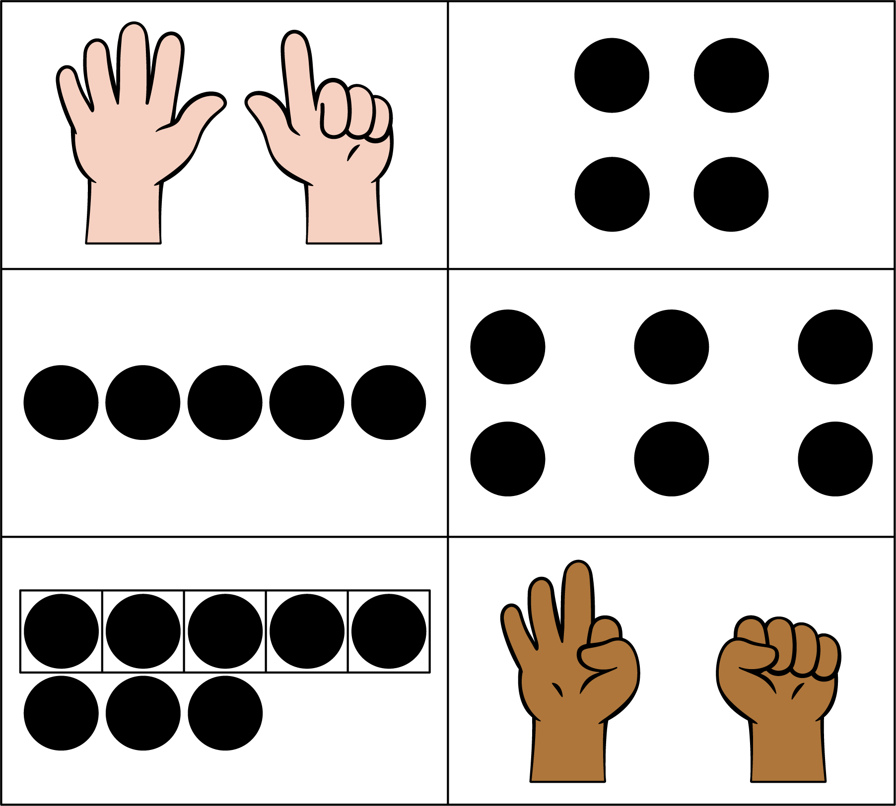

10.2: Introduce Less, Same, More, Images
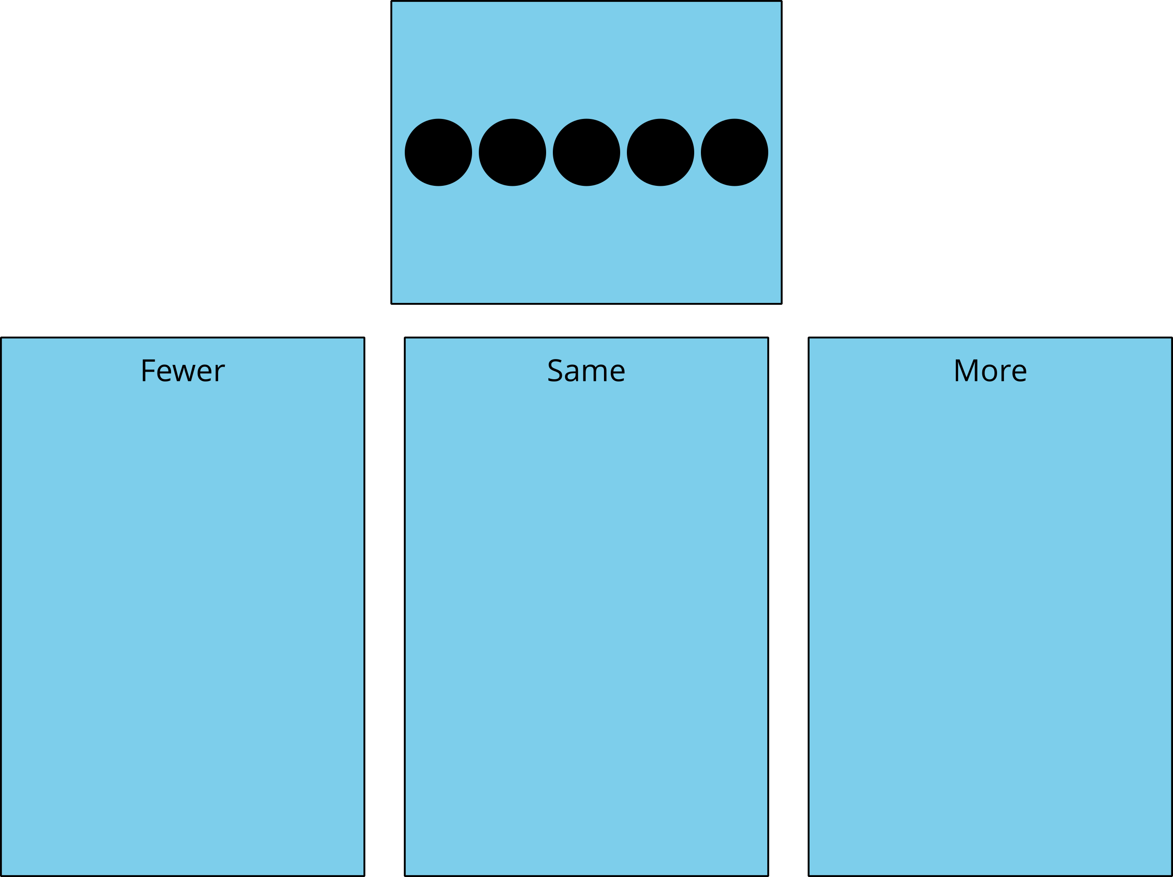

10.3: Centers: Choice Time
Choose a center.
Less, Same, More
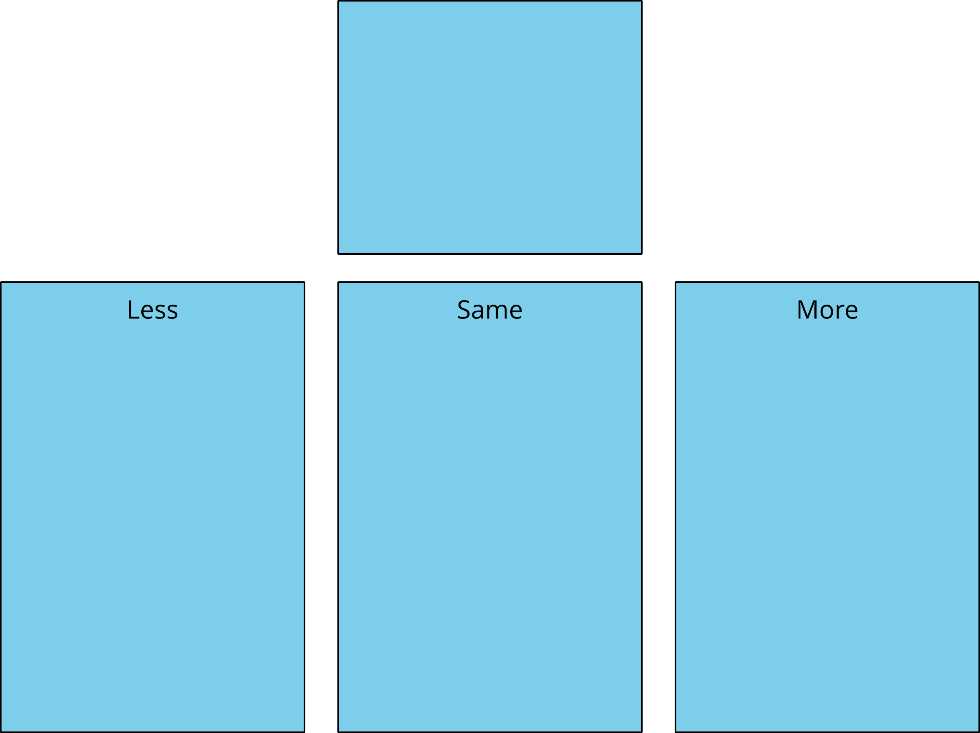
Bingo
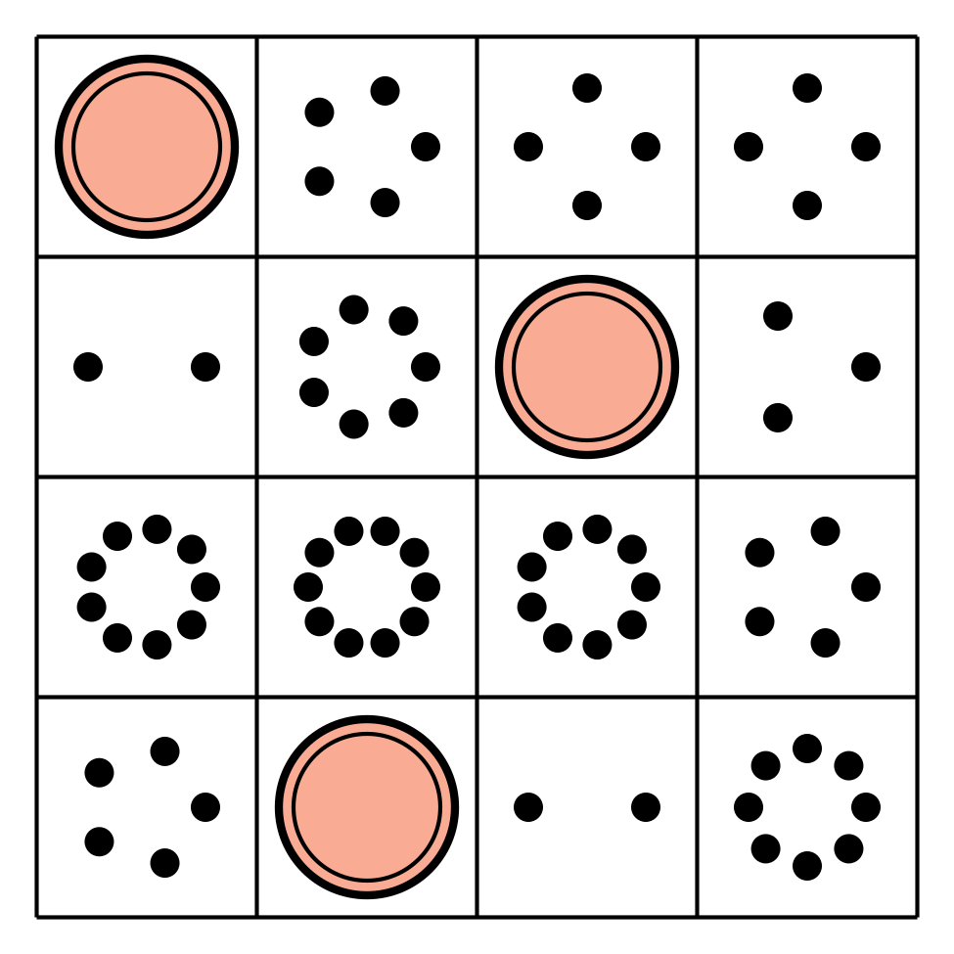
Math Stories
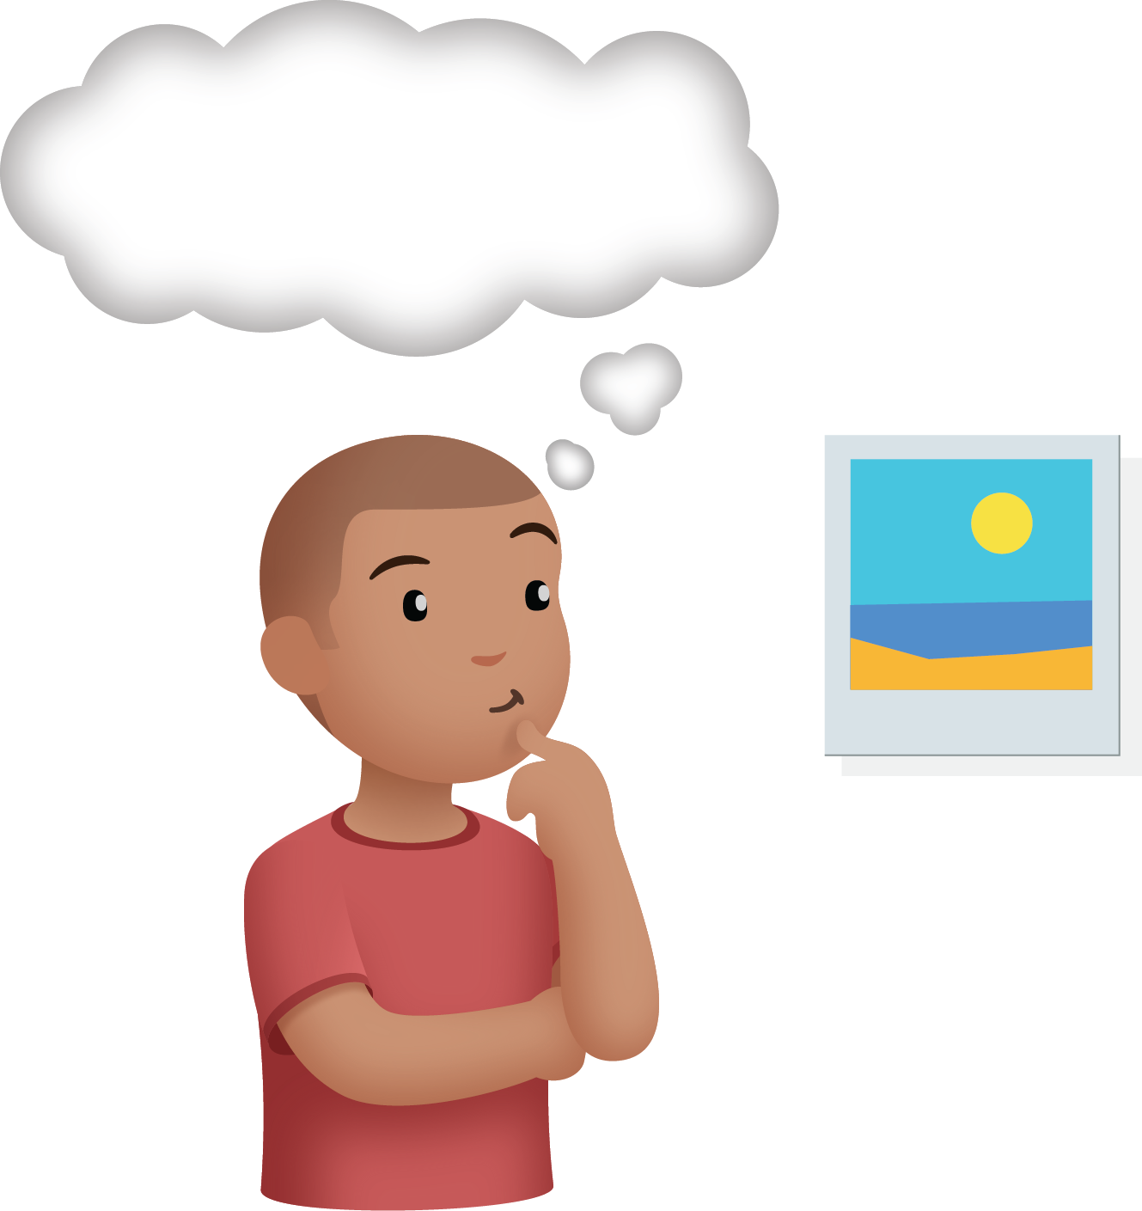
Connecting Cubes
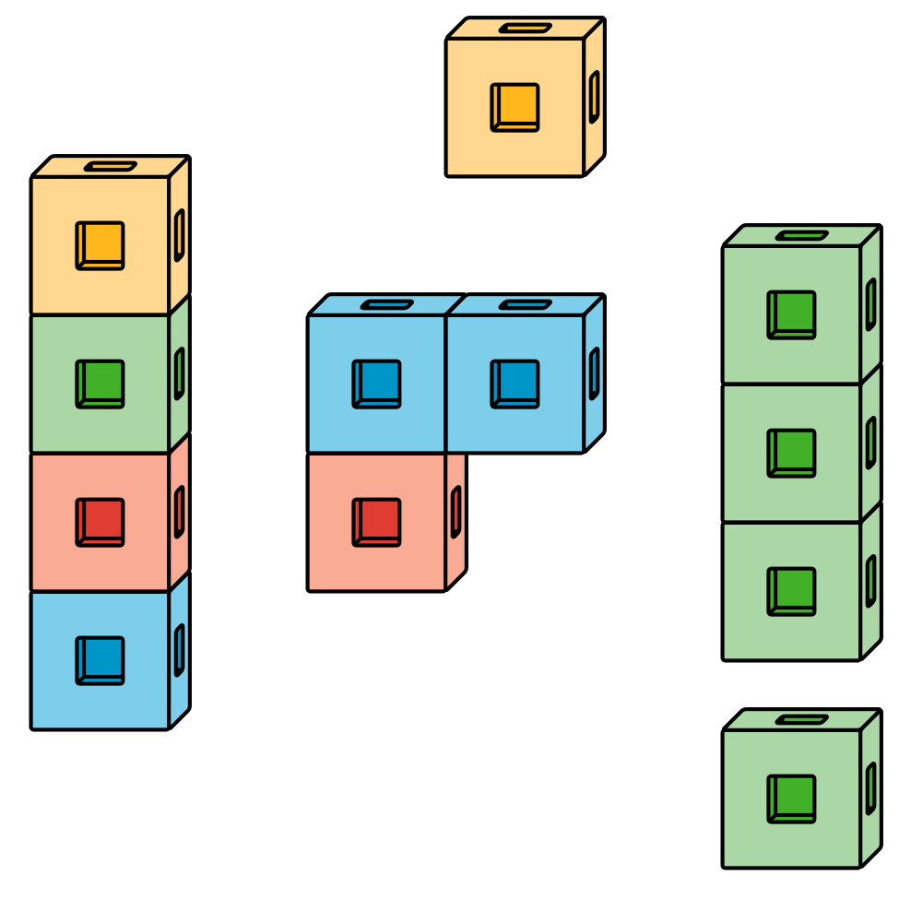
Number Race
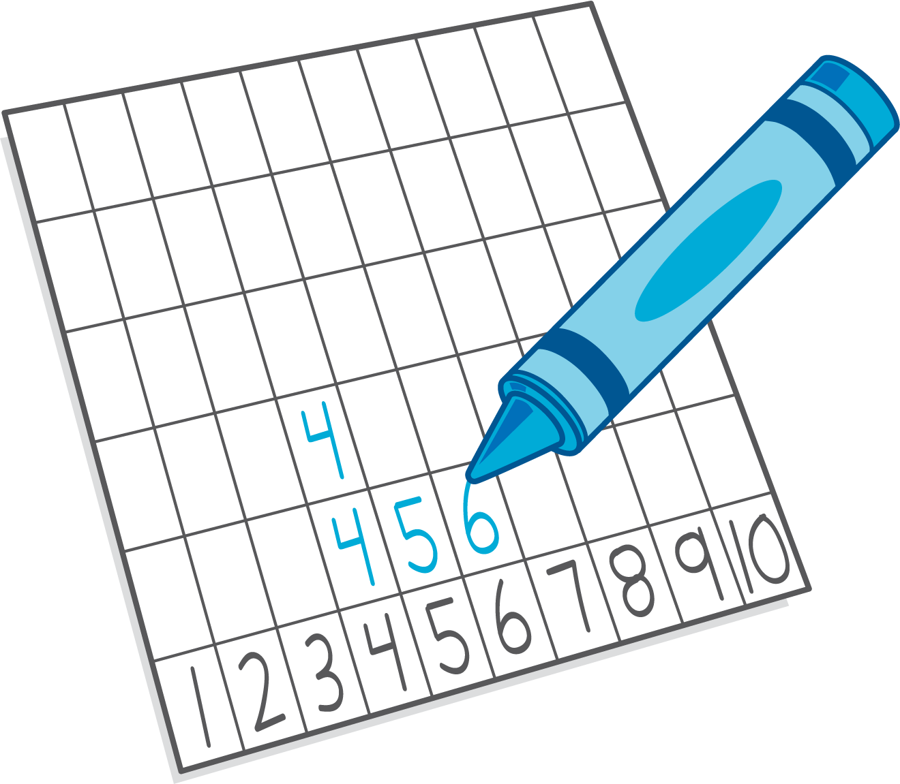
© CC BY 2021 Illustrative Mathematics®

