Grade 6
Unit 2Lesson 6CC BY NC Illustrative Mathematics, based on IM 6–8 Math, CC BY Open Up Resources.
Unit 2, Lesson 6

Introducing Double Number Line Diagrams
Let’s use number lines to represent equivalent ratios.
Grade 6
Unit 2Lesson 6CC BY NC Illustrative Mathematics, based on IM 6–8 Math, CC BY Open Up Resources.

6.1Math Talk: Adjusting Another Factor
Find the value of each product mentally.
- $2⋅45$
- $2⋅\left(4.5\right)$
- $6⋅\left(4.5\right)$
- $\left(0.2\right)⋅45$
Grade 6
Unit 2Lesson 6CC BY NC Illustrative Mathematics, based on IM 6–8 Math, CC BY Open Up Resources.

6.2Drink Mix on a Double Number Line
A drink recipe says to mix 4 teaspoons of powdered drink mix for every cup of water. Here are two ways to represent multiple batches of this recipe:
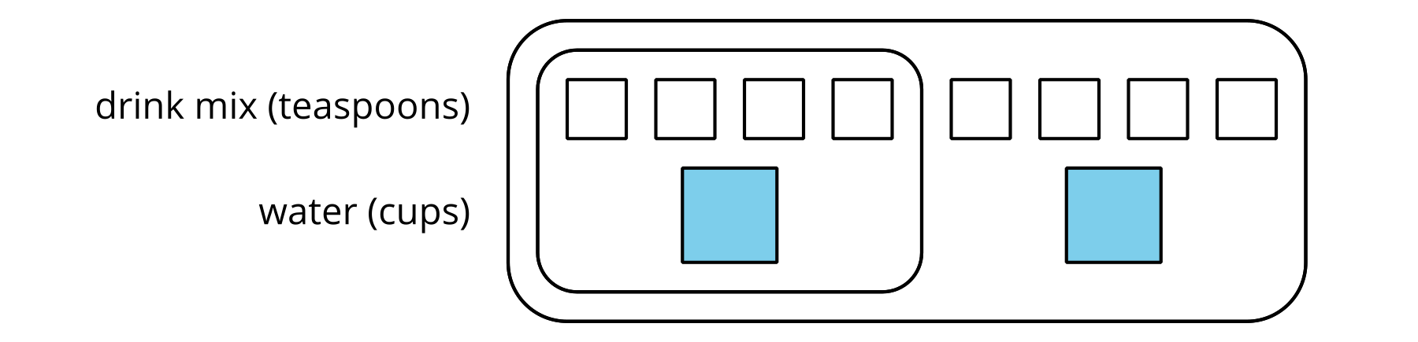
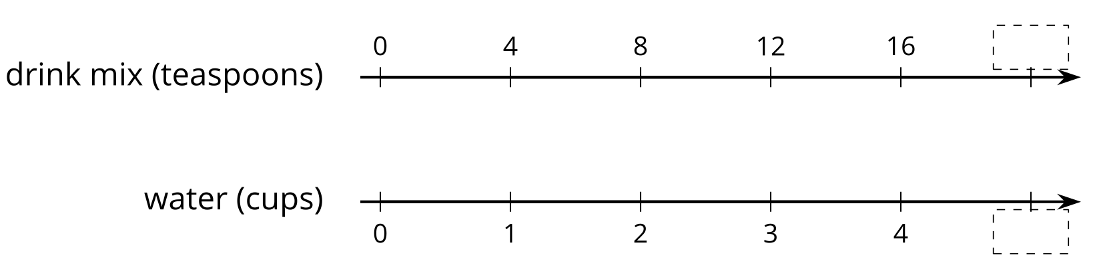
- How can we tell that $4:1$ and $12:3$ are equivalent ratios?
- How are these representations the same? How are these representations different?
- How many teaspoons of drink mix should be used with 3 cups of water?
- How many cups of water should be used with 16 teaspoons of drink mix?
- What numbers should go in the empty boxes on the double number line diagram? What do these numbers mean?

Are you ready for more?
Recall that a perfect square is a number of objects that can be arranged into a square. For example, 9 is a perfect square because 9 objects can be arranged into 3 rows of 3. 16 is also a perfect square, because 16 objects can be arranged into 4 rows of 4. In contrast, 12 is not a perfect square because you can’t arrange 12 objects into a square.
- How many whole numbers starting with 1 and ending with 100 are perfect squares?
- What about whole numbers starting with 1 and ending with 1,000?
Grade 6
Unit 2Lesson 6CC BY NC Illustrative Mathematics, based on IM 6–8 Math, CC BY Open Up Resources.

6.3Blue Paint on a Double Number Line
Here is a diagram showing Elena’s recipe for one batch of light blue paint.
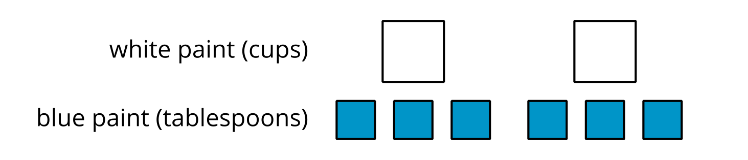
- Complete the double number line diagram to show the amounts of white paint and blue paint in different-sized batches of light blue paint.
- 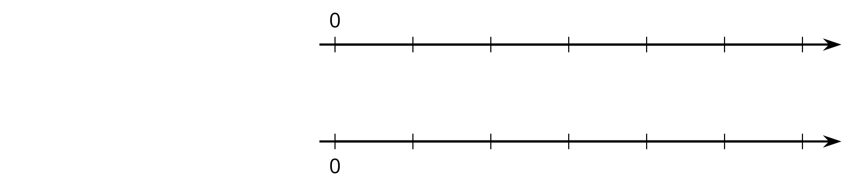
- Compare your double number line diagram with your partner. Discuss your thinking. If needed, revise your diagram.
- How many cups of white paint should Elena mix with 12 tablespoons of blue paint? How many batches would this make?
- How many tablespoons of blue paint should Elena mix with 6 cups of white paint? How many batches would this make?
- Use your double number line diagram to find another amount of white paint and blue paint that would make the same shade of light blue paint.
- How do you know that these mixtures would make the same shade of light blue paint?
Grade 6
Unit 2Lesson 6CC BY NC Illustrative Mathematics, based on IM 6–8 Math, CC BY Open Up Resources.

6.4Fix It!
Andre likes a hot cocoa recipe with 1 cup of milk and 3 tablespoons of cocoa. He poured 1 cup of milk but accidentally added 5 tablespoons of cocoa.
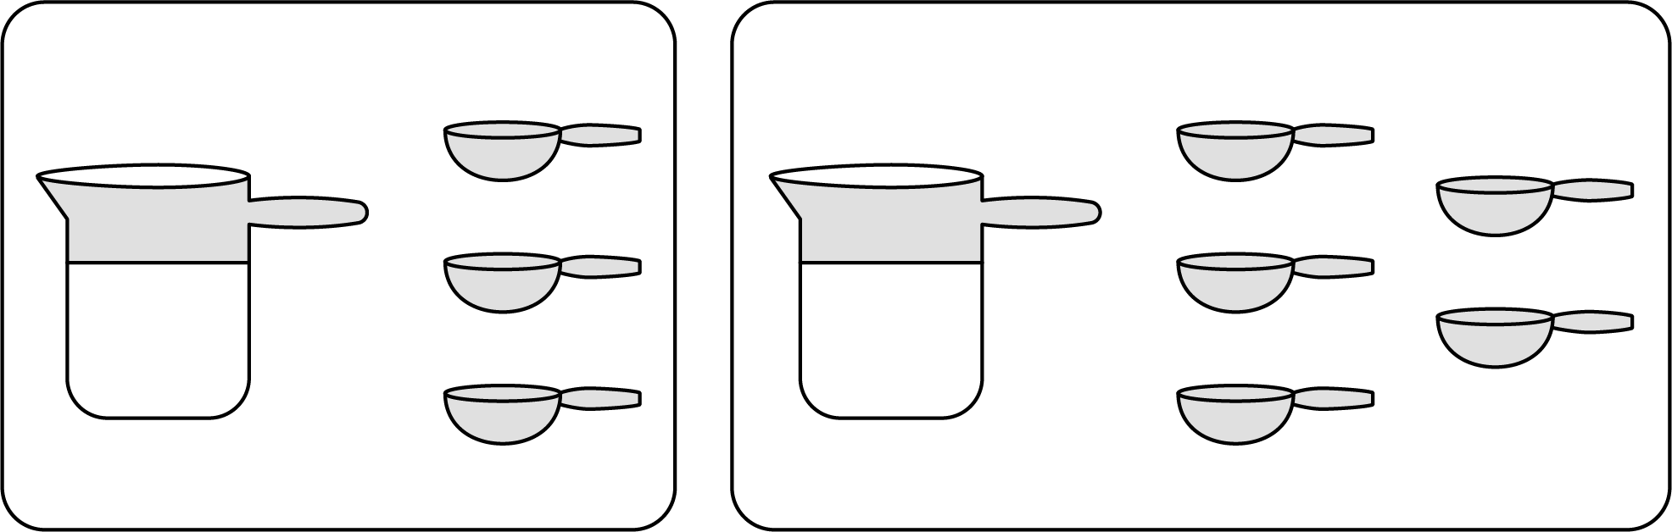
- How can you fix Andre’s mistake and make his hot cocoa taste like the recipe?
- Explain how you know your adjustment will make Andre’s hot cocoa taste the same as the one in the recipe.

Lesson 6 Summary
You can use a double number line diagram to find many equivalent ratios.
For example, a recipe for fizzy juice says, “Mix 5 cups of cranberry juice with 2 cups of soda water.” The ratio of cranberry juice to soda water is $5:2$. Multiplying both ingredients by the same number creates equivalent ratios.
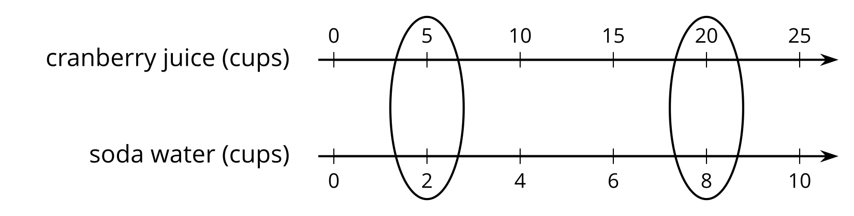
This double number line shows that the ratio $20:8$ is equivalent to $5:2$. If you mix 20 cups of cranberry juice with 8 cups of soda water, it makes 4 times as much fizzy juice that tastes the same as the original recipe.

