Designing a Fountain
Algebra 1Modeling PromptCC BY NC 2024 Illustrative Mathematics®

Task Statement 1
A nearby park has a decorative pool. The board of commissioners of the park is considering installing water jets in the pool to make it into a fountain. They have asked you to design the water jets. Here is a diagram of the pool from above:
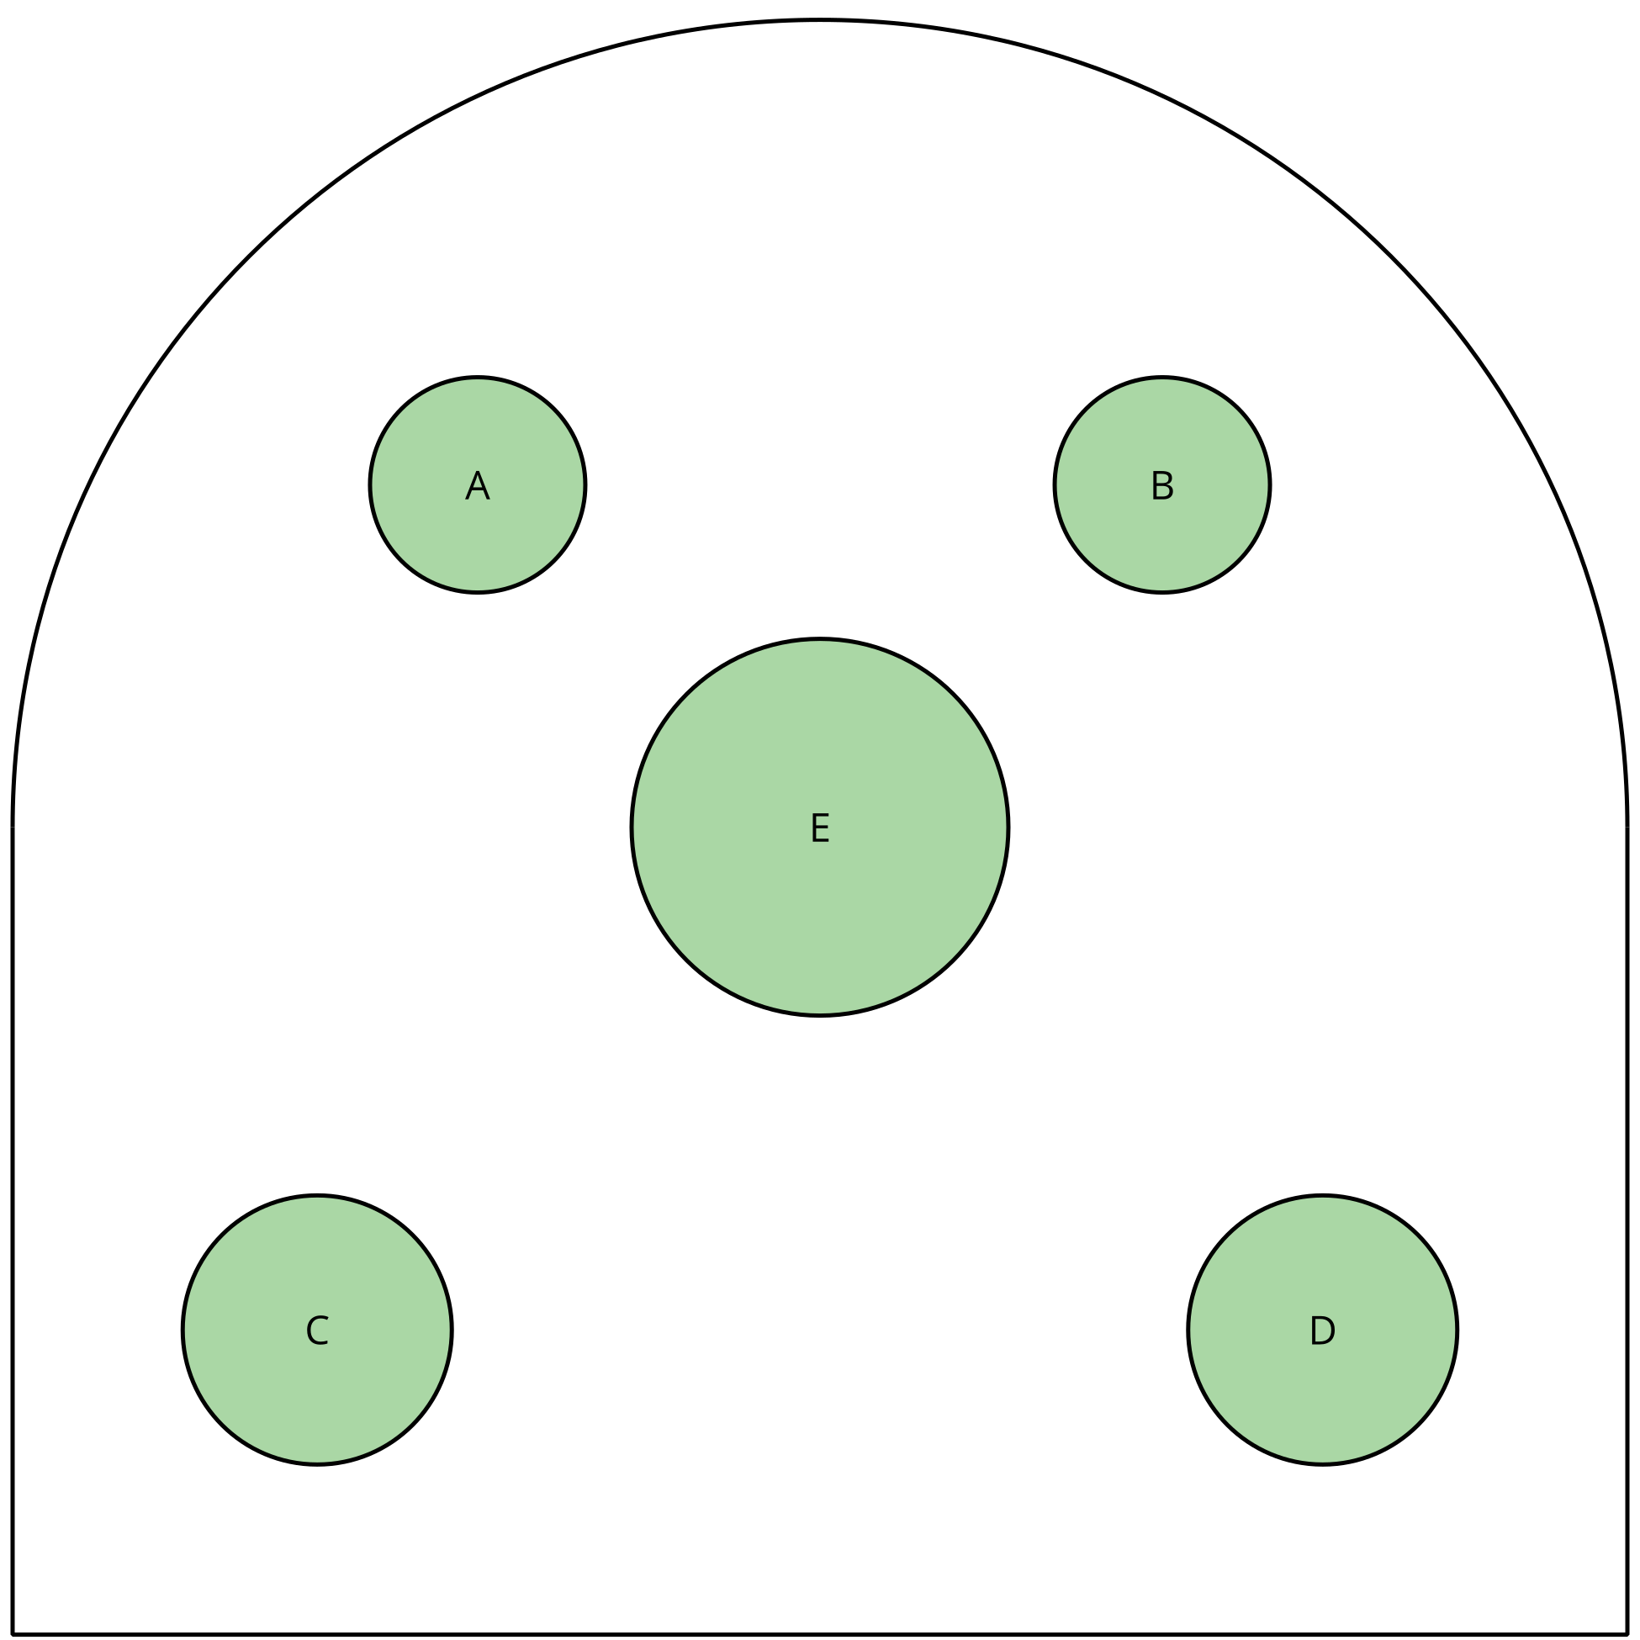
Statues A and B are 4 feet tall each. Statues C and D are wider and 5.5 feet tall each. Statue E is 8 feet tall, with a vase on top. The diagram is drawn to scale, and the pool is 15 feet wide.
The jets are at water level. You need to figure out the number of jets, where they should go, and what path the water should make. Your design needs to meet these criteria:
- The jets are placed only around the edge of the pool.
- There are at least two jets.
- The water doesn't hit any of the statues.
- Some water goes into the vase.
- The water doesn't go higher than 10 feet.
When you have your final design, create a presentation to explain it to the commissioners. The presentation should show the paths of the water and include your mathematical descriptions of the paths.
Algebra 1Modeling PromptCC BY NC 2024 Illustrative Mathematics®

Task Statement 2
A nearby park has a decorative pool. The board of commissioners of the park is considering installing water jets in the pool to make it into a fountain. They have asked you to design the water jets. Here is a diagram of the pool from above:
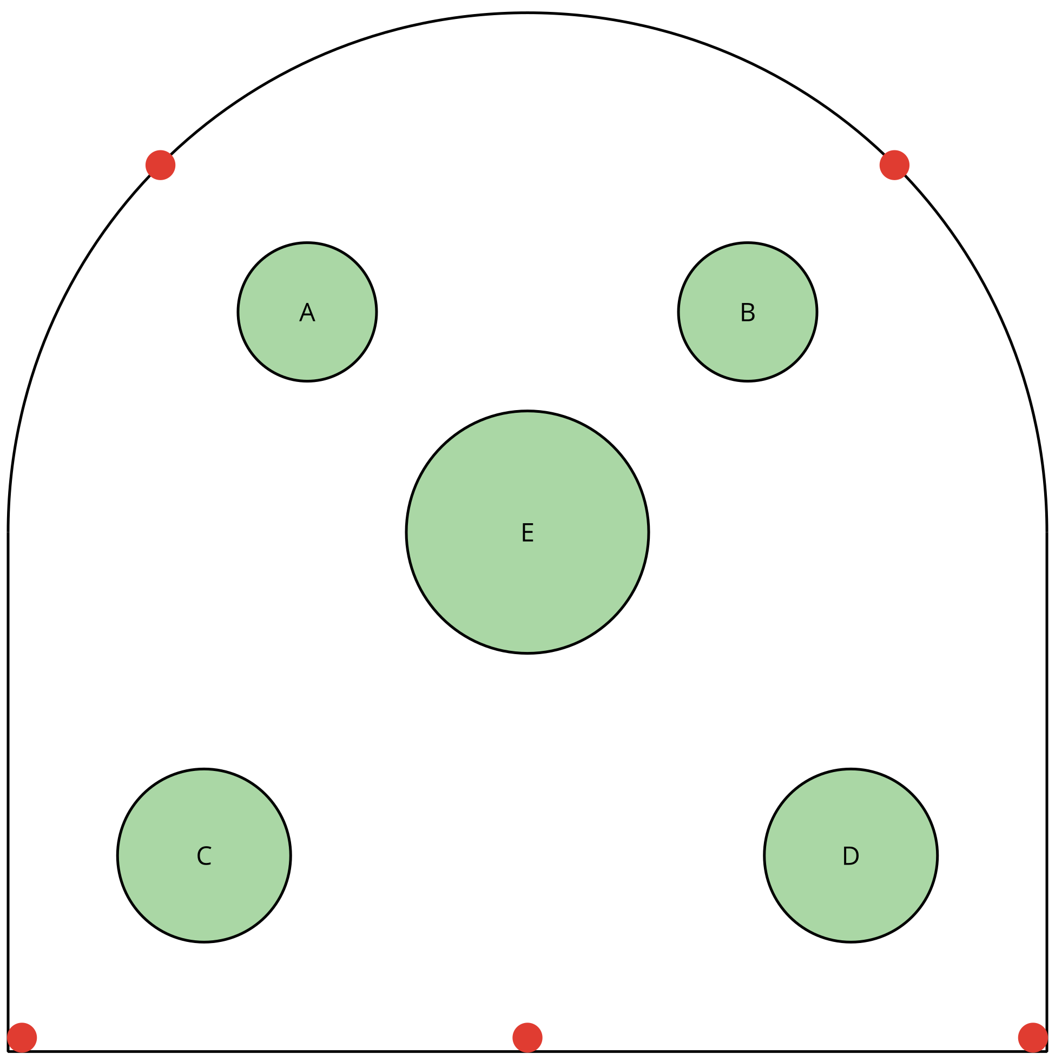
Statues A and B are 4 feet tall each. Statues C and D are wider and 5.5 feet tall each. Statue E is 8 feet tall, with a vase on top. The diagram is drawn to scale, and the pool is 15 feet wide. The dots along the edge show where to place the jets. You don’t have to put jets in all five places. The jets are at water level.
You need to figure out the number of jets, where they should go, and what path the water should make. Your design needs to meet these criteria:
- The jets are only in the places indicated by the dots.
- There are at least two jets.
- The water doesn’t hit any of the statues.
- Some water goes into the vase.
- The water doesn’t go higher than 10 feet.
When you have your final design, create a presentation to explain it to the commissioners. The presentation should show the paths of the water and include your mathematical descriptions of the paths.
Before you begin your design, sketch a side view of the pool, showing the heights of the statues and the vase. This will help you figure out the paths of the water.
Algebra 1Modeling PromptCC BY NC 2024 Illustrative Mathematics®

Task Statement 3
A nearby park has a decorative pool. The board of commissioners of the park is considering installing water jets in the pool to make it into a fountain. They have asked you to design the water jets. Here is a diagram of the pool from above:
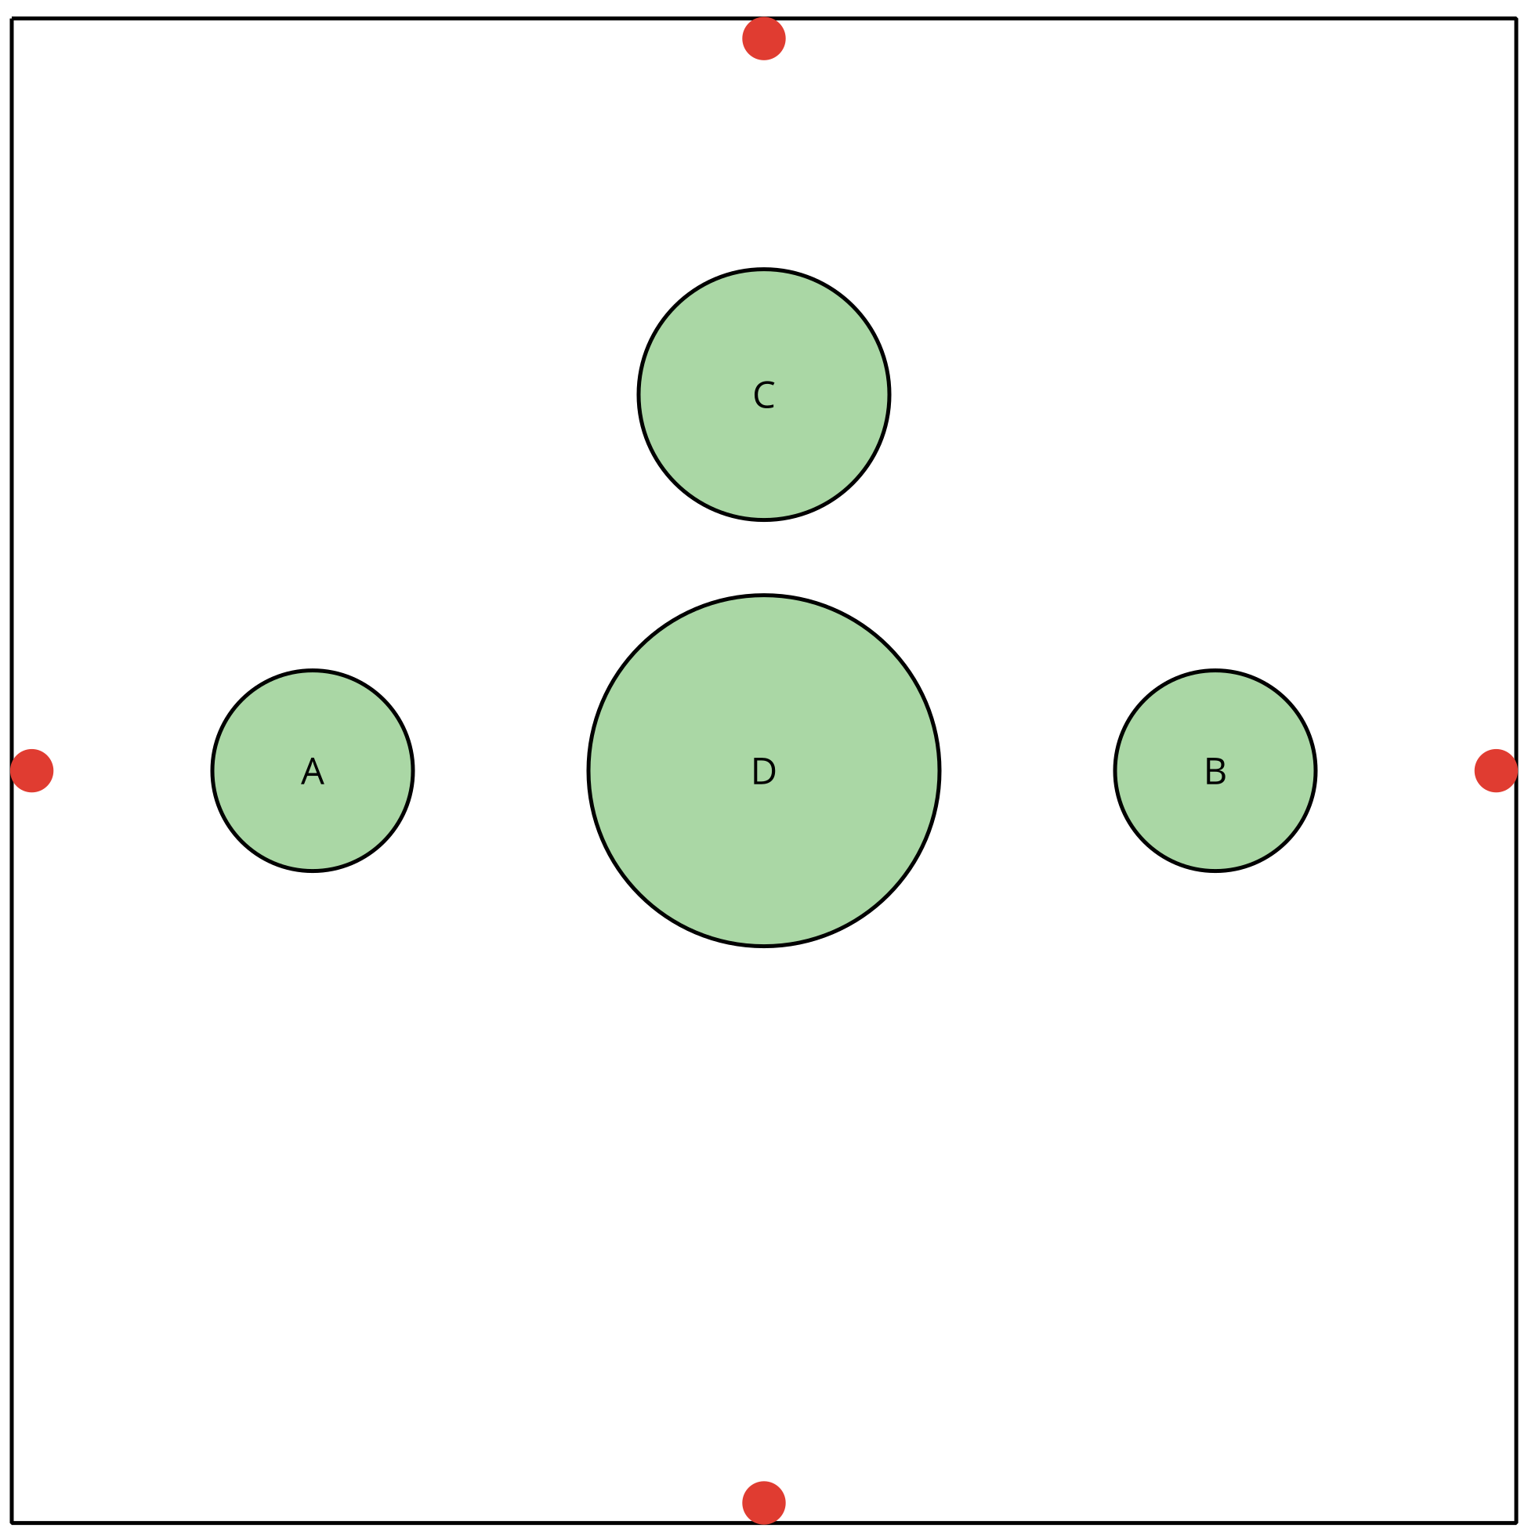
Statues A and B are 4 feet tall each. Statue C is wider and 5.5 feet tall. Statue D is 8 feet tall, with a vase on top. The diagram is drawn to scale, and the pool is 15 feet wide. The dots along the edge show where to place the jets. You don’t have to put jets in all four places. The jets are at water level.
You will need to figure out the number of jets, where they should go, and what path the water should make. Your design needs to meet these criteria:
- The jets are only in the places indicated by the dots.
- There are at least two jets.
- The water doesn’t hit any of the statues.
- Some water goes into the vase.
- The water doesn’t go higher than 12 feet.
When you have your final design, create a presentation to explain it to the commissioners. The presentation should show the paths of the water and include your mathematical descriptions of the paths.
Before you begin your design, sketch what the pool would look like from each side. Make sure to show the heights of the statues and the vase. This will help you figure out the paths of the water.
To help you get started, here is part of one sketch, showing the widths of Statues A, B, and D. It shows what the pool would look like if you were standing near the bottom of the diagram that shows the pool from above. It also shows the jet locations next to Statues A and B. Figure out the heights of Statues A, B, and D, according to the scale of this sketch, and then finish the sketch by representing the heights. Make your own sketches for the other sides of the pool.
