Lesson 14: Using Diagrams to Represent Addition and Subtraction
Let’s represent addition and subtraction of decimals.

14.1: Do the Zeros Matter?
- Evaluate mentally: $1.009+0.391$
- Decide if each equation is true or false. Be prepared to explain your reasoning.
  - $34.56000=34.56$
  - $25=25.0$
  - $2.405=2.45$

14.2: Finding Sums in Different Ways
- Here are two ways to calculate the value of $0.26+0.07$. In the diagram, each rectangle represents 0.1 and each square represents 0.01.
- 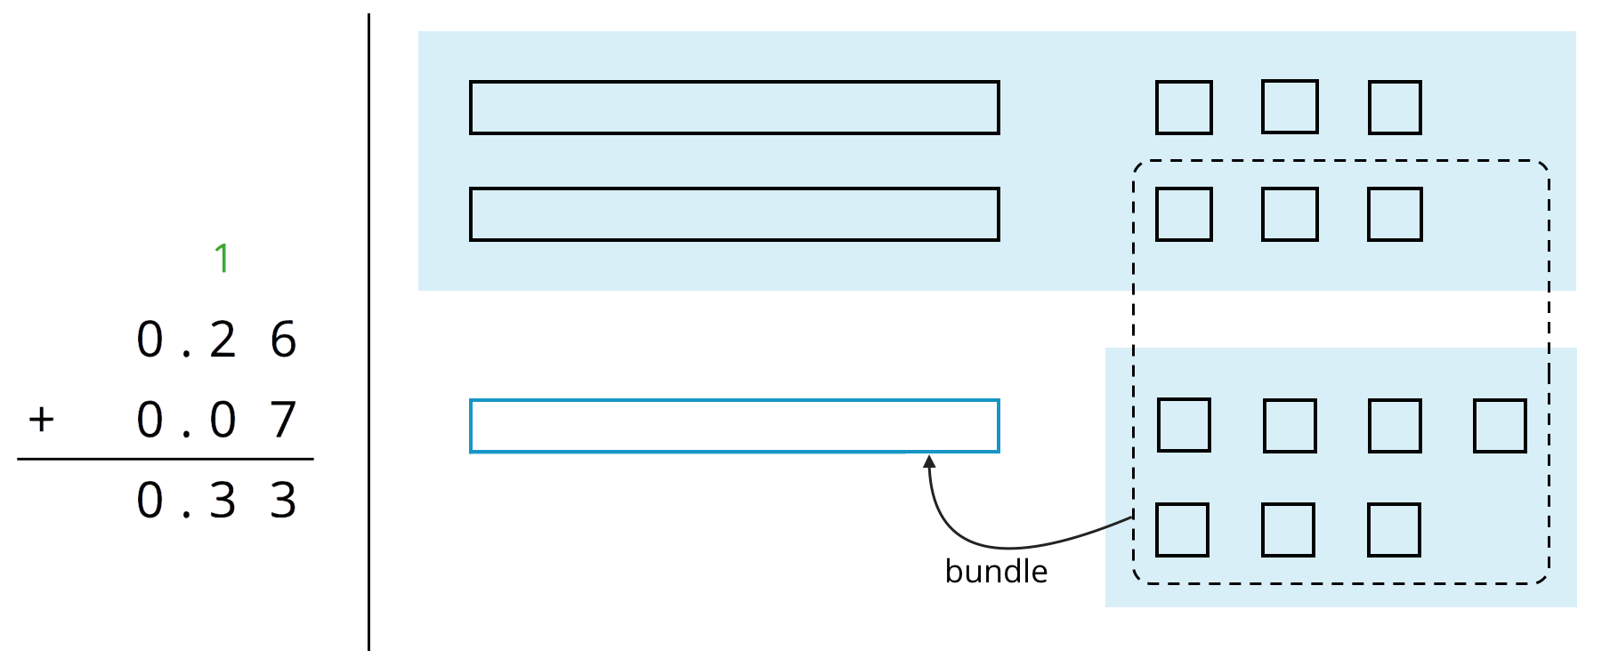
- Use what you know about base-ten units and addition to explain:
  - Why ten squares can be “bundled” into a rectangle.
  - How this “bundling” is represented in the vertical calculation.
- Find the value of $0.38+0.69$ by drawing a diagram. Can you find the sum without bundling? Would it be useful to bundle some pieces? Explain your reasoning.
- Calculate $0.38+0.69$. Check your calculation against your diagram in the previous question.
- Find each sum. The larger square represents 1.

  - 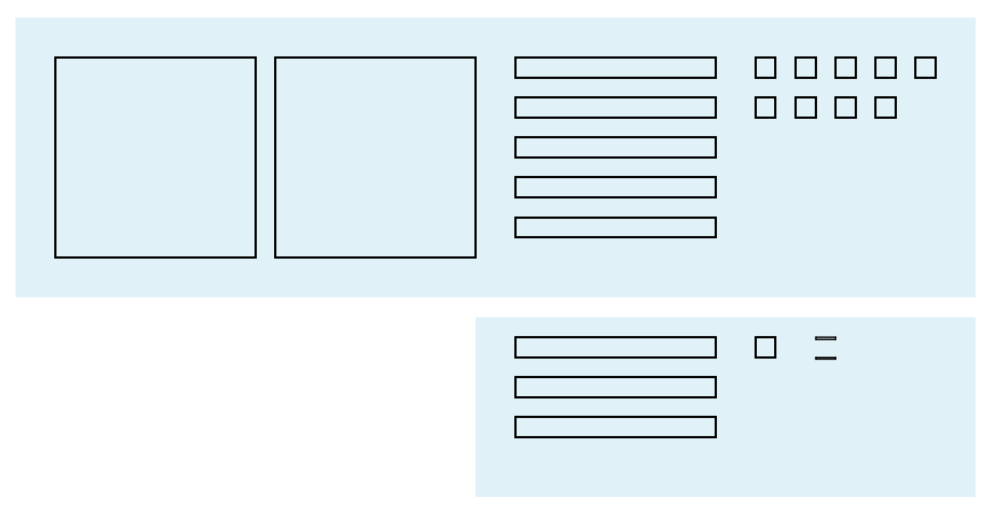

  - 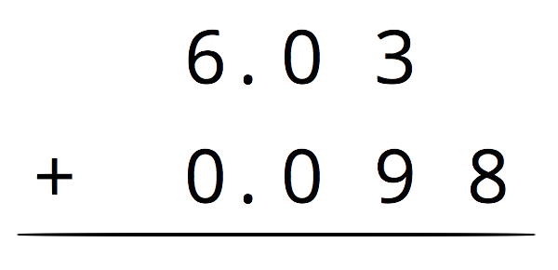

Are you ready for more?
A distant, magical land uses jewels for their bartering system. The jewels are valued and ranked in order of their rarity. Each jewel is worth 3 times the jewel immediately below it in the ranking. The ranking is red, orange, yellow, green, blue, indigo, and violet. So a red jewel is worth 3 orange jewels, a green jewel is worth 3 blue jewels, and so on.
- If you had 500 violet jewels and wanted to trade so that you carried as few jewels as possible, which jewels would you have?
- Suppose you have 1 orange jewel, 2 yellow jewels, and 1 indigo jewel. If you’re given 2 green jewels and 1 yellow jewels, what is the fewest number of jewels that could represent the value of the jewels you have?

14.3: Subtracting Decimals of Different Lengths
Diego and Noah drew different diagrams to represent $0.4−0.03$. Each rectangle represents 0.1. Each square represents 0.01.
- Diego started by drawing 4 rectangles to represent 0.4. He then replaced 1 rectangle with 10 squares and crossed out 3 squares to represent subtraction of 0.03, leaving 3 rectangles and 7 squares in his diagram.
- 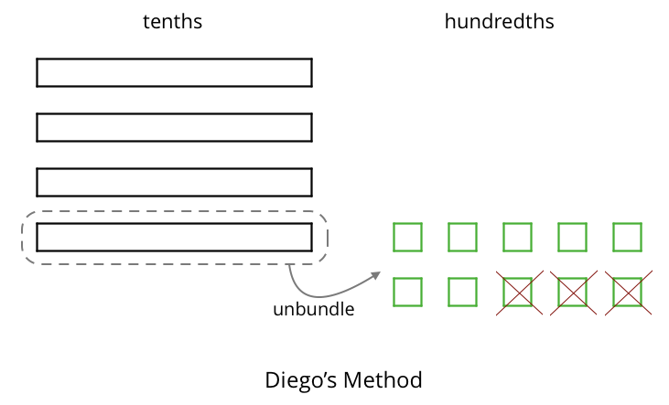
- Noah started by drawing 4 rectangles to represent 0.4. He then crossed out 3 rectangles to represent the subtraction, leaving 1 rectangle in his diagram.
- 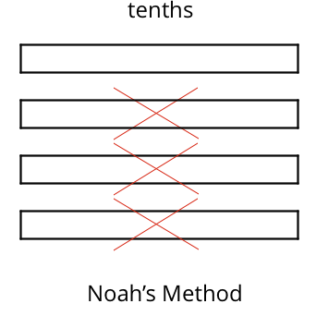
- Do you agree that either diagram correctly represents $0.4−0.03$? Discuss your reasoning with a partner.
- Elena also drew a diagram to represent $0.4−0.03$. She started by drawing 4 rectangles. She then replaced all 4 rectangles with 40 squares and crossed out 3 squares to represent subtraction of 0.03, leaving 37 squares in her diagram. Is her diagram correct? Discuss your reasoning with a partner.
- 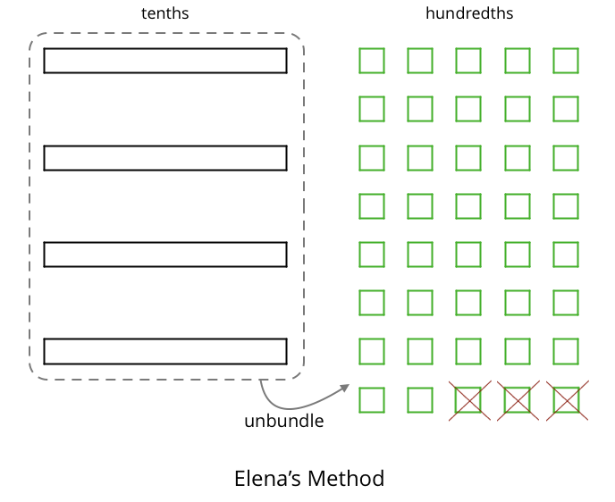
- Find each difference. Explain or show your reasoning.
  - $0.3−0.05$
  - $2.1−0.4$
  - $1.03−0.06$
  - $0.02−0.007$

Are you ready for more?
A distant, magical land uses jewels for their bartering system. The jewels are valued and ranked in order of their rarity. Each jewel is worth 3 times the jewel immediately below it in the ranking. The ranking is red, orange, yellow, green, blue, indigo, and violet. So a red jewel is worth 3 orange jewels, a green jewel is worth 3 blue jewels, and so on.
At the Auld Shoppe, a shopper buys items that are worth 2 yellow jewels, 2 green jewels, 2 blue jewels, and 1 indigo jewel. If they came into the store with 1 red jewel, 1 yellow jewel, 2 green jewels, 1 blue jewel, and 2 violet jewels, what jewels do they leave with? Assume the shopkeeper gives them their change using as few jewels as possible.

Lesson 14 Summary
Base-ten diagrams represent collections of base-ten units—tens, ones, tenths, hundredths, etc. We can use them to help us understand sums of decimals.
Suppose we are finding $0.08+0.13$. Here is a diagram where a square represents 0.01 and a rectangle (made up of ten squares) represents 0.1.
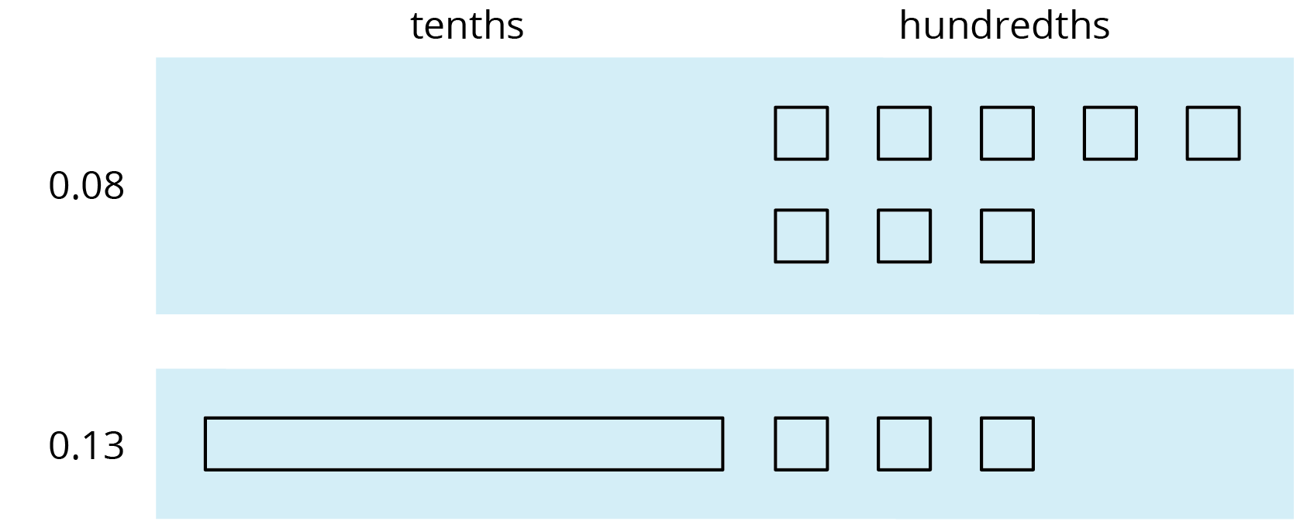
To find the sum, we can “bundle” (or compose) 10 hundredths as 1 tenth.
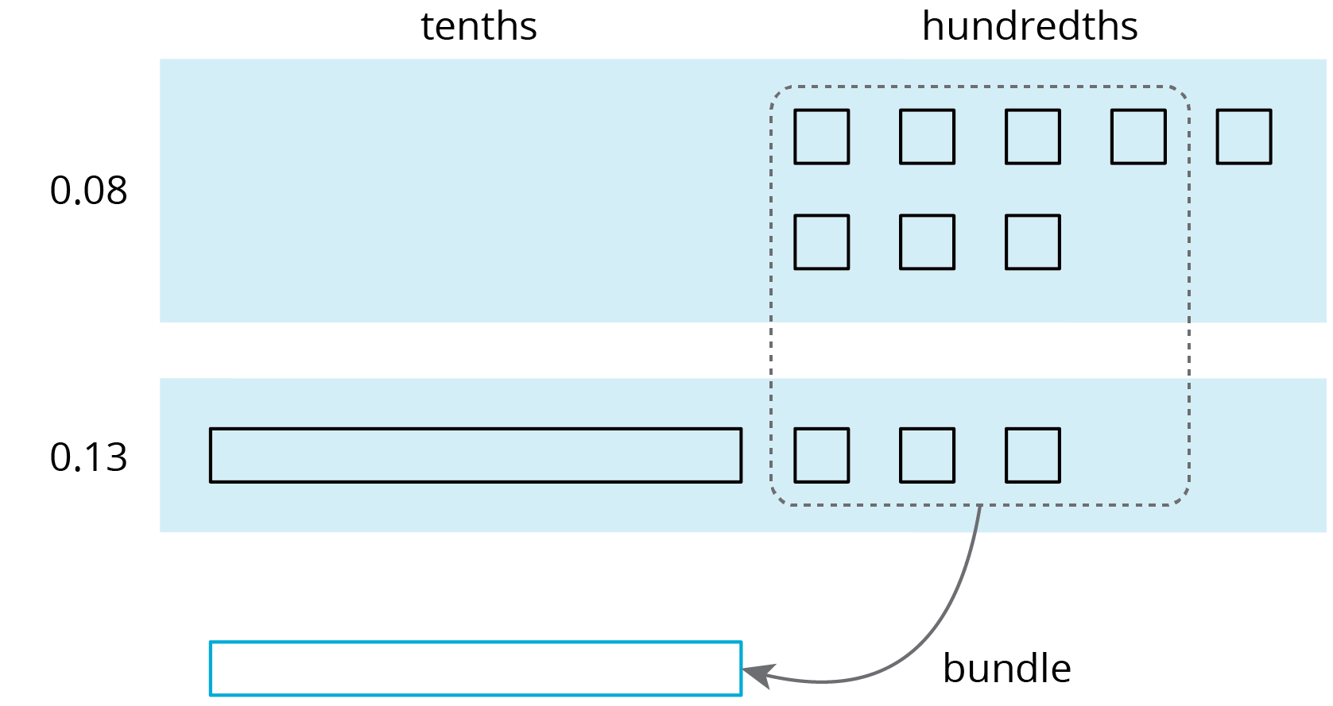
We now have 2 tenths and 1 hundredth, so $0.08+0.13=0.21$.
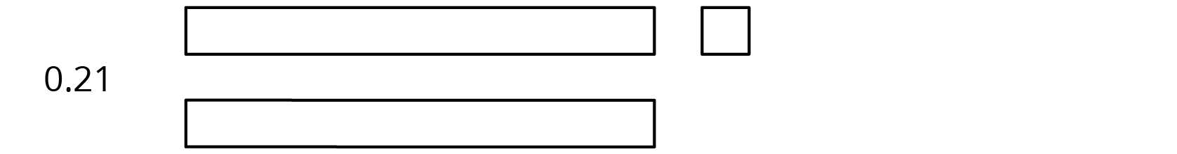
We can also use vertical calculation to find $0.08+0.13$.
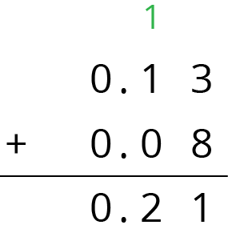
Notice how this representation also shows 10 hundredths are bundled (or composed) as 1 tenth.
This works for any decimal place. Suppose we are finding $0.008+0.013$. Here is a diagram where a small rectangle represents 0.001.
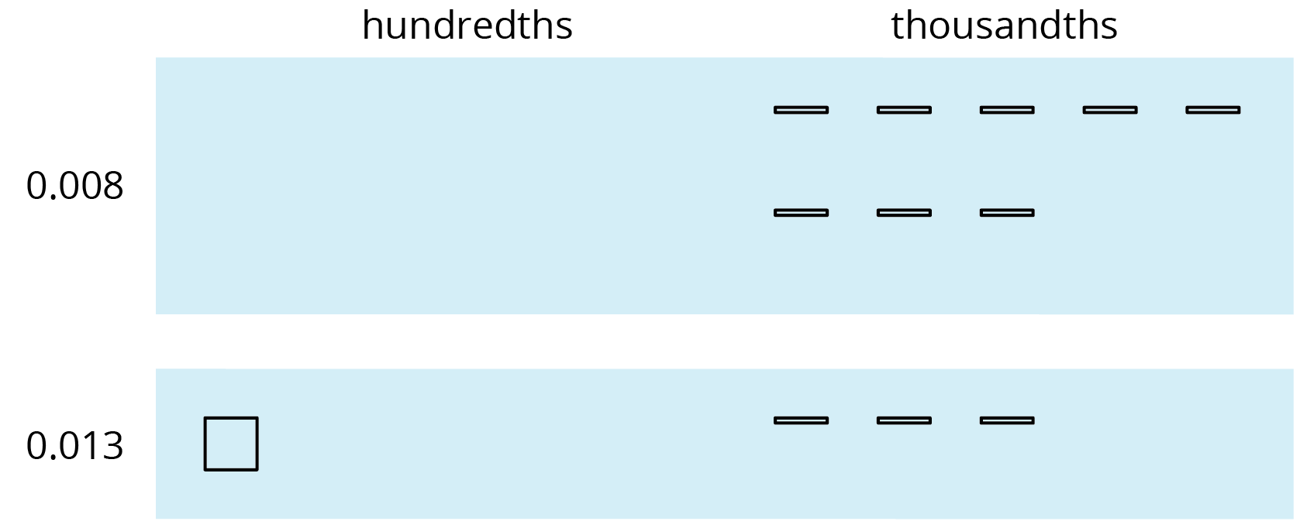
We can “bundle” (or compose) 10 thousandths as 1 hundredth.
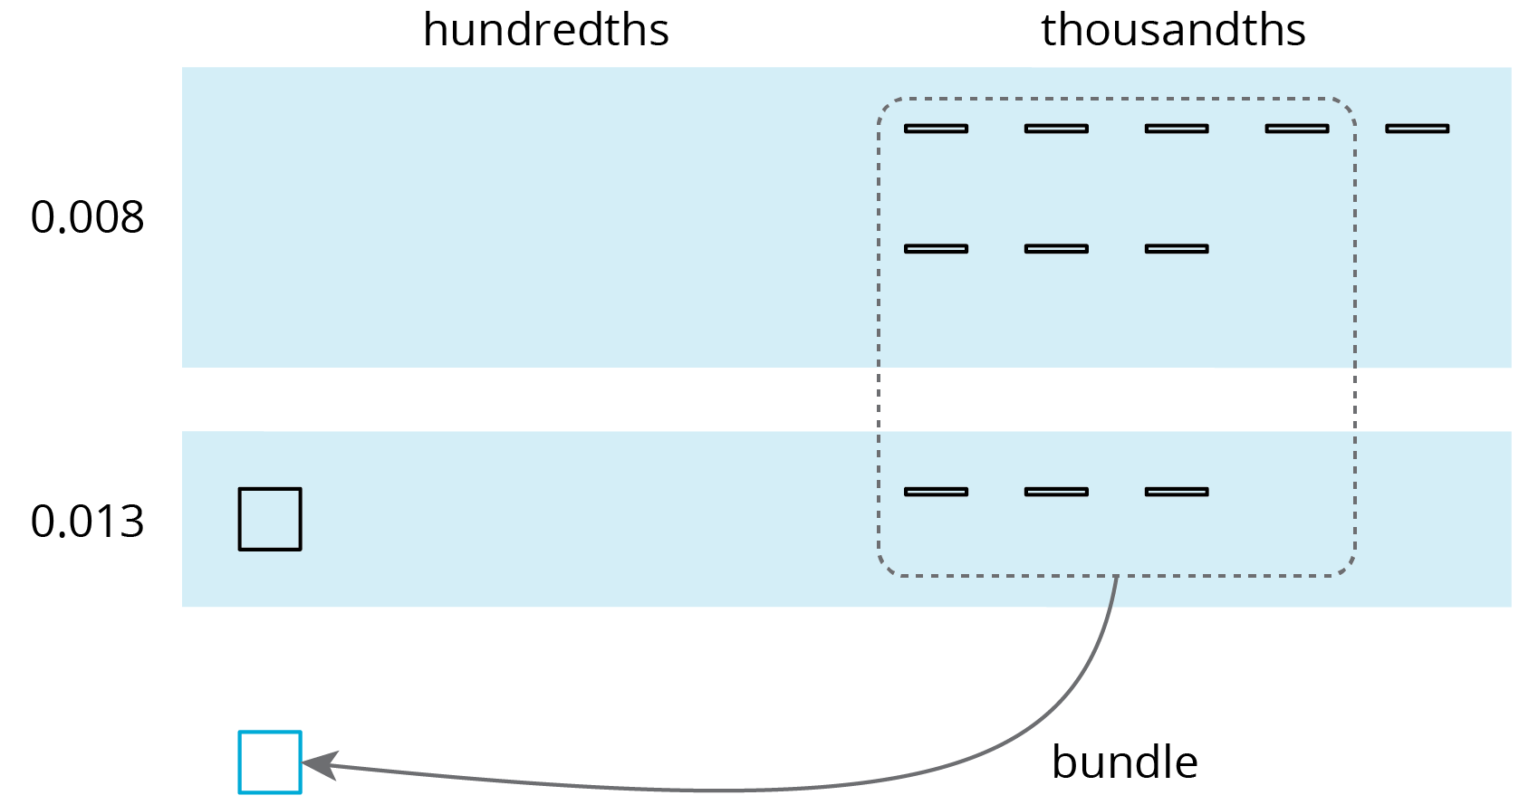
The sum is 2 hundredths and 1 thousandth.
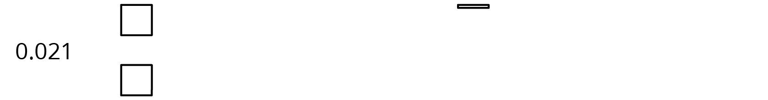
Here is a vertical calculation of $0.008+0.013$.
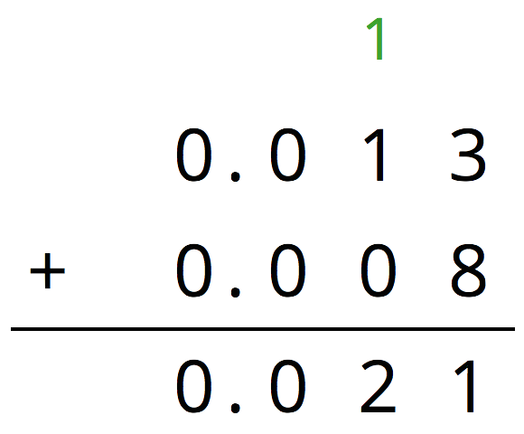
Base-ten diagrams can help us understand subtraction as well. Suppose we are finding $0.23−0.07$. Here is a diagram showing 0.23, or 2 tenths and 3 hundredths.
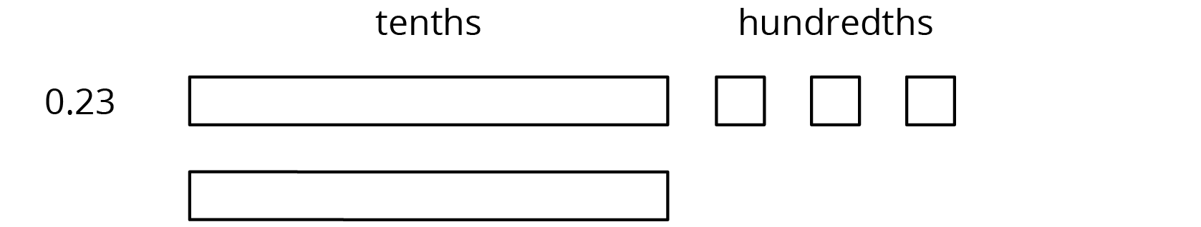
Subtracting 7 hundredths means removing 7 small squares, but we do not have enough to remove. Because 1 tenth is equal to 10 hundredths, we can “unbundle” (or decompose) one of the tenths (1 rectangle) into 10 hundredths (10 small squares).
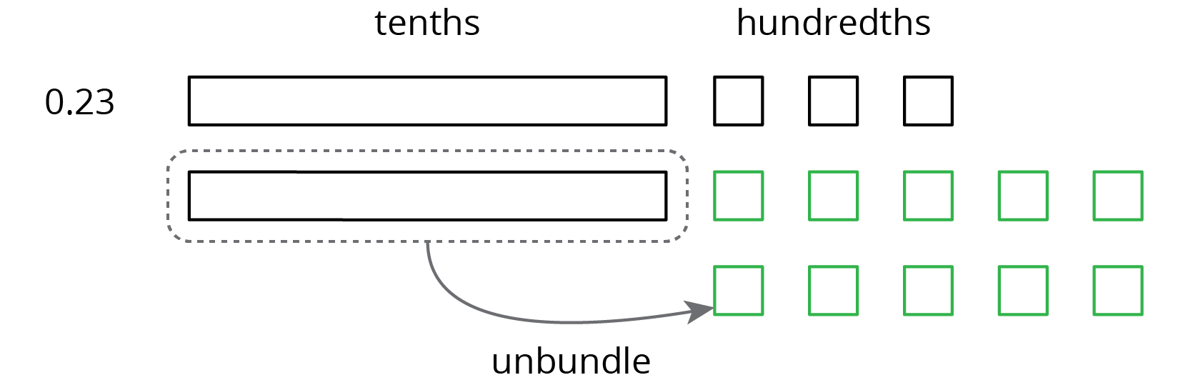
We now have 1 tenth and 13 hundredths, from which we can remove 7 hundredths.
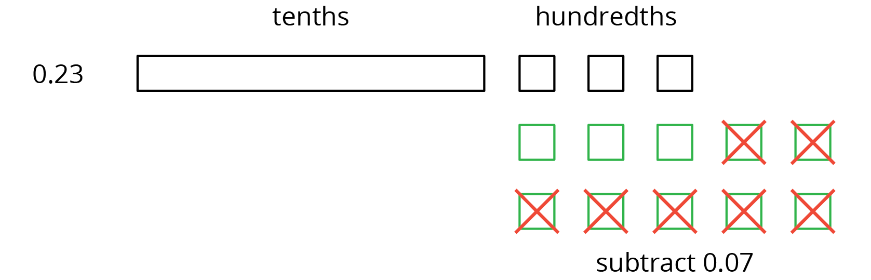
We have 1 tenth and 6 hundredths remaining, so $0.23−0.07=0.16$.
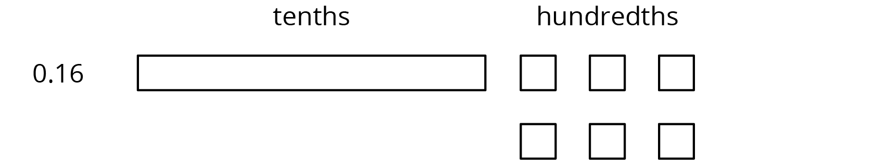
Here is a vertical calculation of $0.23−0.07$.
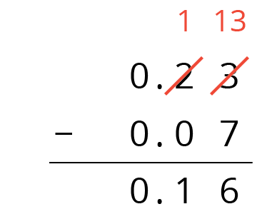
Notice how this representation also shows a tenth is unbundled (or decomposed) into 10 hundredths in order to subtract 7 hundredths.
This works for any decimal place. Suppose we are finding $0.023−0.007$. Here is a diagram showing 0.023.
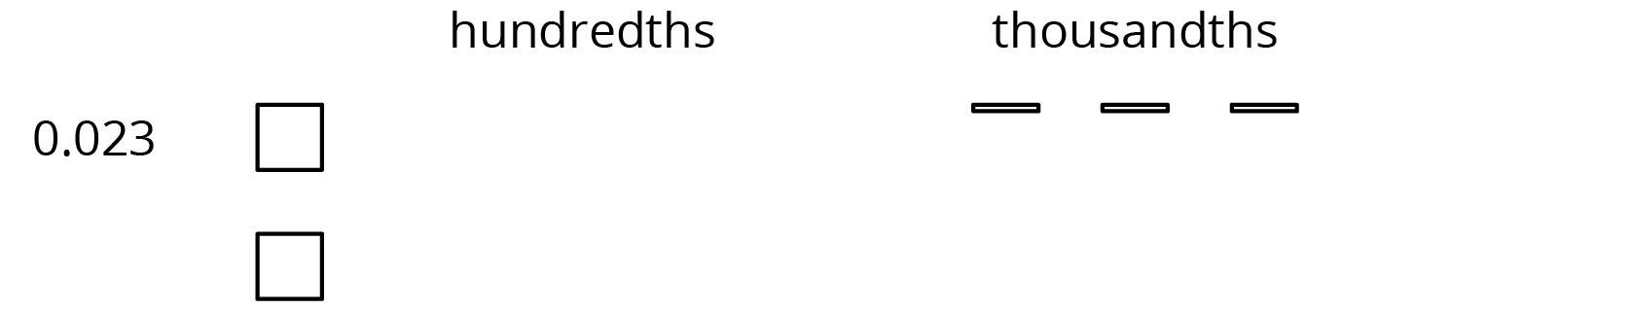
We want to remove 7 thousandths (7 small rectangles). We can “unbundle” (or decompose) one of the hundredths into 10 thousandths.
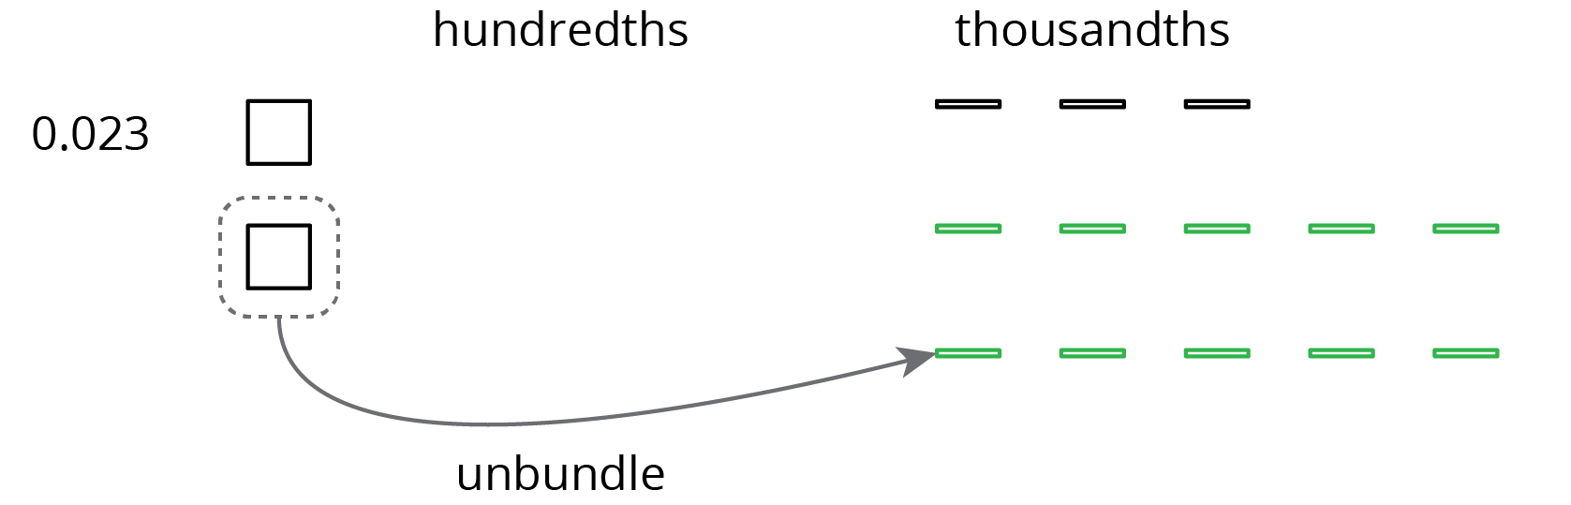
Now we can remove 7 thousandths.
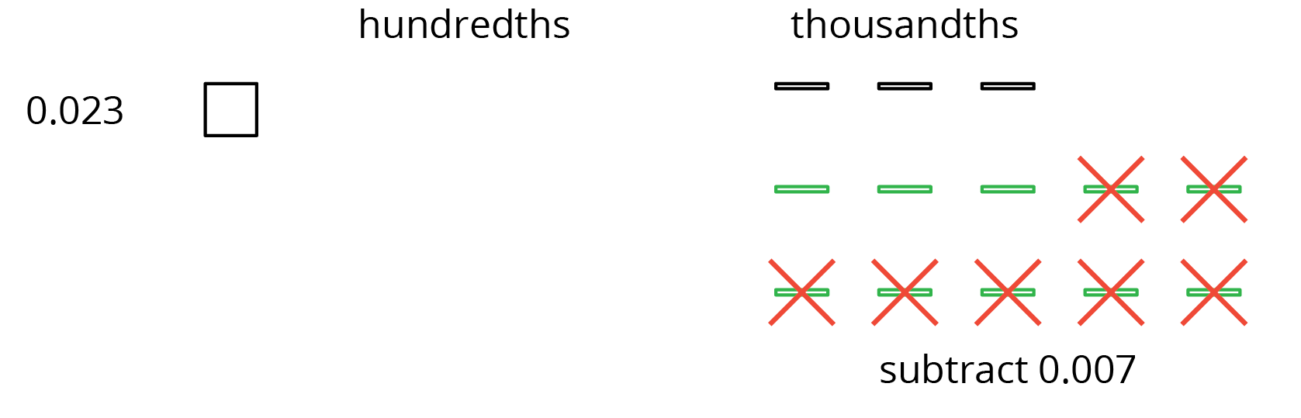
We have 1 hundredth and 6 thousandths remaining, so $0.023−0.007=0.016$.
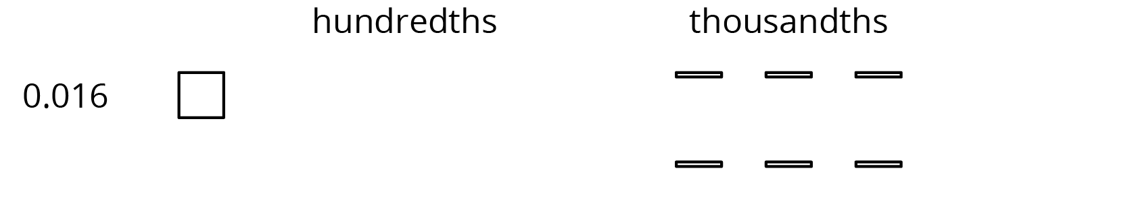
Here is a vertical calculation of $0.023−0.007$.
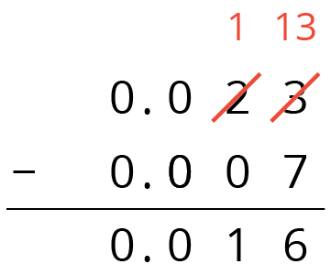
© CC BY Open Up Resources. Adaptations CC BY IM.

