Grade 6
Unit 4Lesson 7CC BY NC Illustrative Mathematics, based on IM 6–8 Math, CC BY Open Up Resources.
Unit 4, Lesson 7

What Fraction of a Group?
Let’s think about dividing things into groups when we can’t even make one whole group.
Grade 6
Unit 4Lesson 7CC BY NC Illustrative Mathematics, based on IM 6–8 Math, CC BY Open Up Resources.

7.1Notice and Wonder: Cups and Days
What do you notice? What do you wonder?
Tuesday
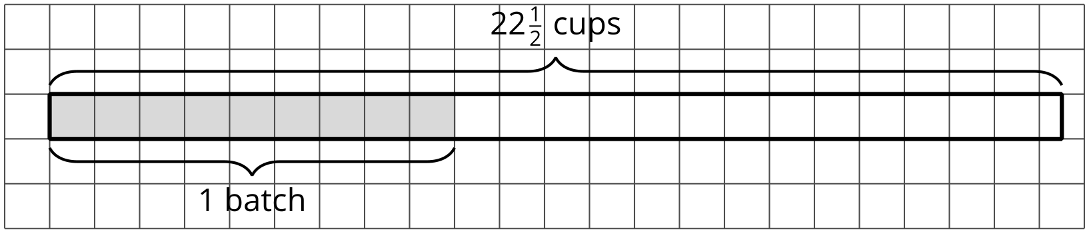
Thursday
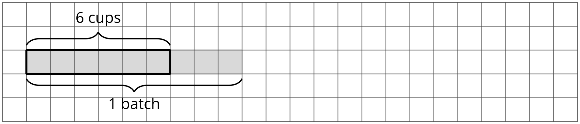
Grade 6
Unit 4Lesson 7CC BY NC Illustrative Mathematics, based on IM 6–8 Math, CC BY Open Up Resources.

7.2Fractional Batches of Soup
One batch of a soup recipe uses 9 cups of milk. A chef makes different amounts of soup on different days. Here are the amounts of milk she used:
- Monday: 12 cups
- Tuesday: $22\frac{1}{2}$ cups
- Thursday: 6 cups
- Friday: $7\frac{1}{2}$ cups
For each question:
- Write a multiplication equation and a division equation that represent it. Use the “?” symbol for the unknown value.
- Answer the question. Use the partially started tape diagram to show your reasoning. The shaded region represents the cups of milk in 1 batch.
- How many batches of soup did she make on Monday?
  - Multiplication equation:
  - Division equation:
  - Answer:
  - 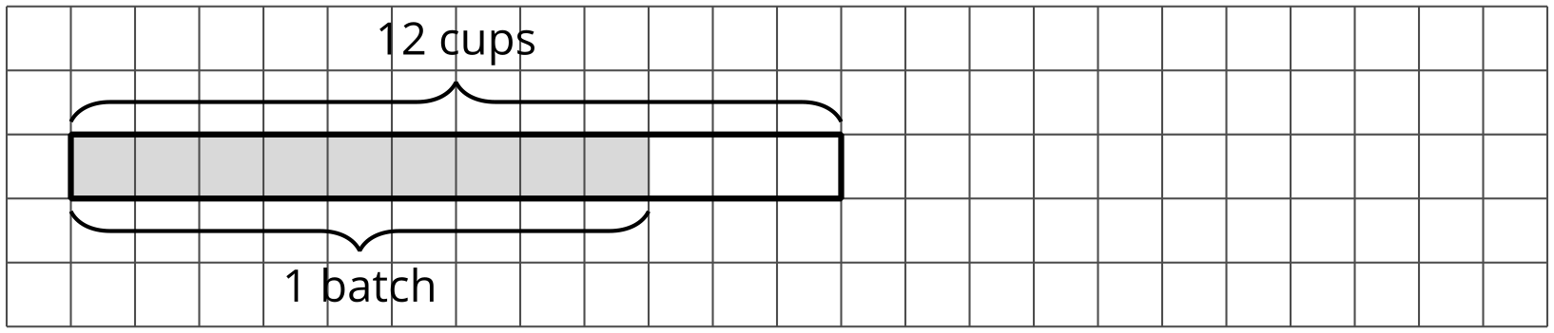
- How many batches of soup did she make on Tuesday?
  - Multiplication equation:
  - Division equation:
  - Answer:
- What fraction of a batch of soup did she make on Thursday?
  - Multiplication equation:
  - Division equation:
  - Answer:
  - 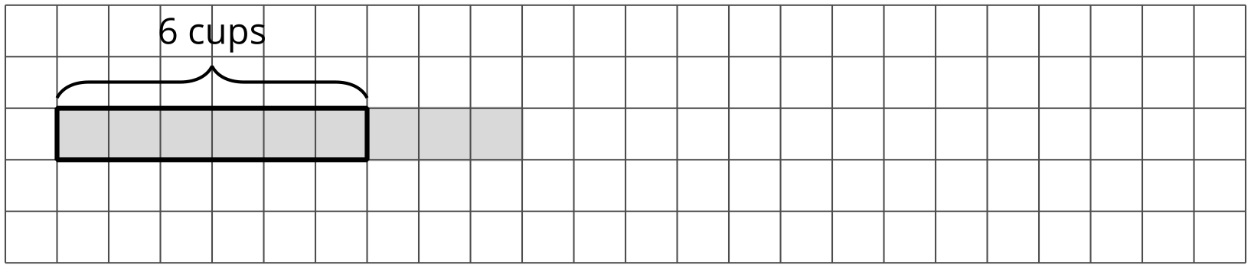
- What fraction of a batch of soup did she make on Friday?
  - Multiplication equation:
  - Division equation:
  - Answer:
  - 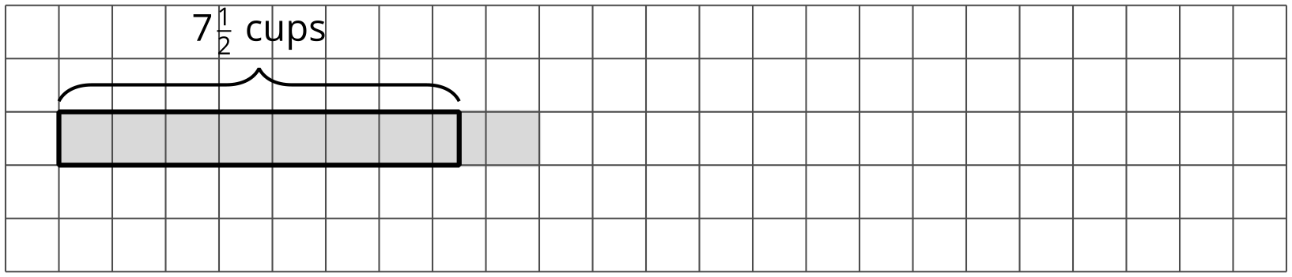
Grade 6
Unit 4Lesson 7CC BY NC Illustrative Mathematics, based on IM 6–8 Math, CC BY Open Up Resources.

7.3Fractions of Ropes
Here is a diagram that shows four ropes of different lengths.
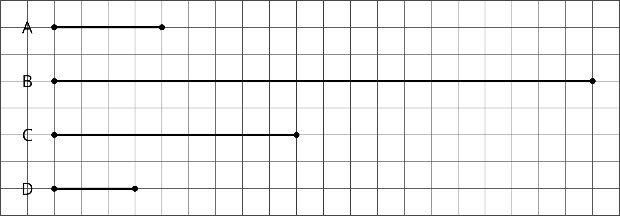
Complete each sentence comparing the ropes’ lengths. Then write a multiplication equation and a division equation for each comparison.
statement | multiplication equation | division equation
Rope B is $\underset{_}{​}$ times as long as Rope A.
Rope C is $\underset{_}{​}$ times as long as Rope A.
Rope D is $\underset{_}{​}$ times as long as Rope A.
Rope D is $\underset{_}{​}$ times as long as Rope C.
Grade 6
Unit 4Lesson 7CC BY NC Illustrative Mathematics, based on IM 6–8 Math, CC BY Open Up Resources.

7.4Not Quite One Group
For each question, write a multiplication equation and a division equation. Then answer the question. You can draw a tape diagram if you find it helpful.
- What fraction of 9 is 3?
  - Multiplication equation:
  - Division equation:
  - Answer:
  - 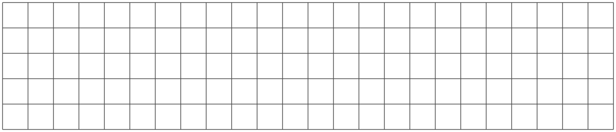
- What fraction of 5 is $\frac{1}{2}$?
  - Multiplication equation:
  - Division equation:
  - Answer:

Lesson 7 Summary
It is natural to think about groups when we have more than one group, but we can also have a fraction of a group.
Sometimes an amount is less than the size of 1 group, and we want to know what fraction of a group that amount is.
Suppose a full bag of flour weighs 6 kg. A chef used 3 kg of flour. What fraction of a full bag was used? In other words, what fraction of 6 kg is 3 kg?
We can still write equations and draw a diagram to represent the situation.
$?⋅6=3$
$3÷6=?$
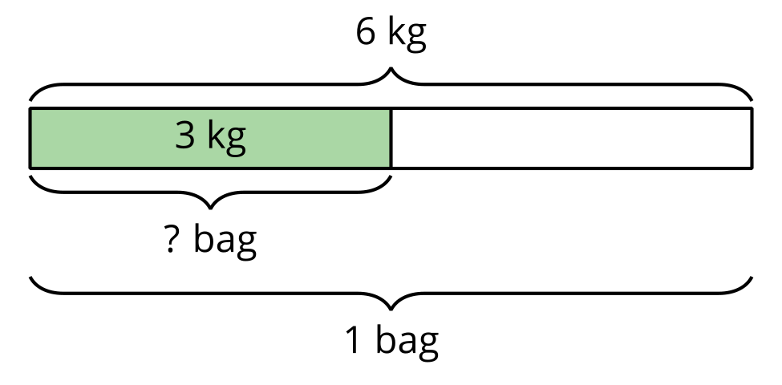
We can see from the diagram that 3 is $\frac{1}{2}$ of 6, so $3÷6=\frac{1}{2}$. We can check this quotient by multiplying: $\frac{1}{2}⋅6=3$.
In any situation where we want to know what fraction one number is of another number, we can write a multiplication equation and a division equation to help us find the answer.
For example, “What fraction of 3 is $2\frac{1}{4}$?” can be expressed as:
$?⋅3=2\frac{1}{4}$
$2\frac{1}{4}÷3=?$
The value of $2\frac{1}{4}÷3$ is also the answer to the original question.
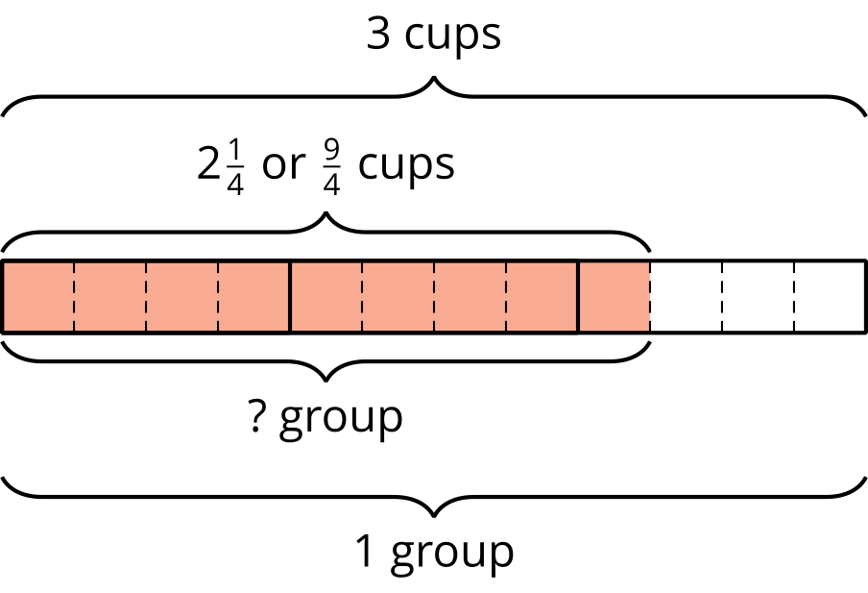
We can use a diagram to reason that there are 12 fourths in 3 and 9 fourths in $2\frac{1}{4}$, so $2\frac{1}{4}$ is $\frac{9}{12}$, or $\frac{3}{4}$, of 3. If we multiply $\frac{3}{4}$ and 3, we get $2\frac{1}{4}$.

