Lesson 16: Multiply Numbers Larger than 20
- Let’s multiply numbers that are larger than 20.

Warm-up: Number Talk: Three Times Some Numbers
Find the value of each expression mentally.
- $3×10$
- $3×20$
- $3×50$
- $3×25$

16.1: $4×23$, Represented
- Here is how Clare and Andre represented $4×23$.
- Clare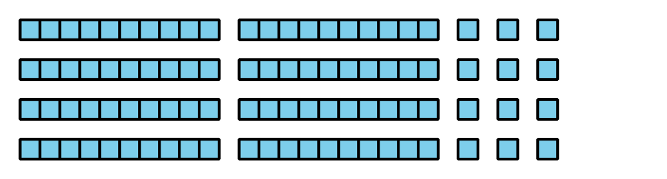
- Andre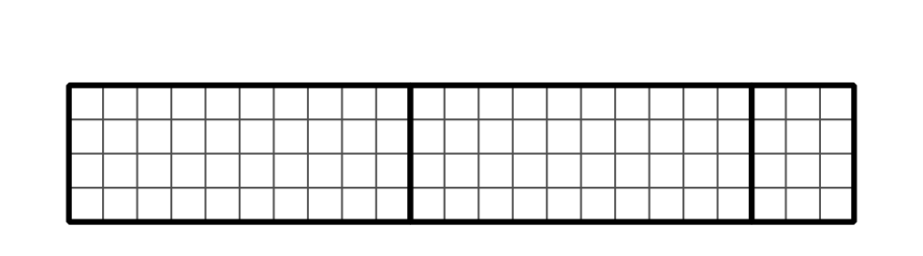
  - How does each diagram show $4×23$?
  - How could we use Clare’s diagram to find the value of $4×23$?
  - How could we use Andre’s diagram to find the value of $4×23$?
- Diego tried different ways to partition or split a diagram to help him find the value of $4×23$.
- A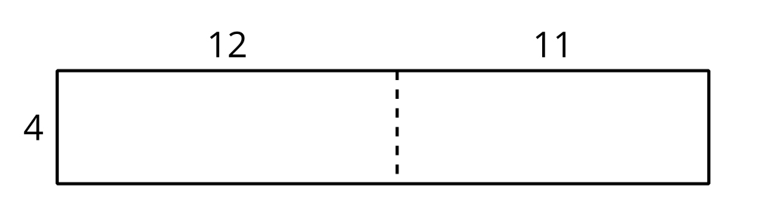
- B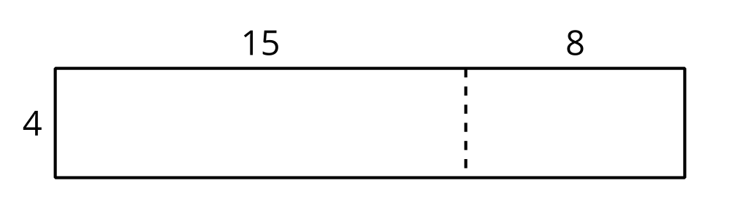
- C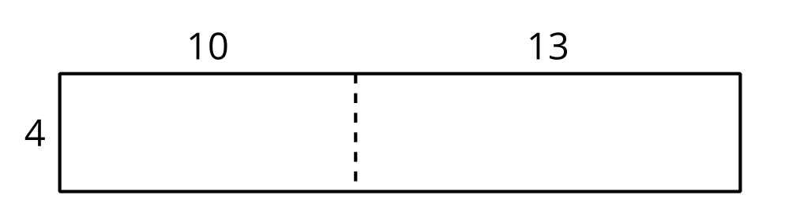
- D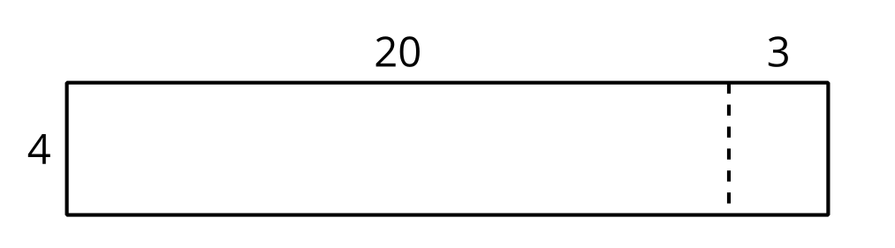
  - What do you notice about the numbers in his diagrams?
  - Which diagram would you use to find the value of $4×23$? Explain your reasoning.
- Find the value of $3×28$. Show your thinking using diagrams, symbols, or other representations.

16.2: Some Fine Products
- To find the value of $2×37$, Mai started by writing this equation:
- $2×30=60$
- Describe or show what Mai would do to finish finding the value of $2×37$.
- Find the value of each product. Show your reasoning.
  - $3×32$
  - $2×43$
  - $4×22$
  - $3×29$

16.3: Play Close to 100, Multiplication
Play Close to 100, Multiplication with a partner.
- Place the cards face down.
- Each player draws 4 cards.
- Each player chooses 2 cards to complete the expression to make a value as close to 100 as possible. Write the 2 digits and the product.
- Player closest to 100 wins.
- Play 5 rounds. Player who wins the most rounds wins.
Game 1
Round 1
0000×1 0000= _
Round 2
0000×1 0000= _
Round 3
0000×1 0000= _
Round 4
0000×1 0000= _
Round 5
0000×1 0000= _
Game 2
Round 1
0000×2 0000= _
Round 2
0000×2 0000= _
Round 3
0000×2 0000= _
Round 4
0000×2 0000= _
Round 5
0000×2 0000= _

© CC BY 2021 Illustrative Mathematics®

