Lesson 10 Practice Problems
- Technology required. Find the area of the isosceles trapezoid.
- 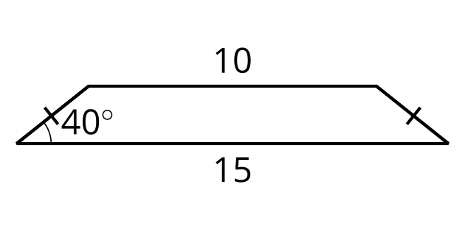
- Technology required. The sun is 62 degrees above the horizon. A tree casts a shadow that is 12 feet long. How tall is the tree?
- 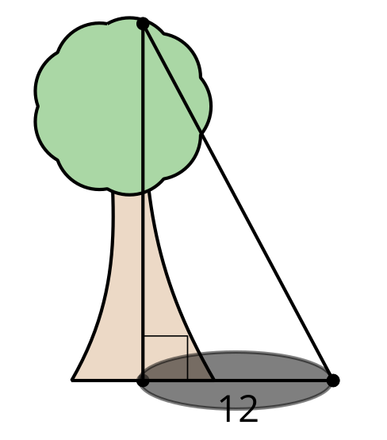
- Technology required. A plane leaves the ground with an elevation angle of 6 degrees. The plane travels 10 miles horizontally.
  - How high is the plane at the time?
  - What is the distance of the plane’s path?
- Technology required. Find the missing measurements.
- 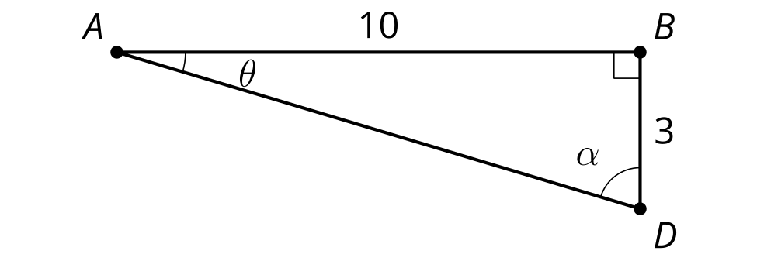
- (From Unit 4, Lesson 9.)
- Technology required. Ramps in a parking garage need to be both steep and safe. The maximum safe incline for a ramp is 8.5 degrees.
- Is this a safe ramp? Explain or show your reasoning.
- 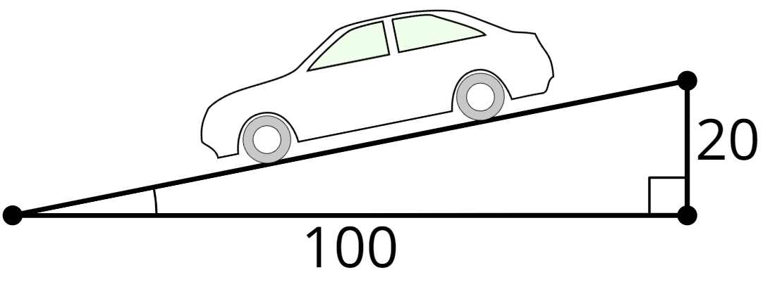
- (From Unit 4, Lesson 9.)
- Select all true equations.
  - $cos\left(37\right)=sin\left(53\right)$
  - $tan\left(37\right)=tan\left(53\right)$
  - $sin\left(37\right)=cos\left(53\right)$
  - $sin\left(37\right)=sin\left(53\right)$
  - $cos\left(θ\right)=sin\left(90−θ\right)$
- (From Unit 4, Lesson 8.)
- Technology required. Clare is flying a kite. She gets tired, so she stakes the kite into the ground. The kite is on a string that is 30 ft long and makes a 27 degree angle with the ground. How high is the kite?
  - 30 ft
  - 13.6 ft
  - 26.7 ft
  - 15.3 ft
- (From Unit 4, Lesson 7.)
- What is the length of the diagonal?
- 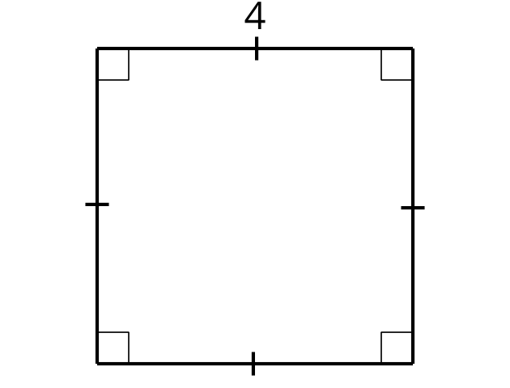
- (From Unit 4, Lesson 2.)
© CC BY 2019 by Illustrative Mathematics®

