Lesson 17: Comparing Transformations
- Let's ask questions to figure out transformations of trigonometric functions.

17.1: Three Functions
For each pair of graphs, be prepared to describe a transformation from the graph on top to the graph on bottom.
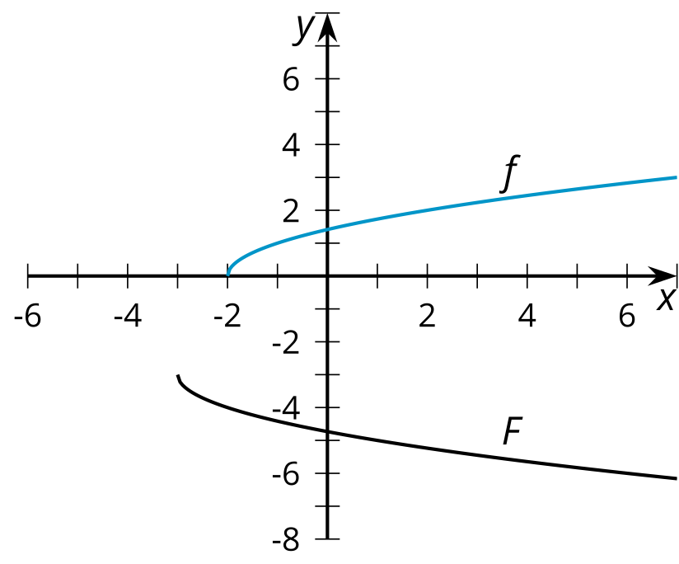
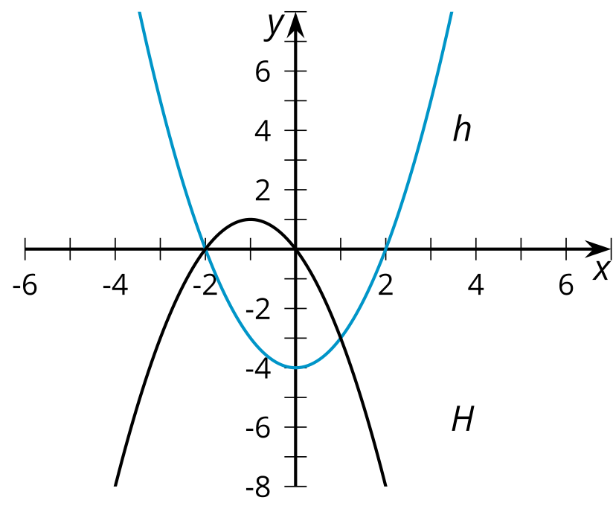
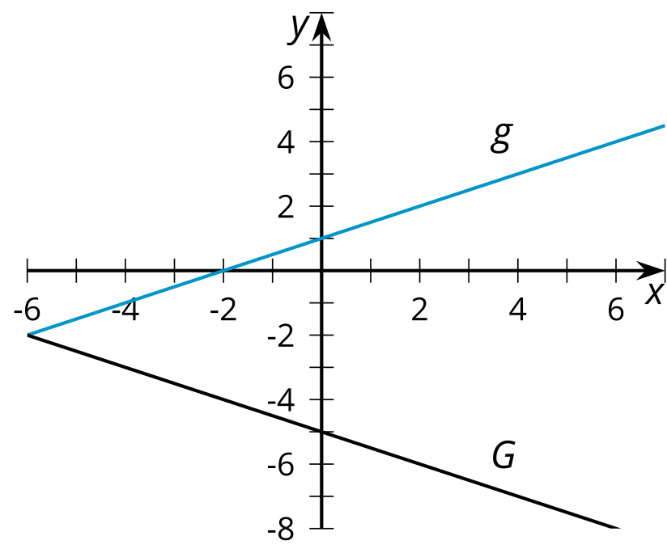

17.2: Info Gap: What's the Transformation?
Your teacher will give you either a problem card or a data card. Do not show or read your card to your partner.
If your teacher gives you the data card:
- Silently read the information on your card.
- Ask your partner “What specific information do you need?” and wait for your partner to ask for information. Only give information that is on your card. (Do not figure out anything for your partner!)
- Before telling your partner the information, ask “Why do you need to know (that piece of information)?”
- Read the problem card, and solve the problem independently.
- Share the data card, and discuss your reasoning.
If your teacher gives you the problem card:
- Silently read your card and think about what information you need to answer the question.
- Ask your partner for the specific information that you need.
- Explain to your partner how you are using the information to solve the problem.
- When you have enough information, share the problem card with your partner, and solve the problem independently.
- Read the data card, and discuss your reasoning.

Are you ready for more?
Suppose we considered the function $T$ which is the sum of $Q$ and $S$. Is $T$ also periodic? If yes, what is its period? If no, explain why not.

17.3: Match the Graph
Here is the graph of $f\left(x\right)=cos\left(x\right)$ and the graph of $g$, which is a transformation of $f$.
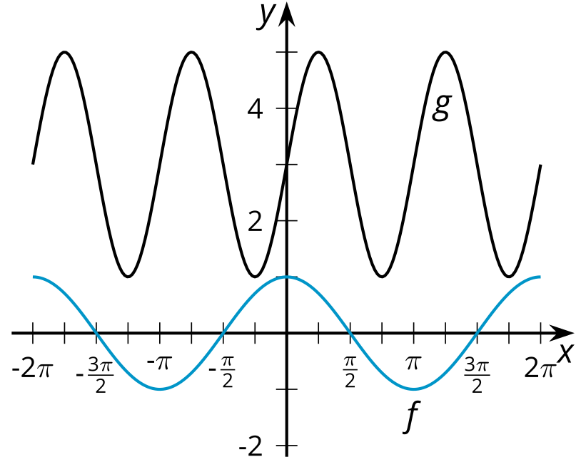
- Identify a transformation that takes $f$ to $g$ and write an equation for $g$ in terms of $f$ matching the transformation.
- Identify at least one other transformation that takes $f$ to $g$ and write an equation for $g$ in terms of $f$ matching the transformation.

Lesson 17 Summary
Here are graphs of two trigonometric functions:
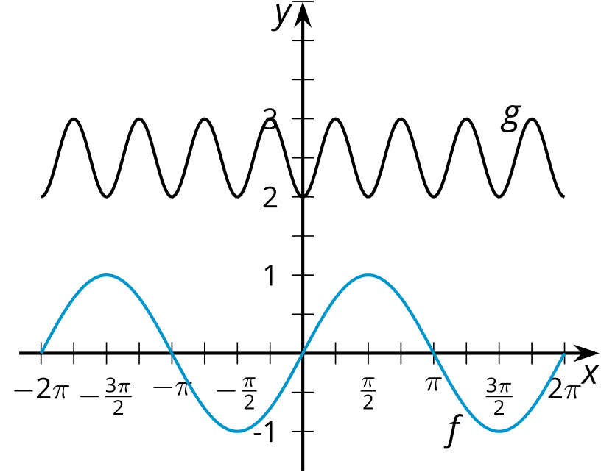
The function $f$ is given by $f\left(x\right)=sin\left(x\right)$. How can we transform the graph of $f$ to look like the graph of $g$? Looking at the graph of $f$, we need to make the period and the amplitude smaller, translate the graph up, and translate the graph horizontally so it has a minimum at $x=0$.
The amplitude of $g$ is $\frac{1}{2}$ and the period is $\frac{π}{2}$ so we can begin by changing $sin\left(x\right)$ to $\frac{1}{2}sin\left(4x\right)$. The midline of $g$ is 2.5 so we need a vertical translation of 2.5, giving us $\frac{1}{2}sin\left(4x\right)+2.5$. The function $g$ has a minimum when $x=0$ while $\frac{1}{2}sin\left(4x\right)+2.5$ has a minimum when $x=\text{-}\frac{π}{8}$. So a horizontal translation to the right by $\frac{π}{8}$ is needed. Putting all of this together, we have an expression for $g$: $g\left(x\right)=\frac{1}{2}sin\left(4\left(x−\frac{π}{8}\right)\right)+2.5$.
Another way to think about the transformation is to first notice that $g$ has a minimum when $x$ is 0. If we translate $sin\left(x\right)$ right by $\frac{π}{2}$, then $sin\left(x−\frac{π}{2}\right)$ also has a minimum at $x=0$. The period of $g$ is $\frac{π}{2}$, so we can write $sin\left(4x−\frac{π}{2}\right)$. The amplitude of $g$ is $\frac{1}{2}$ and it's midline is 2.5, so we end up with the expression $\frac{1}{2}sin\left(4x−\frac{π}{2}\right)+2.5$ for $g$. This is the same as $g\left(x\right)=\frac{1}{2}sin\left(4\left(x−\frac{π}{8}\right)\right)+2.5$, just thinking of the horizontal translation and scaling in different orders.
© CC BY 2019 by Illustrative Mathematics®

