Algebra 1
Unit 7Lesson 5CC BY NC 2024 Illustrative Mathematics®
Unit 7, Lesson 5

Building Quadratic Functions to Describe Situations (Part 1)
- Let’s measure falling objects.
Algebra 1
Unit 7Lesson 5CC BY NC 2024 Illustrative Mathematics®

5.1Notice and Wonder: An Interesting Numerical Pattern
Study the table. What do you notice? What do you wonder?
$x$ | 0 | 1 | 2 | 3 | 4 | 5
$y$ | 0 | 16 | 64 | 144 | 256 | 400
Algebra 1
Unit 7Lesson 5CC BY NC 2024 Illustrative Mathematics®

5.2Falling from the Sky
A rock is dropped from the top floor of a 500-foot tall building. A camera captures the distance the rock traveled, in feet, after each second.
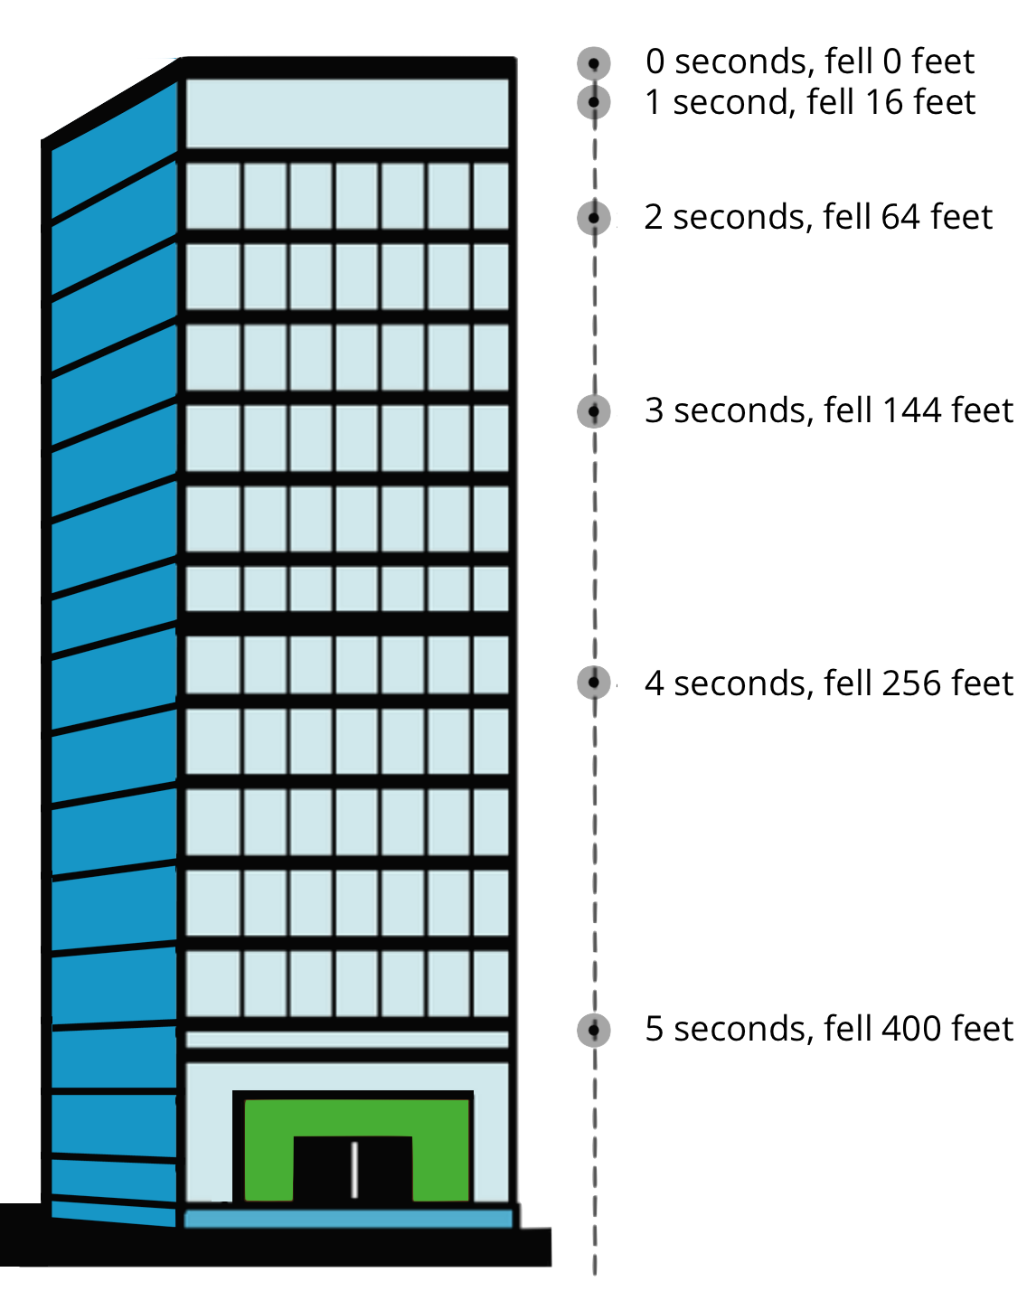
- How far will the rock have fallen after 6 seconds? Show your reasoning.
- Jada noticed that the distances fallen are all multiples of 16.
- She wrote down:
- $\begin{matrix}16 & =16⋅1 \\ 64 & =16⋅4 \\ 144 & =16⋅9 \\ 256 & =16⋅16 \\ 400 & =16⋅25\end{matrix}$
Then, she noticed that 1, 4, 9, 16, and 25 are $1^{2},2^{2},3^{2},4^{2}$ and $5^{2}$.
  - Use Jada’s observations to predict the distance that a rock would fall, after 7 seconds, if it were dropped from an even taller building. (Assume that the building is tall enough that an object dropped from the top of it will continue falling for at least 7 seconds without hitting the ground.) Show your reasoning.
  - Write an equation for the function, with $d$ representing the distance dropped after $t$ seconds.
Algebra 1
Unit 7Lesson 5CC BY NC 2024 Illustrative Mathematics®

5.3Galileo and Gravity
Galileo Galilei, an Italian scientist, and other medieval scholars studied the motion of free-falling objects. The law they discovered can be expressed by the equation $d=16⋅t^{2}$, which gives the distance fallen in feet, $d$, as a function of time, $t$, in seconds.
An object is dropped from a height of 576 feet.
- How far does it fall in 0.5 seconds?
- To find out where the object is after the first few seconds after it was dropped, Elena and Diego created different tables.
- Elena’s table:
- time (seconds) | - distance fallen  (feet)
- 0 | - 0
- 1 | - 16
- 2 | - 64
- 3
- 4
- $t$
- Diego’s table:
- time (seconds) | - distance from the ground (feet)
- 0 | - 576
- 1 | - 560
- 2 | - 512
- 3
- 4
- $t$
  - How are the two tables alike? How are they different?
  - Complete Elena’s and Diego’s tables. Be prepared to explain your reasoning.

Are you ready for more?
Galileo correctly observed that gravity causes objects to fall in a way in which the distance fallen is a quadratic function of the time elapsed. He got a little carried away, however, and assumed that a hanging rope or chain could also be modeled by a quadratic function.
Here is a graph of such a shape (called a “catenary”), along with a table of approximate values.
$x$ | -4 | -3 | -2 | -1 | 0 | 1 | 2 | 3 | 4
$y$ | 7.52 | 4.70 | 3.09 | 2.26 | 2 | 2.26 | 3.09 | 4.70 | 7.52
Show that an equation of the form $y=ax^{2}+b$ cannot model this data well.
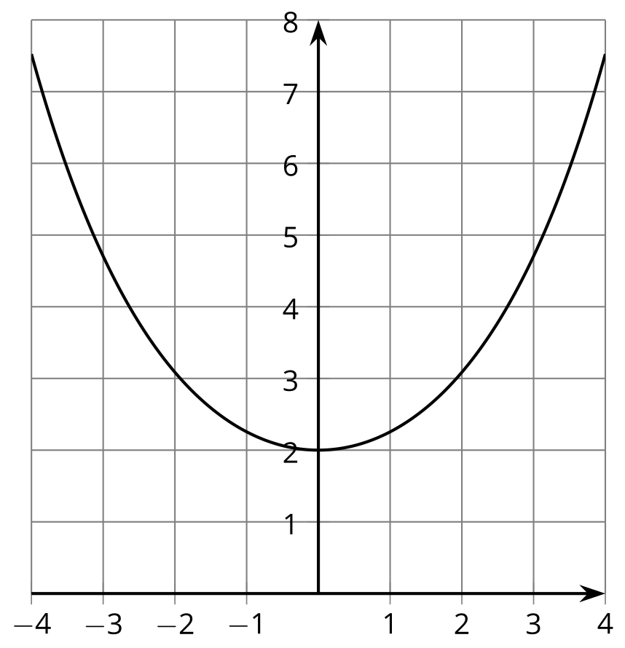

Lesson 5 Summary
The distance traveled by a falling object in a given amount of time is an example of a quadratic function. Galileo is said to have dropped balls of different mass from the Leaning Tower of Pisa, which is about 190 feet tall, to show that they travel the same distance in the same time. In fact the equation $d=16t^{2}$ models the distance $d$, in feet, that a metal ball falls after $t$ seconds, no matter what its mass.
Because $16⋅4^{2}=256$, and the tower is only 190 feet tall, a metal ball hits the ground before 4 seconds.
Here is a table showing how far a metal ball has fallen over the first few seconds.
time (seconds) | distance fallen (feet)
0 | 0
1 | 16
2 | 64
3 | 144
Here are the time and distance pairs plotted on a coordinate plane:
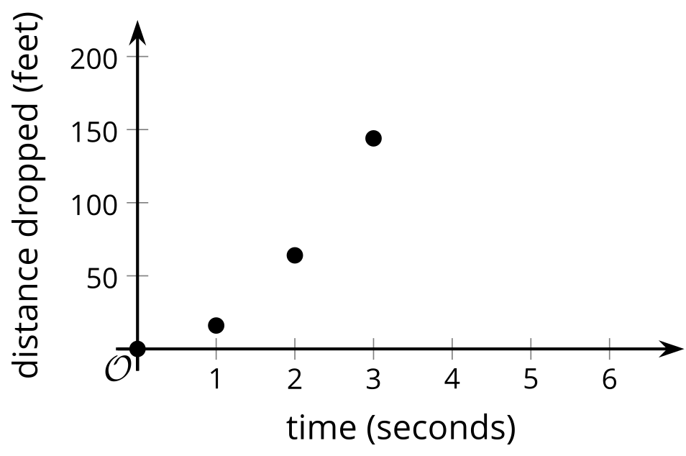
Notice that the distance fallen is increasing each second. The average rate of change is increasing each second, which means that the metal ball is speeding up over time. This comes from the influence of gravity, which is represented by the quadratic expression $16t^{2}$. It is the exponent 2 in that expression that makes it increase by larger and larger amounts.
Another way to study the change in the position of the metal ball is to look at its distance from the ground as a function of time.
Here is a table showing the distance from the ground in feet at 0, 1, 2, and 3 seconds.
time (seconds) | distance from the ground (feet)
0 | 190
1 | 174
2 | 126
3 | 46
Here are those time and distance pairs plotted on a coordinate plane:
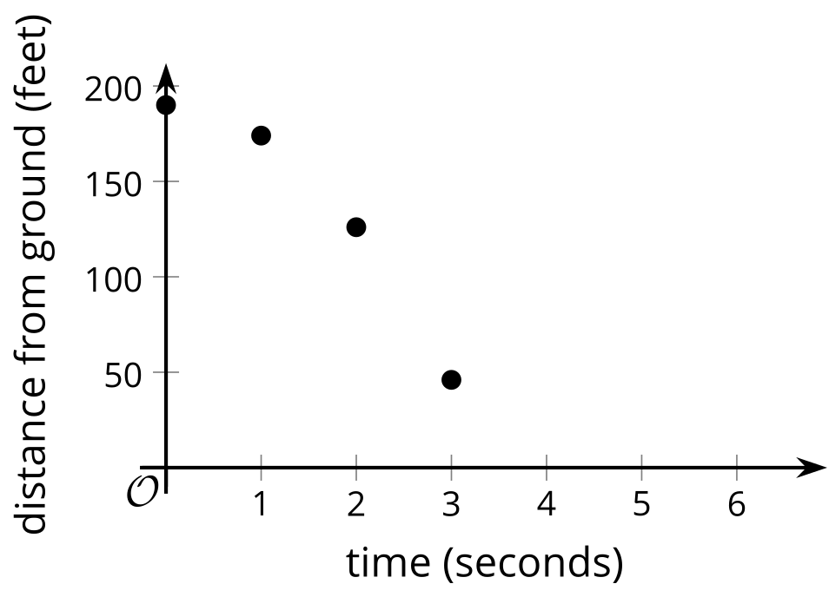
The expression that defines the distance from the ground as a function of time is $190−16t^{2}$. It tells us that the metal ball's distance from the ground is 190 feet before it is dropped and has decreased by $16t^{2}$ when $t$ seconds have passed.

