Grade 2
Unit 7Lesson 5CC BY NC 2024 Illustrative Mathematics®
Unit 7, Lesson 5

Center Day 1
- Let’s add numbers within 1,000.
Grade 2
Unit 7Lesson 5CC BY NC 2024 Illustrative Mathematics®

Warm-upHow Many Do You See: Hundreds, Tens, and Ones
How many do you see? How do you see them?
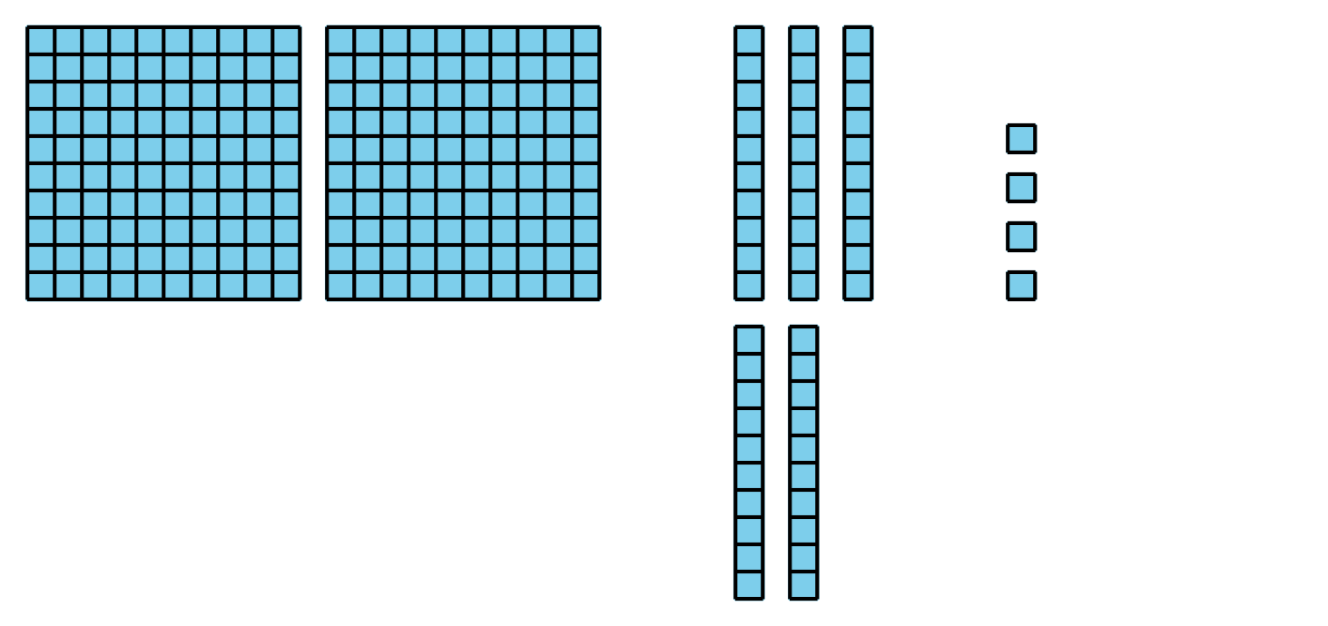
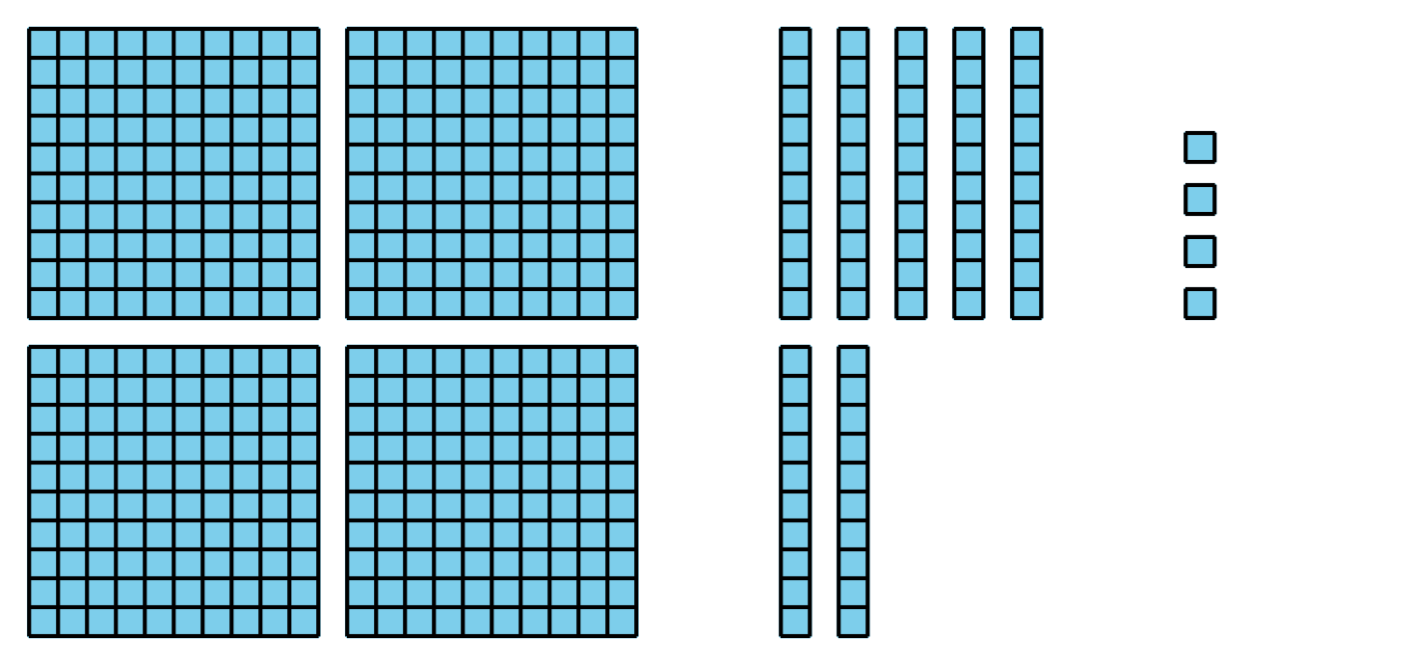
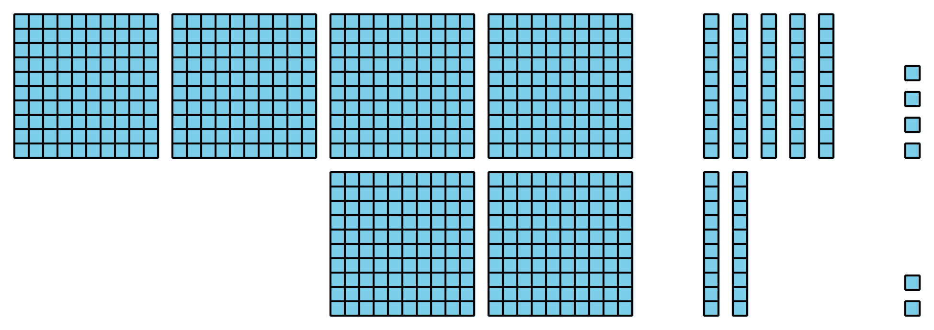
Grade 2
Unit 7Lesson 5CC BY NC 2024 Illustrative Mathematics®

Activity 2 Centers: Choice Time
Choose a center.
Five in a Row: Addition and Subtraction
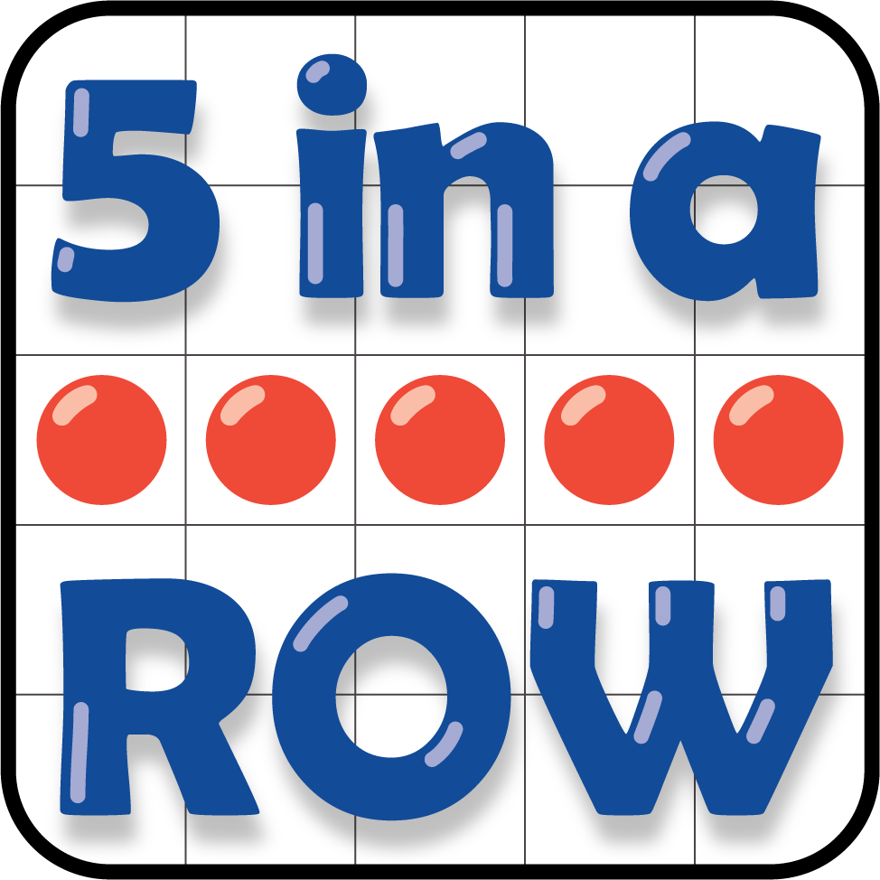
Get Your Numbers in Order
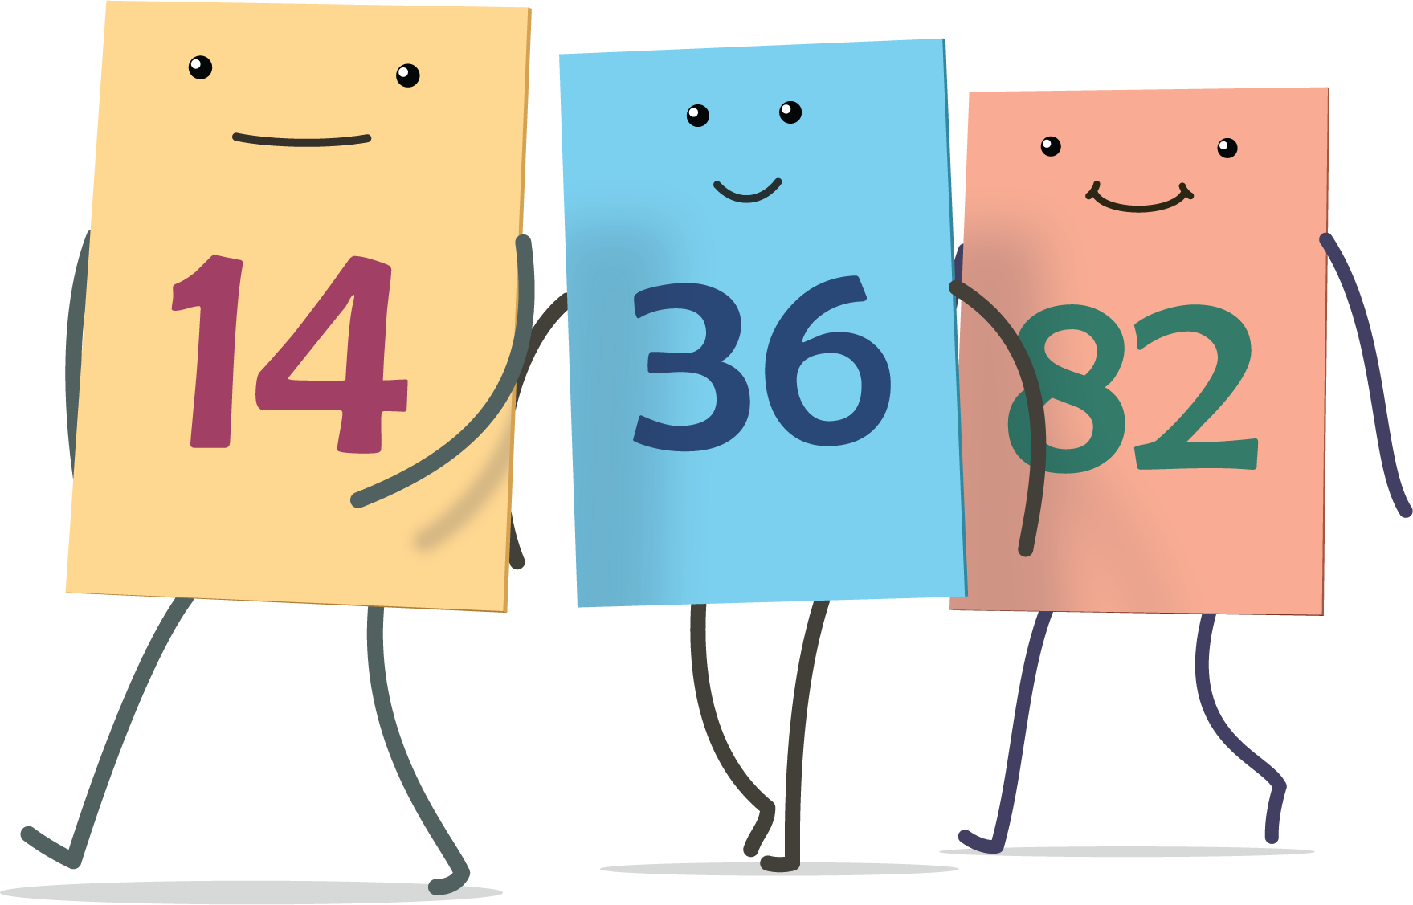
Mystery Number
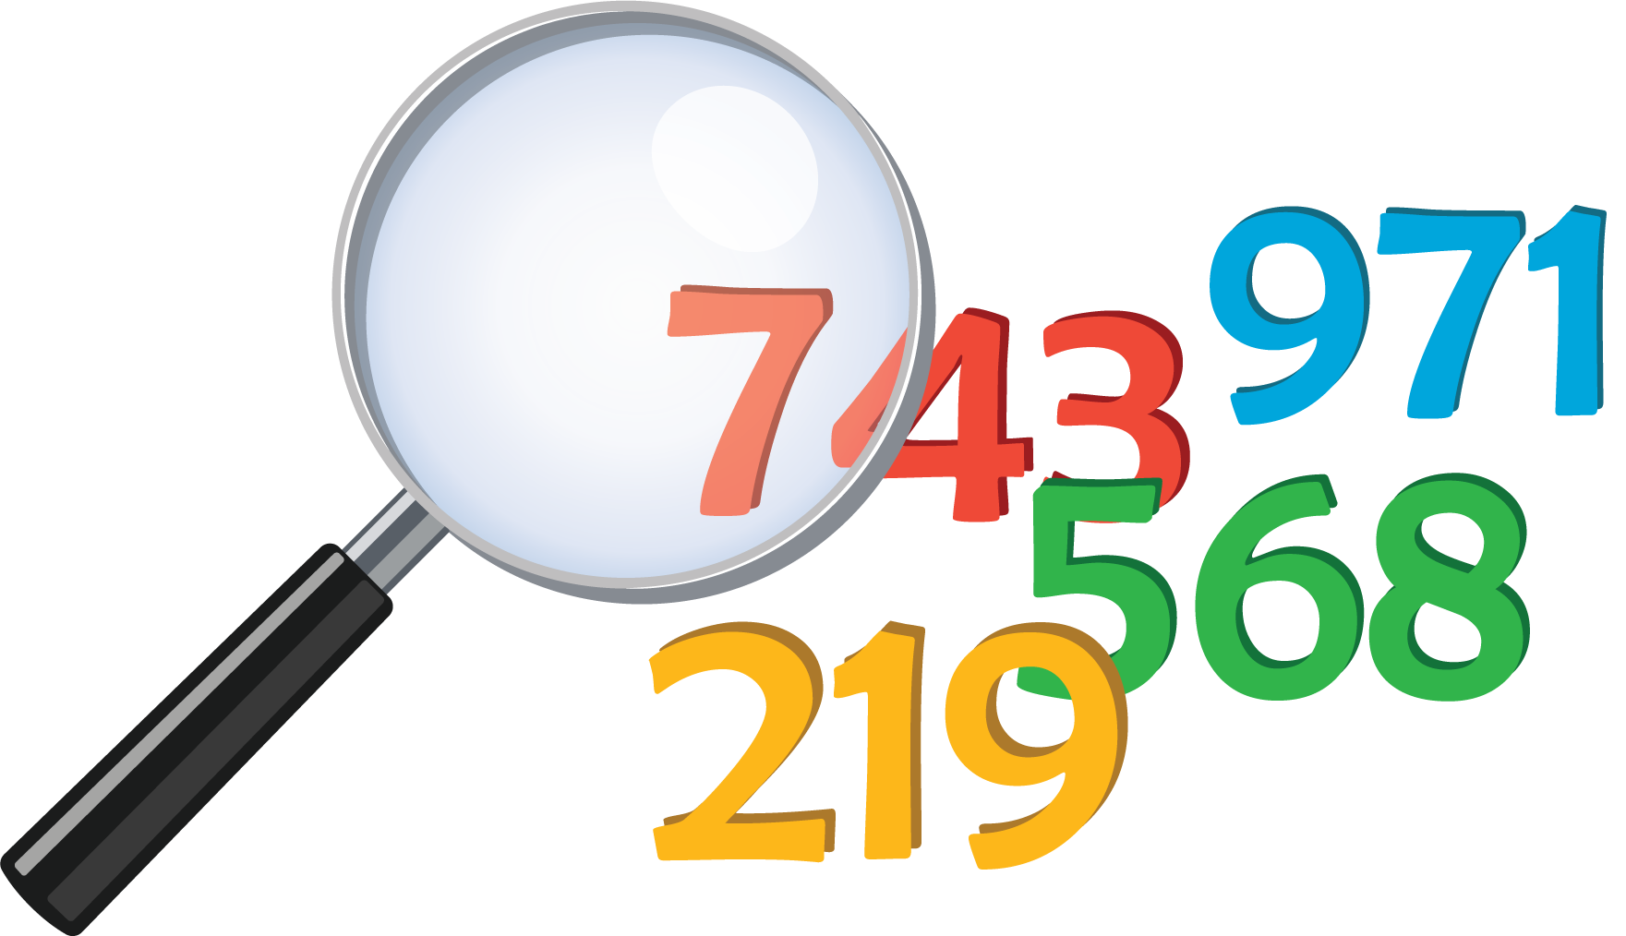
The Greatest of Them All


