Lesson 13: When Is the Same Size Not the Same Size?
- Let’s figure out how aspect ratio affects screen area.

13.1: Three Figures
How are these shapes the same? How are they different?
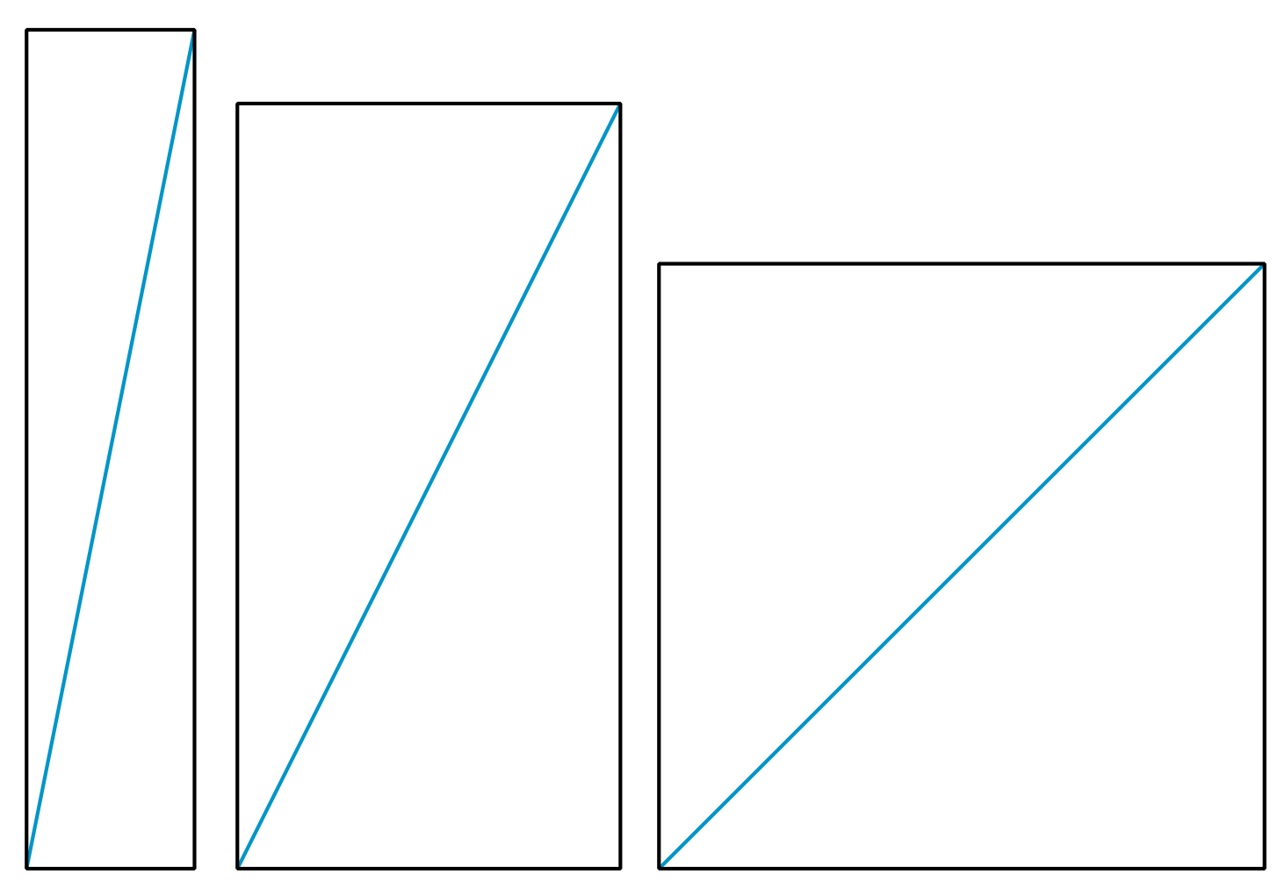

13.2: A $4:3$ Rectangle
A typical aspect ratio for photos is $4:3$. Here’s a rectangle with a $4:3$ aspect ratio.
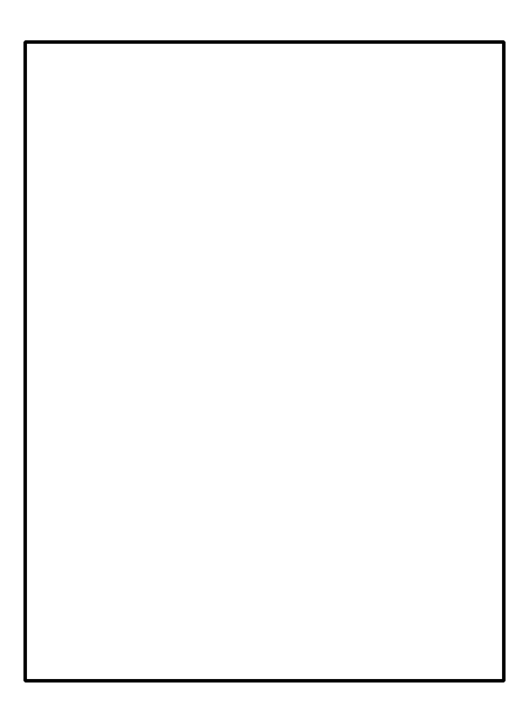
- What does it mean that the aspect ratio is $4:3$? Mark up the diagram to show what that means.
- If the shorter side of the rectangle measures 15 inches:
  - What is the length of the longer side?
  - What is the length of the rectangle’s diagonal?
- If the diagonal of the $4:3$ rectangle measures 10 inches, how long are its sides?
- If the diagonal of the $4:3$ rectangle measures 6 inches, how long are its sides?

13.3: The Screen Is the Same Size . . . Or Is It?
Before 2017, a smart phone manufacturer’s phones had a diagonal length of 5.8 inches and an aspect ratio of $16:9$. In 2017, they released a new phone that also had a 5.8-inch diagonal length, but an aspect ratio of $18.5:9$. Some customers complained that the new phones had a smaller screen. Were they correct? If so, how much smaller was the new screen compared to the old screen?
© CC BY Open Up Resources. Adaptations CC BY IM.

