Lesson 7: Reasoning about Solving Equations (Part 1)
Let’s see how a balanced hanger is like an equation and how moving its weights is like solving the equation.

7.1: Hanger Diagrams
In the two diagrams, all the triangles weigh the same and all the squares weigh the same.
For each diagram, come up with . . .
- One thing that must be true
- One thing that could be true
- One thing that cannot possibly be true
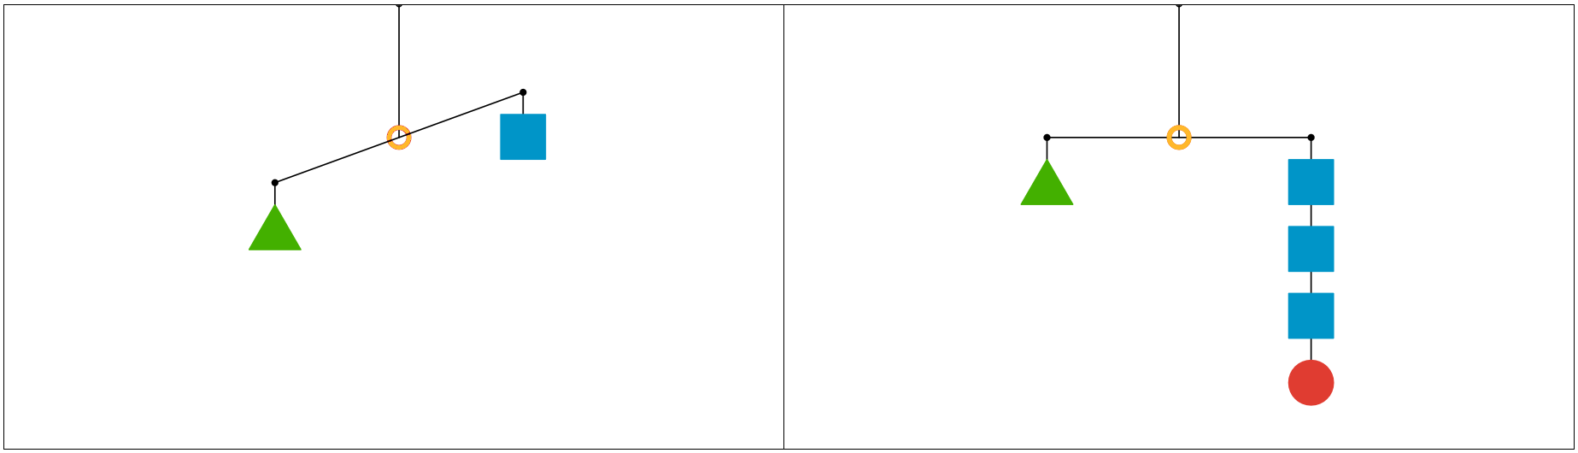

7.2: Hanger and Equation Matching
On each balanced hanger, figures with the same letter have the same weight.
- Match each hanger to an equation. Complete the equation by writing $x$, $y$, $z$, or $w$ in the empty box.
  - 23+3=5
  - 33+2=3
  - 6=23+3
  - 7=33+1
- Find the solution to each equation. Use the hanger to explain what the solution means.
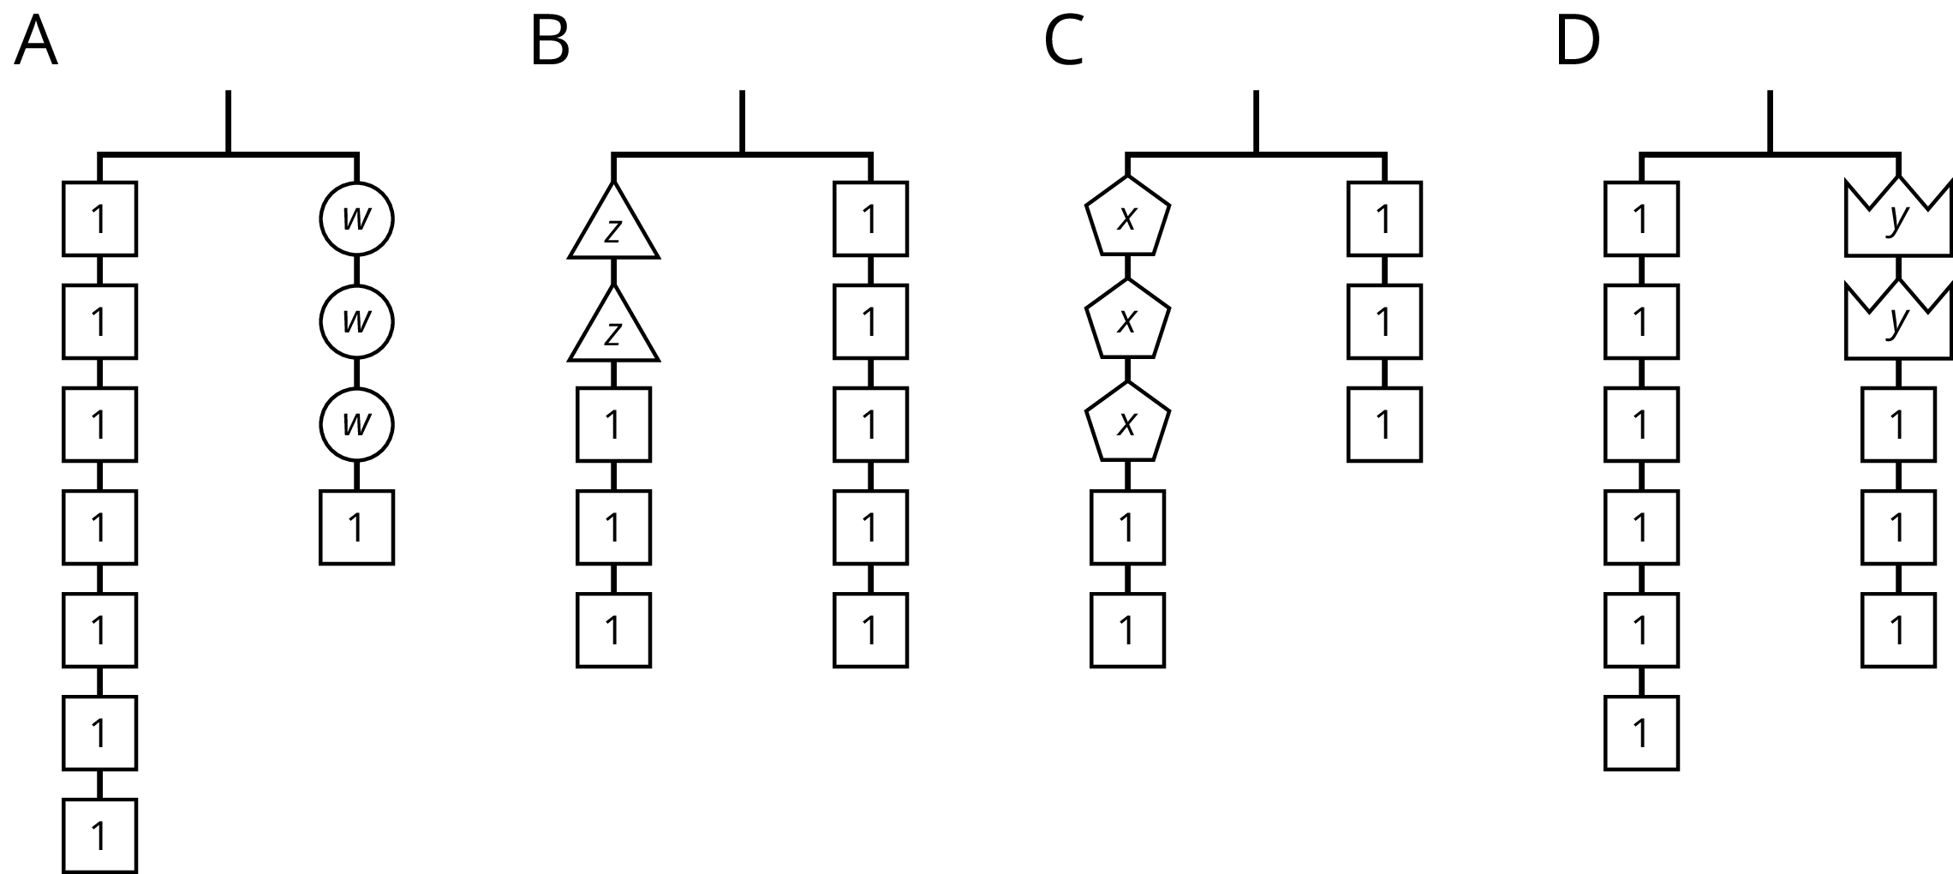

7.3: Use Hangers to Understand Equation Solving
Here are some balanced hangers where each piece is labeled with its weight. For each diagram:
- Write an equation.
- Explain how to figure out the weight of a piece labeled with a letter by reasoning about the diagram.
- Explain how to figure out the weight of a piece labeled with a letter by reasoning about the equation.
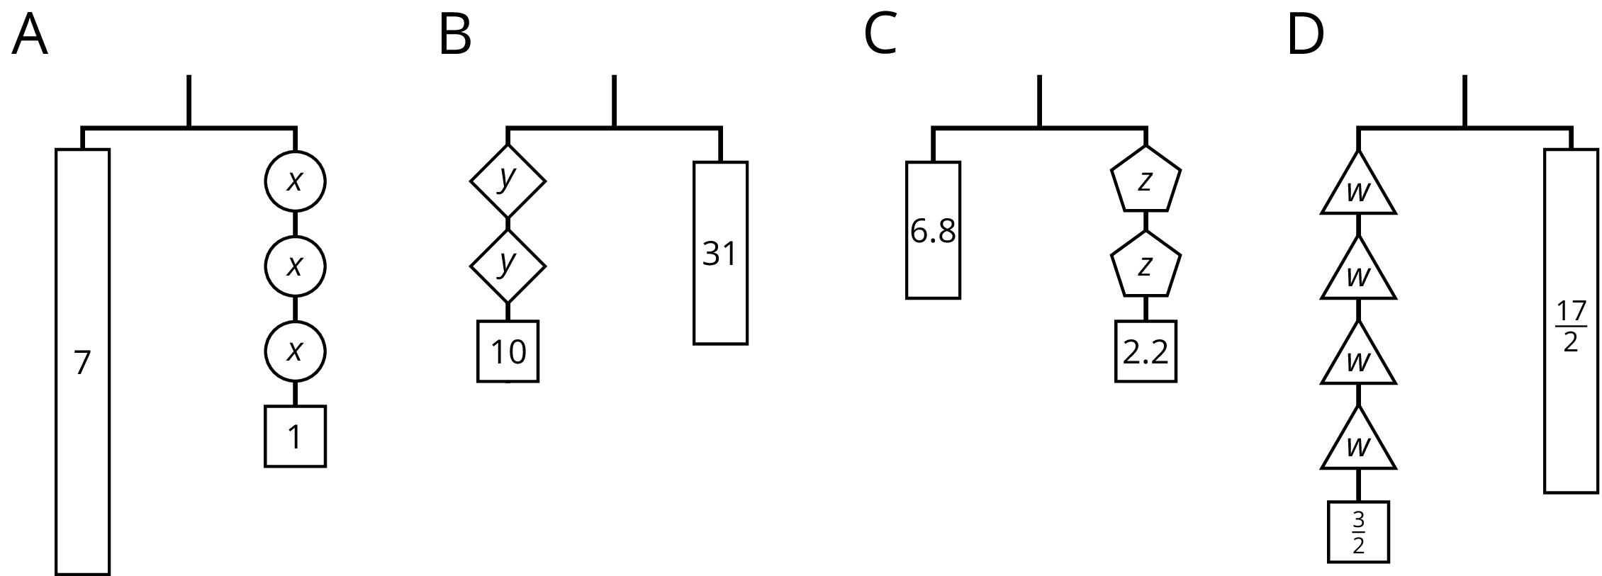

Lesson 7 Summary
In this lesson, we worked with two ways to show that two amounts are equal: a balanced hanger and an equation. We can use a balanced hanger to think about steps to finding an unknown amount in an associated equation.
The hanger shows a total weight of 7 units on one side that is balanced with 3 equal, unknown weights and a 1-unit weight on the other. An equation that represents the relationship is $7=3x+1$.
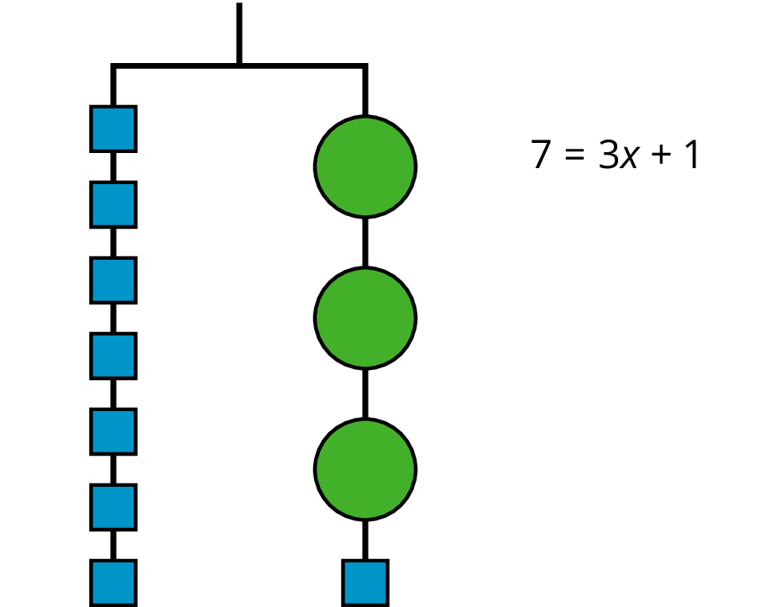
We can remove a weight of 1 unit from each side and the hanger will stay balanced. This is the same as subtracting 1 from each side of the equation.
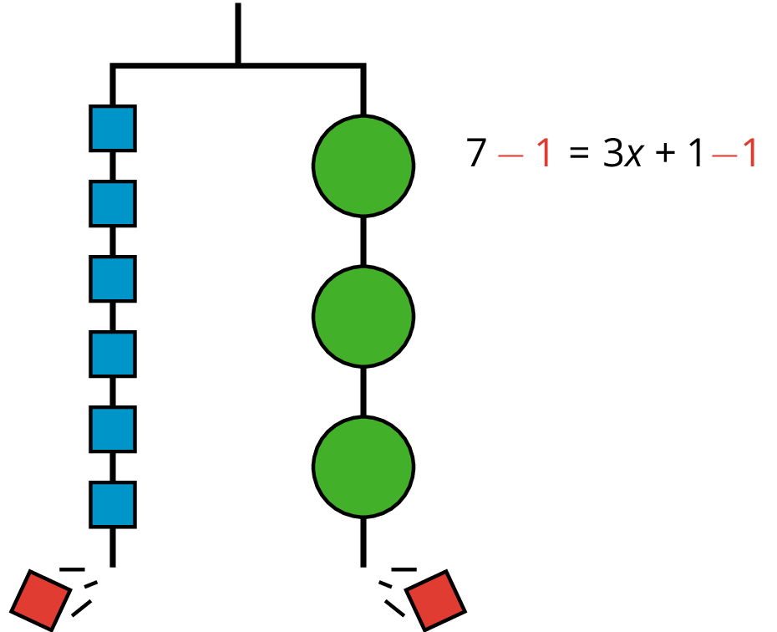
An equation for the new balanced hanger is $6=3x$.
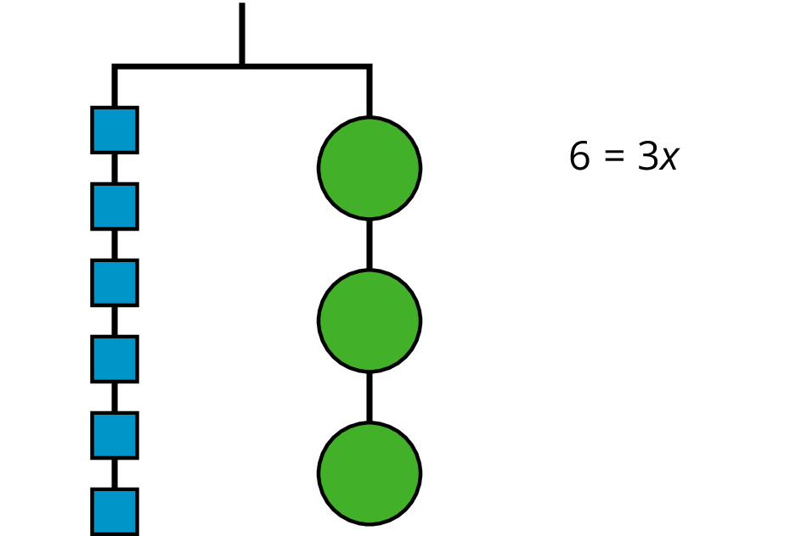
So the hanger will balance with $\frac{1}{3}$ of the weight on each side: $\frac{1}{3}⋅6=\frac{1}{3}⋅3x$.
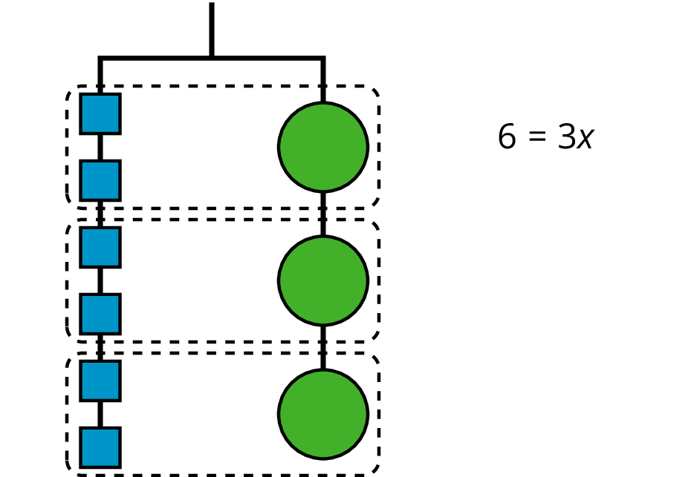
The two sides of the hanger balance with these weights: 6 1-unit weights on one side and 3 weights of unknown size on the other side.
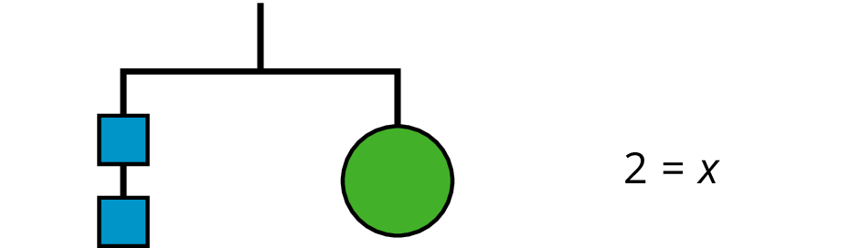
Here is a concise way to write the steps above:
$\begin{matrix}7 & =3x+1 & \\ 6 & =3x & \text{after subtracting 1 from each side} \\ 2 & =x & \text{after multiplying each side by }\frac{1}{3}\end{matrix}$
© CC BY Open Up Resources. Adaptations CC BY IM.

