Lesson 5: Attributes of Other Quadrilaterals

Standards Alignments
Addressing | 3.G.A.1, 3.OA.C.7

Teacher-facing Learning Goals
- Draw examples of quadrilaterals that are not rhombuses, rectangles, or squares.
- Understand that shapes can be in more than one category.

Student-facing Learning Goals
- Let’s describe and draw shapes in specific groups.

Lesson Purpose
The purpose of this lesson is for students to use their knowledge of geometric attributes to name quadrilaterals in different ways and to draw quadrilaterals that are not rhombuses, rectangles, or squares.
In previous lessons, students learned the defining attributes of a rhombus, a rectangle, and a square. In this lesson, students apply that knowledge to name quadrilaterals in multiple ways and to draw quadrilaterals that are not rhombuses, rectangles, or squares.
Throughout the lesson, offer rulers to students if needed to determine if sides have the same length.
This lesson has a Student Section Summary.

Access for:

Students with Disabilities
- Engagement (Activity 1)

English Learners
- MLR8 (Activity 1)

Instructional Routines
Number Talk (Warm-up)

Lesson Timeline
Warm-up | 10 min
Activity 1 | 20 min
Activity 2 | 15 min
Lesson Synthesis | 10 min
Cool-down | 5 min

Teacher Reflection Question
What surprised you about student thinking as they drew quadrilaterals that were not rectangles, rhombuses, or squares?

Cool-down
(to be completed at the end of the lesson) 5min
Describe It, Draw It

Standards Alignments
Addressing | 3.G.A.1

Student-facing Task Statement
- Select all the ways you could name this shape. Explain your reasoning.
- 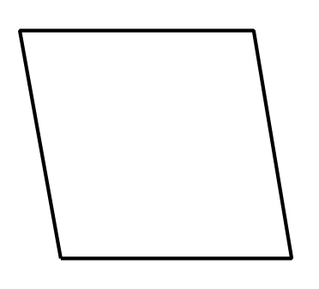
  - triangle
  - quadrilateral
  - pentagon
  - square
  - rhombus
  - rectangle
- Draw a quadrilateral that is not a rectangle, a rhombus, or a square.
- 

Student Responses
- B and E. It has 4 sides, which makes it a quadrilateral. All the sides have the same length, which makes it a rhombus.
- Sample response: A drawing of a quadrilateral with no right angles and no sides having the same length.

