Grade 6
Unit 1Lesson 12CC BY NC Illustrative Mathematics, based on IM 6–8 Math, CC BY Open Up Resources.
Unit 1, Lesson 12

What Is Surface Area?
Let’s cover the surfaces of some three-dimensional objects.
Grade 6
Unit 1Lesson 12CC BY NC Illustrative Mathematics, based on IM 6–8 Math, CC BY Open Up Resources.

12.1Covering the Cabinet (Part 1)
Your teacher will show you a video about a cabinet or some pictures of it.
Estimate an answer to the question: How many sticky notes would it take to cover the cabinet, excluding the bottom?
Grade 6
Unit 1Lesson 12CC BY NC Illustrative Mathematics, based on IM 6–8 Math, CC BY Open Up Resources.

12.2Covering the Cabinet (Part 2)
Earlier you learned about a cabinet being covered with sticky notes.
- How could you find the actual number of sticky notes it will take to cover the cabinet, excluding the bottom? What information would you need to know?
- Use the information you have to find the number of sticky notes needed to cover the cabinet. Show your reasoning.

Are you ready for more?
How many sticky notes are needed to cover the outside of 2 cabinets pushed together (including the bottom)? What about 3 cabinets? 20 cabinets?
Grade 6
Unit 1Lesson 12CC BY NC Illustrative Mathematics, based on IM 6–8 Math, CC BY Open Up Resources.

12.3Prisms Built from Cubes
- Here is a sketch of a rectangular prism built from 12 cubes. It has six faces, but you can see only three of them in the sketch.
- Show that it has a surface area of 32 square units.
- 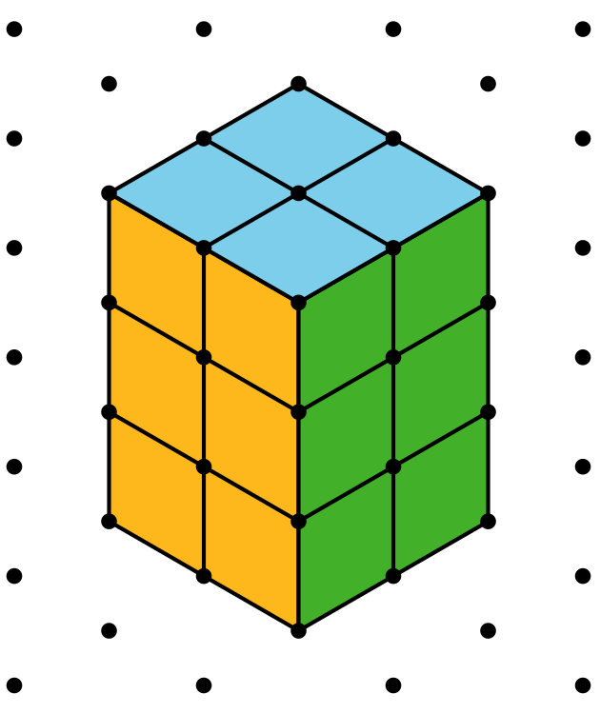
- Here is a sketch of another rectangular prism built from 12 cubes. What is its surface area? Be prepared to explain or show your reasoning.
- 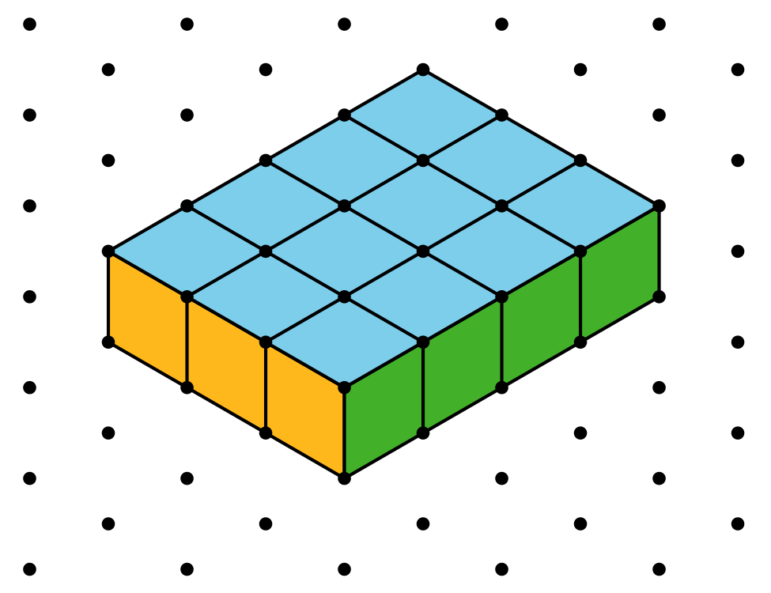

Are you ready for more?
Is it possible to use 12 cubes to build a rectangular prism that has a greater surface area than either prism shown earlier? Explain or show your reasoning. You can draw prisms on the dot paper if it helps.
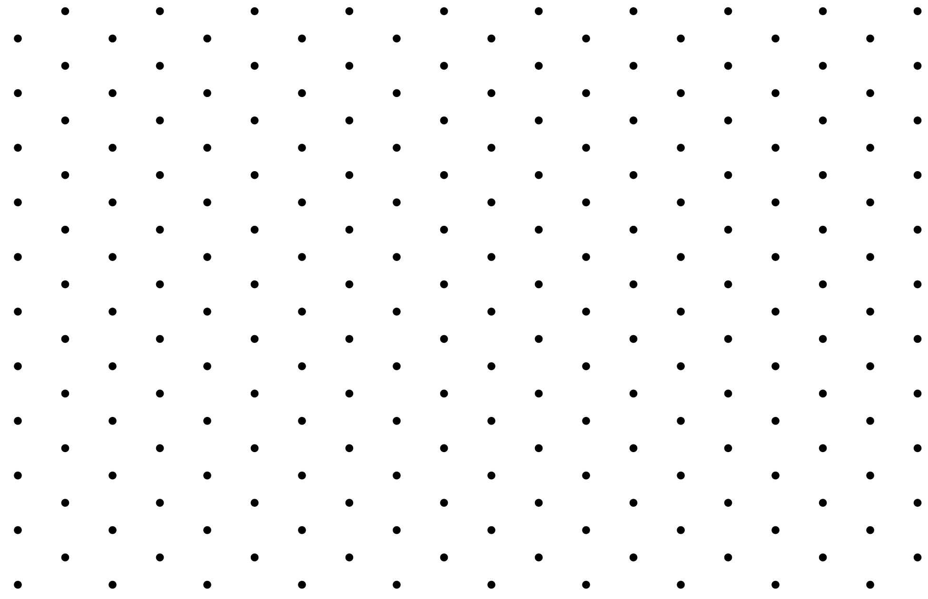

Lesson 12 Summary
- The surface area of a figure (in square units) is the number of unit squares it takes to cover the entire surface without gaps or overlaps.
- If a three-dimensional figure has flat sides, the sides are called faces.
- The surface area is the total of the areas of the faces.
For example, a rectangular prism has six faces. The surface area of the prism is the total of the areas of the six rectangular faces.
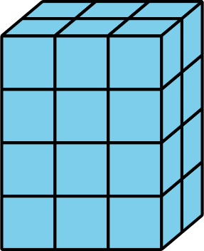
So the surface area of a rectangular prism that has edge-lengths of 2 cm, 3 cm, and 4 cm has a surface area of
$\left(2⋅3\right)+\left(2⋅3\right)+\left(2⋅4\right)+\left(2⋅4\right)+\left(3⋅4\right)+\left(3⋅4\right)$
or 52 square centimeters.

