Grade 2
Unit 2Lesson 1CC BY NC 2024 Illustrative Mathematics®
Unit 2, Lesson 1

Add and Subtract to Compare
- Let’s solve Compare problems with greater numbers.
Grade 2
Unit 2Lesson 1CC BY NC 2024 Illustrative Mathematics®

Warm-upWhich Three Go Together: Compare Representations
Which 3 go together?
A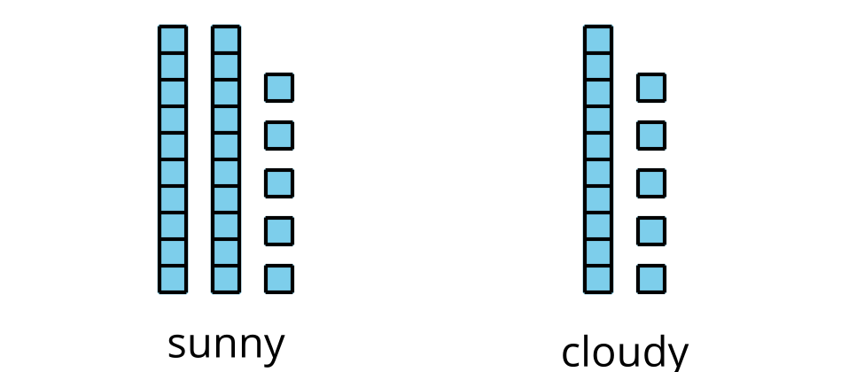
B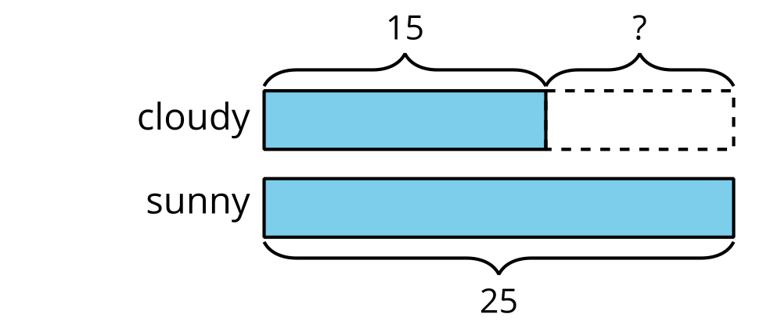
C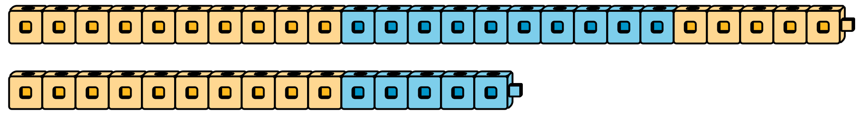
D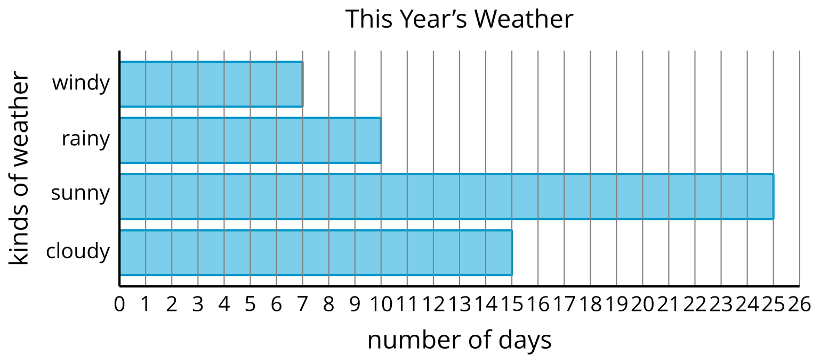
Grade 2
Unit 2Lesson 1CC BY NC 2024 Illustrative Mathematics®

Activity 1After-School Activities
Use the bar graph to answer the questions.
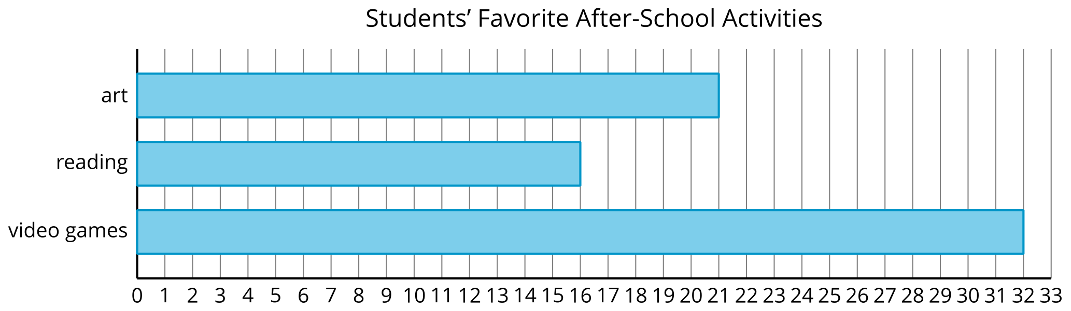
- How many students chose art or reading? Show your thinking using drawings, numbers, or words.
- How many more students chose video games than art?
- 
Grade 2
Unit 2Lesson 1CC BY NC 2024 Illustrative Mathematics®

Activity 2Build and Compare
- Lin and Clare make cube trains. What do you notice? What do you wonder?
- 
- Make cube trains.
- partner | - number of cubes
- Partner A | - 46
- Partner B | - 22
- Find the total number of cubes you both used. Show your thinking using drawings, numbers, or words.
- Find the difference between the number of cubes you each used. Show your thinking using drawings, numbers, or words.

