Grade 2
Unit 3Lesson 4CC BY NC 2024 Illustrative Mathematics®
Unit 3, Lesson 4

Measure and Estimate in Centimeters
- Let’s estimate and measure in centimeters.
Grade 2
Unit 3Lesson 4CC BY NC 2024 Illustrative Mathematics®

Warm-upWhich Three Go Together: Length
Which 3 go together?
A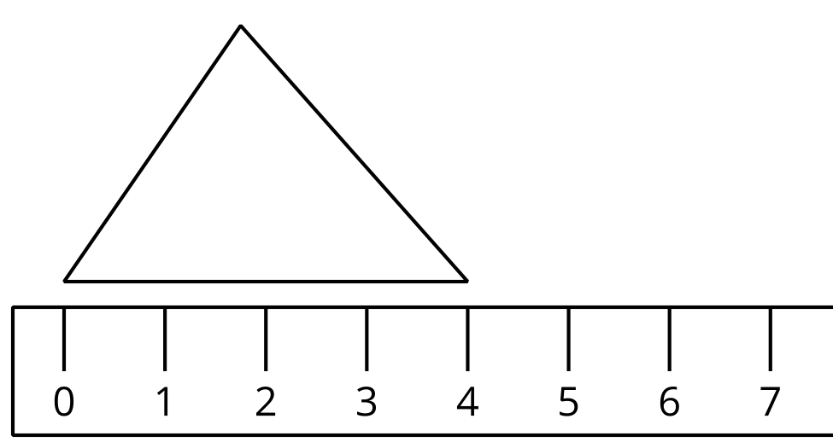
B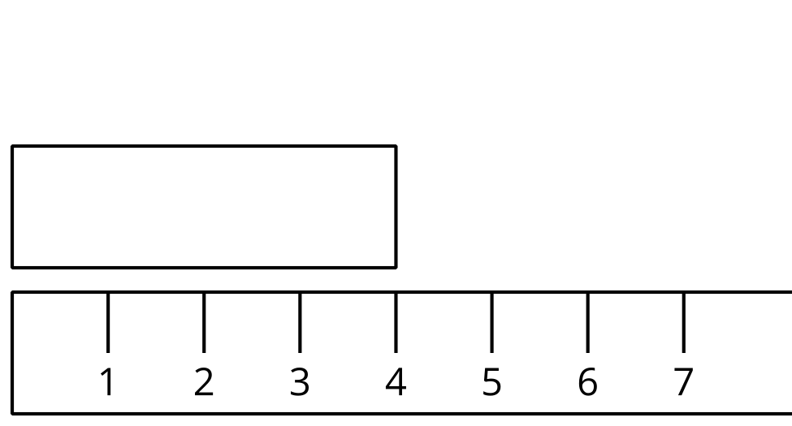
C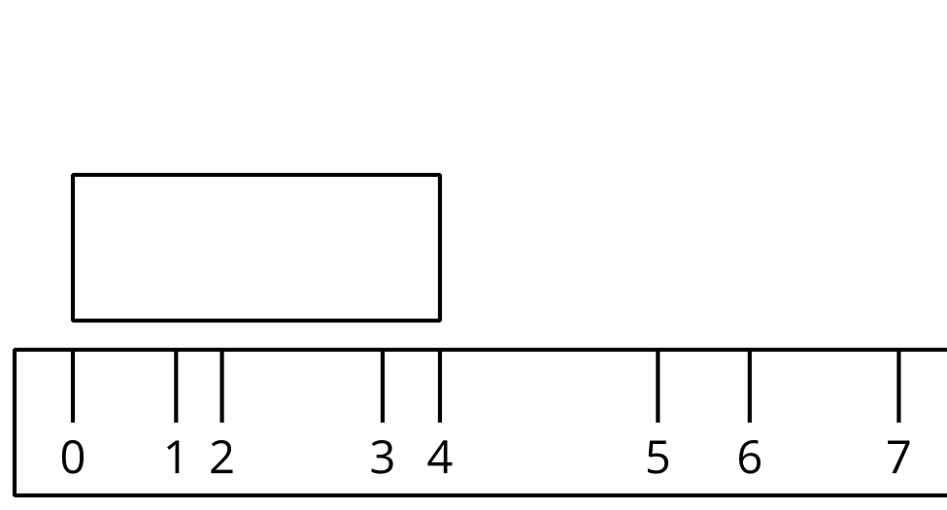
D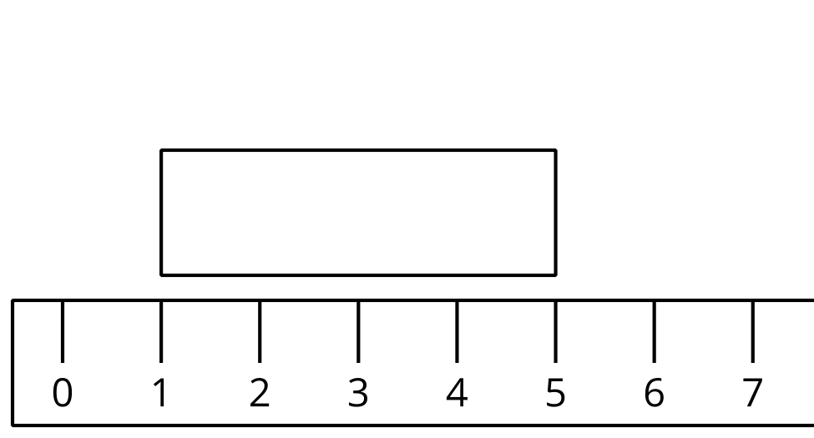
Grade 2
Unit 3Lesson 4CC BY NC 2024 Illustrative Mathematics®

Activity 1Estimate Length in Centimeters
- Record an estimate that is:
- too low | - about right | - too high
- Record an estimate that is:
- too low | - about right | - too high
- Record an estimate for each object.
- Tell your partner why your estimates are “about right.”
Recording Sheet
object | estimate | measurement
Choose an object:
Grade 2
Unit 3Lesson 4CC BY NC 2024 Illustrative Mathematics®

Activity 2Measure and Compare
- Measure each object on your recording sheet. Record each length in centimeters.
- Compare the measurements to your estimates.

