Grade 6
Unit 7Lesson 6CC BY NC Illustrative Mathematics, based on IM 6–8 Math, CC BY Open Up Resources.
Unit 7, Lesson 6

Absolute Value of Numbers
Let’s explore distances from zero more closely.
Grade 6
Unit 7Lesson 6CC BY NC Illustrative Mathematics, based on IM 6–8 Math, CC BY Open Up Resources.

6.1Math Talk: Closer to Zero
For each pair of expressions, decide mentally which one has a value that is closer to 0.
- $\frac{9}{11}$ or $\frac{15}{11}$
- $\frac{1}{5}$ or $\frac{1}{9}$
- $1.25$ or $\frac{5}{4}$
- $0.01$ or $0.001$
Grade 6
Unit 7Lesson 6CC BY NC Illustrative Mathematics, based on IM 6–8 Math, CC BY Open Up Resources.

6.2Jumping Bug
- A bug is jumping around on a number line.
  - If the bug starts at 1 and jumps 4 units to the right, where does it end up? How far away from 0 is this?
  - If the bug starts at 1 and jumps 4 units to the left, where does it end up? How far away from 0 is this?
  - If the bug starts at 0 and jumps 3 units away, where might it land?
  - If the bug jumps 7 units and lands at 0, where could it have started?
  - The absolute value of a number is its distance from 0. The bug is currently to the left of 0 and the absolute value of its location is 4. Where on the number line is it?
  - If the bug is to the left of 0 and the absolute value of its location is 5, where on the number line is it?
  - If the bug is to the right of 0 and the absolute value of its location is 2.5, where on the number line is it?
- We use the notation $\left|\text{-}2\right|$ to say "the absolute value of -2," which means "the distance of -2 from 0 on the number line."
  - What does $\left|\text{-}7\right|$ mean, and what is its value?
  - What does $\left|1.8\right|$ mean, and what is its value?
Grade 6
Unit 7Lesson 6CC BY NC Illustrative Mathematics, based on IM 6–8 Math, CC BY Open Up Resources.

6.3Absolute Elevation and Temperature
- Match each number with a description of a situation.
  - ${23}^{∘}\text{C}$
  - $\text{-}7^{∘}\text{C}$
  - ${\left|23\right|}^{∘}\text{C}$
  - ${\left|\text{-}7\right|}^{∘}\text{C}$
  - The indoor temperature is above freezing.
  - The indoor temperature is away from the freezing point.
  - The outdoor temperature is below freezing.
  - The outdoor temperature is away from the freezing point.

  - Which temperature is colder: $\text{-}6^{∘}\text{C}$ or $3^{∘}\text{C}$?
  - Which temperature is closer to the freezing point: $\text{-}6^{∘}\text{C}$ or $3^{∘}\text{C}$?
  - Which temperature has a smaller absolute value? Explain how you know.
- Match each number with a description of an elevation situation.
  - 12 feet
  - $\left|\text{-}800\right|$ feet
  - -51 feet
  - $\left|30\right|$ feet
  - The elevation of a fish swimming below sea level
  - The elevation of a bird flying above sea level
  - The distance between the surface of the water and a submerged submarine
  - The distance between the top of a tree and the ground
- The elevation of a city has a difference from sea level of 10 feet. Name the two elevations that the city could have.

Are you ready for more?
At a certain time, the difference between the temperature in New York City and in Boston was 7 degrees Celsius. The difference between the temperature in Boston and in Chicago was also 7 degrees Celsius. Was the temperature in New York City the same as the temperature in Chicago? Explain your answer.

Lesson 6 Summary
We can compare two numbers by looking at their positions on the number line: The number farther to the right is greater. The number farther to the left is less.
Sometimes we want to compare which one is closer to or farther from 0. For example, we may want to know how far away the temperature is from the freezing point of $0^{∘}\text{C}$, regardless of whether it is above or below freezing.
The absolute value of a number tells us its distance from 0.
For example, the absolute value of -4 is 4, because -4 is 4 units to the left of 0. The absolute value of 4 is also 4, because 4 is 4 units to the right of 0. Opposites always have the same absolute value because they are both the same distance from 0.
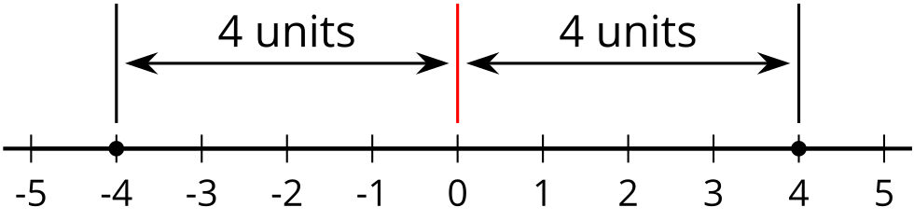
The distance from 0 to itself is 0, so the absolute value of 0 is 0. Zero is the only number whose distance to 0 is 0. For all other absolute values, there are always two numbers—one positive and one negative—that have that distance from 0.
To say, “the absolute value of 4,” we write "$\left|4\right|$."
To say, “the absolute value of -8 is 8,” we write "$\left|\text{-}8\right|=8$."

