Lesson 9 Practice Problems
- Here are graphs of functions $f$ and $g$. For each, determine the value of $k$ so that $g\left(x\right)=f\left(kx\right)$.
- 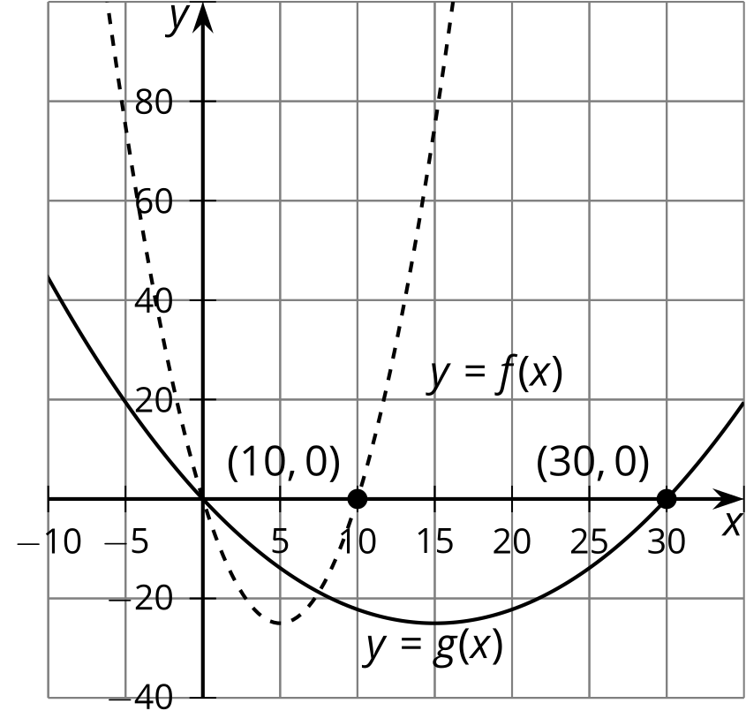
- 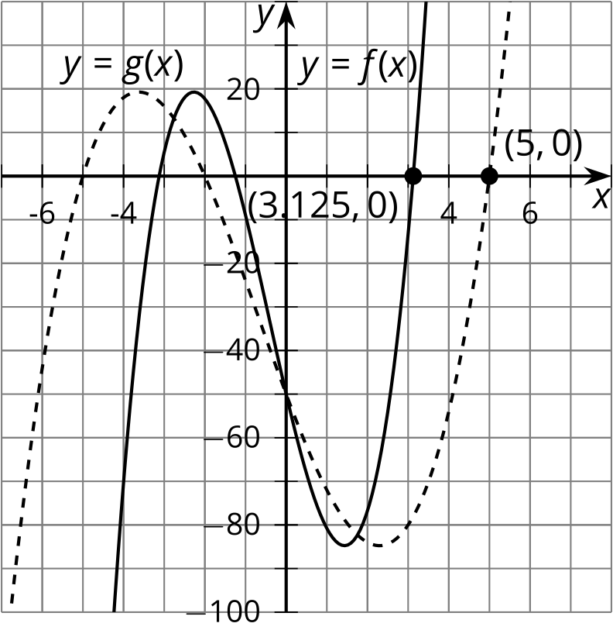
- 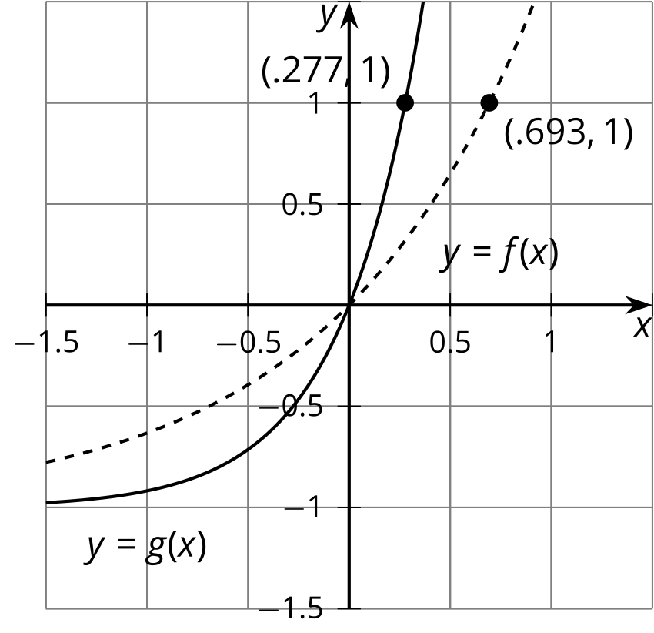
- 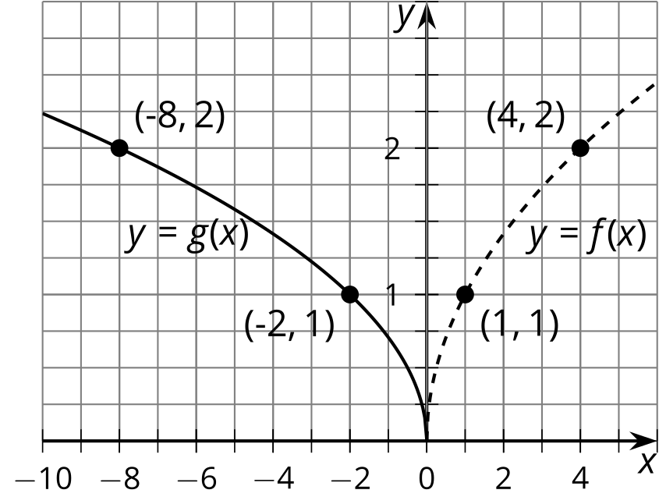
- Let $f\left(x\right)=x\left(x−5\right)\left(x+2\right)\left(x+5\right)$. Decide if the reasoning about each of the following functions is correct. Explain your reasoning.
  - Andre says that $g\left(x\right)=0.1x\left(0.1x−5\right)\left(0.1x+2\right)\left(0.1x+5\right)$ is obtained from $f$ by scaling the inputs by a factor of 0.1.
  - Clare says this graph is a vertical shift of the graph of $f$ down 100 units.
  - 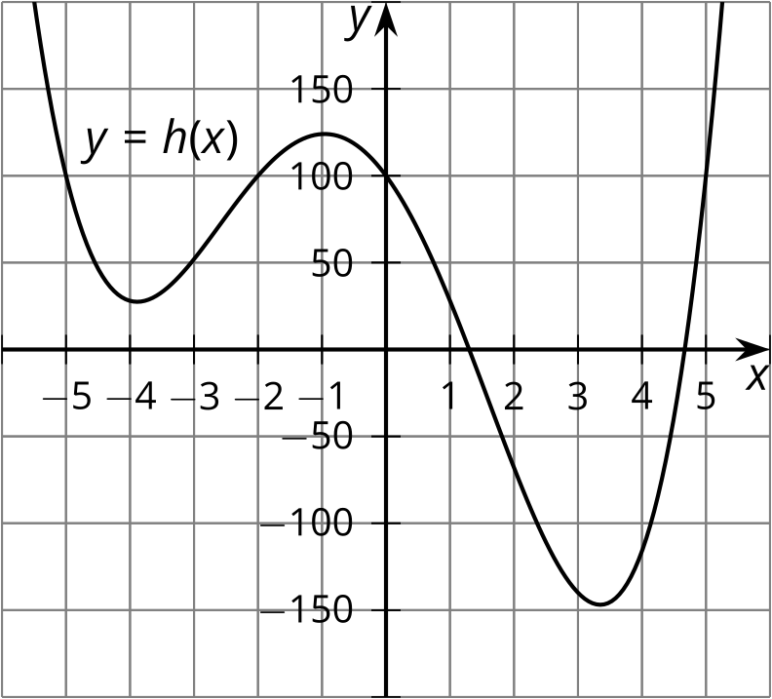
  - Diego says the graph of $k\left(x\right)=\text{-}x\left(x−5\right)\left(x+2\right)\left(x+5\right)$ is the reflection of the graph of $f$ over the $y$-axis.
- A bacteria population, in thousands, is modeled by the function $f\left(d\right)=30⋅2^{d}$ where $d$ is the number of days since it was first measured. The function $g$ gives the bacteria population, in thousands, $w$ weeks after it was first measured. Express $g$ in terms of $f$. Explain your reasoning.
- The height of a hot air balloon, in feet, $m$ minutes after takeoff is modeled by the function $f\left(m\right)=16m$.
  - How many minutes does it take for the balloon to reach 200 feet?
  - Another balloon takes off 5 minutes later and rises at the same speed. Write an equation for the function $g$, where $g\left(t\right)$ is the height, in feet, of this balloon in terms of $m$. Explain your reasoning.
  - Sketch graphs of the two functions $f$ and $g$.
  - 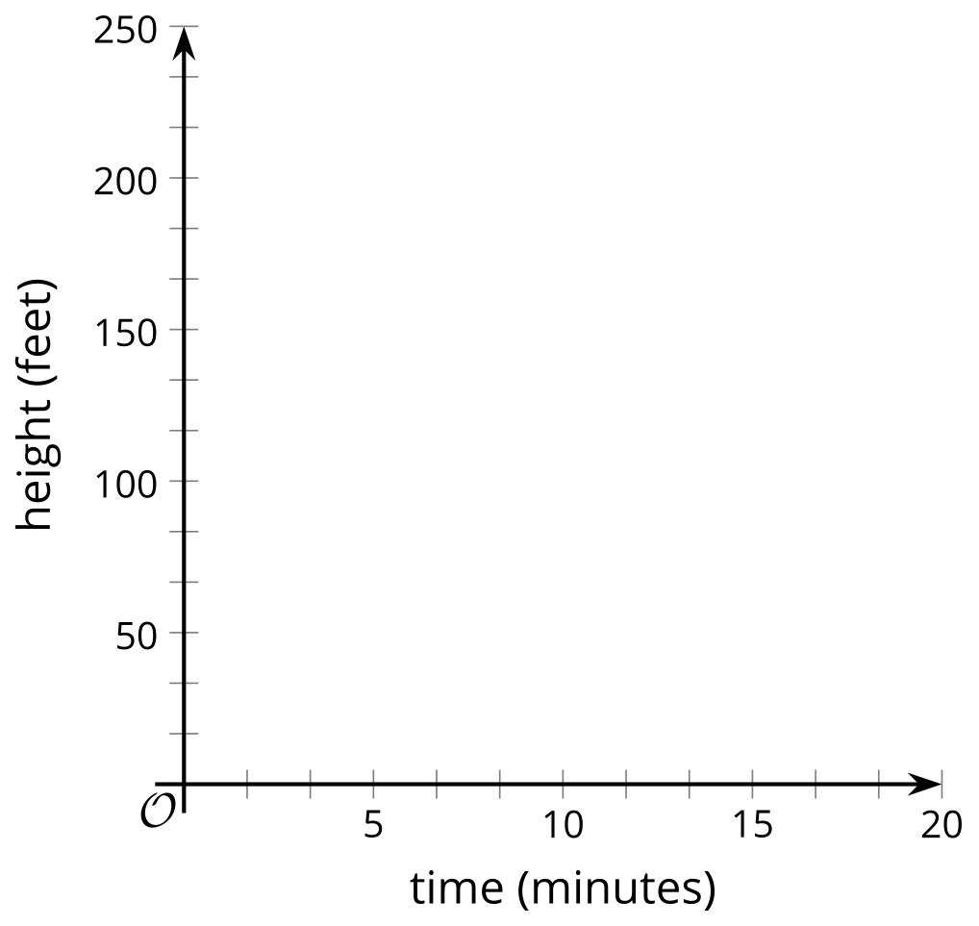
- (From Unit 5, Lesson 3.)
- Here is the graph of a function $f$.
- 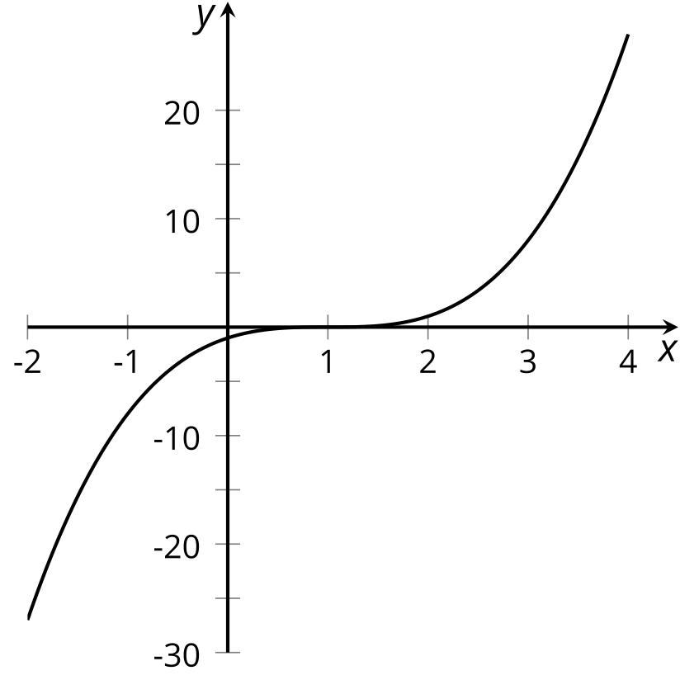
- Reflecting $f$ across the $x$-axis and then across the vertical line $y=1$ takes the graph of $f$ back to itself. Tyler says that this means $f$ is an odd function. Do you agree with Tyler? Explain your reasoning.
- (From Unit 5, Lesson 5.)
- The population of sloths in an area has been increasing by 5% each year since 2000. Let $P$ model the population $P\left(t\right)$, in thousands, of sloths $t$ years after the year 2000. The graph of $p\left(t\right)={1.05}^{t}$ has a general shape that fits the data. Find a scale factor $k$ so that $P\left(t\right)=kp\left(t\right)$ fits the data.
- years (since 2000) | - population (in thousands)
- 5 | - 15.7
- 8 | - 18.2
- 10 | - 20.0
- 12 | - 22.1
- 15 | - 25.6
- 19 | - 33.1
- (From Unit 5, Lesson 8.)
© CC BY 2019 by Illustrative Mathematics®

