Grade 6
Unit 4Lesson 3CC BY NC Illustrative Mathematics, based on IM 6–8 Math, CC BY Open Up Resources.
Unit 4, Lesson 3

Interpreting Division Situations
Let’s explore situations that involve division.
Grade 6
Unit 4Lesson 3CC BY NC Illustrative Mathematics, based on IM 6–8 Math, CC BY Open Up Resources.

3.1Which Three Go Together: Situations with 4
Which three go together? Why do they go together?

- 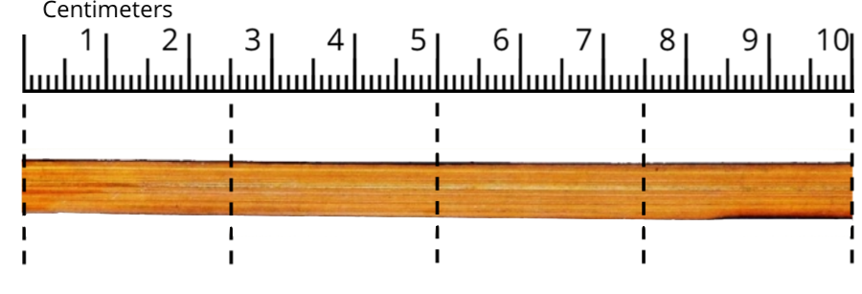
- Jada fills 4 jars with salsa. Each jar has 10 ounces of salsa. How many ounces of salsa are in all the jars?

- 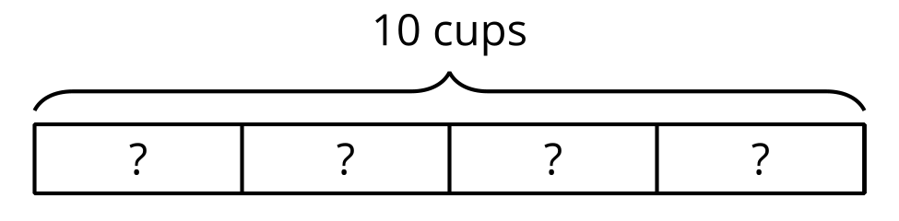
- Andre is filling 4-liter jugs with water. How many jugs can he fill if he has 10 liters of water?
Grade 6
Unit 4Lesson 3CC BY NC Illustrative Mathematics, based on IM 6–8 Math, CC BY Open Up Resources.

3.2Making Bubble Mixture
Mai is making a bubble mixture. The recipe says to add sugar to help the bubbles last longer.
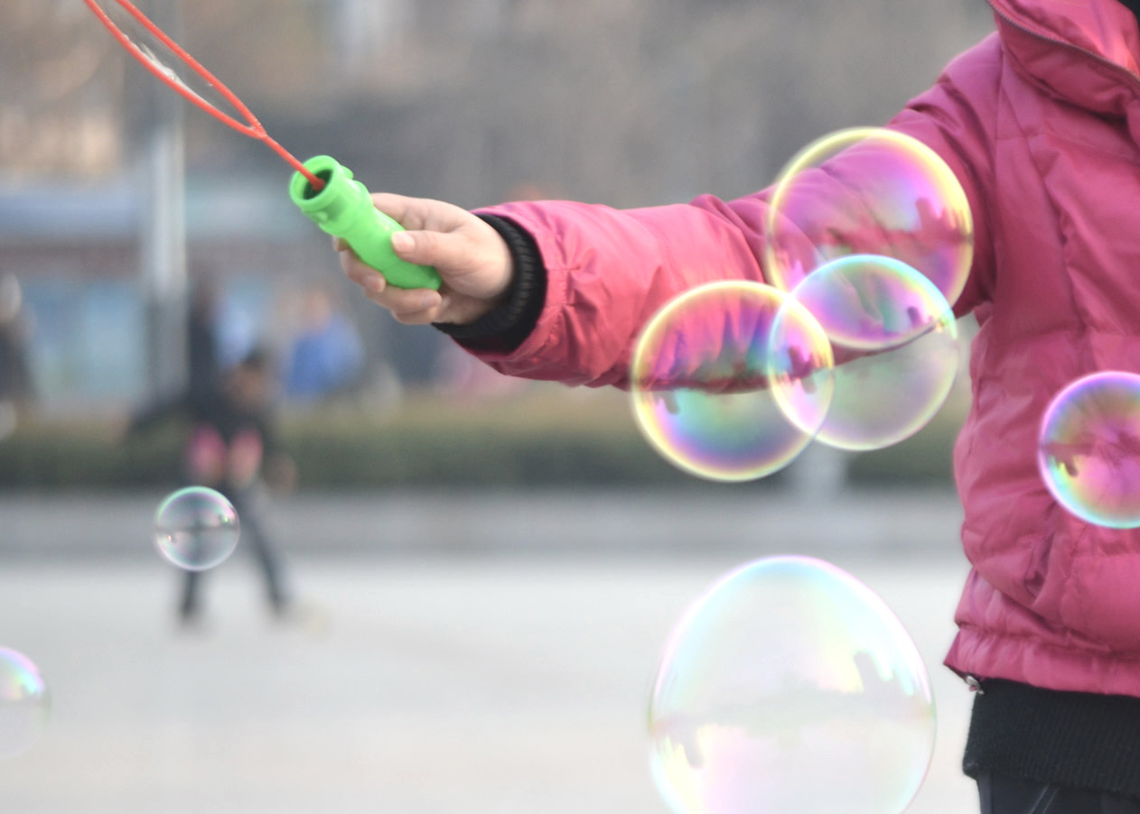
- To make one batch of mixture, 14 grams of sugar is needed. To get that amount, Mai uses 4 packets of sugar.
  - In this situation, what does the value of $14÷4$ represent?
  - Find the quotient. Show your reasoning. If you get stuck, consider drawing a diagram
- Mai needs 26 fl oz of water to make a larger amount of the mixture. The only measuring tool she has is a 4-fl oz scoop. How many scoops will it take to measure 26 fl oz of water?
  - Will the answer be more than 1 or less than 1?
  - Write a multiplication equation and a division equation that represent this situation.
Use “?” to represent the unknown quantity.
  - Find the unknown quantity. If you get stuck, consider drawing a diagram.
Grade 6
Unit 4Lesson 3CC BY NC Illustrative Mathematics, based on IM 6–8 Math, CC BY Open Up Resources.

3.3Revisiting Situations with 4
Here are descriptions and diagrams of situations that involve equal-size groups.

- Jada fills 4 jars with salsa. Each jar has 10 ounces of salsa. How many ounces of salsa are in all the jars?

- Andre is filling 4-liter jugs with water. How many jugs can he fill with 10 liters of water?
Choose a situation.
- If you choose one that is described in words, draw a diagram to represent the situation. Be sure to include labels.
- If you choose an image or a diagram, write a story with a question that the image or diagram could represent.
- Write a multiplication equation and a division equation to represent the relationships between the quantities.
- Answer the question. Be prepared to explain how you know.

Lesson 3 Summary
When a situation involves equal-size groups, it is helpful to make sense of it in terms of the number of groups, the size of each group, and the total amount. Here are three examples:
- Suppose we have 3 bottles with $6\frac{1}{2}$ ounces of water in each, and we want to know the total amount of water.
- 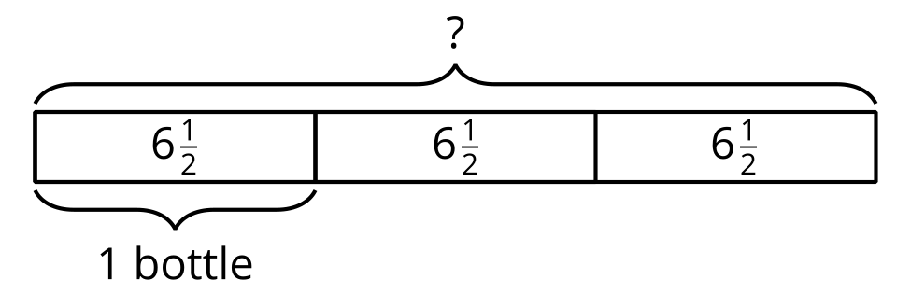
- We can think of this situation as a multiplication problem, “What is 3 groups of $6\frac{1}{2}$?” and represent it with a multiplication equation, $3⋅6\frac{1}{2}=?$.
- The unknown value is the product. To find it, we can multiply 3 and $6\frac{1}{2}$, which gives $19\frac{1}{2}$.
- Next, suppose we have 20 ounces of water to fill 6 bottles equally, and we want to know the amount in each bottle.
- 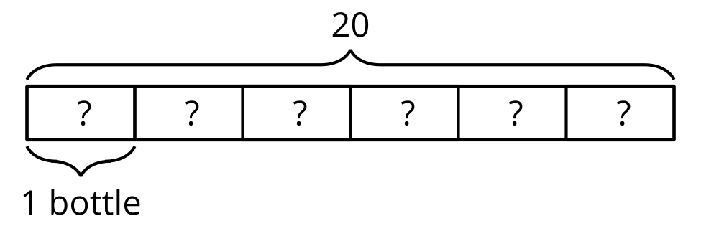
- We can also express this situation as a multiplication problem, “Six groups of what number make 20?” and with an equation, $6 ⋅?=20$.
- The unknown value is a factor. To find it, we can divide: $20÷6= ?$. The quotient is $\frac{20}{6}$ or $3\frac{1}{3}$.
- Now, suppose we have 50 ounces of water to fill 12-ounce bottles, and we want to know how many bottles will be filled.
- 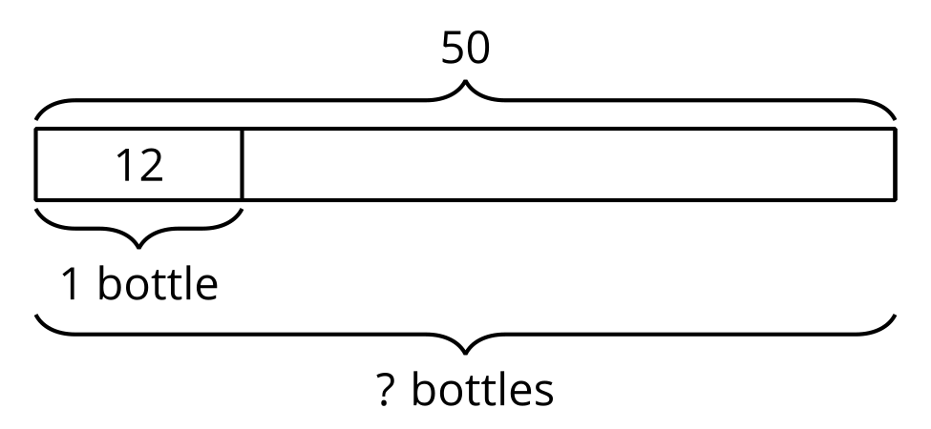
- Again, we can see this as a multiplication problem, “How many groups of 12 make 50?” and write a multiplication equation, $?⋅12=50$.
- The unknown value is a different factor. To find it, we can again use division: $50÷12= ?$. The quotient is $\frac{50}{12}$ or $4\frac{1}{6}$.
In any situation that involves equal-size groups, we can use division to find the amount in each group or the number of groups.

