Lesson 23: Solving Problems with Inequalities in Two Variables
- Let’s practice writing, interpreting, and graphing solutions to inequalities in two variables.

23.1: Graphing Inequalities with Technology
Use graphing technology to graph the solution region of each inequality and sketch each graph. Adjust the graphing window as needed to show meaningful information.
$y>x$
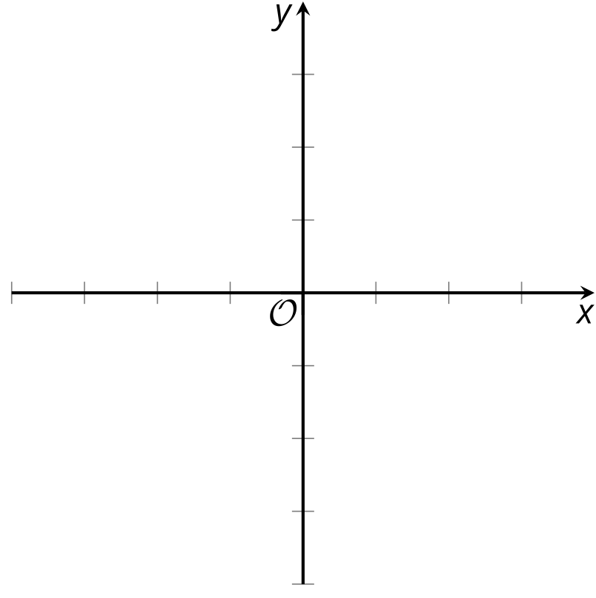
$y≥x$
$y<\text{-}8$
$\text{-}x+8≤y$
$y<10x−200$
$2x+3y>60$

23.2: Solving Problems with Inequalities in Two Variables
Here are three situations. There are two questions about each situation. For each question that you work on:
a. Write an inequality to describe the constraints. Specify what each variable represents.
b. Use graphing technology to graph the inequality. Sketch the solution region on the coordinate plane and label the axes.
c. Name one solution to the inequality and explain what it represents in that situation.
d. Answer the question about the situation.
Bank Accounts
- A customer opens a checking account and a savings account at a bank. They will deposit a maximum of $600, some in the checking account and some in the savings account. (They might not deposit all of it and keep some of the money as cash.)
- If the customer deposits $200 in their checking account, what can you say about the amount they deposit in their savings account?
- The bank requires a minimum balance of $50 in the savings account. It does not matter how much money is kept in the checking account.
- If the customer deposits no money in the checking account but is able to maintain both accounts without penalty, what can you say about the amount deposited in the savings account?
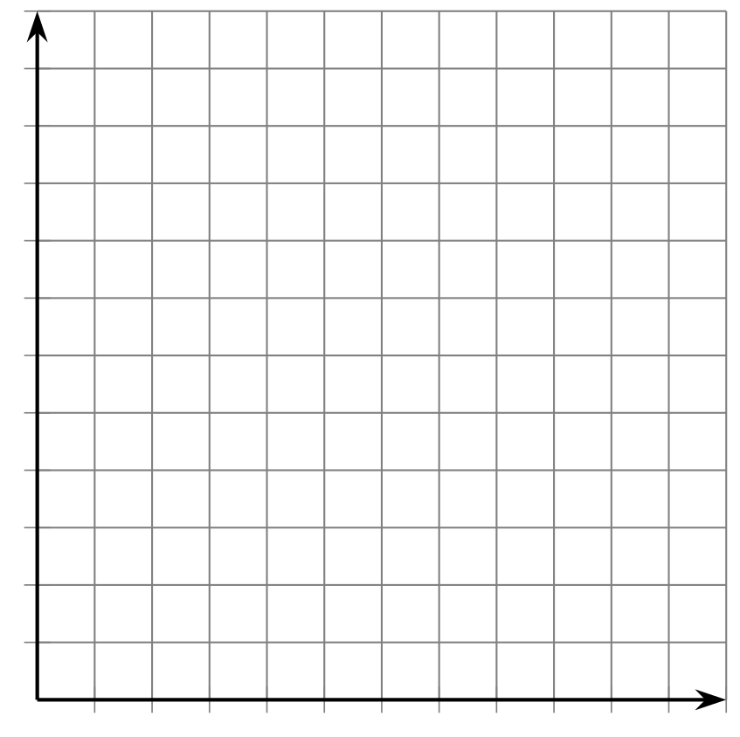
Concert Tickets
- Two kinds of tickets to an outdoor concert were sold: lawn tickets and seat tickets. Fewer than 400 tickets in total were sold.
- If you know that exactly 100 lawn tickets were sold, what can you say about the number of seat tickets?
- Lawn tickets cost $30 each and seat tickets cost $50 each. The organizers want to make at least $14,000 from ticket sales.
- If you know that exactly 200 seat tickets were sold, what can you say about the number of lawn tickets?
Advertising Packages
- An advertising agency offers two packages for small businesses who need advertising services. A basic package includes only design services. A premium package includes design and promotion. The agency's goal is to sell at least 60 packages in total.
- If the agency sells exactly 45 basic packages, what can you say about the number of premium packages it needs to sell to meet its goal?
- The basic advertising package has a value of $1,000 and the premium package has a value of $2,500. The goal of the agency is to sell more than $60,000 worth of small-business advertising packages.
- If you know that exactly 10 premium packages were sold, what can you say about the number of basic packages the agency needs to sell to meet its goal?

Are you ready for more?
This activity will require a partner.
- Without letting your partner see it, write an equation of a line so that both the $x$-intercept and the $y$-intercept are each between -3 and 3. Graph your equation on one of the coordinate systems.

- Your Inequality
- 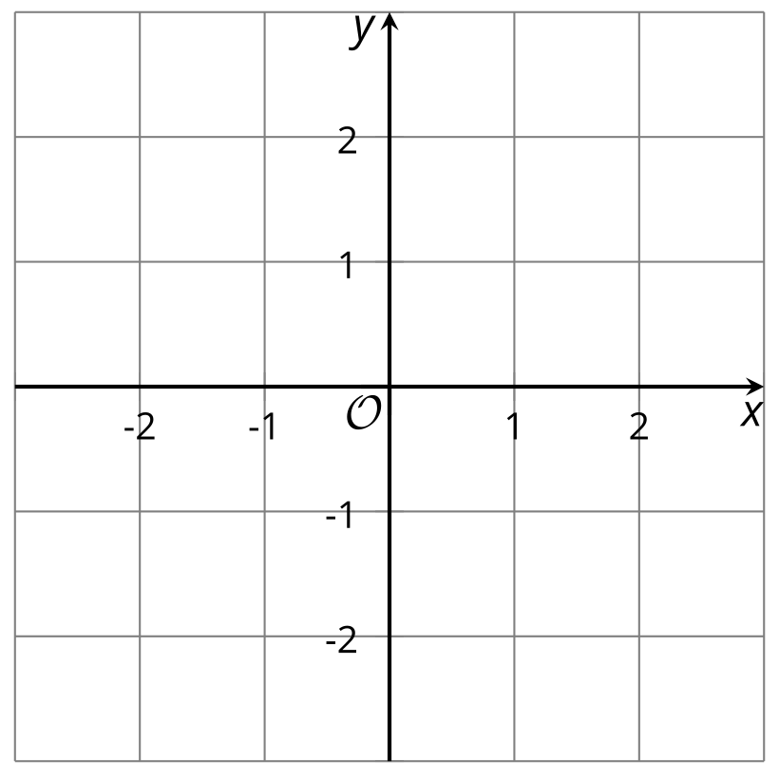

- Your Partner's Inequality
- Still without letting your partner see it, write an inequality for which your equation is the related equation. In other words, your line should be the boundary between solutions and non-solutions. Shade the solutions on your graph.
- Take turns stating coordinates of points. Your partner will tell you whether your guess is a solution to their inequality. After each partner has stated a point, each may guess what the other’s inequality is. If neither guesses correctly, play continues. Use the other coordinate system to keep track of your guesses.

23.3: Card Sort: Representations of Inequalities
Your teacher will give you a set of cards. Take turns with your partner to match a group of 4 cards that contain: a situation, an inequality that represents it, a graph that represents the solution region, and a solution written as a coordinate pair.
For each match that you find, explain to your partner how you know it’s a match.
For each match that your partner finds, listen carefully to their explanation. If you disagree, discuss your thinking and work to reach an agreement.
Record your matches.
Group 1
- situation: perimeter of a rectangle
- inequality:
- a solution:
- sketch of graph:
Group 2
- situation: jar of coins
- inequality:
- a solution:
- sketch of graph:
Group 3
- situation: honey and jam
- inequality:
- a solution:
- sketch of graph:
Group 4
- situation: a school trip
- inequality:
- a solution:
- sketch of graph:

Lesson 23 Summary
Suppose we want to find the solution to $x−y>5$. We can start by graphing the related equation $x−y=5$.
When identifying the solution region, it is important not to assume that the solution will be above the line because of a “>” symbol or below the line because of a “<” symbol.
Instead, test the points on the line and on either side of the line and see if they are solutions.​​​​​​
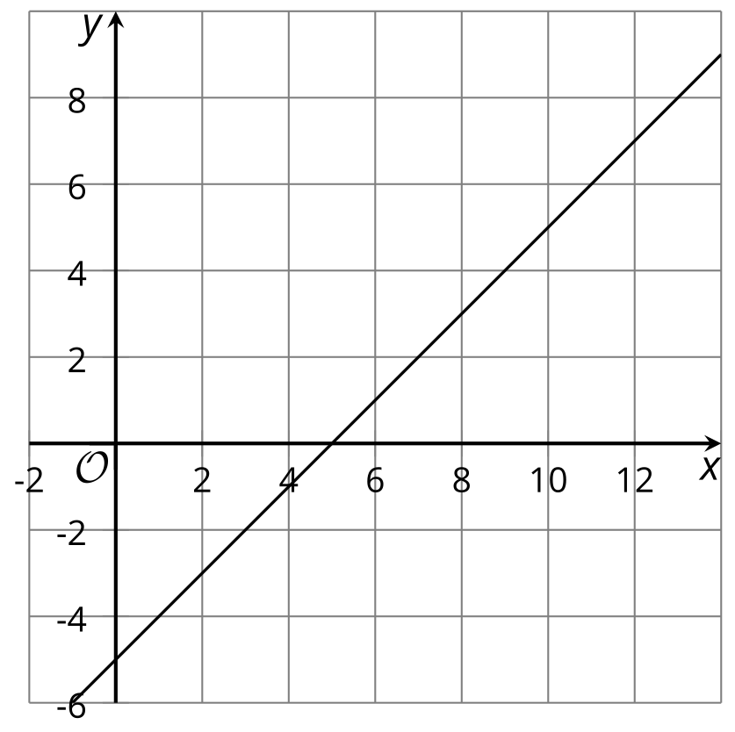
For $x−y>5$, points on the line and above the line are not solutions to the inequality because the $\left(x,y\right)$ pairs make the inequality false. Points that are below the lines are solutions, so we can shade that lower region.
Graphing technology can help us graph the solution to an inequality in two variables.
Many graphing tools allow us to enter inequalities such as $x−y>5$ and will show the solution region, as shown here.
Some tools, however, may require the inequalities to be in slope-intercept form or another form before displaying the solution region. Be sure to learn how to use the graphing technology available in your classroom.​​​​​​
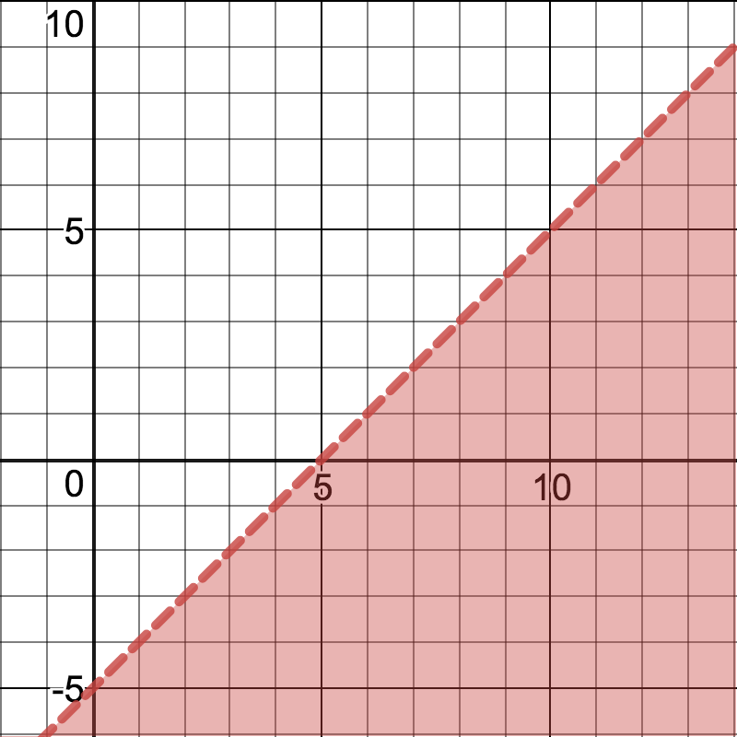
Although graphing using technology is efficient, we still need to analyze the graph with care. Here are some things to consider:
- The graphing window. If the graphing window is too small, we may not be able to really see the solution region or the boundary line, as shown here.
- The meaning of solution points in the situation. For example, if $x$ and $y$ represent the lengths of two sides of a rectangle, then only positive values of $x$ and $y$ (or points in the first quadrant) make sense in the situation.
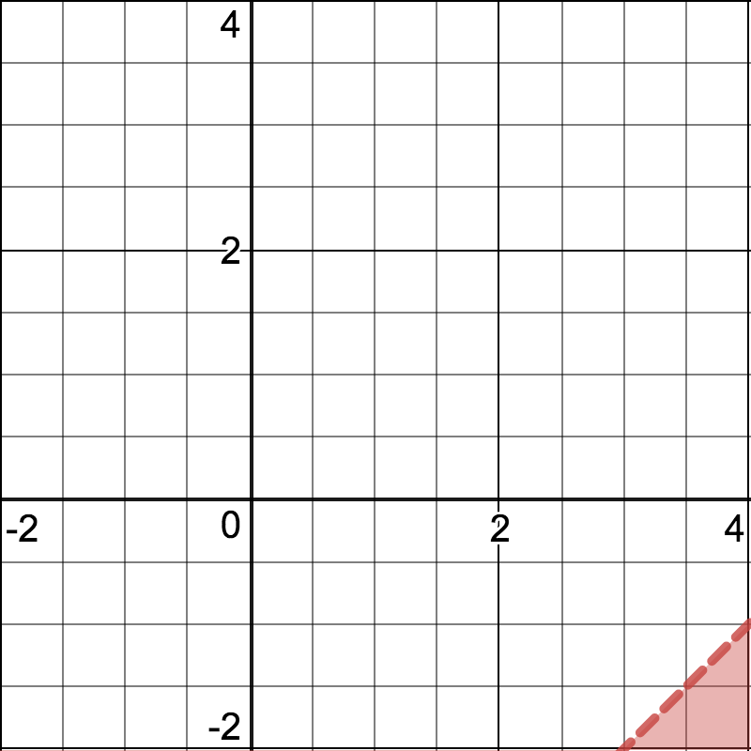
© CC BY 2019 by Illustrative Mathematics®

