Grade 2
Unit 5Lesson 1CC BY NC 2024 Illustrative Mathematics®
Unit 5, Lesson 1

How Do We Compose a Hundred?
- Let’s compose a hundred.
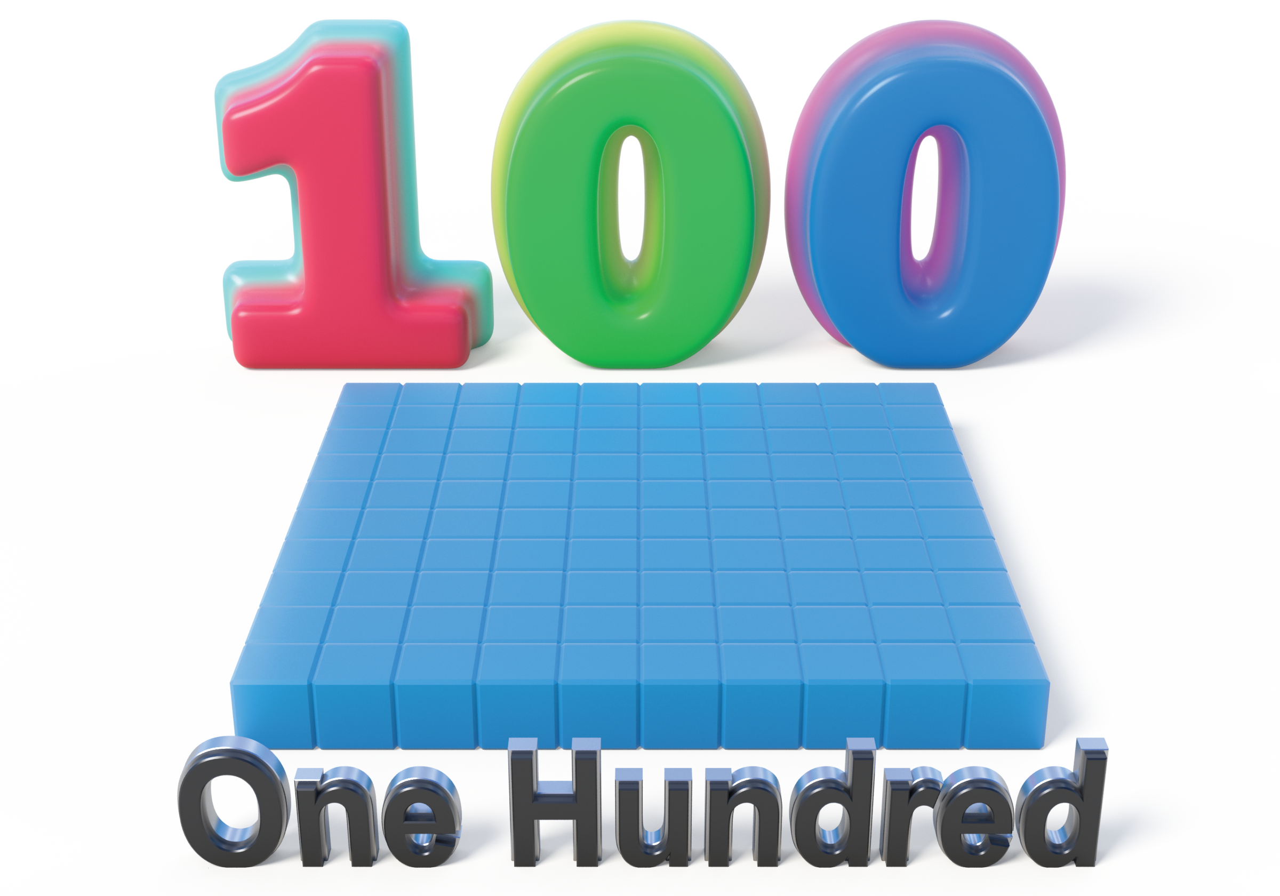
Grade 2
Unit 5Lesson 1CC BY NC 2024 Illustrative Mathematics®

Activity 1 How Do We Make a Hundred?
- How many do you see? How do you see them?
- 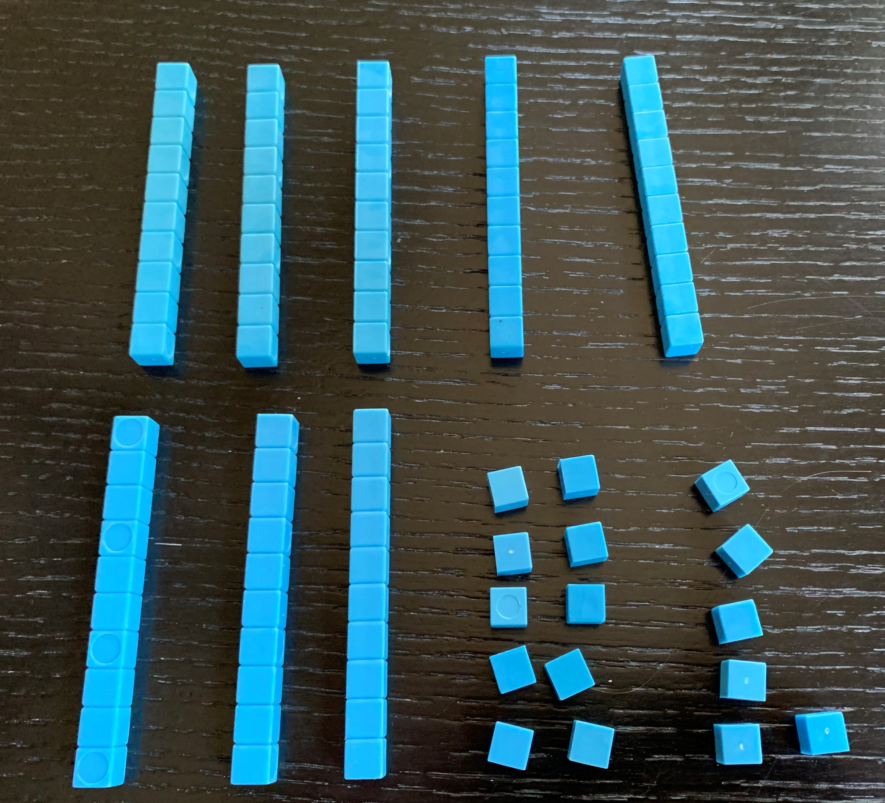
- Andre added more blocks.
- 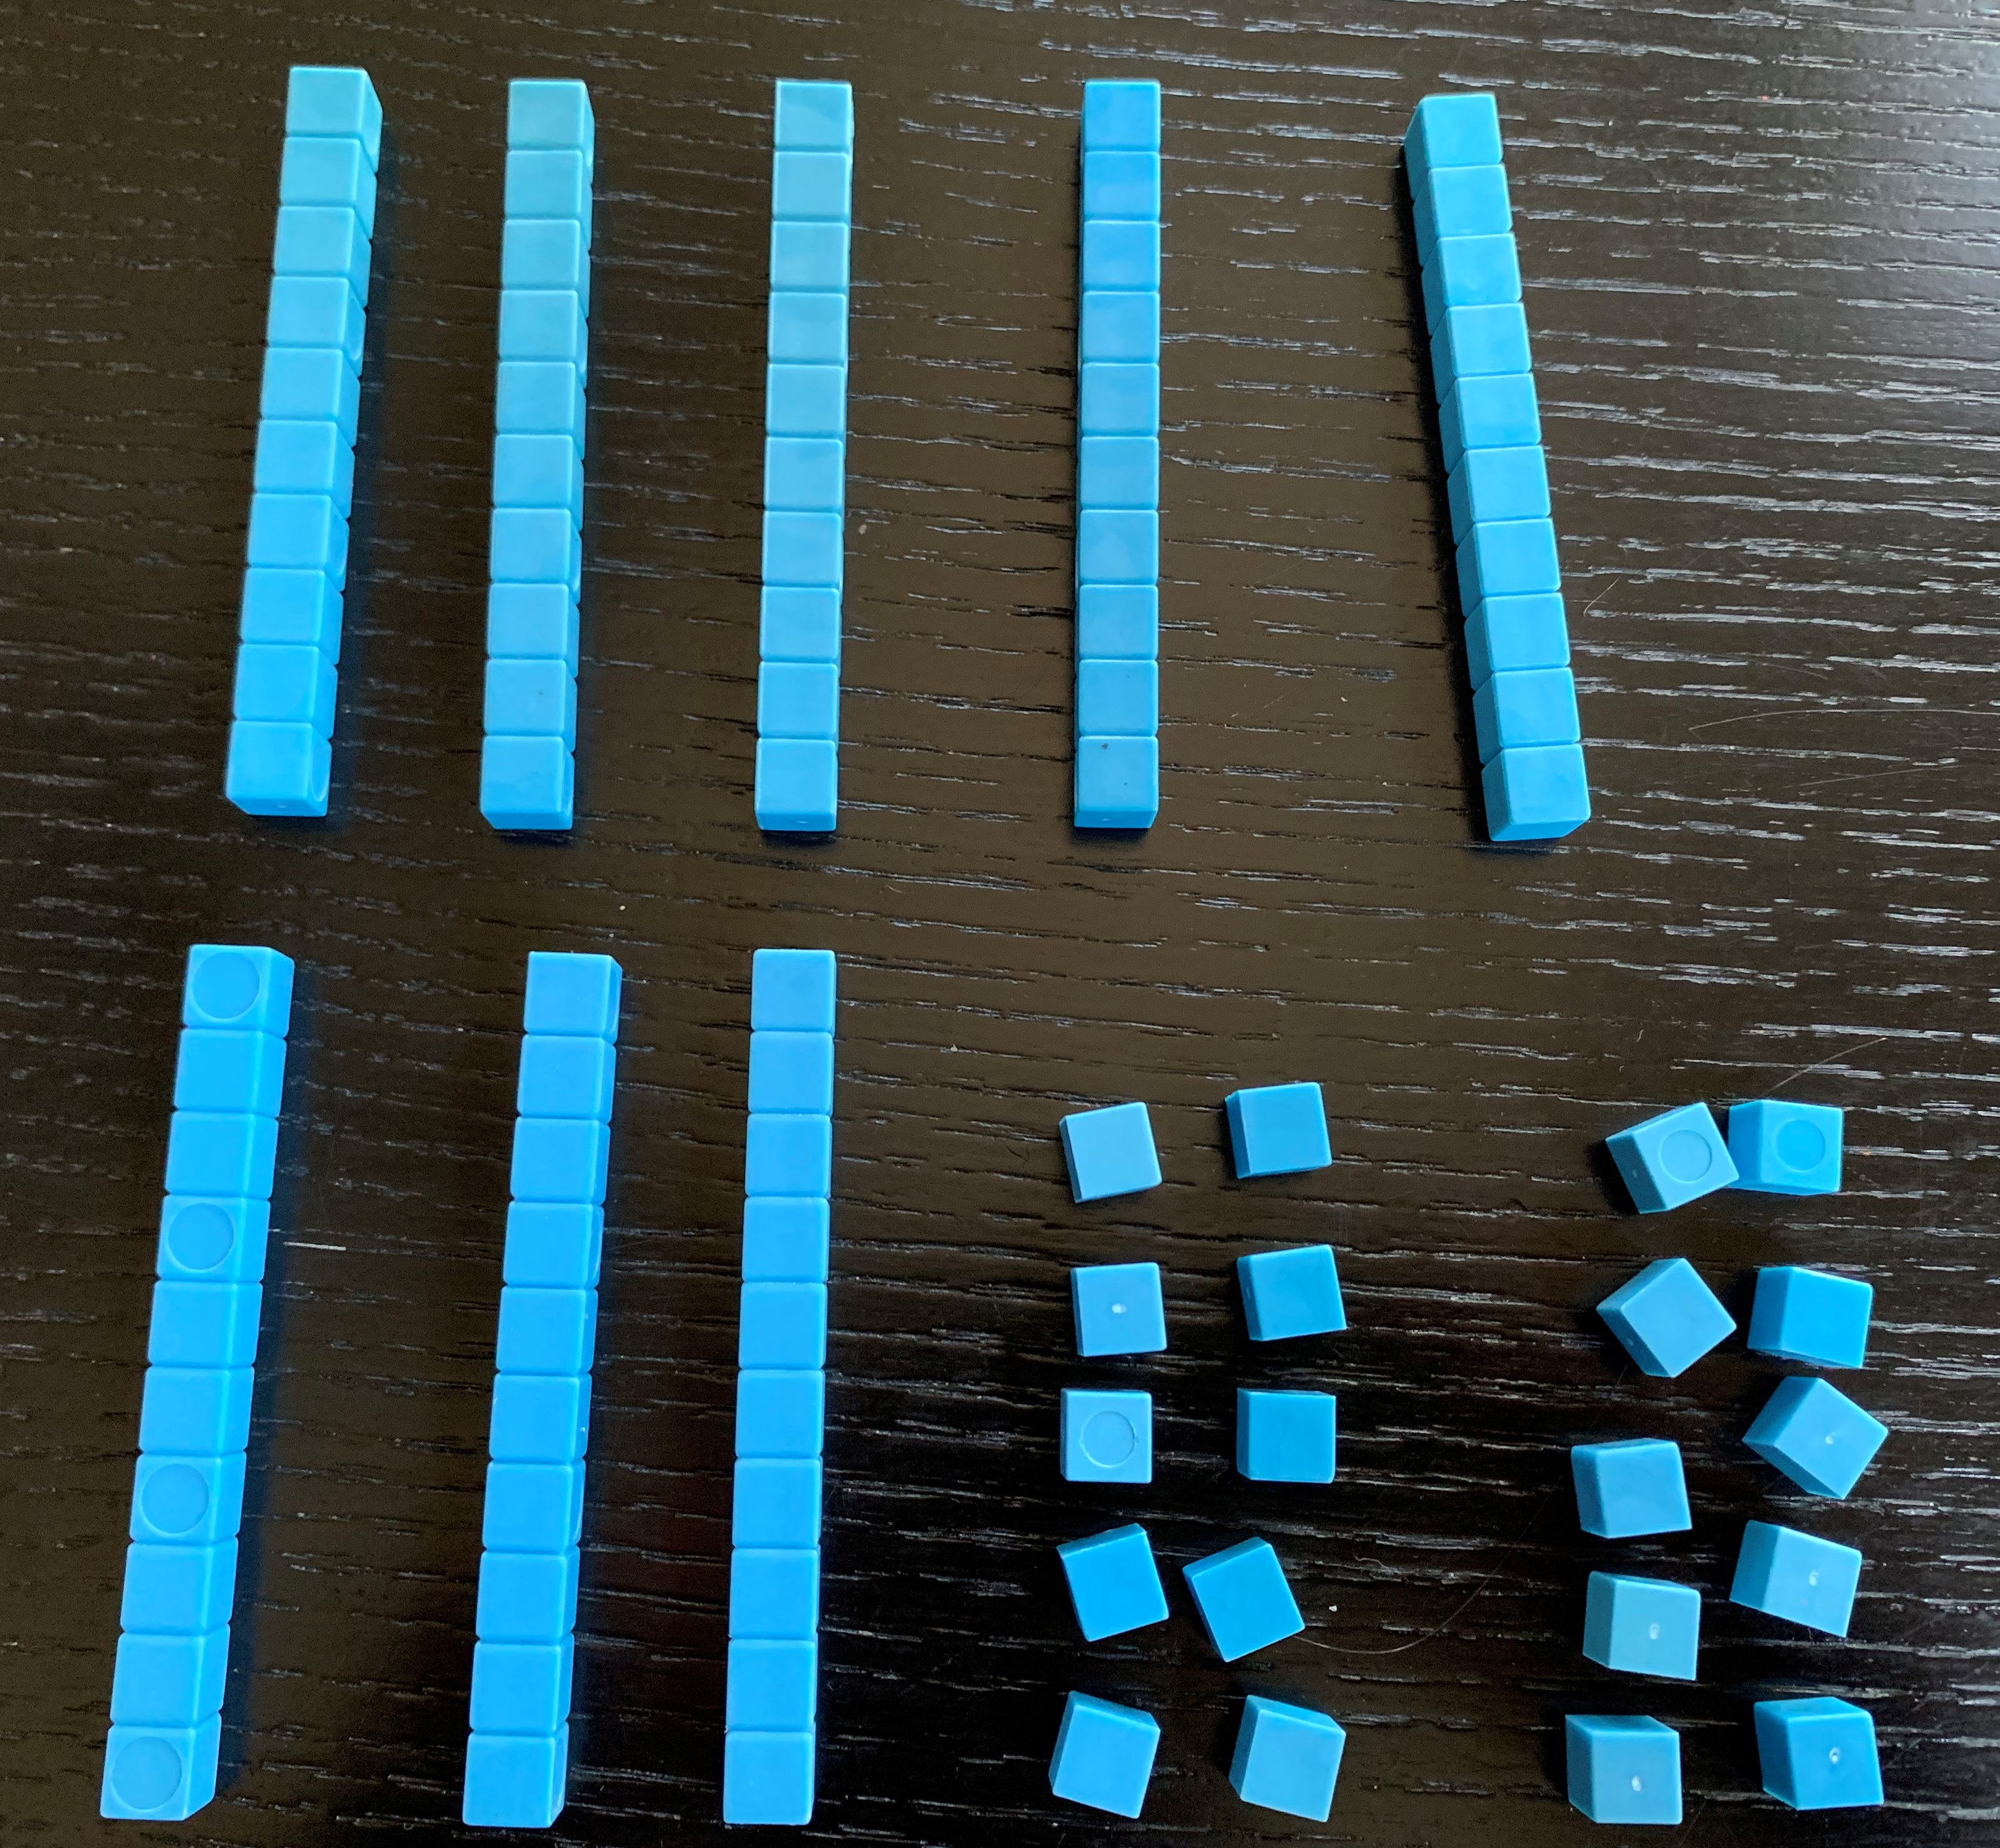
  - What is the value of his blocks now?
  - How many tens and ones does he have?
- Andre made the same number with the fewest number of blocks possible. Draw a base-ten diagram to show how the number looks now. Use your base-ten blocks to help.
Grade 2
Unit 5Lesson 1CC BY NC 2024 Illustrative Mathematics®

Activity 2Different Ways to Make 100
Three students look at 100 small squares arranged this way.
Unable to process <img src="/tikz_files/238851.svg">Failed: rsvg-convert --format png --dpi-x 300 --dpi-y 300 /app/tmp/svgtopng-1786381035.4977224.svg --output /app/tmp/svgtopng-1786381035.4977224.png Backtrace: /app/app/services/script/runner.rb:34:in `block in run_cmd' <internal:kernel>:90:in `tap' /app/app/services/script/runner.rb:32:in `run_cmd' /app/app/services/script/svg_to_png.rb:27:in `convert_svg_to_png' /app/app/services/script/svg_to_png.rb:17:in `to_png' /app/vendor/bundle/ruby/3.3.0/gems/embeddable_content-1.1.0/app/services/embeddable_content/images/image_downloader.rb:37:in `png_rendered_from_svg' /app/vendor/bundle/ruby/3.3.0/gems/embeddable_content-1.1.0/app/services/embeddable_content/images/image_downloader.rb:33:in `raw_image_data' /app/vendor/bundle/ruby/3.3.0/gems/embeddable_content-1.1.0/app/services/embeddable_content/images/image_downloader.rb:13:in `block in save' <internal:kernel>:90:in `tap' /app/vendor/bundle/ruby/3.3.0/gems/embeddable_content-1.1.0/app/services/embeddable_content/images/image_downloader.rb:13:in `save'
- Match the diagrams to the statements. Label each diagram with a, b, or c.
  - Priya said, “I see 100 ones.”
  - Kiran said, “I see 10 tens.”
  - Lin said, “I see 1 hundred.”
- Unable to process <img src="/tikz_files/236726.svg">Failed: rsvg-convert --format png --dpi-x 300 --dpi-y 300 /app/tmp/svgtopng-1786381035.5379515.svg --output /app/tmp/svgtopng-1786381035.5379515.png Backtrace: /app/app/services/script/runner.rb:34:in `block in run_cmd' <internal:kernel>:90:in `tap' /app/app/services/script/runner.rb:32:in `run_cmd' /app/app/services/script/svg_to_png.rb:27:in `convert_svg_to_png' /app/app/services/script/svg_to_png.rb:17:in `to_png' /app/vendor/bundle/ruby/3.3.0/gems/embeddable_content-1.1.0/app/services/embeddable_content/images/image_downloader.rb:37:in `png_rendered_from_svg' /app/vendor/bundle/ruby/3.3.0/gems/embeddable_content-1.1.0/app/services/embeddable_content/images/image_downloader.rb:33:in `raw_image_data' /app/vendor/bundle/ruby/3.3.0/gems/embeddable_content-1.1.0/app/services/embeddable_content/images/image_downloader.rb:13:in `block in save' <internal:kernel>:90:in `tap' /app/vendor/bundle/ruby/3.3.0/gems/embeddable_content-1.1.0/app/services/embeddable_content/images/image_downloader.rb:13:in `save' Unable to process <img src="/tikz_files/236727.svg">Failed: rsvg-convert --format png --dpi-x 300 --dpi-y 300 /app/tmp/svgtopng-1786381035.583879.svg --output /app/tmp/svgtopng-1786381035.583879.png Backtrace: /app/app/services/script/runner.rb:34:in `block in run_cmd' <internal:kernel>:90:in `tap' /app/app/services/script/runner.rb:32:in `run_cmd' /app/app/services/script/svg_to_png.rb:27:in `convert_svg_to_png' /app/app/services/script/svg_to_png.rb:17:in `to_png' /app/vendor/bundle/ruby/3.3.0/gems/embeddable_content-1.1.0/app/services/embeddable_content/images/image_downloader.rb:37:in `png_rendered_from_svg' /app/vendor/bundle/ruby/3.3.0/gems/embeddable_content-1.1.0/app/services/embeddable_content/images/image_downloader.rb:33:in `raw_image_data' /app/vendor/bundle/ruby/3.3.0/gems/embeddable_content-1.1.0/app/services/embeddable_content/images/image_downloader.rb:13:in `block in save' <internal:kernel>:90:in `tap' /app/vendor/bundle/ruby/3.3.0/gems/embeddable_content-1.1.0/app/services/embeddable_content/images/image_downloader.rb:13:in `save' Unable to process <img src="/tikz_files/236728.svg">Failed: rsvg-convert --format png --dpi-x 300 --dpi-y 300 /app/tmp/svgtopng-1786381035.6267242.svg --output /app/tmp/svgtopng-1786381035.6267242.png Backtrace: /app/app/services/script/runner.rb:34:in `block in run_cmd' <internal:kernel>:90:in `tap' /app/app/services/script/runner.rb:32:in `run_cmd' /app/app/services/script/svg_to_png.rb:27:in `convert_svg_to_png' /app/app/services/script/svg_to_png.rb:17:in `to_png' /app/vendor/bundle/ruby/3.3.0/gems/embeddable_content-1.1.0/app/services/embeddable_content/images/image_downloader.rb:37:in `png_rendered_from_svg' /app/vendor/bundle/ruby/3.3.0/gems/embeddable_content-1.1.0/app/services/embeddable_content/images/image_downloader.rb:33:in `raw_image_data' /app/vendor/bundle/ruby/3.3.0/gems/embeddable_content-1.1.0/app/services/embeddable_content/images/image_downloader.rb:13:in `block in save' <internal:kernel>:90:in `tap' /app/vendor/bundle/ruby/3.3.0/gems/embeddable_content-1.1.0/app/services/embeddable_content/images/image_downloader.rb:13:in `save'
- ____________
- ____________
- ____________
- Represent $100+11$ with blocks or a diagram.

