Grade 6
Unit 1Lesson 4CC BY NC Illustrative Mathematics, based on IM 6–8 Math, CC BY Open Up Resources.
Unit 1, Lesson 4

Parallelograms
Let’s investigate the characteristics and area of parallelograms.
Grade 6
Unit 1Lesson 4CC BY NC Illustrative Mathematics, based on IM 6–8 Math, CC BY Open Up Resources.

4.1What Are Parallelograms?
Figures A, B, and C are parallelograms.
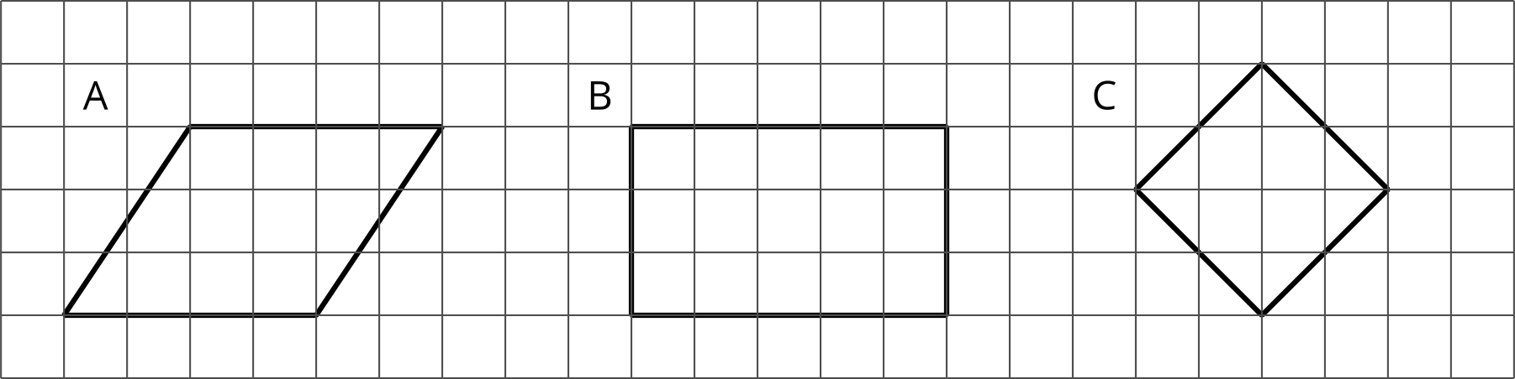
Figures D, E, and F are not parallelograms.
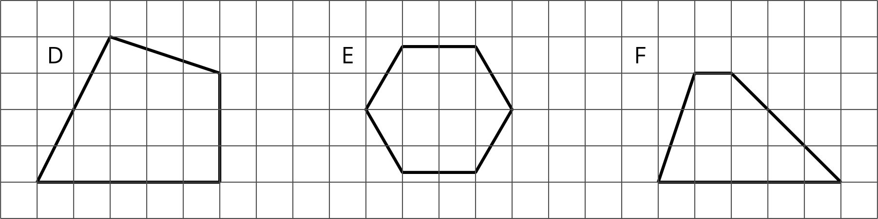
What do you notice about:
- The number of sides that a parallelogram has?
- Opposite sides of a parallelogram?
- Opposite angles of a parallelogram?
Grade 6
Unit 1Lesson 4CC BY NC Illustrative Mathematics, based on IM 6–8 Math, CC BY Open Up Resources.

4.2Area of a Parallelogram
Find the area of each parallelogram. Show your reasoning.
1.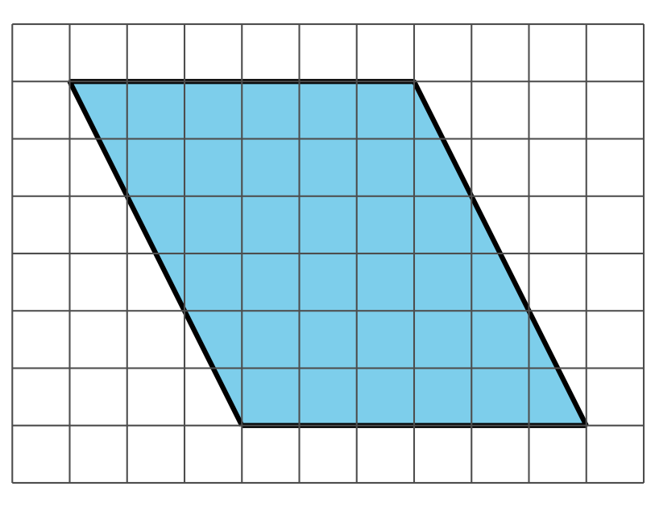
2.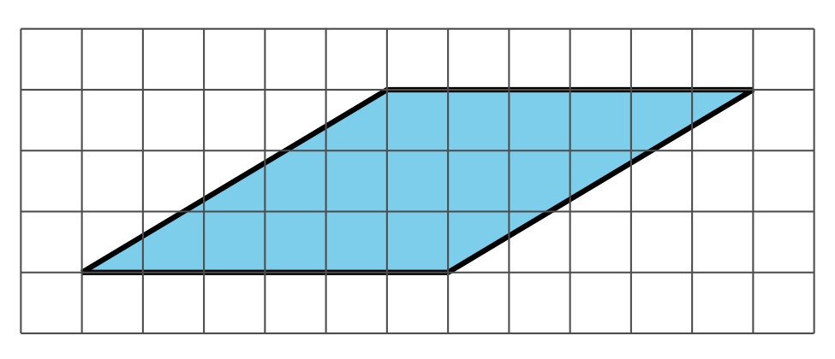

Grade 6
Unit 1Lesson 4CC BY NC Illustrative Mathematics, based on IM 6–8 Math, CC BY Open Up Resources.

4.3Lots of Parallelograms
Find the area of each parallelogram. Show your reasoning.
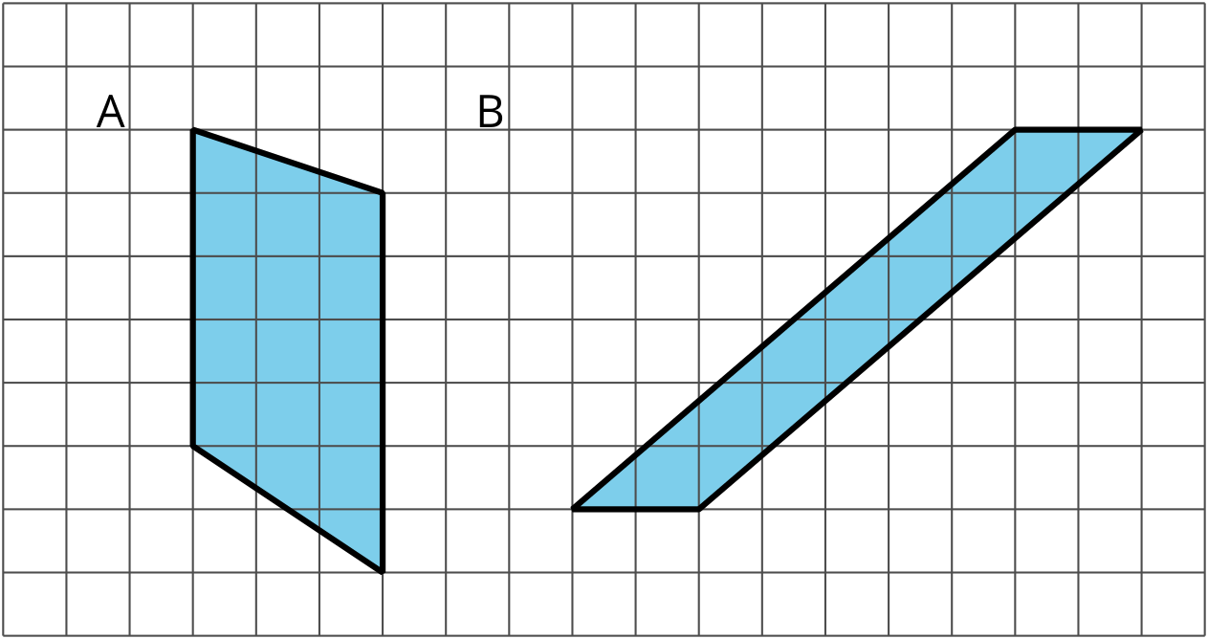
C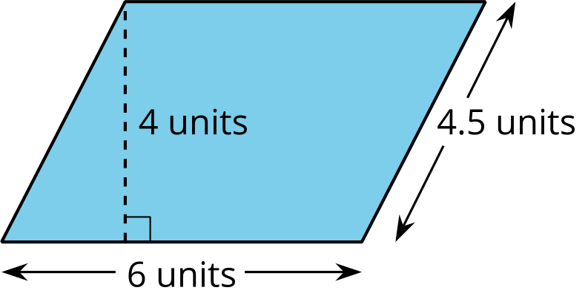

Lesson 4 Summary
A parallelogram is a quadrilateral (it has four sides). The opposite sides of a parallelogram are parallel. The opposite sides of a parallelogram have the same length, and the opposite angles of a parallelogram have the same measure in degrees.
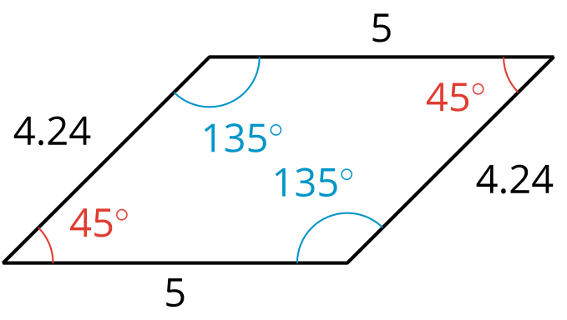
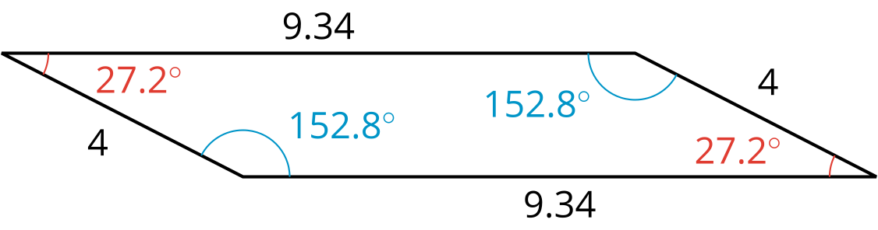
There are several strategies for finding the area of a parallelogram.
- We can decompose and rearrange a parallelogram to form a rectangle. Here are three ways:
- 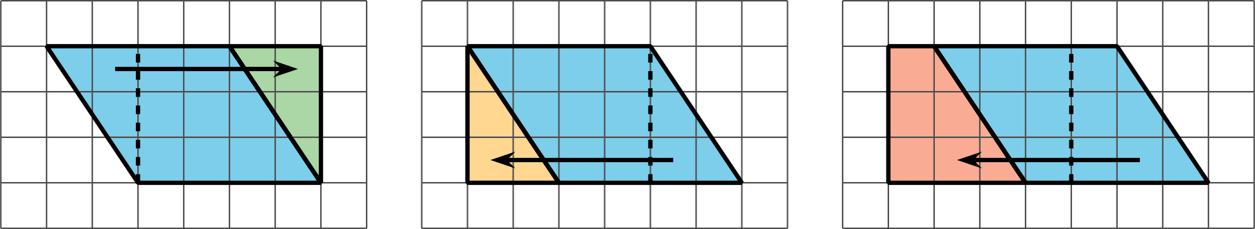
- We can enclose the parallelogram and then subtract the area of the two triangles in the corner.
- 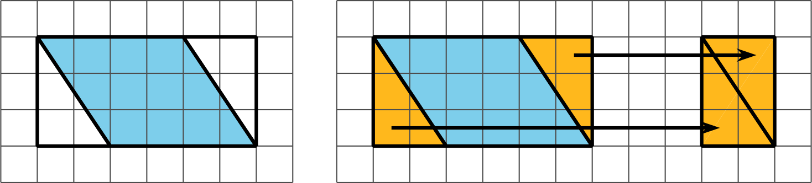
Both of these ways will work for any parallelogram. However, for some parallelograms the process of decomposing and rearranging requires a lot more steps than if we enclose the parallelogram with a rectangle and subtract the combined area of the two triangles in the corners.
