Grade 6
Unit 6Lesson 15CC BY NC Illustrative Mathematics, based on IM 6–8 Math, CC BY Open Up Resources.
Unit 6, Lesson 15

Equivalent Exponential Expressions
Let's investigate expressions with variables and exponents.
Grade 6
Unit 6Lesson 15CC BY NC Illustrative Mathematics, based on IM 6–8 Math, CC BY Open Up Resources.

15.1Up or Down?
Find the values of $3^{x}$ and ${\left(\frac{1}{3}\right)}^{x}$ for each value of $x$. What patterns do you notice?
$x$ | $3^{x}$ | ${\left(\frac{1}{3}\right)}^{x}$
1
2
3
4
Grade 6
Unit 6Lesson 15CC BY NC Illustrative Mathematics, based on IM 6–8 Math, CC BY Open Up Resources.

15.2What's the Value?
Find the value of each expression for the given value of $x$.
- $3x^{2}$ when $x$ is 10
- $3x^{2}$ when $x$ is $\frac{1}{9}$
- ${\left(3x\right)}^{2}$ when $x$ is 4
- $\frac{x^{3}}{4}$ when $x$ is $4$
- $9+x^{7}$ when $x$ is 1
- $9+x^{7}$ when $x$ is $\frac{1}{2}$
Grade 6
Unit 6Lesson 15CC BY NC Illustrative Mathematics, based on IM 6–8 Math, CC BY Open Up Resources.

15.3Exponent Experimentation
Find a solution to each equation in the list. (Numbers in the list may be a solution to more than one equation, and not all numbers in the list will be used.)
- $64=x^{2}$
- $64=x^{3}$
- $2^{x}=32$
- $x={\left(\frac{2}{5}\right)}^{3}$
- $\frac{16}{9}=x^{2}$
- $2⋅2^{5}=2^{x}$
- $2x=2^{4}$
- $4^{3}=8^{x}$
List:
$\frac{8}{125}$
$\frac{6}{15}$
$\frac{5}{8}$
$\frac{8}{9}$
1
$\frac{4}{3}$
2
3
4
5
6
8

Are you ready for more?
A fractal is a special kind of geometric pattern. In a fractal, each part makes up a larger part with the same features, or is formed by smaller parts with the same features.
Here is a fractal called a Sierpinski Tetrahedron. A tetrahedron is a polyhedron that has 4 triangular faces. In the picture, we see tetrahedra in three sizes:
- Small: A small tetrahedron has 4 small triangular faces.
- Medium: A medium tetrahedron is formed by 4 small tetrahedra that are connected at their vertices. The picture shows 4 medium tetrahedra, each in a different color.
- Large: A large tetrahedron is formed by 4 medium tetrahedra that are connected at their vertices.
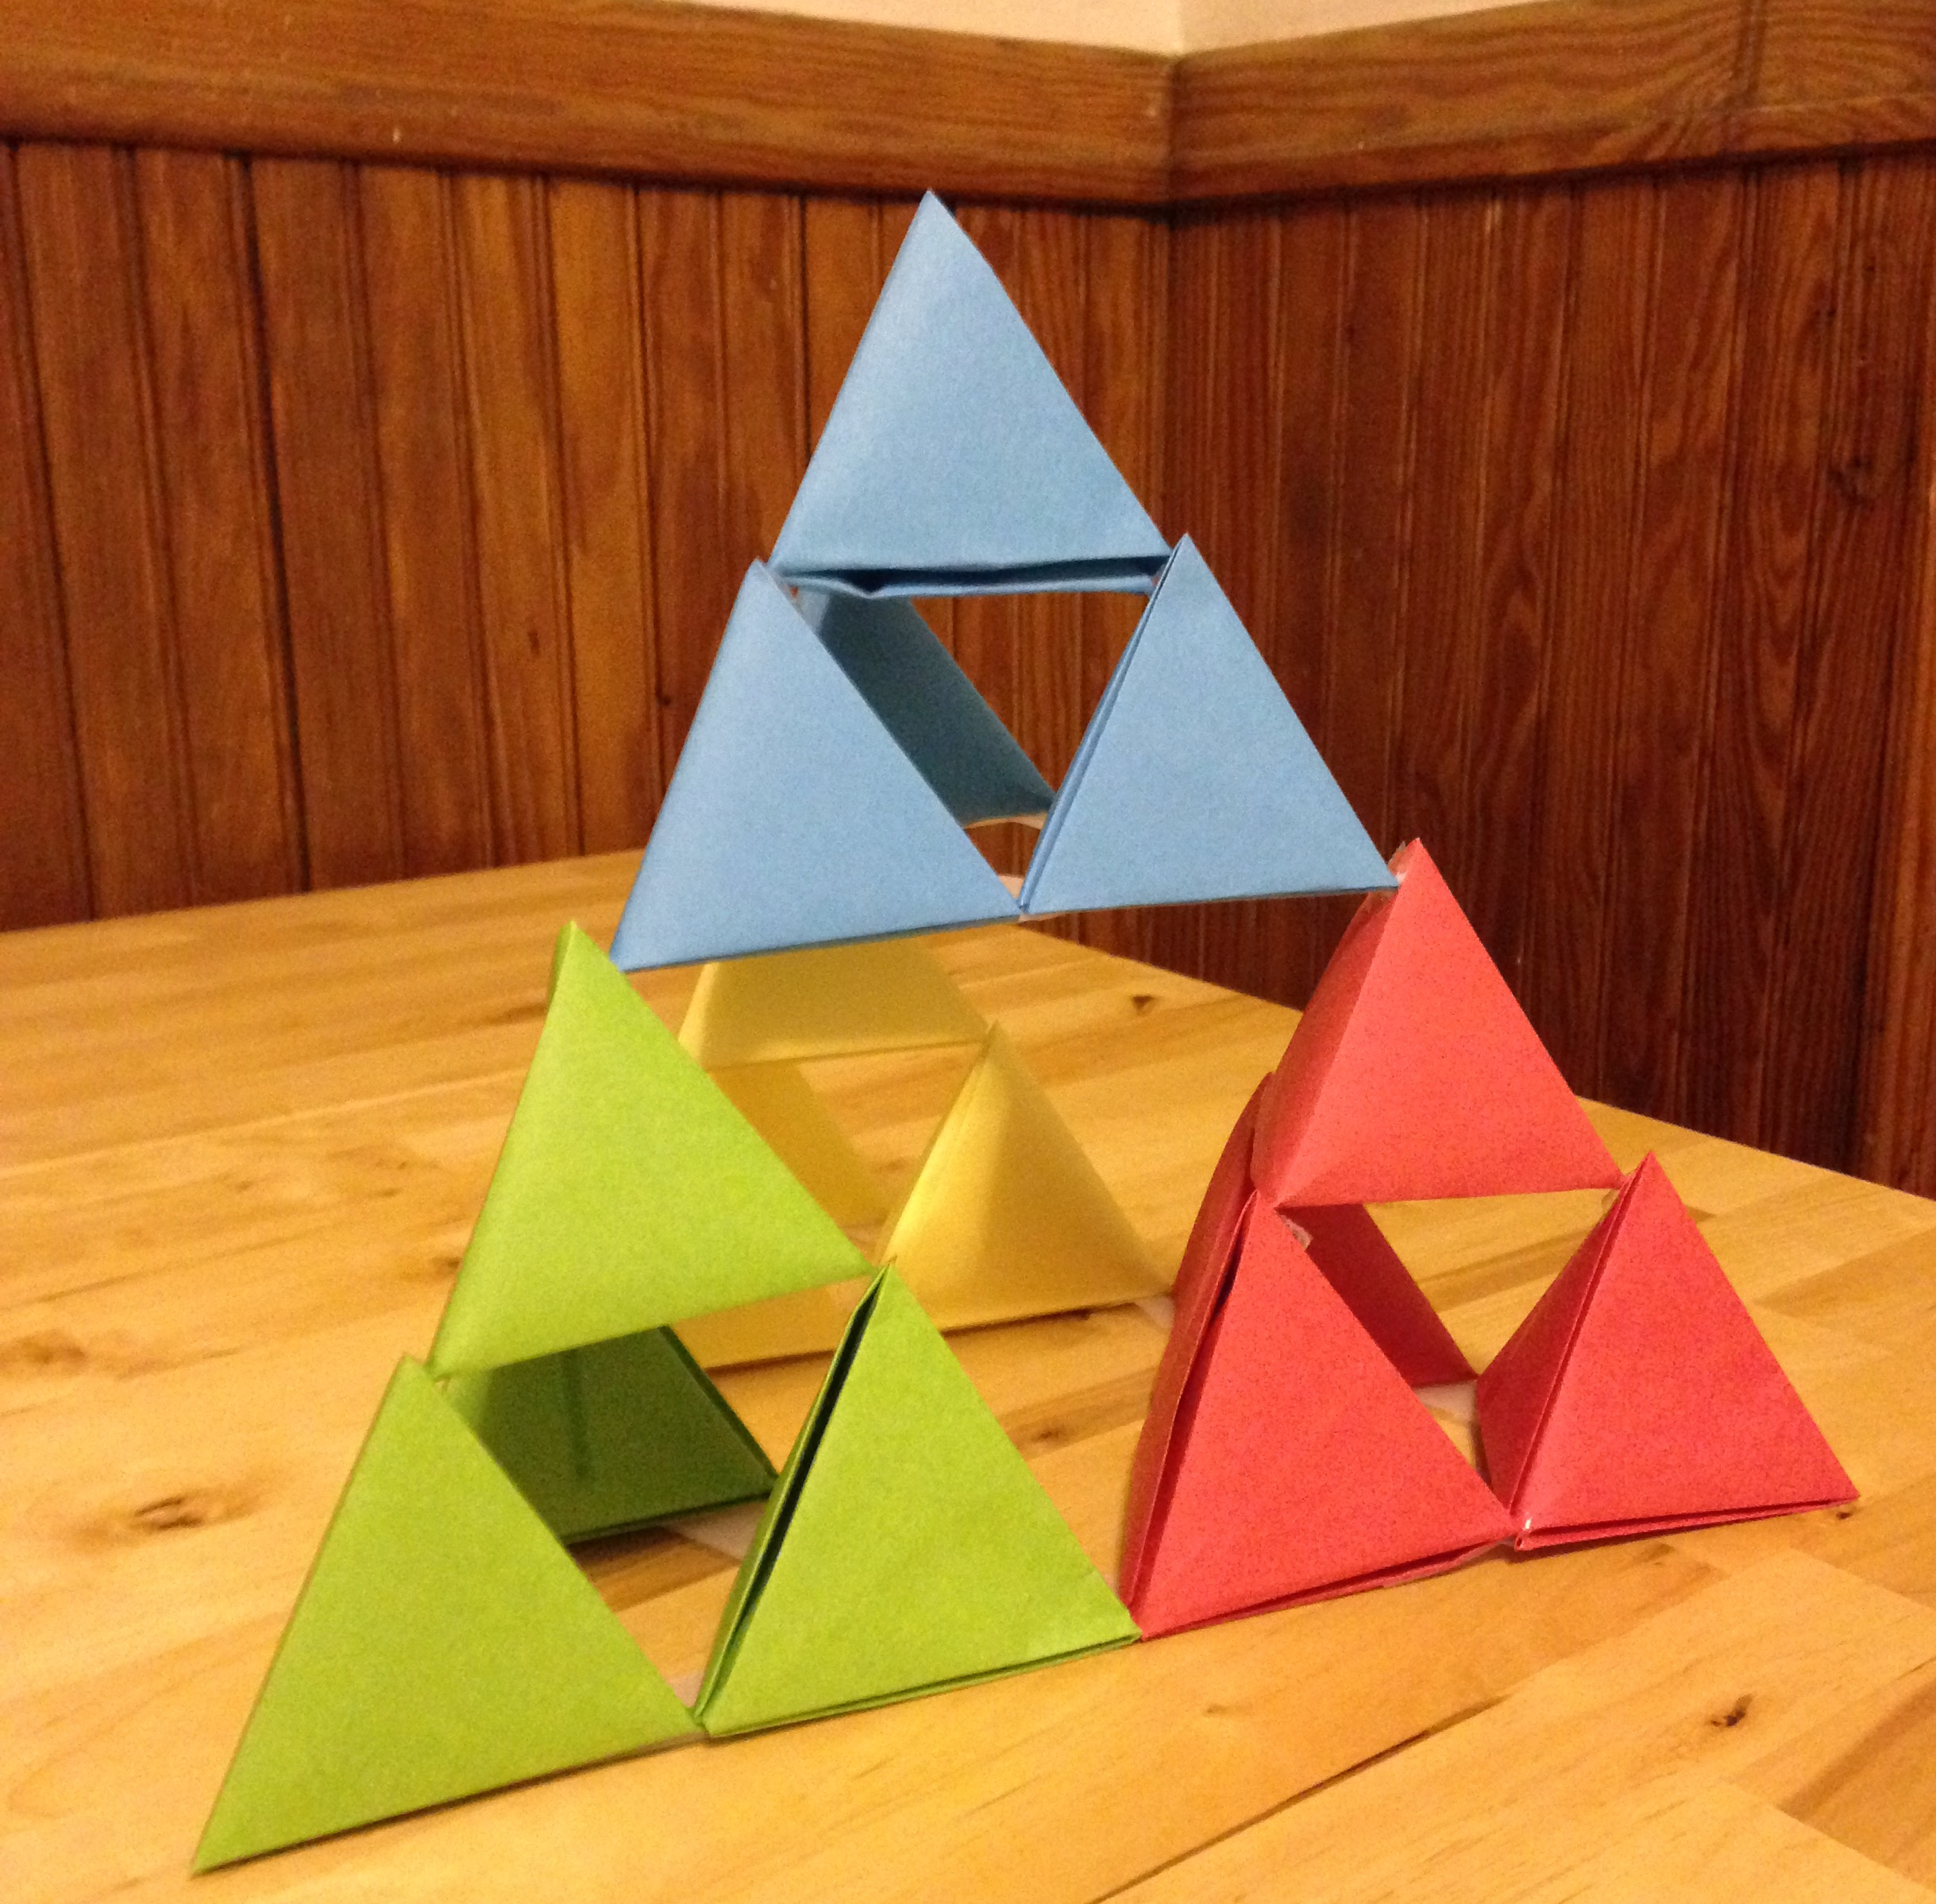
- Look at 1 medium tetrahedron.
  - How many small tetrahedra are in it?
  - How many small tetrahedra are in the bottom layer, touching the table?
- Look at 1 large tetrahedron.
  - How many small tetrahedra are in it?
  - How many small tetrahedra are in the bottom layer, touching the table?
- Record information about small, medium, and large tetrahedra in the table. What patterns do you see?
 | - small tetrahedron | - medium tetrahedron | - large tetrahedron | - extra-large tetrahedron
- number of small tetrahedra | - 1 | - 4
- number of small tetrahedra touching the table | - 1
- sketch of triangular faces touching the table | - 
- Suppose we build an extra-large tetrahedron formed by 4 large tetrahedra that are connected at their vertices. Complete the last column of the table. Use any patterns you noticed to help you.
Can you find other patterns in this fractal? Try it!

Lesson 15 Summary
We can find the value of expressions with an exponent and a variable for different values of the variable. For example:
- To find the value of the expression $2x^{3}$ when $x$ is 5, we replace the variable $x$ with 5 to get $2⋅5^{3}$.
- This is equal to $2⋅125$, or just 250.
- So, the value of $2x^{3}$ is 250 when $x$ is 5.
- To find the value of $\frac{x^{2}}{8}$ when $x$ is 4, we replace the variable $x$ with 4 to get $\frac{4^{2}}{8}=\frac{16}{8}$, which equals 2.
- So, $\frac{x^{2}}{8}$ has a value of 2 when $x$ is 4.
Equations may also have an exponent and a variable. We can find out what value of the variable would make such an equation true.
- Suppose we have an equation $10⋅3^{x}=90$ and a list of possible solutions: $1,2,3,9,11$.
The only value of $x$ that makes the equation true is 2 because $10⋅3^{2}=10⋅3⋅3$, which equals 90.
- So, 2 is the solution to the equation, which we can express as $x=2$.

