Lesson 6: Relate Division and Multiplication
- Let’s explore the relationship between multiplication and division.

Warm-up: Number Talk: Multiply and Divide
Find the value of each expression mentally.
- $3×\frac{1}{2}$
- $3×\frac{2}{2}$
- $3×\frac{3}{2}$
- $5×\frac{3}{2}$

6.1: The Race

- Lin and Han ran a 3 mile relay race as a team. They each ran the same distance. Draw a diagram to represent the situation.
- Take turns describing to your partner how your diagrams represent the situation.
- How far did each person run?

6.2: Where Do You See It?
Diagram A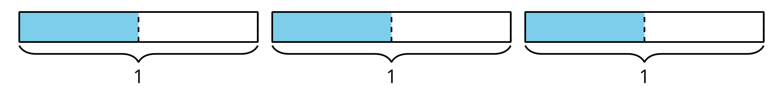
Diagram B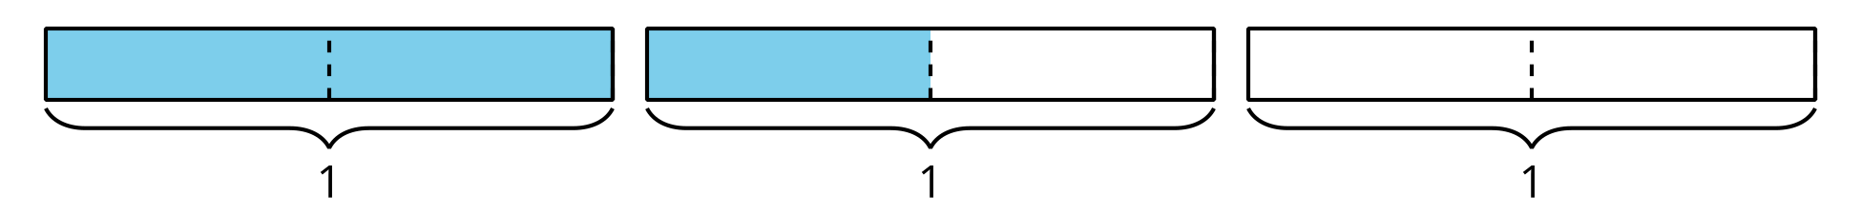
For each expression, choose one of the diagrams and describe how the diagram represents the expression. Be prepared to explain why you chose that diagram.
- $3×\frac{1}{2}$
- $3÷2$
- $\frac{1}{2}×3$
© CC BY 2021 Illustrative Mathematics®

