Unit 6 Lesson 12: Tangent

1 Notice and Wonder: An Unusual Function (Warm up)

Student Task Statement
What do you notice? What do you wonder?
$θ$ | $cos\left(θ\right)$ | $sin\left(θ\right)$ | $tan\left(θ\right)$
$\text{-}\frac{π}{2}$ | 0 | -1
$\text{-}\frac{π}{3}$ | 0.5 | -0.87
$\text{-}\frac{π}{6}$ | 0.87 | -0.5
0 | 1 | 0
$\frac{π}{6}$ | 0.87 | 0.5
$\frac{π}{3}$ | 0.5 | 0.87
$\frac{π}{2}$ | 0 | 1

2 A Tangent Ratio

Student Task Statement
- Complete the table. For each positive angle in the table, add the corresponding point and the segment between it and the origin to the unit circle.
- 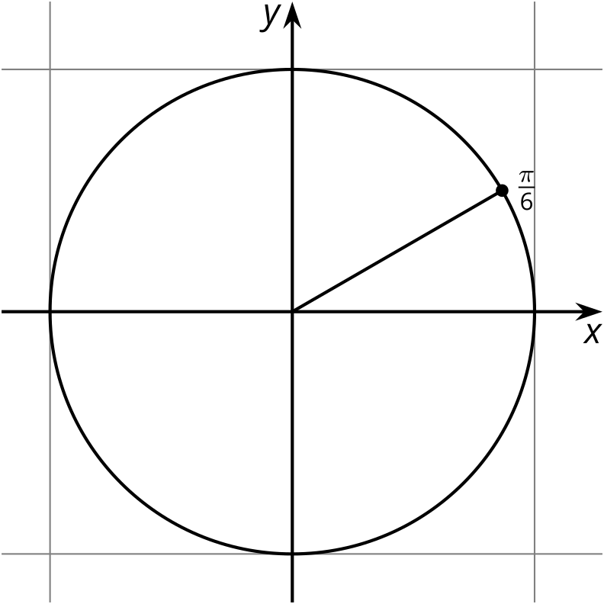
- $θ$ | - $cos\left(θ\right)$ | - $sin\left(θ\right)$ | - $tan\left(θ\right)$
- $\text{-}\frac{π}{2}$ | - 0 | - -1
- $\text{-}\frac{π}{3}$ | - 0.5 | - -0.87
- $\text{-}\frac{π}{6}$ | - 0.87 | - -0.5
- 0 | - 1 | - 0
- $\frac{π}{6}$ | - 0.87 | - 0.5
- $\frac{π}{3}$ | - 0.5 | - 0.87
- $\frac{π}{2}$ | - 0 | - 1
- $\frac{2π}{3}$
- $\frac{5π}{6}$
- $π$
- $\frac{7π}{6}$
- $\frac{4π}{3}$
- $\frac{3π}{2}$
- $\frac{5π}{3}$
- $\frac{11π}{6}$
- $2π$
- How are the values of $tan\left(θ\right)$ like the values of $cos\left(θ\right)$ and $sin\left(θ\right)$? How are they different?

3 The Tangent Function

Student Task Statement
Before we graph $y=tan\left(θ\right)$, let’s figure out some things that must be true.
- Explain why the graph of $tan\left(θ\right)$ has a vertical asymptote at $x=\frac{π}{2}$.
- Does the graph of $tan\left(θ\right)$ have other vertical asymptotes? Explain how you know.
- For which values of $θ$ is $tan\left(θ\right)$ zero? For which values of $θ$ is $tan\left(θ\right)$ one? Explain how you know.
- Is the graph of $tan\left(θ\right)$ periodic? Explain how you know.

Images for Activity Synthesis
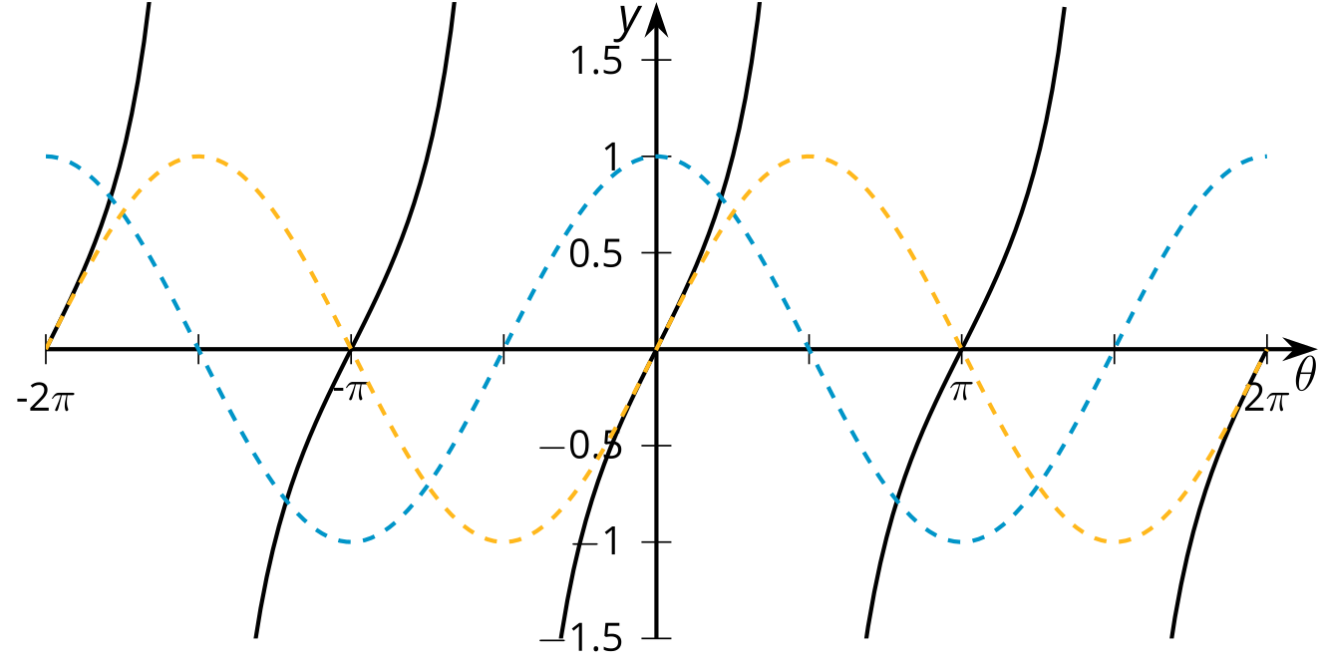
© CC BY 2019 by Illustrative Mathematics®

