Grade 2
Unit 8Lesson 9CC BY NC 2024 Illustrative Mathematics®
Unit 8, Lesson 9

A Sum of Equal Addends
- Let’s match expressions with arrays.
Grade 2
Unit 8Lesson 9CC BY NC 2024 Illustrative Mathematics®

Warm-up Estimation Exploration: How Many Waffles?
How many waffles are on the tray?

Record an estimate that is:
too low | about right | too high
How many waffles are on the tray?

Record an estimate that is:
too low | about right | too high
Grade 2
Unit 8Lesson 9CC BY NC 2024 Illustrative Mathematics®

Activity 1 Sums of Rows and Sums of Columns
Mai and Diego represent this array. They use different expressions.
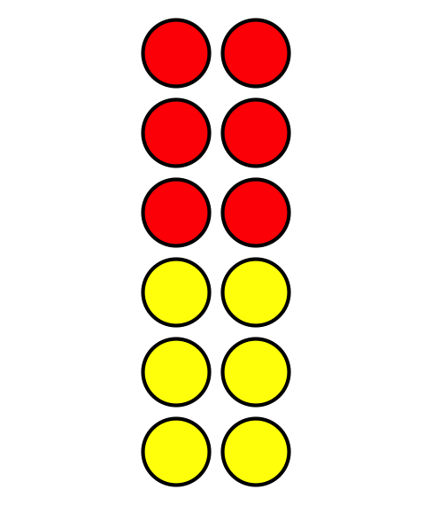
Diego’s expression
$2+2+2+2+2+2$
Mai’s expression
$6+6$
Do you agree with Diego or Mai?
Show your thinking using drawings, numbers, or words.
Grade 2
Unit 8Lesson 9CC BY NC 2024 Illustrative Mathematics®

Activity 2Card Sort: Arrays and Expressions
Your teacher will give you a set of cards. Match each array card with 2 expression cards and 1 number card. Be ready to explain your reasoning.
Grade 2
Unit 8Lesson 9CC BY NC 2024 Illustrative Mathematics®

Activity 3 Add It All Up

  - How many counters are in the array?
  - 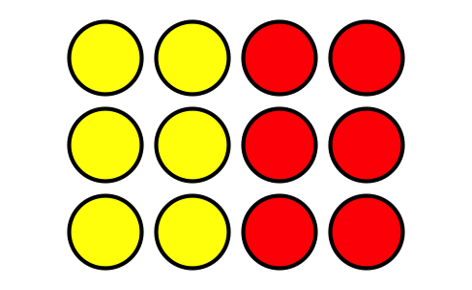
  - Explain how you found the total.
  - Circle 2 expressions that represent the array.
  - $3+3+3+3$
  - $3+3+3$
  - $4+3$
  - $4+4+4$
  - $4+4+4+4$

  - How many counters are in the array?
  - 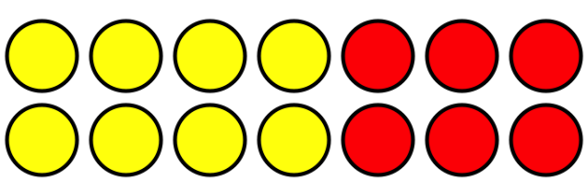
  - Explain how you found the total.
  - Circle 2 expressions that represent the array.
  - $2+2+2+2+2+2+2$
  - $6+6$
  - $7+7$
  - $2+2+2+2+2$

