Unit 4 Lesson 1: Growing and Shrinking

1 Bank Accounts (Warm up)

Student Task Statement
A bank account has a balance of $120 on January 1. Describe a situation in which the account balance for each month (February 1, March 1, . . .) forms the following sequences. Write the first three terms of each sequence.
- an arithmetic sequence
- a geometric sequence

2 Shrinking a Passport Photo

Student Task Statement
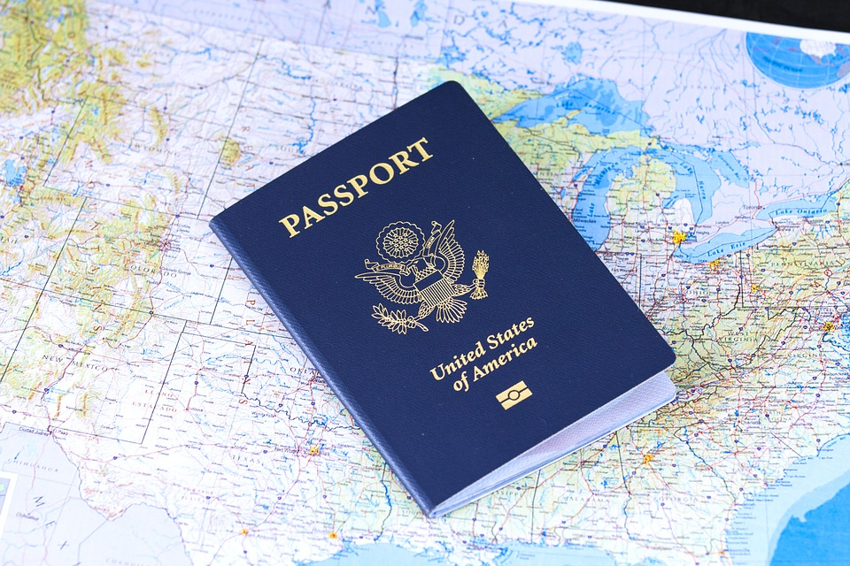
The distance from Elena’s chin to the top of her head is 150 mm in an image. For a U.S. passport photo, this measurement needs to be between 25 mm and 35 mm.

- Find the height of the image after it has been scaled by 80% the following number of times. Explain or show your reasoning.
  - 3 times
  - 6 times
- How many times would the image need to be scaled by 80% for the image to be less than 35 mm?
- How many times would the image need to be scaled by 80% to be less than 25 mm?

Activity Synthesis
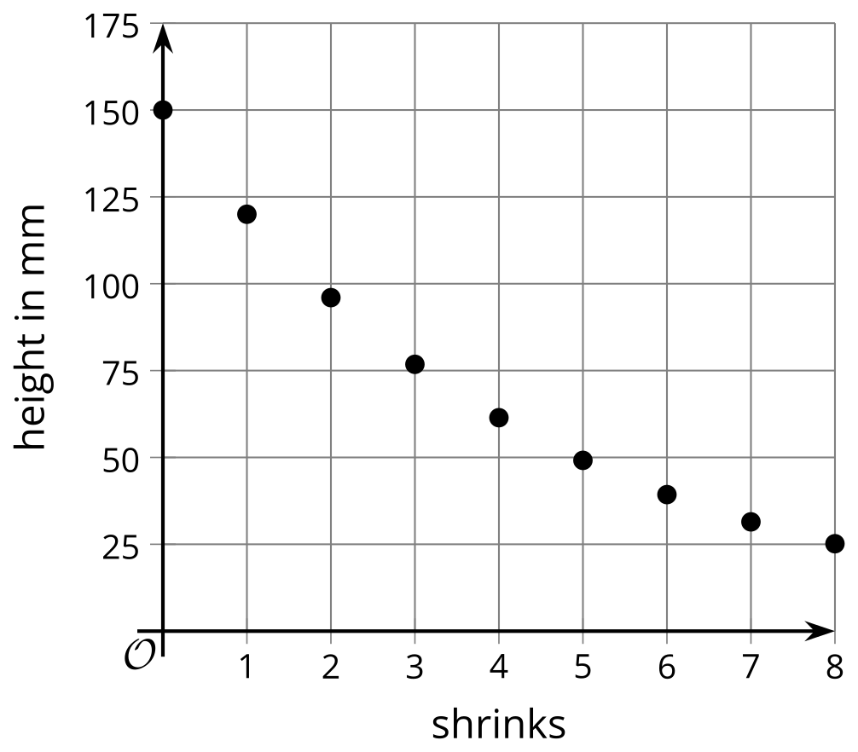

3 Pond in a Park

Student Task Statement
On May 12, a fast-growing species of algae is accidentally introduced to a pond in an urban park. The area of the pond that the algae covers doubles each day. If not controlled, the algae will cover the entire surface of the pond, depriving the fish in the pond of oxygen. At the rate it is growing, this will happen on May 24.
- On which day is the pond halfway covered?
- On May 18, Clare visits the park. A park caretaker mentions to her that the pond will be completely covered in less than a week. Clare thinks that the caretaker must be mistaken. Why might she find the caretaker’s claim hard to believe?
- What fraction of the area of the pond was covered by the algae initially, on May 12? Explain or show your reasoning.
© CC BY 2019 by Illustrative Mathematics®

