Lesson 1: Name the Parts
- Let’s name parts of a whole.

Warm-up: Which One Doesn’t Belong: Shapes with Parts
Which one doesn’t belong?
A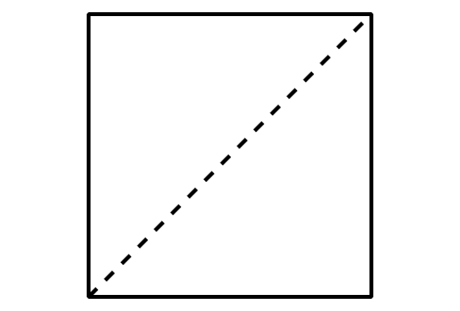
B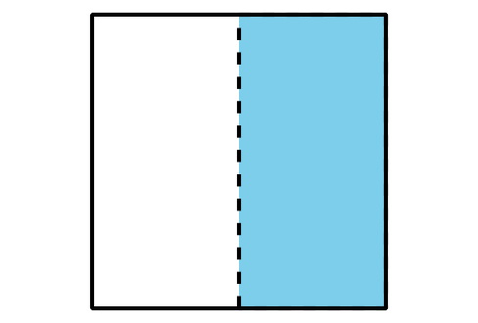
C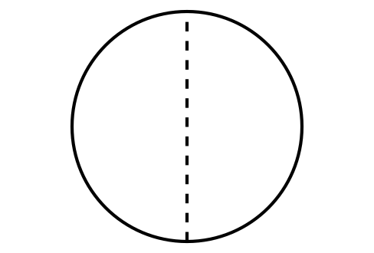
D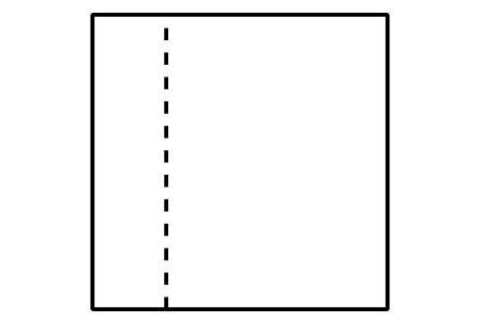

1.1: Card Sort: Partitions
Your teacher will give you a set of cards that show some shapes that are partitioned.
Sort the cards into 2 categories of your choosing. Be prepared to explain the meaning of your categories.
A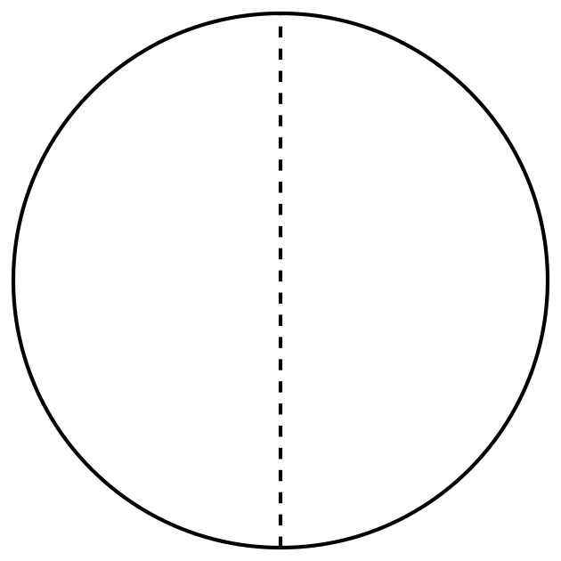
E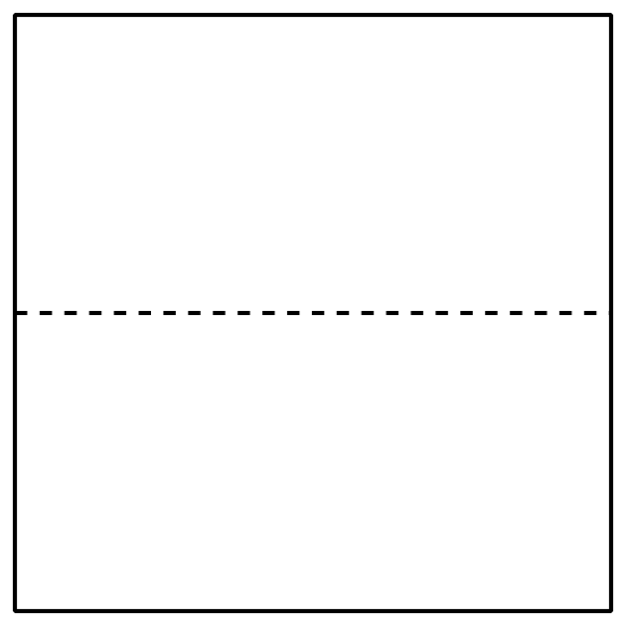
I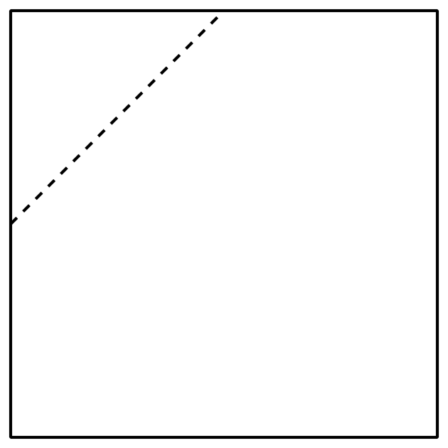
B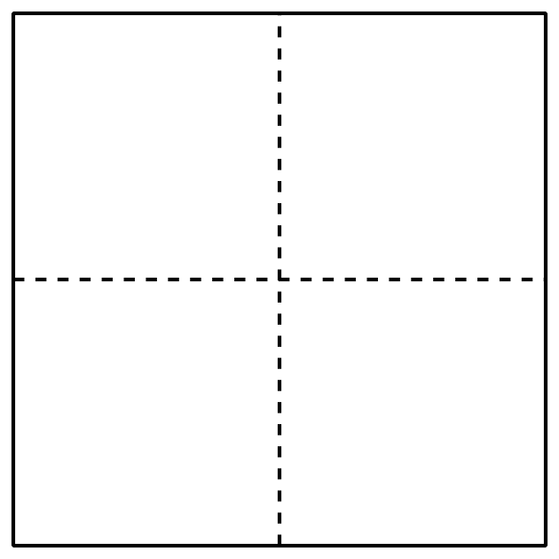
F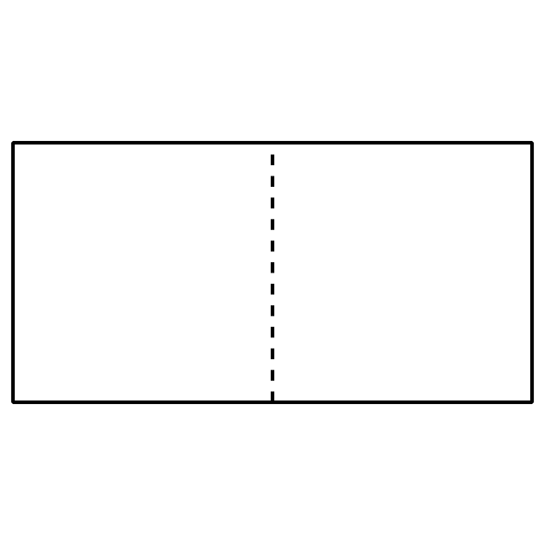
J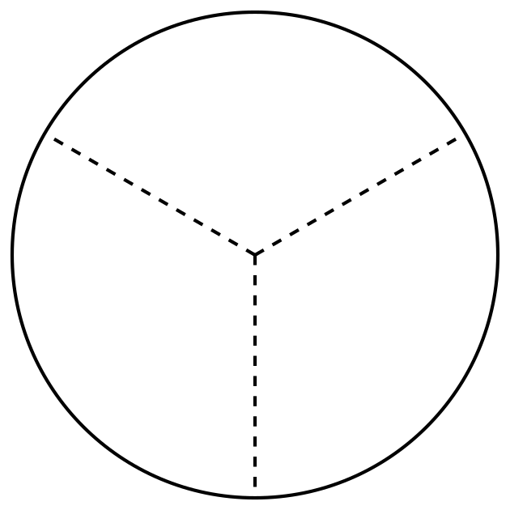
C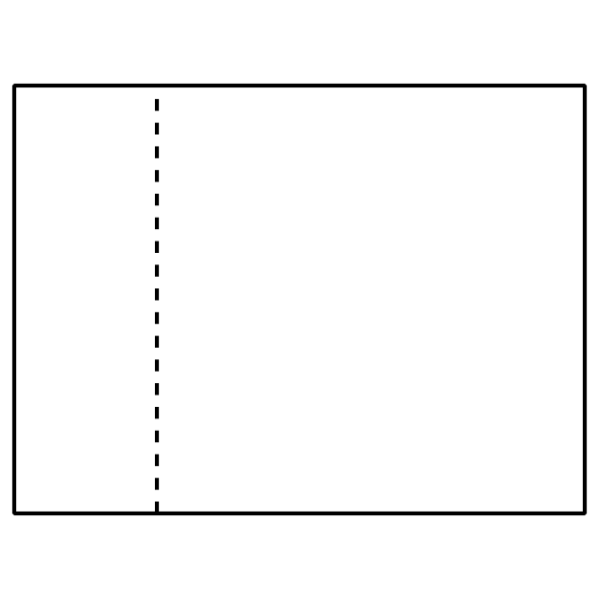
G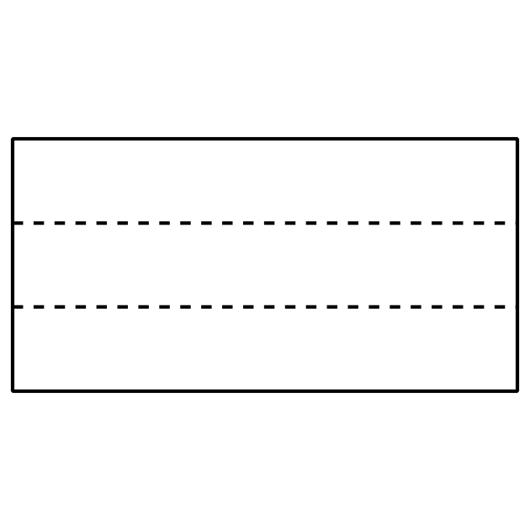
K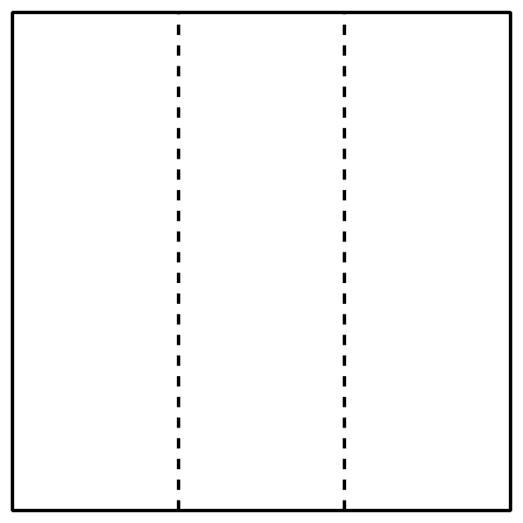
D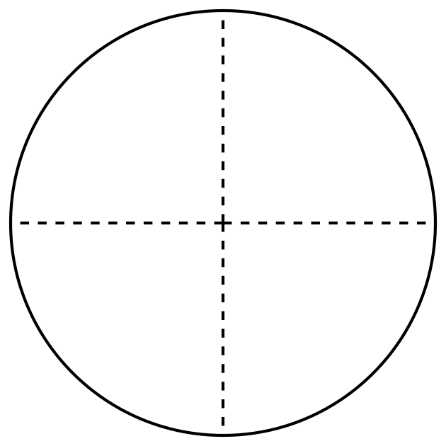
H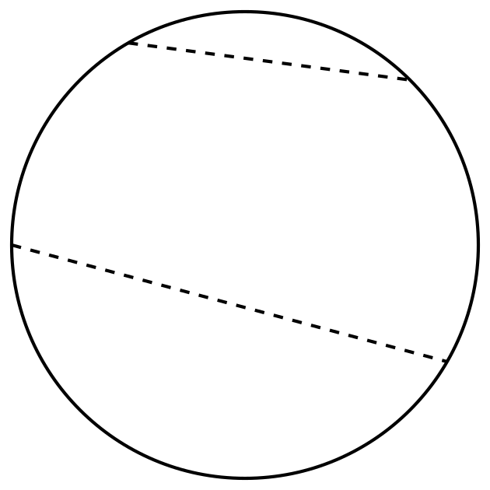
L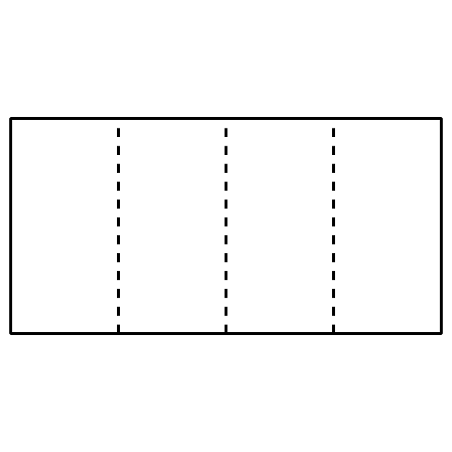

1.2: Fold and Name
Fold each rectangle your teacher gives you into 3, 6, 4, or 8 equal parts. Draw lines where you folded to partition the rectangles. Be prepared to share how you folded your shapes.
© CC BY 2021 Illustrative Mathematics®

