Grade 2
Unit 1Lesson 12CC BY NC 2024 Illustrative Mathematics®
Unit 1, Lesson 12

Center Day 2
- Let’s sort a collection and make graphs about it.
Grade 2
Unit 1Lesson 12CC BY NC 2024 Illustrative Mathematics®

Warm-upNumber Talk: Differences
Find the value of each expression mentally.
- $17−7$
- $17−9$
- $15−5$
- $15−8$
Grade 2
Unit 1Lesson 12CC BY NC 2024 Illustrative Mathematics®

Activity 2Centers: Choice Time
Choose a center.
What's Behind My Back?
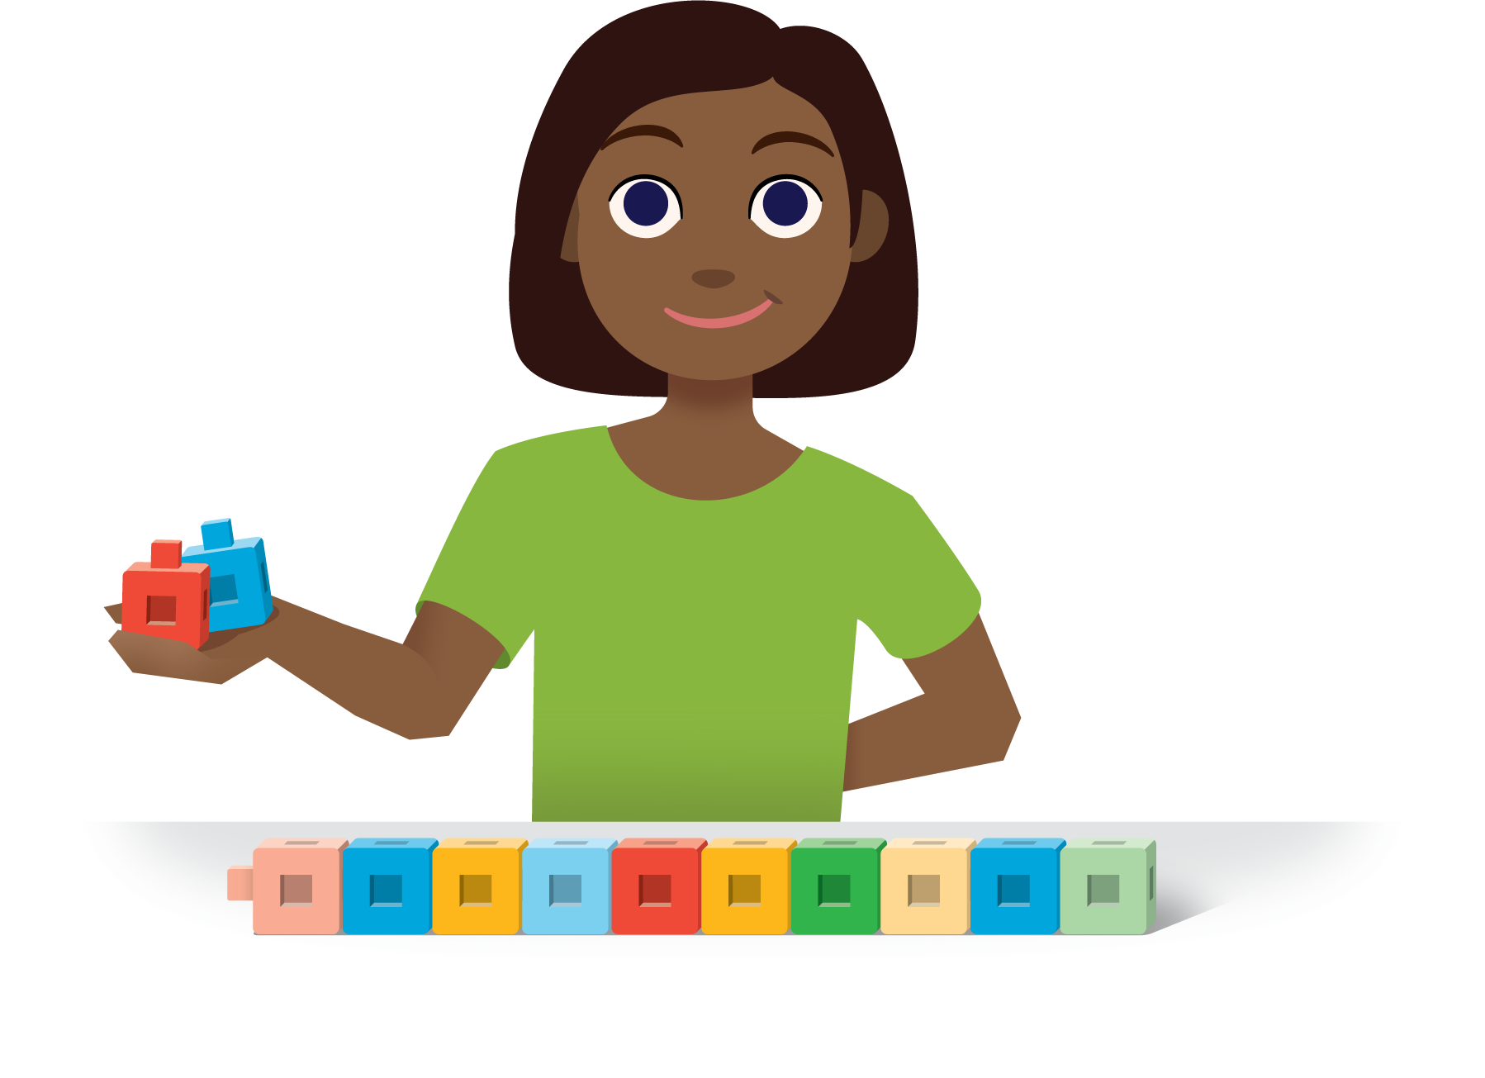
How Close?
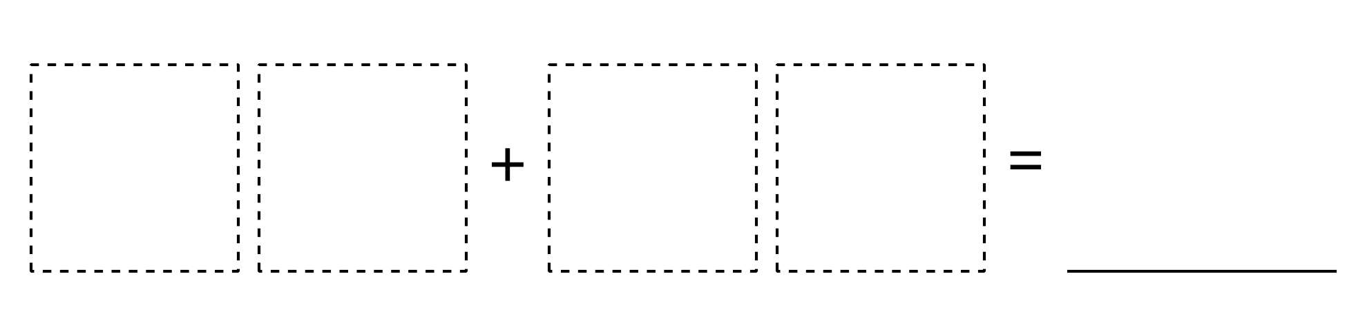
Number Puzzles
