Unit 5 Lesson 12: How Many Are Missing?

WU Which One Doesn’t Belong: 10-frames (Warm up)

Student Task Statement
Which one doesn’t belong?
A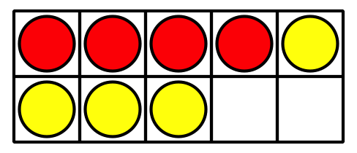
B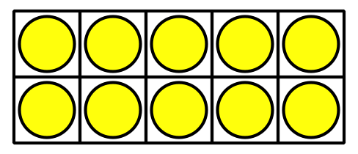
C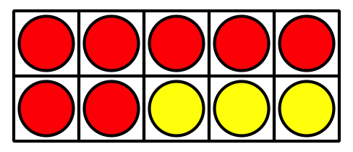
D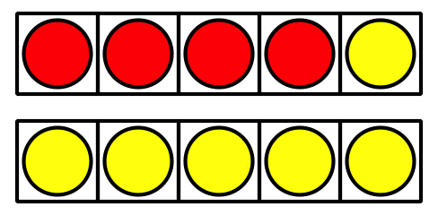

1 Shake, Spill, and Arrange with 10

Student Task Statement
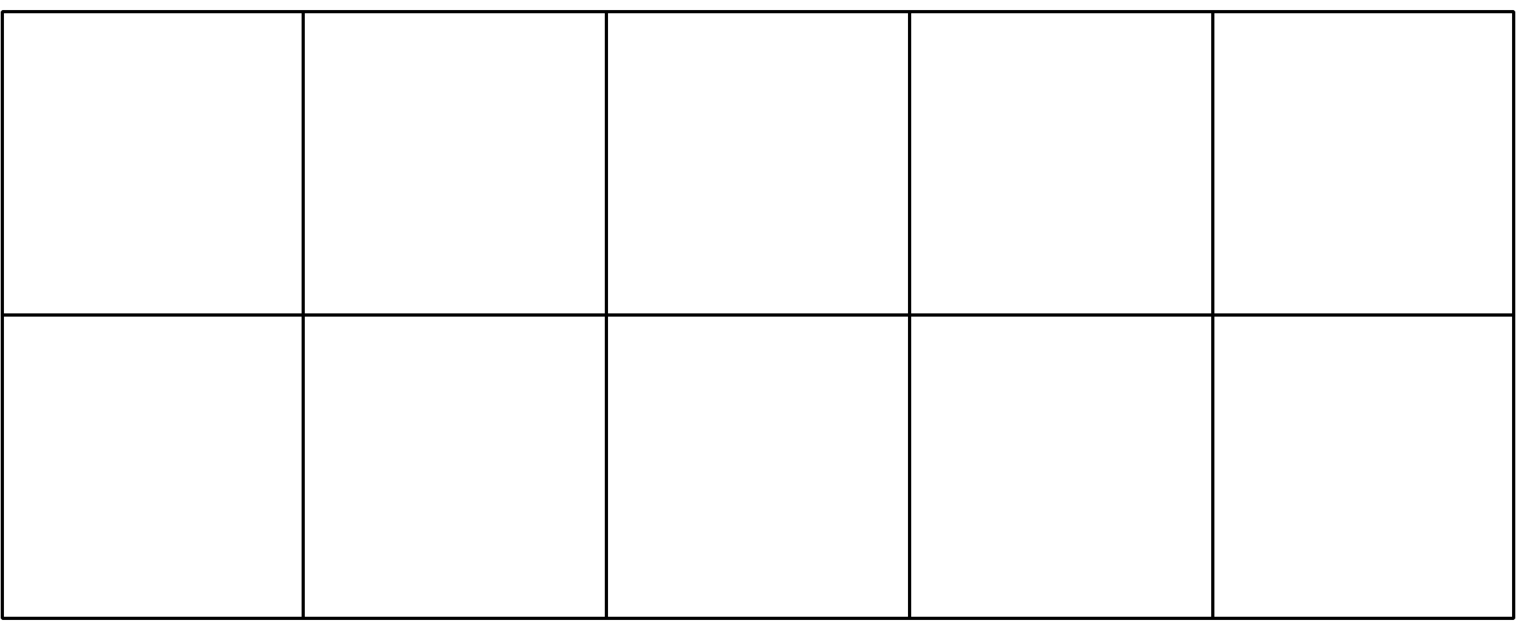
$10=5+5$
$10=9+1$
$10=4+6$
$10=2+8$
$10=6+4$
$10=3+7$
$10=1+9$
$10=8+2$
$10=5+5$

2 How Many to Fill the 10-frame?

Student Task Statement

- 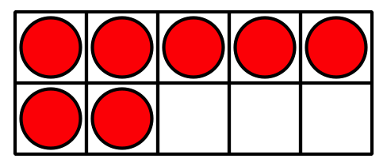
- _______________
- $10=7+3$
- $10=8+2$
- $10=5+5$

- 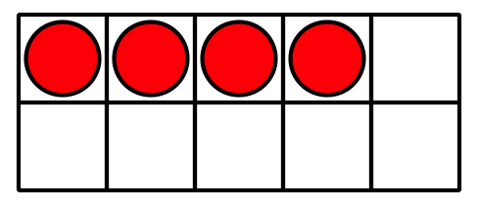
- _______________
- $10=8+2$
- $10=1+9$
- $10=4+6$

- 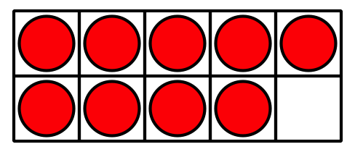
- _______________
- $10=9+1$
- $10=5+5$
- $10=7+3$

- 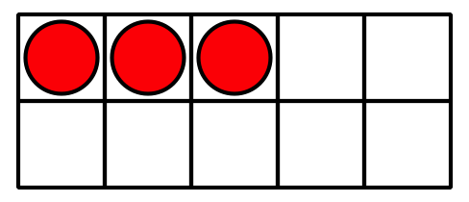
- _______________
- $10=5+5$
- $10=3+7$
- $10=2+8$

- 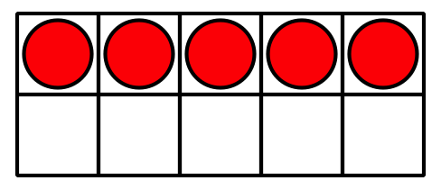
- _______________
- $10=9+1$
- $10=6+4$
- $10=5+5$

- 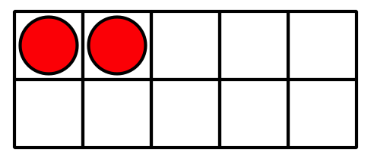
- _______________
- $10=1+9$
- $10=2+8$
- $10=4+6$

3 Centers: Choice Time

Student Task Statement
Choose a center.
Shake and Spill

Counting Collections
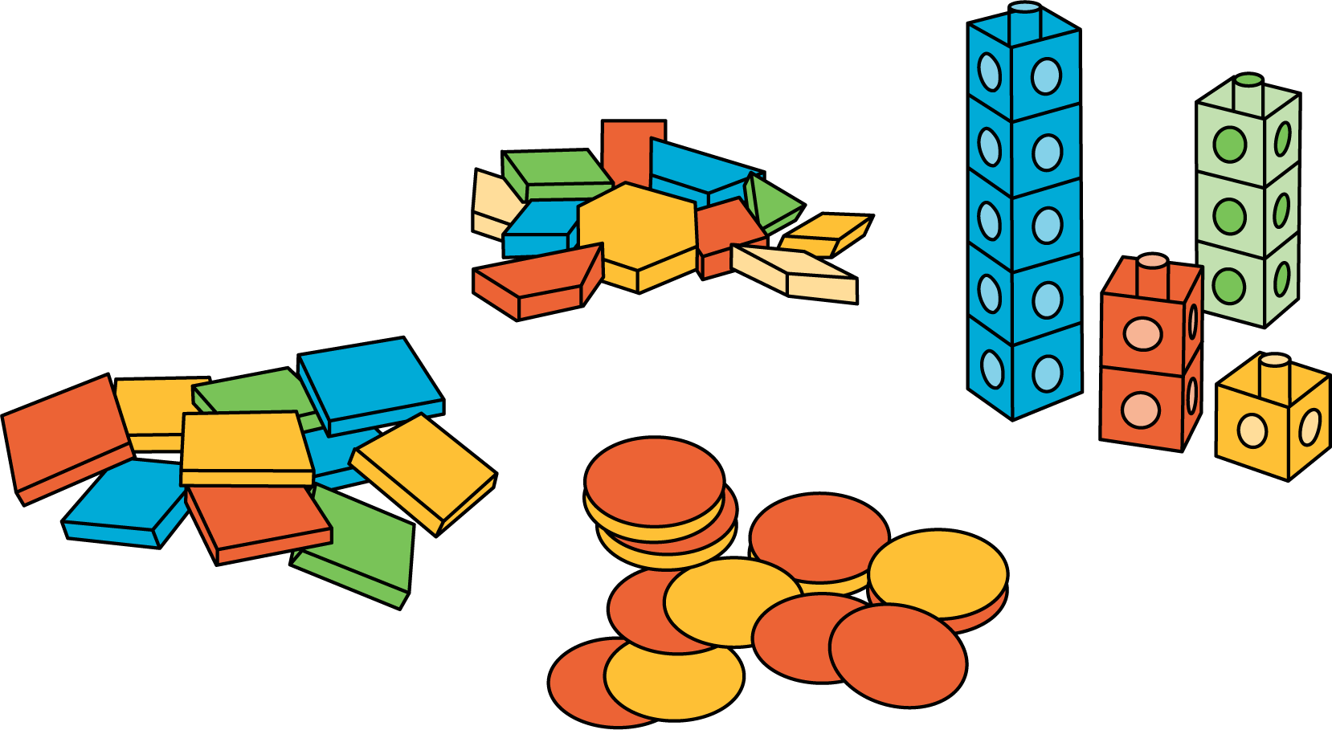
Roll and Add
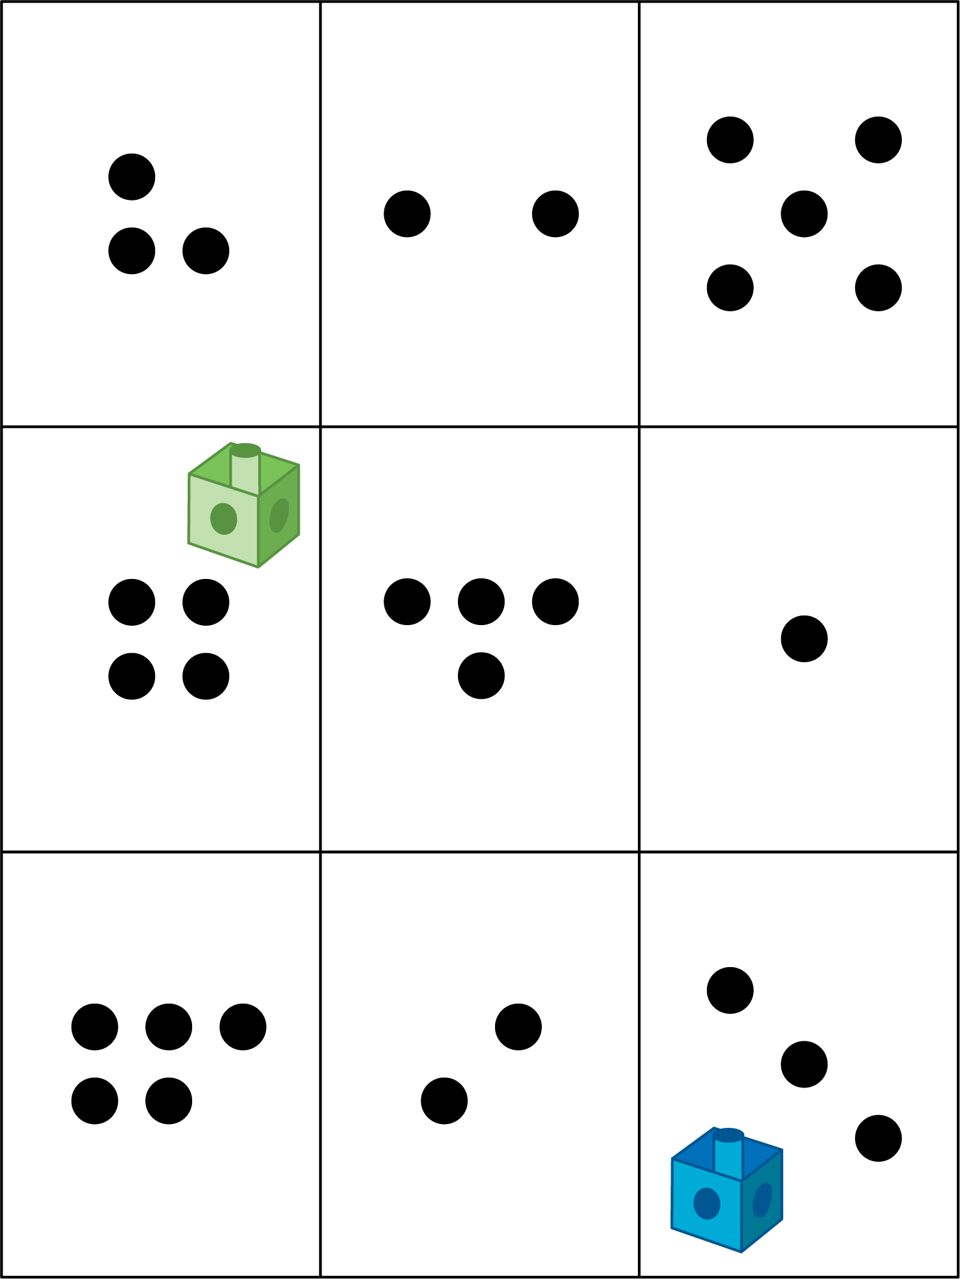

Images for Activity Synthesis
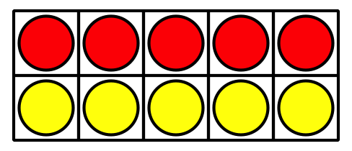
© CC BY 2021 Illustrative Mathematics®

