Grade 6
Unit 3Lesson 3CC BY NC Illustrative Mathematics, based on IM 6–8 Math, CC BY Open Up Resources.
Unit 3, Lesson 3

Converting Units
Let’s convert measurements to different units.
Grade 6
Unit 3Lesson 3CC BY NC Illustrative Mathematics, based on IM 6–8 Math, CC BY Open Up Resources.

3.1Math Talk: Fractions of a Number
Find the values mentally.
- $\frac{1}{4}$ of 32
- $\frac{3}{4}$ of 32
- $\frac{3}{8}$ of 32
- $\frac{3}{8}$ of 64
Grade 6
Unit 3Lesson 3CC BY NC Illustrative Mathematics, based on IM 6–8 Math, CC BY Open Up Resources.

3.2Road Sign
- A distance of 8 kilometers is approximately 5 miles.
  - How many kilometers are in 1 mile?
  - How many miles are in 1 kilometer?
- The speed limit on a Canadian highway is 80 kilometers per hour. An American driver was driving 75 miles per hour.
- Was the American driving too fast? If so, by how much? Explain or show your reasoning.
- 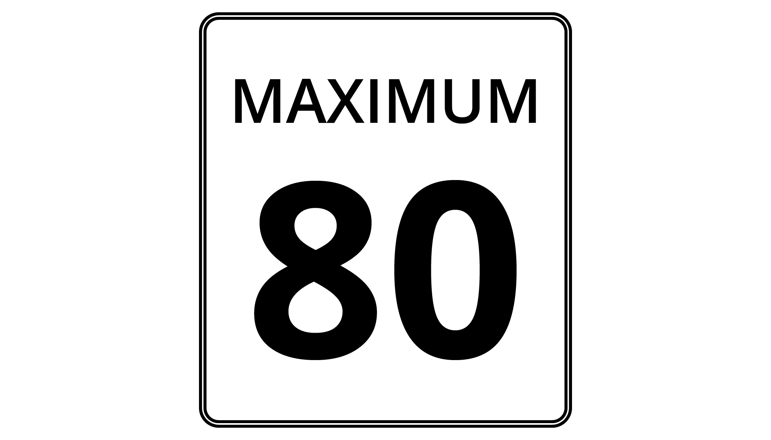
Grade 6
Unit 3Lesson 3CC BY NC Illustrative Mathematics, based on IM 6–8 Math, CC BY Open Up Resources.

3.3Veterinary Weights
A veterinarian uses weights in kilograms to figure out what dosages of medicines to prescribe for animals. For every 10 kilograms, there are 22 pounds.
- Calculate each animal’s weight in kilograms. Explain or show your reasoning. If you get stuck, consider drawing a double number line diagram or table.
  - Fido the Labrador weighs 88 pounds.
  - Spot the Beagle weighs 33 pounds.
  - Bella the Chihuahua weighs $5\frac{1}{2}$ pounds.
- 
- A certain medication says it can be given only to animals over 8 kilograms. How much is this in pounds?

Are you ready for more?
Have you ever seen videos of astronauts on the Moon jumping really high? An object on the Moon weighs less than it does on Earth because the Moon has much less mass than Earth does.
- A person who weighs 100 pounds on Earth weighs 16.5 pounds on the Moon. If a boy weighs 60 pounds on Earth, how much does he weigh on the Moon?
- Every 100 pounds on Earth are the equivalent to 38 pounds on Mars. If the same boy travels to Mars, how much would he weigh there?
Grade 6
Unit 3Lesson 3CC BY NC Illustrative Mathematics, based on IM 6–8 Math, CC BY Open Up Resources.

3.4Cooking with a Tablespoon
Diego is trying to follow a recipe, but he cannot find any measuring cups! He has only a tablespoon. In the cookbook, it says that 1 cup equals 16 tablespoons.
- How could Diego use the tablespoon to measure out these ingredients?
  - $\frac{1}{2}$ cup of almonds
  - $1\frac{1}{4}$ cups of oatmeal
  - $2\frac{3}{4}$ cups of flour
- Diego also adds the following ingredients. How many cups of each did he use?
  - 28 tablespoons of sugar
  - 6 tablespoons of cocoa powder

Lesson 3 Summary
When we measure something in two different units, the measurements form an equivalent ratio. We can reason with these equivalent ratios to convert measurements from one unit to another.
Suppose you cut off 20 inches of hair. Your Canadian friend asks how many centimeters of hair that was. Since 100 inches equal 254 centimeters, we can use equivalent ratios to find out how many centimeters equal 20 inches.
Using a double number line:
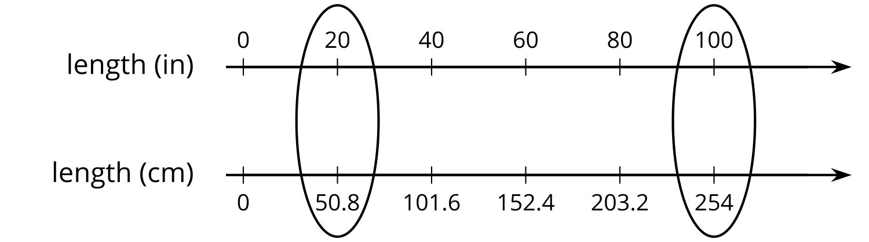
Using a table:
length (in) | length (cm)
100 | 254
1 | 2.54
20 | 50.8
One quick way to solve the problem is to start by finding out how many centimeters are in 1 inch. We can then multiply 2.54 and 20 to find that 20 inches equal 50.8 centimeters.

