Grade 2
Unit 8Lesson 3CC BY NC 2024 Illustrative Mathematics®
Unit 8, Lesson 3

Is It Odd or Even?
- Let’s explain why the number of objects in a group is even or odd.
Grade 2
Unit 8Lesson 3CC BY NC 2024 Illustrative Mathematics®

Activity 1 Color by Number
Han wants to color a design with the same number of yellow and blue shapes.
A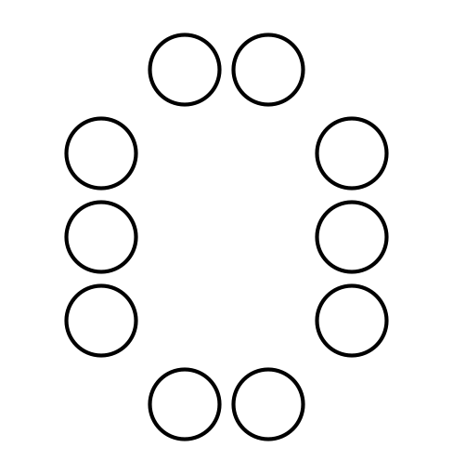
B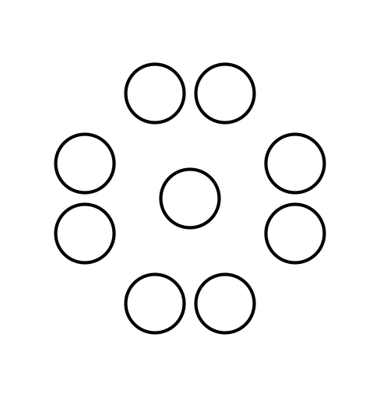
C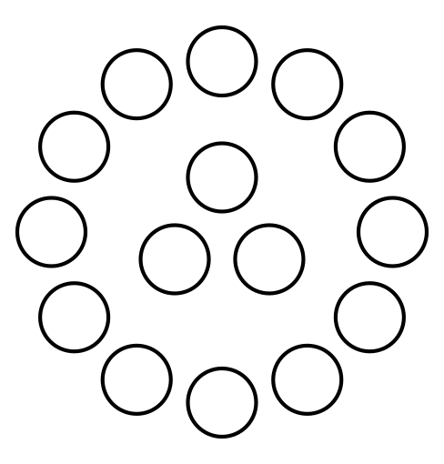
D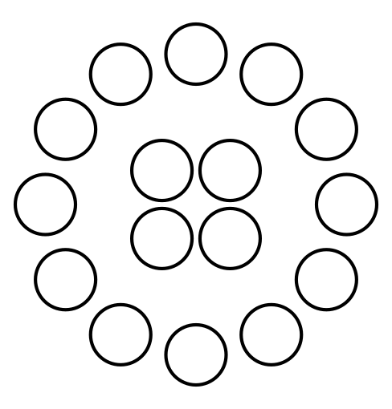
- Which designs can Han use? Show your thinking using objects, drawings, numbers, or words.
- Draw a circle design that would work for Han. Then draw a circle design that would not work for Han.
If you have time:
Priya draws a design with 6 circles, 3 triangles, and 3 squares. Can Han color it the way he wants? Show your thinking using objects, drawings, numbers, or words.
Grade 2
Unit 8Lesson 3CC BY NC 2024 Illustrative Mathematics®

Activity 2Card Sort: Even or Odd
Your teacher will give you a set of cards.
- Take turns sorting your cards into 2 groups. Make 1 group that shows even numbers and 1 group that shows odd numbers.
- Explain your thinking to your partner.
- Now sort the cards into groups that show the same number. How do the cards in each group show whether the number is even or odd?
- Explain your thinking to your partner.

