Grade 2
Unit 7Lesson 19CC BY NC 2024 Illustrative Mathematics®
Unit 7, Lesson 19

Book Drive
- Let’s organize information about a book drive.
Grade 2
Unit 7Lesson 19CC BY NC 2024 Illustrative Mathematics®

Warm-upNotice and Wonder: Book Drive Notes
What do you notice? What do you wonder?
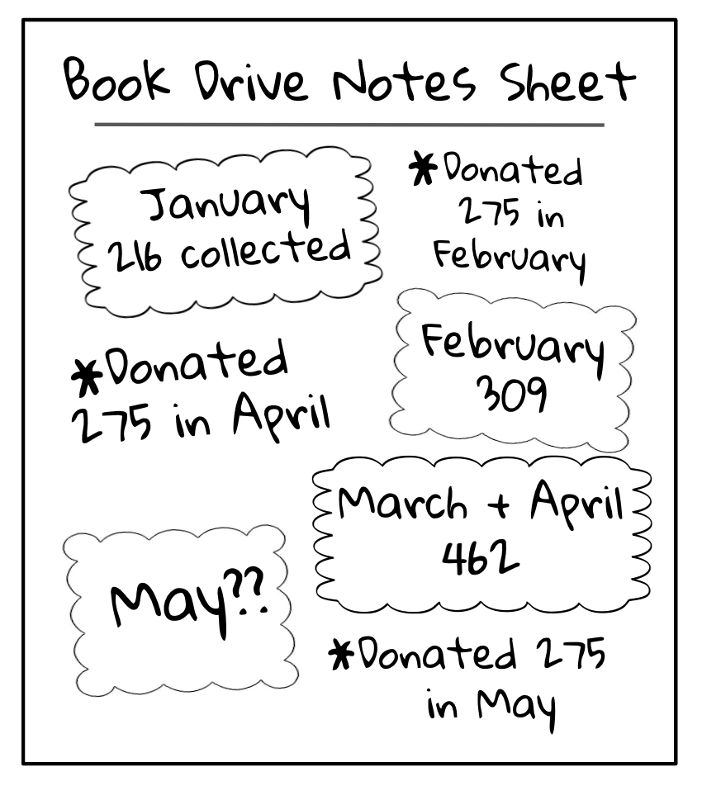
Grade 2
Unit 7Lesson 19CC BY NC 2024 Illustrative Mathematics®

Activity 1Organizing the Notes
Organize the information for the book drive.
Grade 2
Unit 7Lesson 19CC BY NC 2024 Illustrative Mathematics®

Activity 2Questions about the Book Drive
Solve the problems. Show your thinking, using drawings, numbers, or words.
- The school donated books to 3 different places. The school donated 275 books to each place. How many books did the school donate in all?
- What information do you need to find the number of books the school has left over at the end of the book drive?
- Choose a number of books that you think is reasonable for the school to have collected in May. How many books would the school have left when the book drive is done? Explain your reasoning.
- What could the school do with the leftover books?

