Algebra 1
Unit 5Lesson 8CC BY NC 2024 Illustrative Mathematics®
Unit 5, Lesson 8

Interpreting and Creating Graphs
- Let’s sketch graphs to represent situations.
Algebra 1
Unit 5Lesson 8CC BY NC 2024 Illustrative Mathematics®

8.1Which Three Go Together: Temperature over Time
Which three go together? Why do they go together?

A
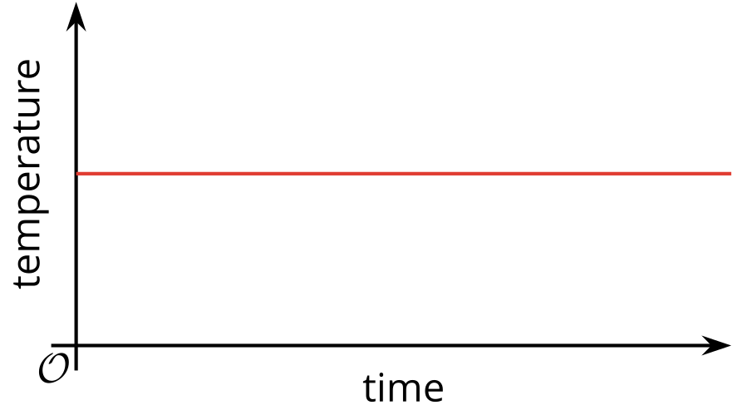

B
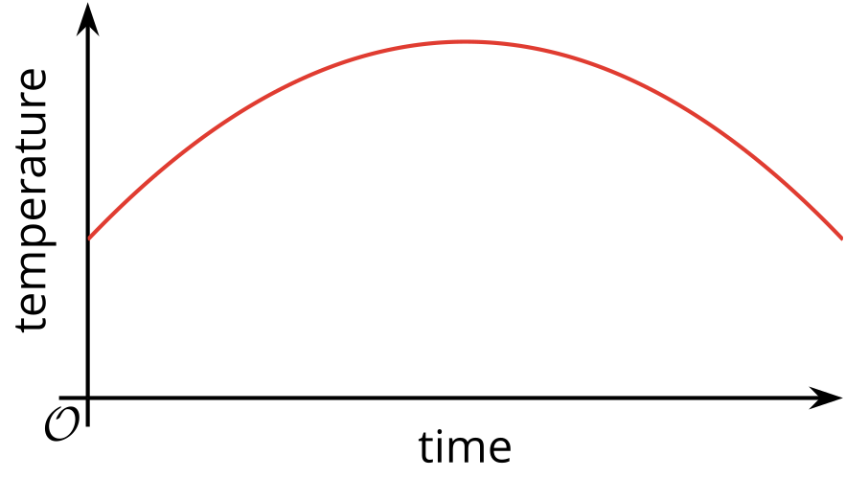

C
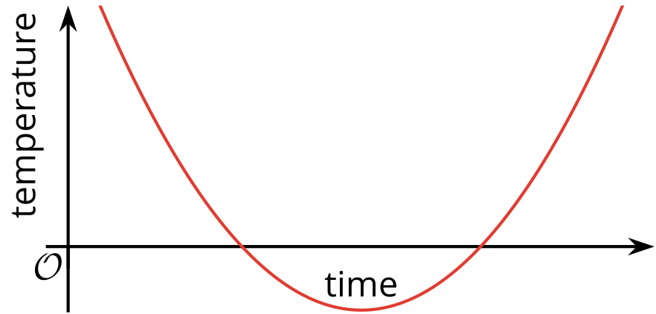

D
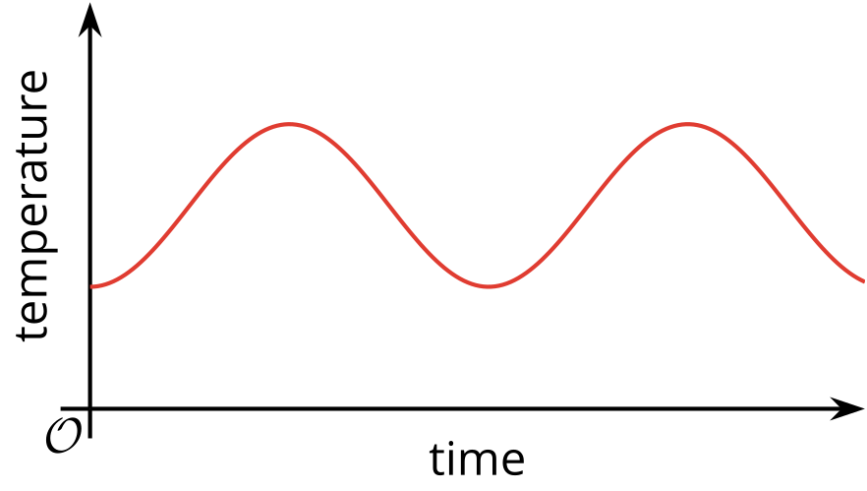

Algebra 1
Unit 5Lesson 8CC BY NC 2024 Illustrative Mathematics®

8.2Flag Raising (Part 1)
A flag ceremony is held at a Fourth of July event. The height of the flag is a function of time.
Here are some graphs that could each be a possible representation of the function.


A
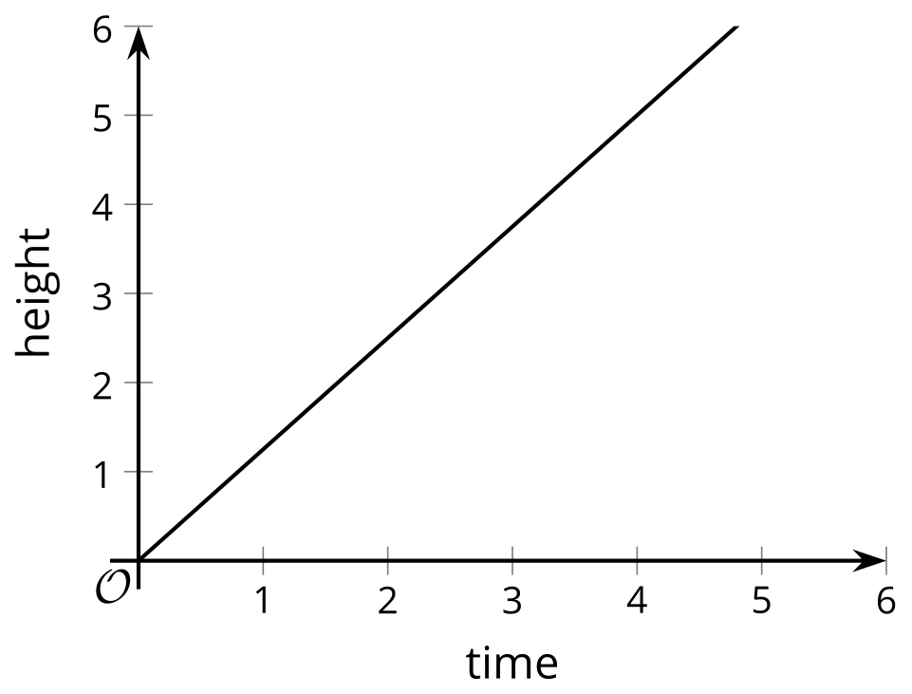

B
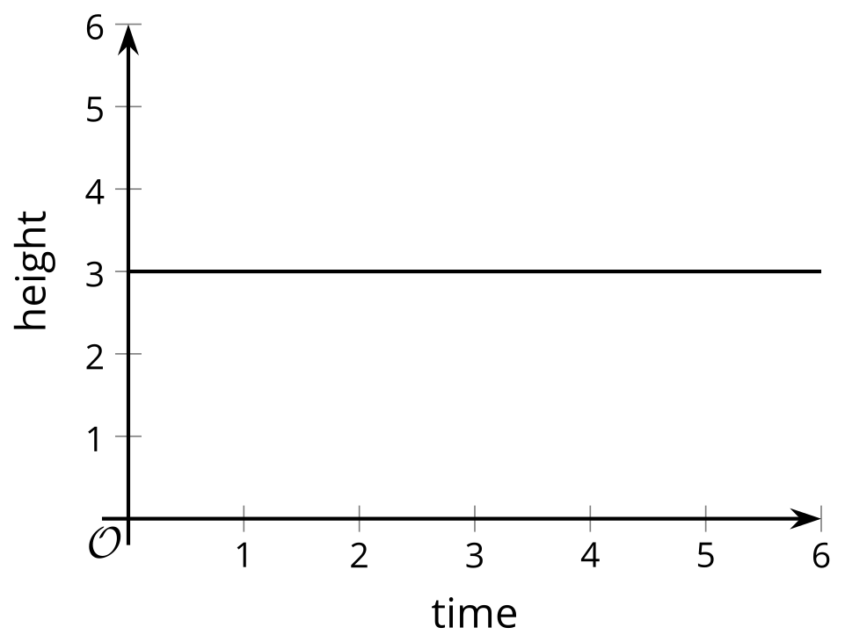

C
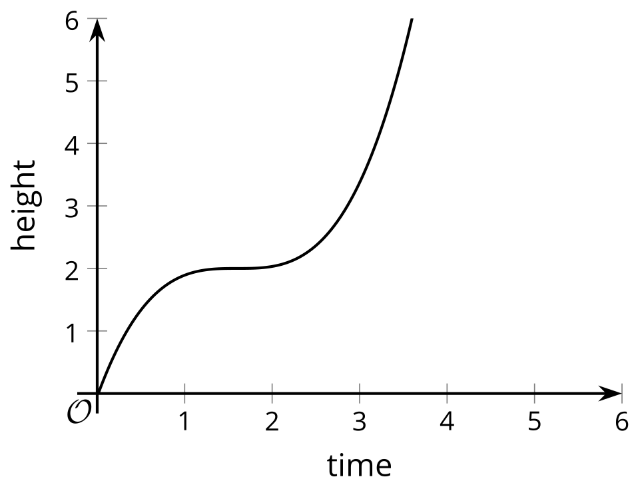

D
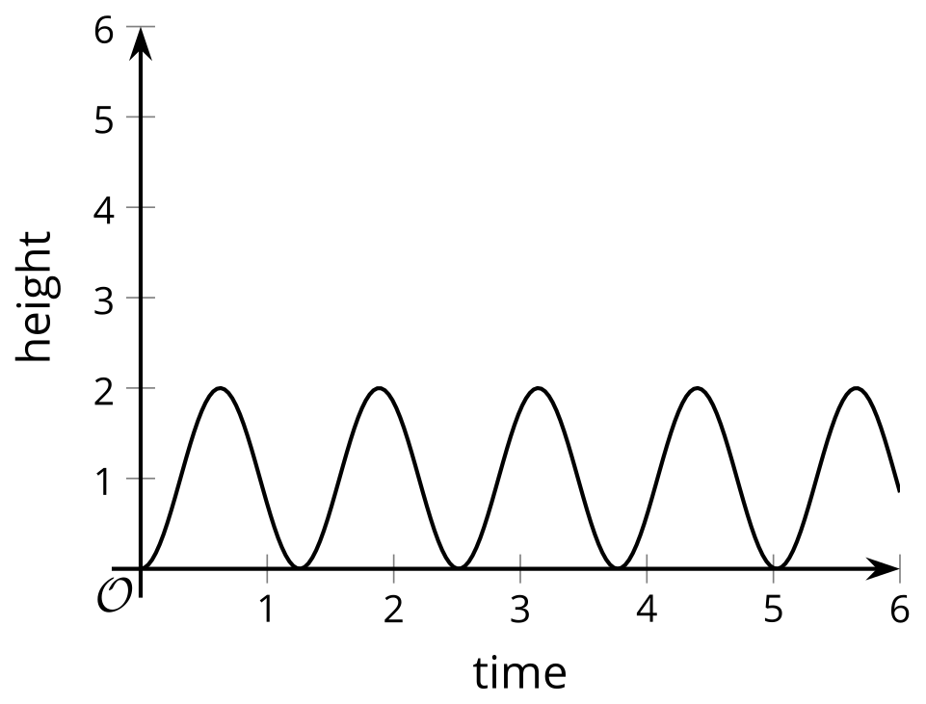

E
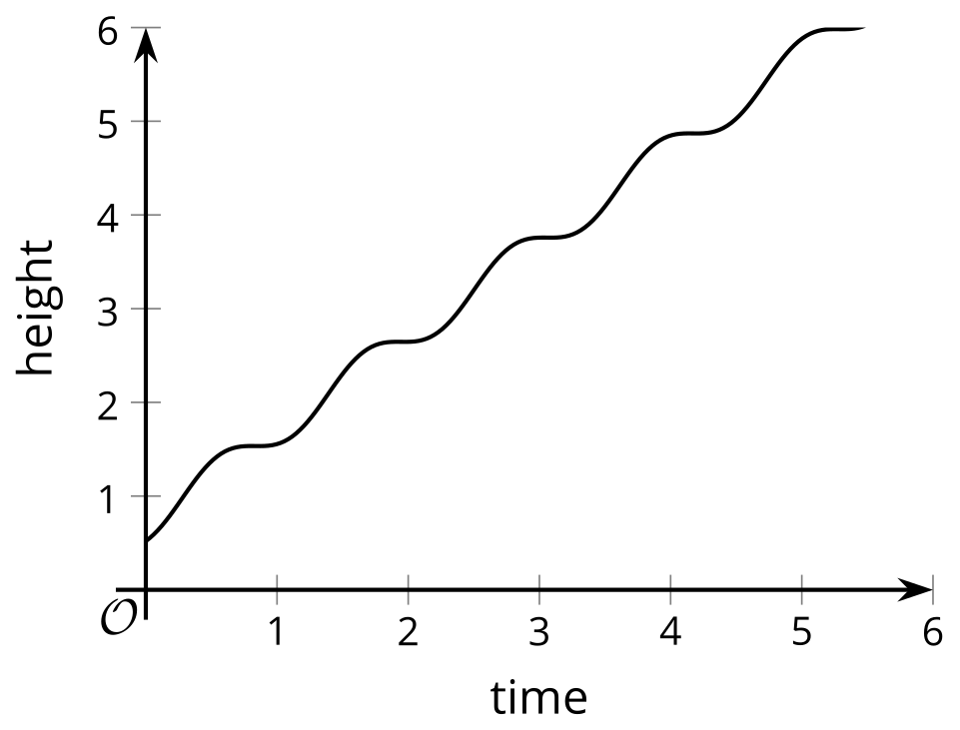

F
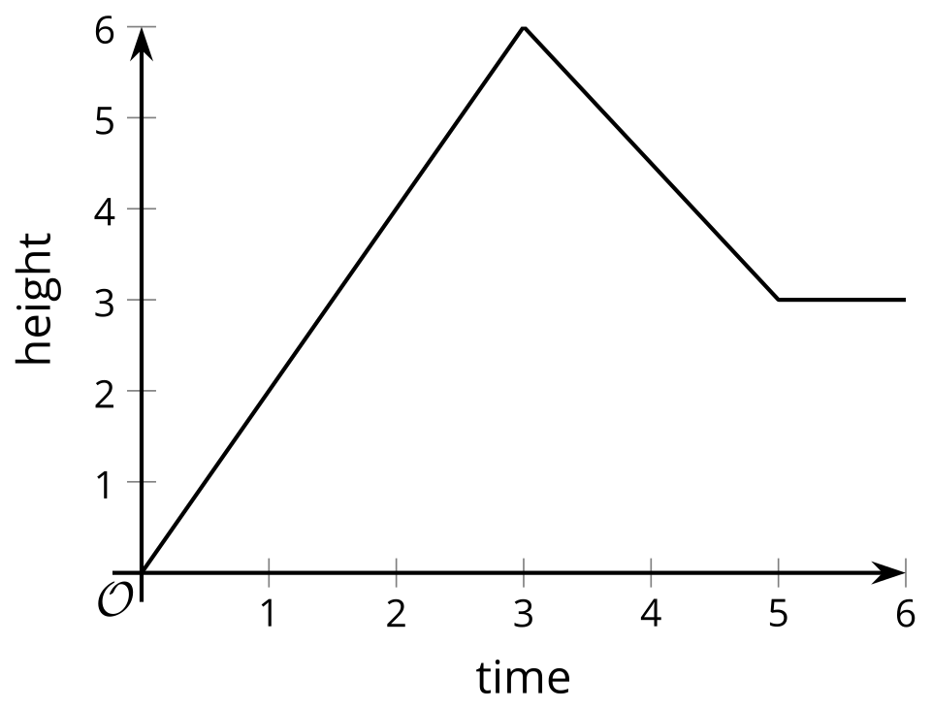

  - For each graph assigned to you, explain what it tells us about the flag.
  - Graph: $\underset{_}{}$
  - Decide as a group which graph(s) appear to be most realistic and which ones least realistic.
- Here is another graph that relates time and height.
- 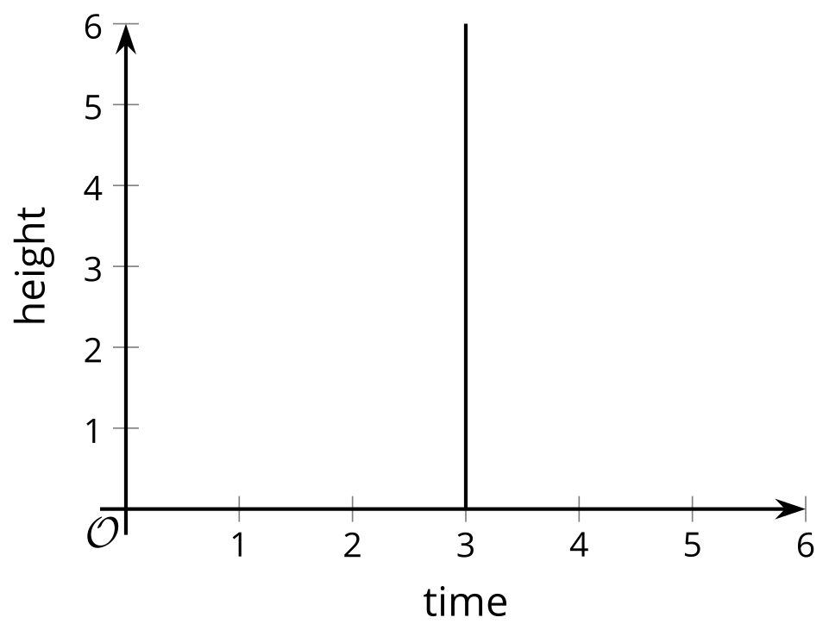
  - Can this graph represent the time and height of the flag? Explain your reasoning.
  - Is this a graph of a function? Explain your reasoning.

Are you ready for more?
Suppose an ant is moving at a rate of 1 millimeter per second and keeps going at that rate for a long time.
If time, $x$, is measured in seconds, then the distance, in millimeters, that the ant has traveled, $y$, is $y=1x$. If time, $x$, is measured in minutes, the distance in millimeters is $y=60x$.
- Explain why the equation $y=\left(365⋅24⋅3,​600\right)x$ gives the distance, in millimeters, that the ant has traveled as a function of time, $x$, in years.
- Use graphing technology to graph the equation.
  - Label the axes with appropriate quantities and units.
  - Does the graph look like that of a function? Why do you think it looks this way?
- Adjust the graphing window until the graph no longer looks this way. If you manage to do so, describe the graphing window that you use.
- Do you think the last graph in the flag activity could represent a function relating time and height of the flag? Explain your reasoning.
Algebra 1
Unit 5Lesson 8CC BY NC 2024 Illustrative Mathematics®

8.3Flag Raising (Part 2)
Your teacher will show a video of a flag being raised. Function $H$ gives the height of the flag over time. Height is measured in feet. Time is measured in seconds since the flag is fully secured to the string, which is when the video clip begins.
- On the coordinate plane, sketch a graph that could represent function $H$. Be sure to include a label and a scale for each axis.
- 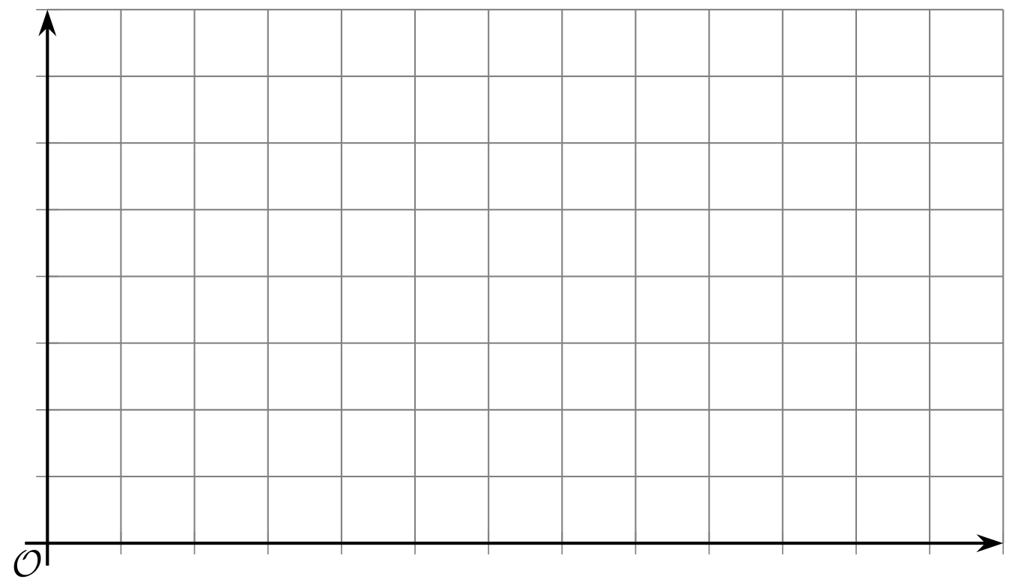
- Use your graph to estimate the average rate of change from the time the flag starts moving to the time it reaches the top. Be prepared to explain what the average rate of change tells us about the flag.
Algebra 1
Unit 5Lesson 8CC BY NC 2024 Illustrative Mathematics®

8.4Two Pools
To prepare for a backyard party, a parent uses two identical hoses to fill a small pool that is 15 inches deep and a large pool that is 27 inches deep.
The height of the water in each pool is a function of time since the water is turned on.

Here are descriptions of three situations. For each situation, sketch the graphs of the two functions on the same coordinate plane so that $S\left(t\right)$ is the height of the water in the small pool after $t$ minutes and $L\left(t\right)$ is the height of the water in the large pool after $t$ minutes.
In both functions, the height of the water is measured in inches.
- Situation 1: Each hose fills one pool at a constant rate. When the small pool is full, the water for that hose is shut off. The other hose keeps filling the larger pool until it is full.
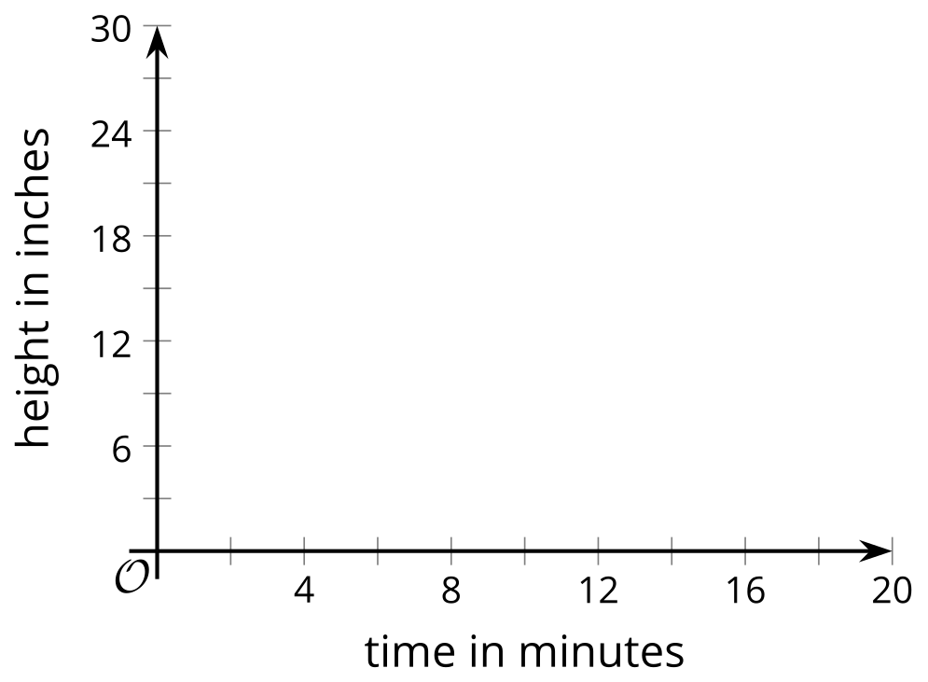
- Situation 2: Each hose fills one pool at a constant rate. When the small pool is full, both hoses are shut off.
- Situation 3: Each hose fills one pool at a constant rate. When the small pool is full, both hoses are used to fill the large pool until it is full.

Algebra 1
Unit 5Lesson 8CC BY NC 2024 Illustrative Mathematics®

8.5The Bouncing Ball
Your teacher will show you one or more videos of a tennis ball being dropped from 6 feet off the ground. Here are some still images of the situation.
The height of the ball is a function of time. Suppose the height is $h$ feet, $t$ seconds after the ball is dropped.
- Use the blank coordinate plane to sketch a graph of the height of the tennis ball as a function of time.
- To help you get started, here are some pictures and a table. Complete the table with your estimates before sketching your graph.

- 0 seconds
- 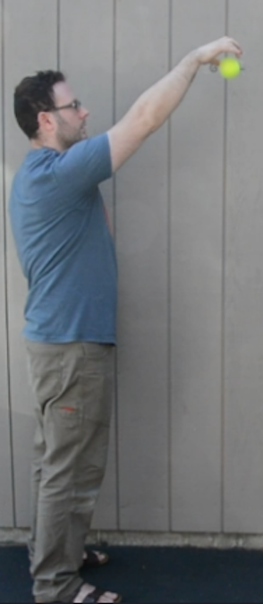

- 0.28 seconds
- 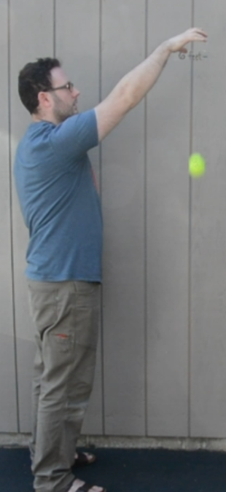

- 0.54 seconds
- 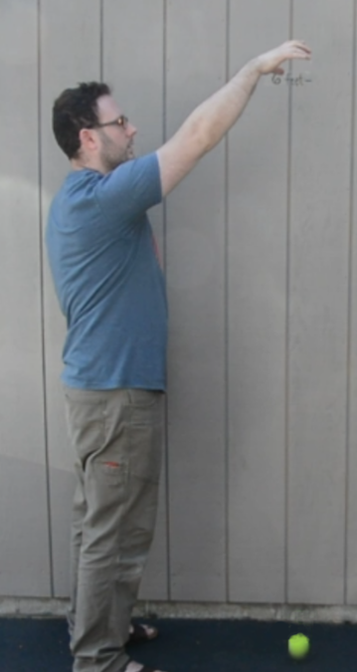

- 0.74 seconds
- 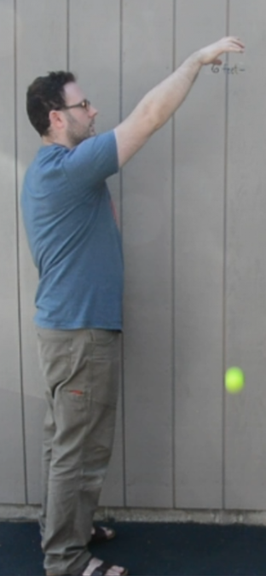

- 1.03 seconds
- 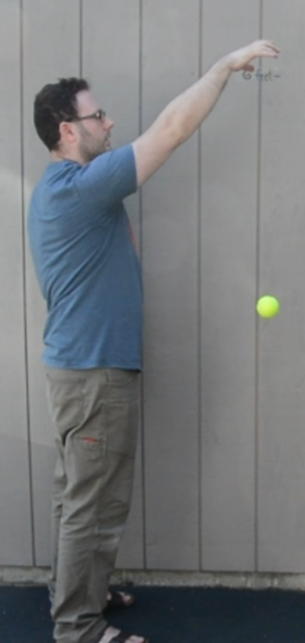

- 1.48 seconds
- 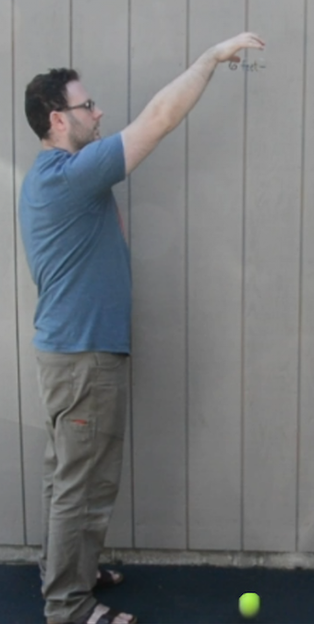

- 1.88 seconds
- 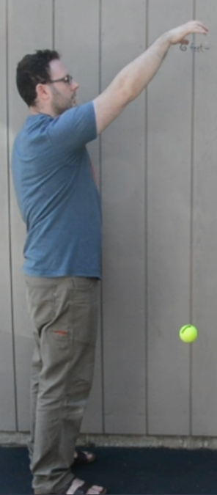

- 2.25 seconds
- 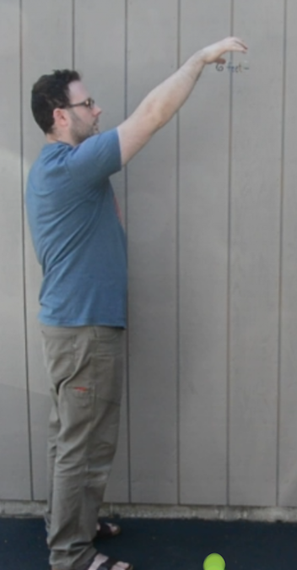
- time  (seconds) | - height  (feet)
- 0
- 0.28
- 0.54
- 0.74
- 1.03
- 1.48
- 1.88
- 2.25
- 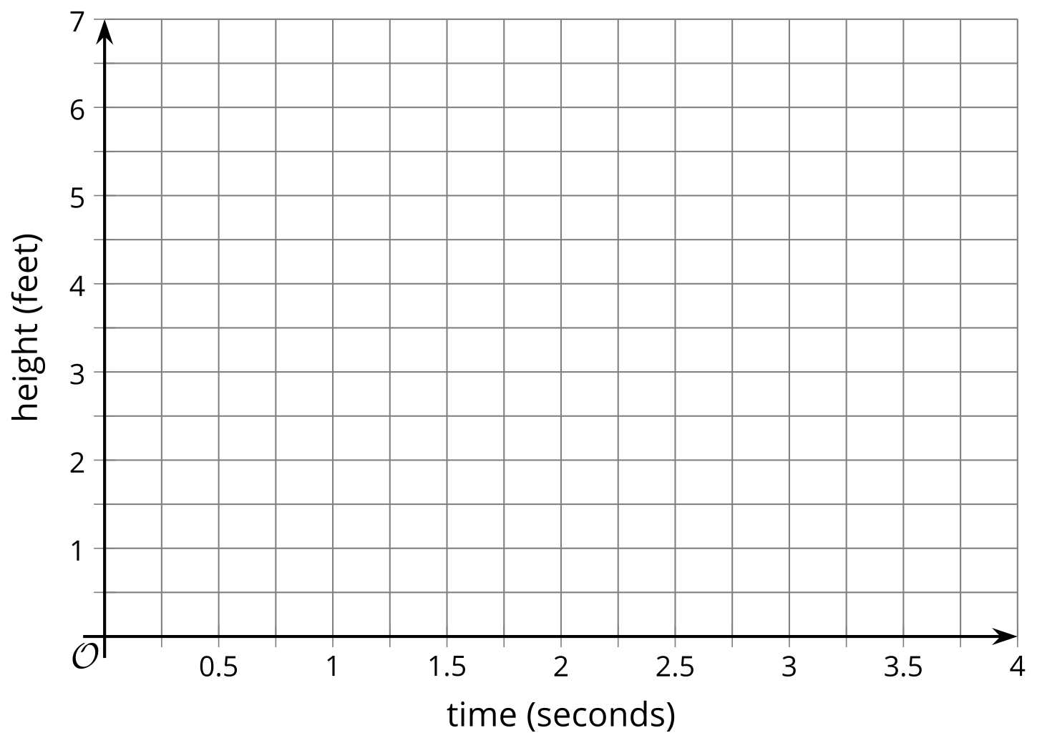
- Identify horizontal and vertical intercepts of the graph. Explain what the coordinates tell us about the tennis ball.
- Find the maximum and minimum values of the function. Explain what they tell us about the tennis ball.

Are you ready for more?
If you see only the still images of the ball and not the video of the ball bouncing, can you accurately graph the height of the ball as a function of time? Explain your reasoning.

Lesson 8 Summary
We can use graphs to help visualize the relationship between quantities in a situation, even if we have only a general description.
Here is a description of a hiker’s journey on a trail:
A hiker walked briskly and steadily for about 30 minutes and then took a 10-minute break. Afterward, she jogged all the way to the end of the trail, which took about 20 minutes. There, she took a 15-minute break, and then started walking back leisurely, stopping twice to enjoy the scenery. Her return trip along the same trail took 105 minutes.
We can sketch a graph of the distance the hiker has traveled as a function of time based on this description.
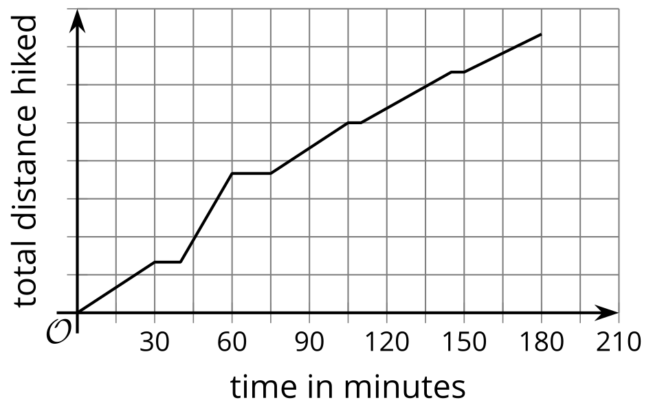
Even though we don’t know the specific distances she has traveled or the length of the trail, we can show some important features of the situation in the graph. For example:
- The intervals in which the distance increased or stayed constant
- How quickly the distance was increasing
- The amount of time the hiker was hiking
If we are looking at distance from the trailhead (the start of the trail) as a function of time, the graph of the function might look something like this:
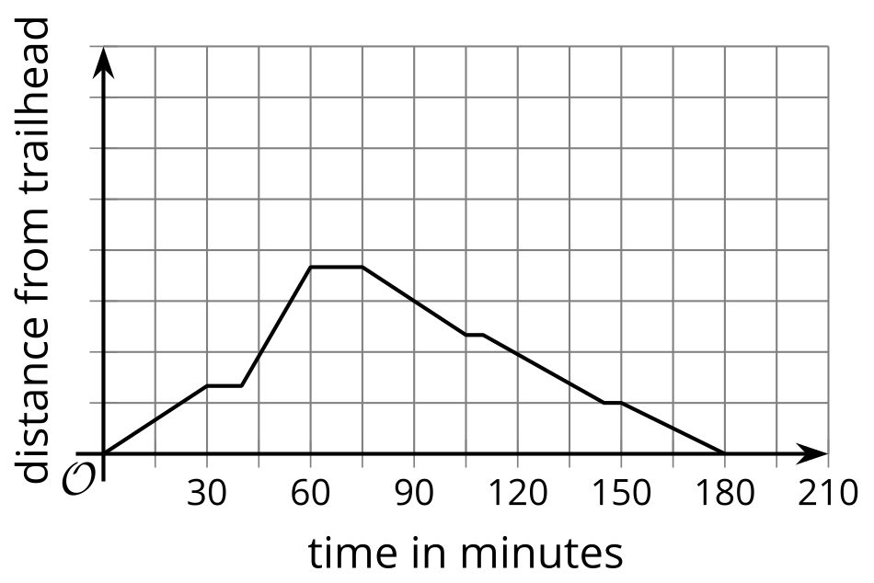
It shows the distance increasing as the hiker was walking away from the trailhead, then decreasing as she was returning to the trailhead.

