Lesson 10: Angles, Arcs, and Radii
- Let’s analyze relationships between arc lengths, radii, and central angles.

10.1: Comparing Progress
Han and Tyler are each completing the same set of tasks on an online homework site. Han is using his smartphone and Tyler is using his tablet computer. Their progress is indicated by the circular bars shown in the image. The shaded arc represents the tasks that have been completed. When the full circumference of the circle is shaded, they will be finished with all the tasks.

Han's progress
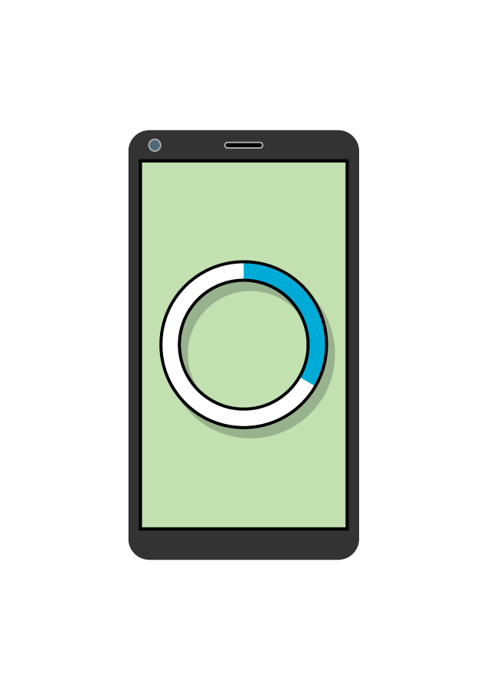

Tyler's progress
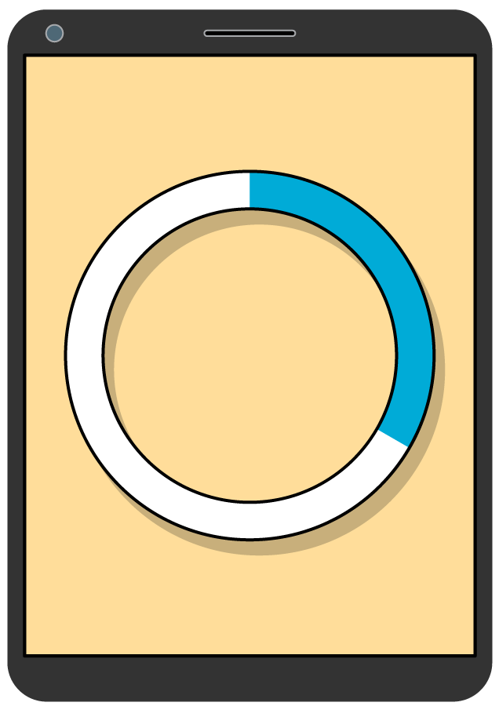
Tyler says, “The arc length on my progress bar measures 4.75 centimeters. The arc length on Han’s progress bar measures 2.25 centimeters. So, I’ve completed more tasks than Han has.”
- Do you agree with Tyler? Why or why not?
- What information would you need to make a completely accurate comparison between the two students’ progress?

10.2: A Dilated Circle
The image shows 2 circles. The second circle is a dilation of the first circle using a scale factor of 3.
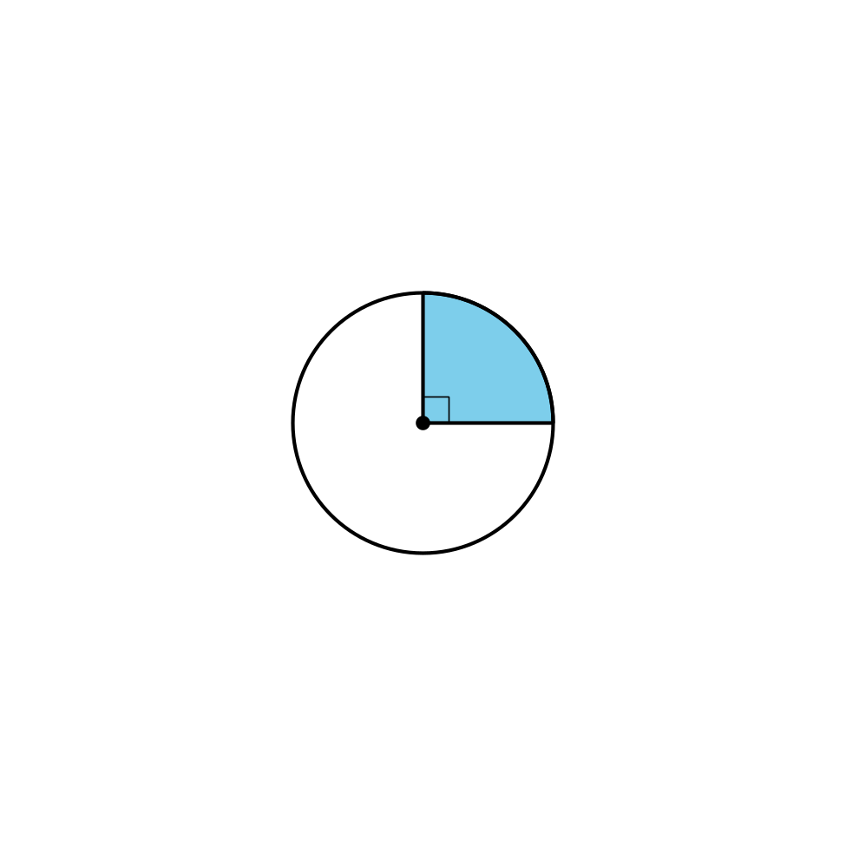
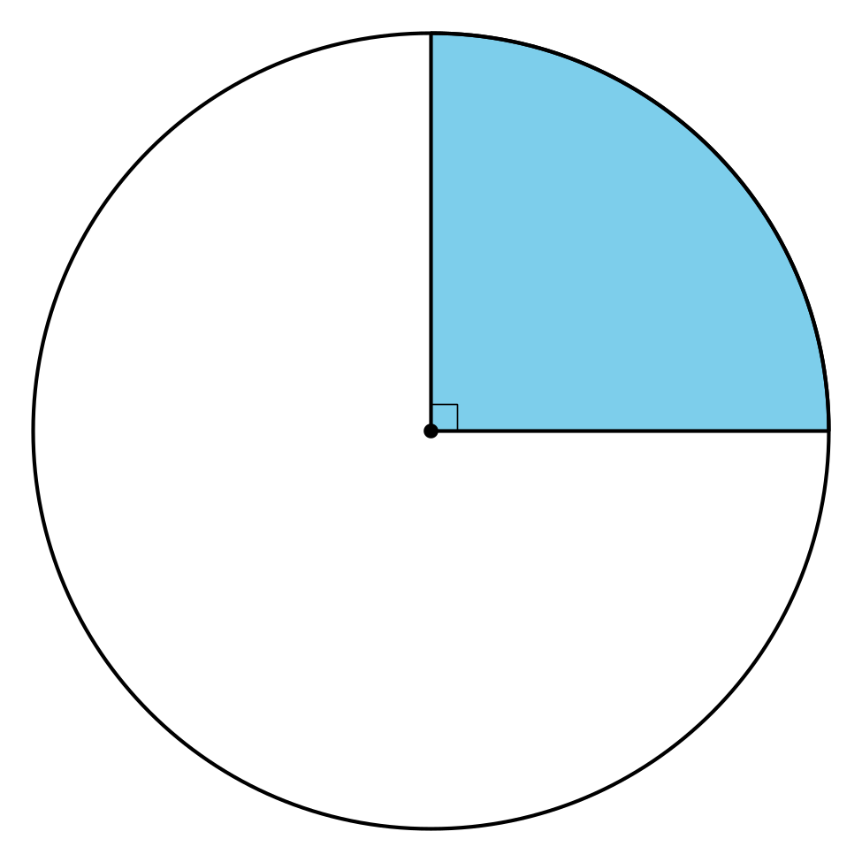
For each part of the dilated image, determine the factor by which it’s changed when compared to the corresponding part of the original circle.
- the area of the sector
- the central angle of the sector
- the radius
- the length of the arc defined by the sector
- the ratio of the circle’s circumference to its diameter

10.3: Card Sort: Angles, Arcs, and Radii
Your teacher will give you a set of cards. Sort the cards into categories of your choosing. Be prepared to explain the meaning of your categories. Then, sort the cards into categories in a different way. Be prepared to explain the meaning of your new categories.

Are you ready for more?
For a circle of radius $r$, an expression that relates the area of a sector to the arc length defined by that sector is $A=\frac{1}{2}rℓ$ where $A$ is the area of the sector and $ℓ$ is the length of the arc. Explain why this is true and provide an example.

Lesson 10 Summary
If we have the same central angle in 2 different circles, the length of the arc defined by the angle depends on the size of the circle. So, we can use the relationship between the arc length and the circle’s radius to get some information about the size of the central angle.
For example, suppose circle A has radius 9 units and a central angle that defines an arc with length $3π$. Circle B has radius 15 units and a central angle that defines an arc with length $5π$. How do the 2 angles compare?
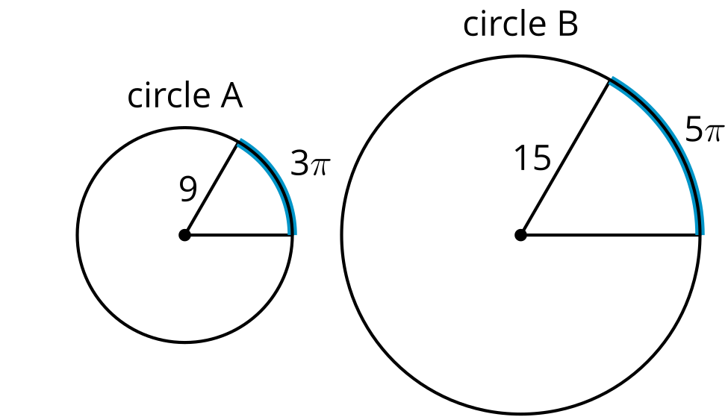
For the angle in Circle A, the ratio of the arc length to the radius is $\frac{3π}{9}$, which can be rewritten as $\frac{π}{3}$. For the angle in Circle B, the arc length to radius ratio is $\frac{5π}{15}$, which can also be written as $\frac{π}{3}$. That seems to indicate that the angles are the same size. Let’s check.
Circle A’s circumference is $18π$ units. The arc length $3π$ is $\frac{1}{6}$ of $18π$, so the angle measurement must be $\frac{1}{6}$ of 360 degrees, or 60 degrees. Circle B’s circumference is $30π$ units. The arc length $5π$ is $\frac{1}{6}$ of $30π$, so this angle also measures $\frac{1}{6}$ of 360 degrees or 60 degrees. The 2 angles are indeed congruent.
© CC BY 2019 by Illustrative Mathematics®

