Lesson 16: Find the Value of Expressions

Standards Alignments
Addressing | K.OA.A.1, K.OA.A.2

Teacher-facing Learning Goals
- Find the value of addition and subtraction expressions.

Student-facing Learning Goals
- Let’s find the value of expressions.

Lesson Purpose
The purpose of this lesson is for students to find the value of addition and subtraction expressions in a way that makes sense to them.
In previous lessons, students interpreted expressions and connected expressions to story problems and drawings. This is the first lesson where students begin by working with only expressions. Because students have matched expressions to drawings in previous lessons, students may create a drawing to find the value of the expression. Students may also use their fingers or objects to represent the expression and count to find the total or difference.

Access for:

Students with Disabilities
- Action and Expression (Activity 2)

English Learners
- MLR8 (Activity 2)

Instructional Routines
What Do You Know About _____? (Warm-up)

Materials to Gather
- Connecting cubes or counters: Activity 1, Activity 2
- Materials from previous centers: Activity 3

Materials to Copy
- Number Mat 1–5 (groups of 2): Activity 1
- Roll and Add Stage 2 Recording Sheet (groups of 1): Activity 1

Lesson Timeline
Warm-up | 10 min
Activity 1 | 10 min
Activity 2 | 10 min
Activity 3 | 20 min
Lesson Synthesis | 5 min
Cool-down | 5 min

Teacher Reflection Question
In a previous unit, students represented numbers in multiple ways, including using their fingers, objects, and drawings. How did students work with representing numbers prepare them to find the value of expressions in this lesson?

Cool-down
(to be completed at the end of the lesson) 5min
Find the Value of the Expression

Standards Alignments
Addressing | K.OA.A.1, K.OA.A.2

Student-facing Task Statement
Find the value of the expression.
Show your thinking using objects, drawings, numbers, or words.
$1+4$
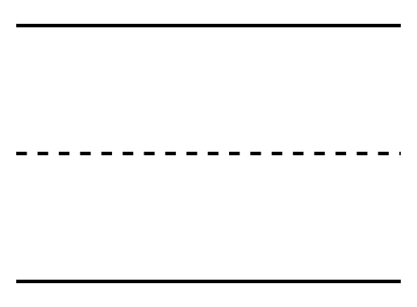

Student Responses
5. Sample response:


