Grade 6
Unit 2Lesson 4CC BY NC Illustrative Mathematics, based on IM 6–8 Math, CC BY Open Up Resources.
Unit 2, Lesson 4

Color Mixtures
Let’s see what color-mixing has to do with ratios.
Grade 6
Unit 2Lesson 4CC BY NC Illustrative Mathematics, based on IM 6–8 Math, CC BY Open Up Resources.

4.1Two Containers
Here is a picture of two containers of colored water.
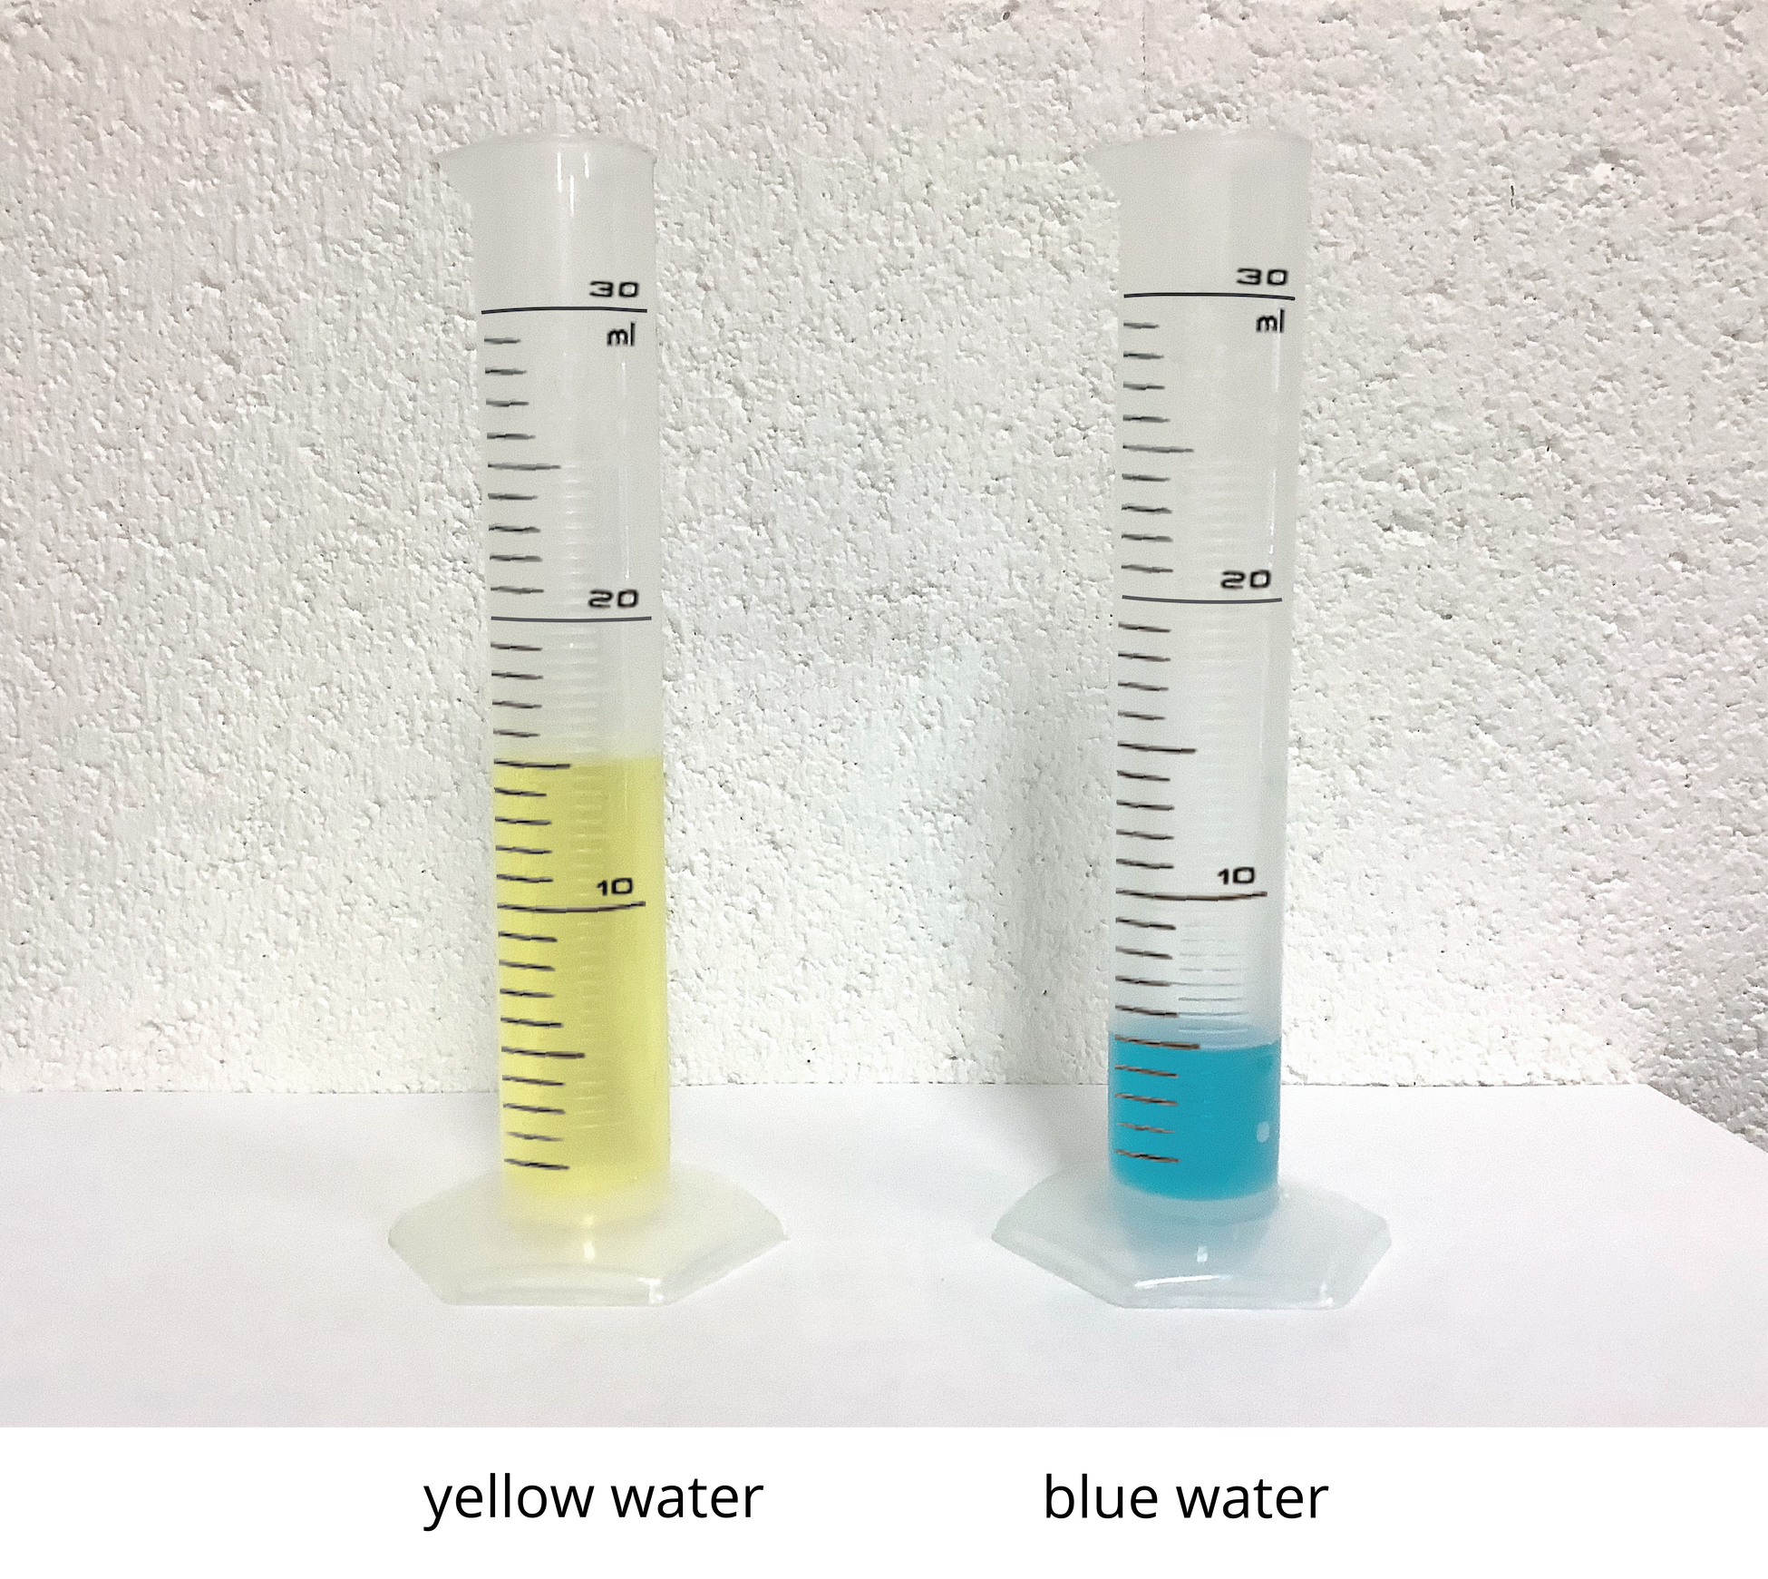
- What do you notice about the colored water? Make 1–2 observations.
- What would happen if we mixed the blue water and yellow water together?
- What would happen if we mixed more blue water with the same amount of yellow water?
Grade 6
Unit 2Lesson 4CC BY NC Illustrative Mathematics, based on IM 6–8 Math, CC BY Open Up Resources.

4.2Turning Green
A recipe for green water says to mix milliliters of blue water and milliliters of yellow water in the ratio $5:15$.
Perform the following experiments. For each experiment, complete all the steps.
- Doubling the original recipe:
  - Draw a diagram to represent the amount of each color in the doubled recipe.
  - Label an empty cup with the ratio of blue water to yellow water.
  - Predict how the shade of this mixture will compare to the original mixture. Then, check your prediction by measuring these amounts and mixing them in a cup.
  - Is the ratio of blue water to yellow water in your mixture equivalent to the ratio in the original recipe? Explain your reasoning.
- Tripling the original recipe:
  - Draw a diagram to represent the amount of each color in the tripled recipe.
  - Label an empty cup with the ratio of blue water to yellow water.
  - Predict how the shade of this mixture will compare to the original mixture. Then, check your prediction by measuring these amounts and mixing them in a cup.
  - Is the ratio of blue water to yellow water in your mixture equivalent to the ratio in the original recipe? Explain your reasoning.
- Inventing your own recipe for a bluer shade of green water.
  - Draw a diagram to represent the amount of each color in your recipe.
  - Label an empty cup with the ratio of blue water to yellow water.
  - Check if your recipe makes a bluer shade by mixing one batch in a cup.
  - Is the ratio of blue water to yellow water in your mixture equivalent to the ratio in the original recipe? Explain your reasoning

Are you ready for more?
Someone has made a shade of green by using 17 ml of blue and 13 ml of yellow. They are sure it cannot be turned into the original shade of green by adding more blue or yellow. Either explain how more can be added to create the original green shade, or explain why this is impossible.
Grade 6
Unit 2Lesson 4CC BY NC Illustrative Mathematics, based on IM 6–8 Math, CC BY Open Up Resources.

4.3Perfect Purple Water
The recipe for Perfect Purple Water says, “Mix 8 ml of blue water with 3 ml of red water.”
Jada mixes 24 ml of blue water with 9 ml of red water. Andre mixes 16 ml of blue water with 9 ml of red water.
- Which person will get a color mixture that is the same shade as Perfect Purple Water? Explain or show your reasoning.
- Find another combination of blue water and red water that will also result in the same shade as Perfect Purple Water. Explain or show your reasoning.

Lesson 4 Summary
When mixing colors, doubling or tripling the amount of each color will create the same shade of the mixed color. In fact, you can always multiply the amount of each color by the same number to create a different amount of the same mixed color.
For example, a batch of dark orange paint uses 4 ml of red paint and 2 ml of yellow paint.
- To make two batches of dark orange paint, we can mix 8 ml of red paint with 4 ml of yellow paint.
- To make three batches of dark orange paint, we can mix 12 ml of red paint with 6 ml of yellow paint.
Here is a diagram that represents 1, 2, and 3 batches of this recipe.
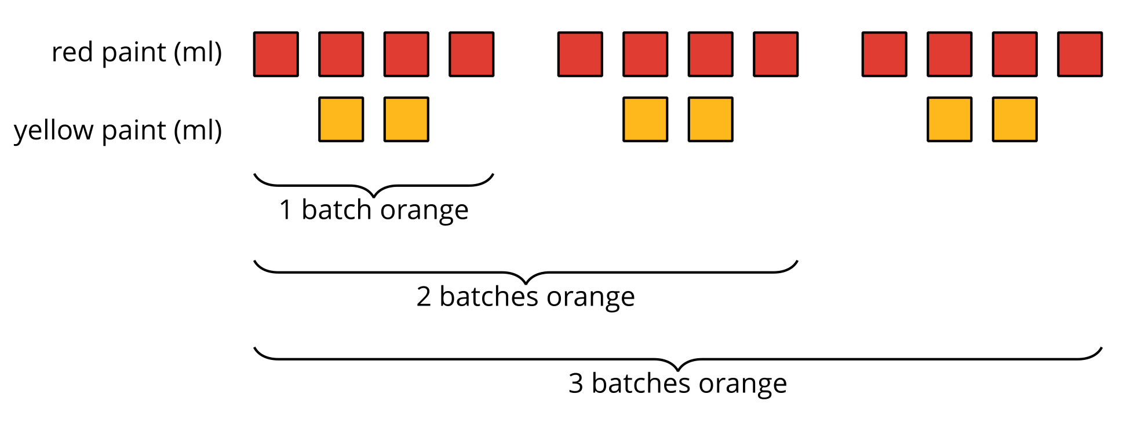
We say that the ratios $4:2$, $8:4$, and $12:6$ are equivalent because they describe the same color mixture in different numbers of batches, and they make the same shade of orange.

