Grade 6
Unit 6Lesson 14CC BY NC Illustrative Mathematics, based on IM 6–8 Math, CC BY Open Up Resources.
Unit 6, Lesson 14

Evaluating Expressions with Exponents
Let’s find the values of expressions with exponents.
Grade 6
Unit 6Lesson 14CC BY NC Illustrative Mathematics, based on IM 6–8 Math, CC BY Open Up Resources.

14.1Revisiting the Cube
Based on the given information, what other measurements of the square and cube could we find?
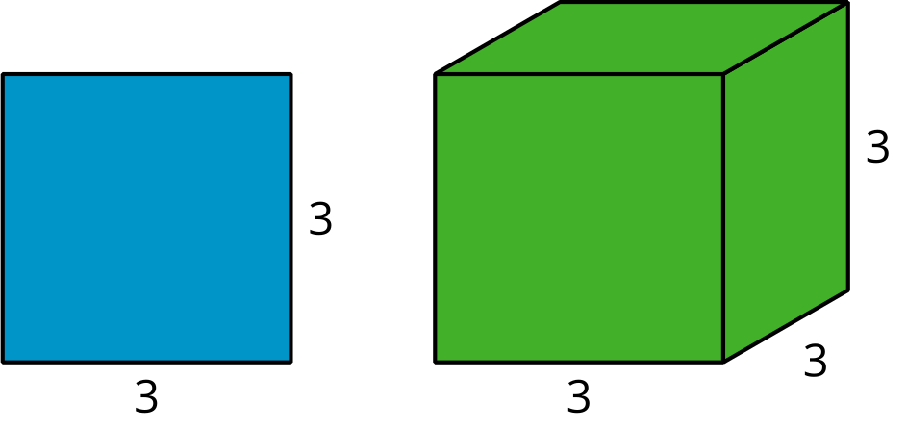
Grade 6
Unit 6Lesson 14CC BY NC Illustrative Mathematics, based on IM 6–8 Math, CC BY Open Up Resources.

14.2Calculating Surface Area
A cube has edge lengths of 10 inches. Jada says the surface area of the cube is 600 in², and Noah says the surface area of the cube is 3,600 in². Here is how each of them reasoned:
Jada’s Method:
$6⋅{10}^{2}6⋅100600$
Noah’s Method:
$6⋅{10}^{2}{60}^{2}3,​600$
Do you agree with either of them? Explain your reasoning.
Grade 6
Unit 6Lesson 14CC BY NC Illustrative Mathematics, based on IM 6–8 Math, CC BY Open Up Resources.

14.3Row Game: Expression Explosion
Find the value of the expressions in one of the columns. Your partner will work on the other column.
Check with your partner after you finish each row. Your answers in each row should be the same. If your answers aren’t the same, work together to find the error.
column A | column B
$5^{2}+4$ | $2^{2}+25$
$2^{4}⋅5$ | $2^{3}⋅10$
$3⋅4^{2}$ | $12⋅2^{2}$
$20+2^{3}$ | $1+3^{3}$
$9⋅2^{1}$ | $3⋅6^{1}$
$\frac{1}{9}⋅{\left(\frac{1}{2}\right)}^{3}$ | $\frac{1}{8}⋅{\left(\frac{1}{3}\right)}^{2}$

Are you ready for more?
- An example of 3 different whole numbers that could go in the boxes to make the equation true are 3, 4, and 5, since $3^{2}+4^{2}=5^{2}$. (That is, $9+16=25$.)
- Can you find a different set of 3 whole numbers that make the equation true?
- 332+332=332
- How many sets of 3 different whole numbers can you find?
- Can you find a set of 3 different whole numbers that make this equation true?
- 333+333=333
- How about this one?
- 334+334=334
- Once you have worked on this a little while, you can understand a problem that is famous in the history of math. (But this space is too small to contain it.) If you are interested, consider doing some further research on Fermat’s Last Theorem.

Lesson 14 Summary
Exponents give us a new way to describe operations with numbers, so we need to understand how exponents work with other operations.
When we write an expression such as $6⋅4^{2}$, we want to make sure everyone agrees about how to find its value. Otherwise, some people might multiply first and others compute the exponent first, and different people would get different values for the same expression!
Earlier we saw situations in which $6⋅4^{2}$ represented the surface area of a cube with edge lengths of 4 units. When computing the surface area, we compute $4^{2}$ first (or find the area of one face of the cube first) and then multiply the result by 6 (because the cube has 6 faces).
In many other expressions that use exponents, the part with an exponent is intended to be computed first.
To make everyone agree about the value of expressions like $6⋅4^{2}$, we follow the convention to find the value of the part of the expression with the exponent first. Here are a couple of examples:
$\begin{matrix}6 & ⋅4^{2} \\ 6 & ⋅16 \\ & 96\end{matrix}$
$\begin{matrix}45 & +5^{2} \\ 45 & +25 \\ & 70\end{matrix}$
If we want to communicate that 6 and 4 should be multiplied first and then squared, then we can use parentheses to group parts of the expression together:
$\begin{matrix}(6 & ⋅4)^{2} \\ & {24}^{2} \\ & 576\end{matrix}$
$\begin{matrix}(45 & +5)^{2} \\ & {50}^{2} \\ 2, & 500\end{matrix}$
In general, to find the value of expressions, we use this order of operations:
- Do any operations in parentheses.
- Apply any exponents.
- Multiply or divide from left to right in the expression.
- Add or subtract from left to right in the expression.

