Lesson 4 Practice Problems
- Which of the dot plots shows a symmetric distribution?
  - 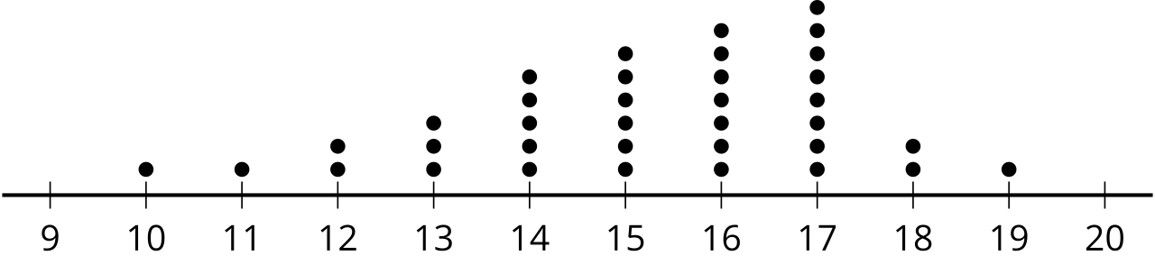
  - 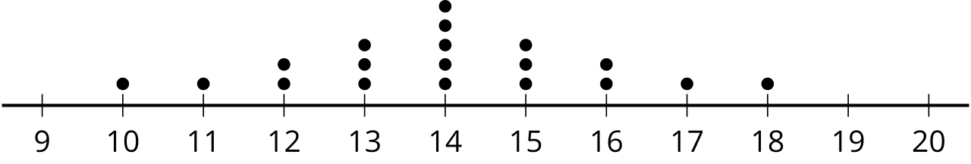
  - 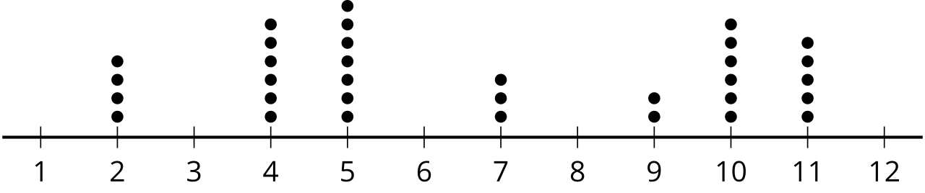
  - 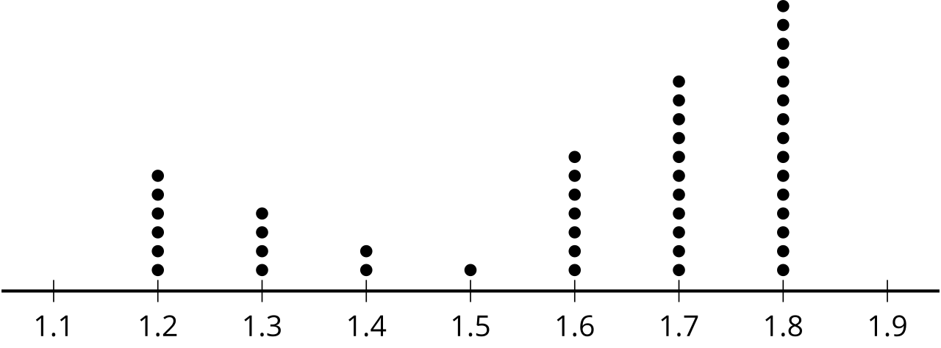

- Which of the dot plots shows a skewed distribution?
  - 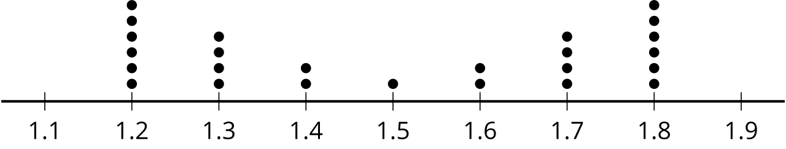
  - 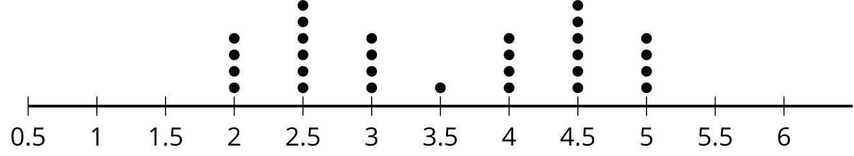
  - 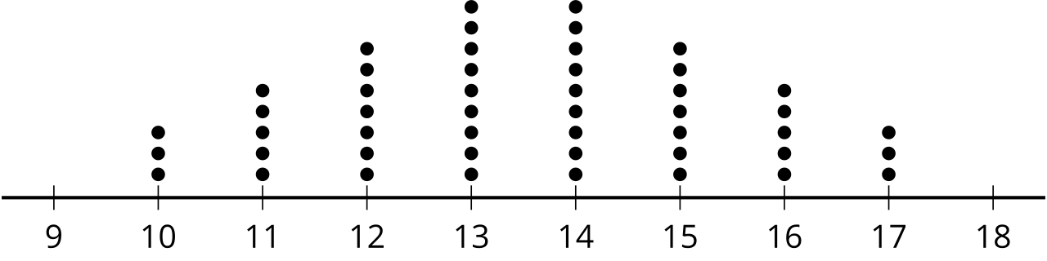
  - 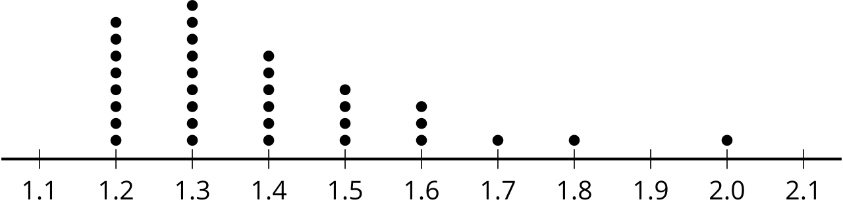
- Create a dot plot showing a uniform distribution.
- The data represent the number of ounces of water that 26 students drank before donating blood: 8, 8, 8, 16, 16, 16, 32, 32, 32, 32, 32, 32, 64, 64, 64, 64, 64, 64, 64, 80, 80, 80, 80, 88, 88, 88.
  - Create a dot plot for the data.
  - Create a box plot for the data.
  - What information about the data is provided by the box plot that is not provided by the dot plot?
  - What information about the data is provided by the dot plot that is not provided by the box plot?
  - It was recommended that students drink 48 or more ounces of water. How could you use a histogram to easily display the number of students who drank the recommended amount?
- (From Unit 1, Lesson 3.)
- The box plot represents the distribution of the number of points scored by a cross country team at 12 meets.
- 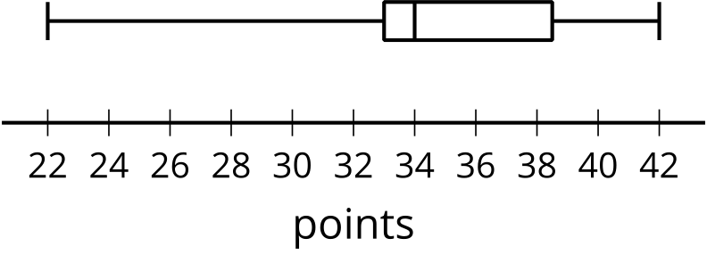
  - If possible, find the mean. If not possible, explain why not.
  - If possible, find the median. If not possible, explain why not.
  - Did the cross country team ever score 30 points at a meet?
- (From Unit 1, Lesson 2.)
© CC BY 2019 by Illustrative Mathematics®

