Lesson 11: Dibujos para representar problemas-historia

Standards Alignments
Addressing | K.OA.A.2
Building Towards | K.OA.A.2

Teacher-facing Learning Goals
- Create drawings that represent story problems.
- Solve Add To, Result Unknown and Take From, Result Unknown story problems.

Student-facing Learning Goals
- Hagamos un dibujo para mostrar lo que ocurre en un problema-historia.

Lesson Purpose
The purpose of this lesson is for students to draw a picture to represent and solve a story problem.
In previous lessons, students have explained how objects and drawings represent story problems. Students also compared organized and disorganized drawings. This is the first lesson where students are asked to produce a drawing. Students should always be able to use objects to represent the story problem if they find them helpful. It is not an expectation that students will organize or label their drawings. With practice, students should be able to explain how each part of their drawing connects to the story with prompting.

Access for:

Students with Disabilities
- Action and Expression (Activity 1)

English Learners
- MLR8 (Activity 2)

Instructional Routines
Which One Doesn’t Belong? (Warm-up)

Materials to Gather
- Connecting cubes or two-color counters: Activity 1
- Materials from previous centers: Activity 3

Lesson Timeline
Warm-up | 10 min
Activity 1 | 10 min
Activity 2 | 15 min
Activity 3 | 15 min
Lesson Synthesis | 5 min
Cool-down | 5 min

Teacher Reflection Question
How did the student work that you selected impact the direction of the discussion? What student work might you pick next time if you taught the lesson again?

Cool-down
(to be completed at the end of the lesson) 5min
Representa y resuelve un problema-historia

Standards Alignments
Addressing | K.OA.A.2

Student-facing Task Statement
Han recogió 4 hojas en el parque.
Priya le dio 5 hojas más.
¿Cuántas hojas tiene Han ahora?
Muestra cómo pensaste. Usa objetos, dibujos, números o palabras.
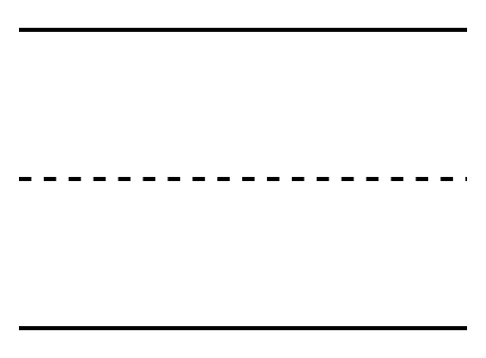

Student Responses
9 leaves. Sample responses:
- Students use objects to represent the story problem.
- Students draw a detailed picture to represent the story problem.
- Students draw symbols such as circles to represent the story problem.

