Unit 7 Lesson 6: A Special Point

1 Notice and Wonder: Salt Pile (Warm up)

Student Task Statement
What do you notice? What do you wonder?
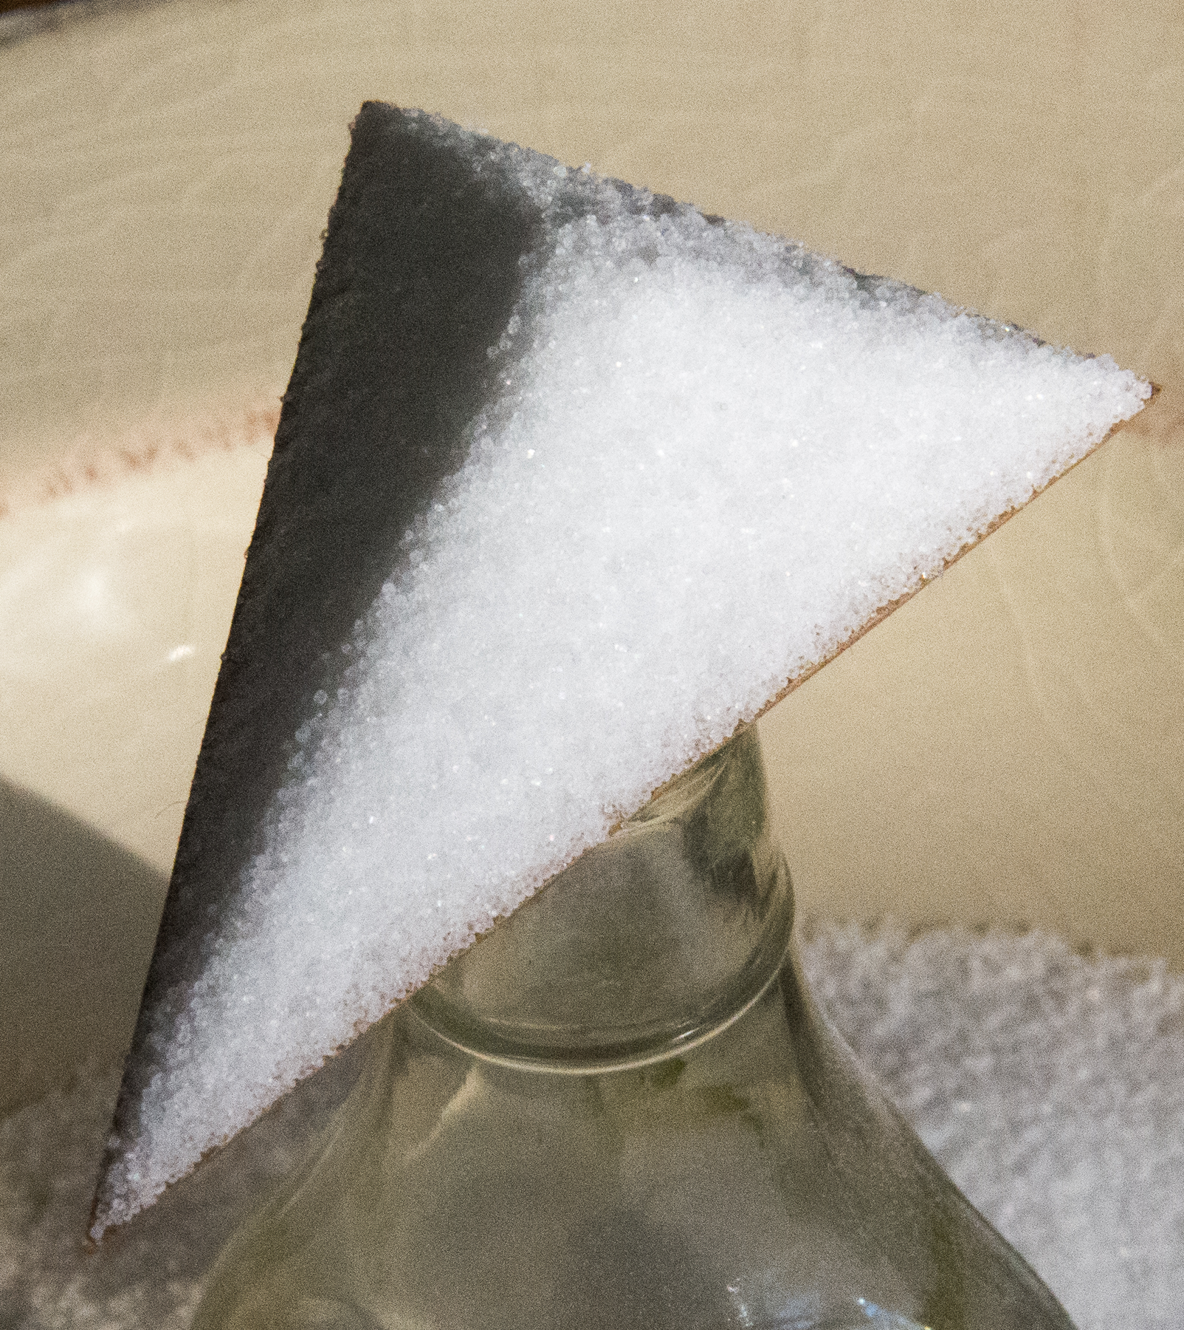
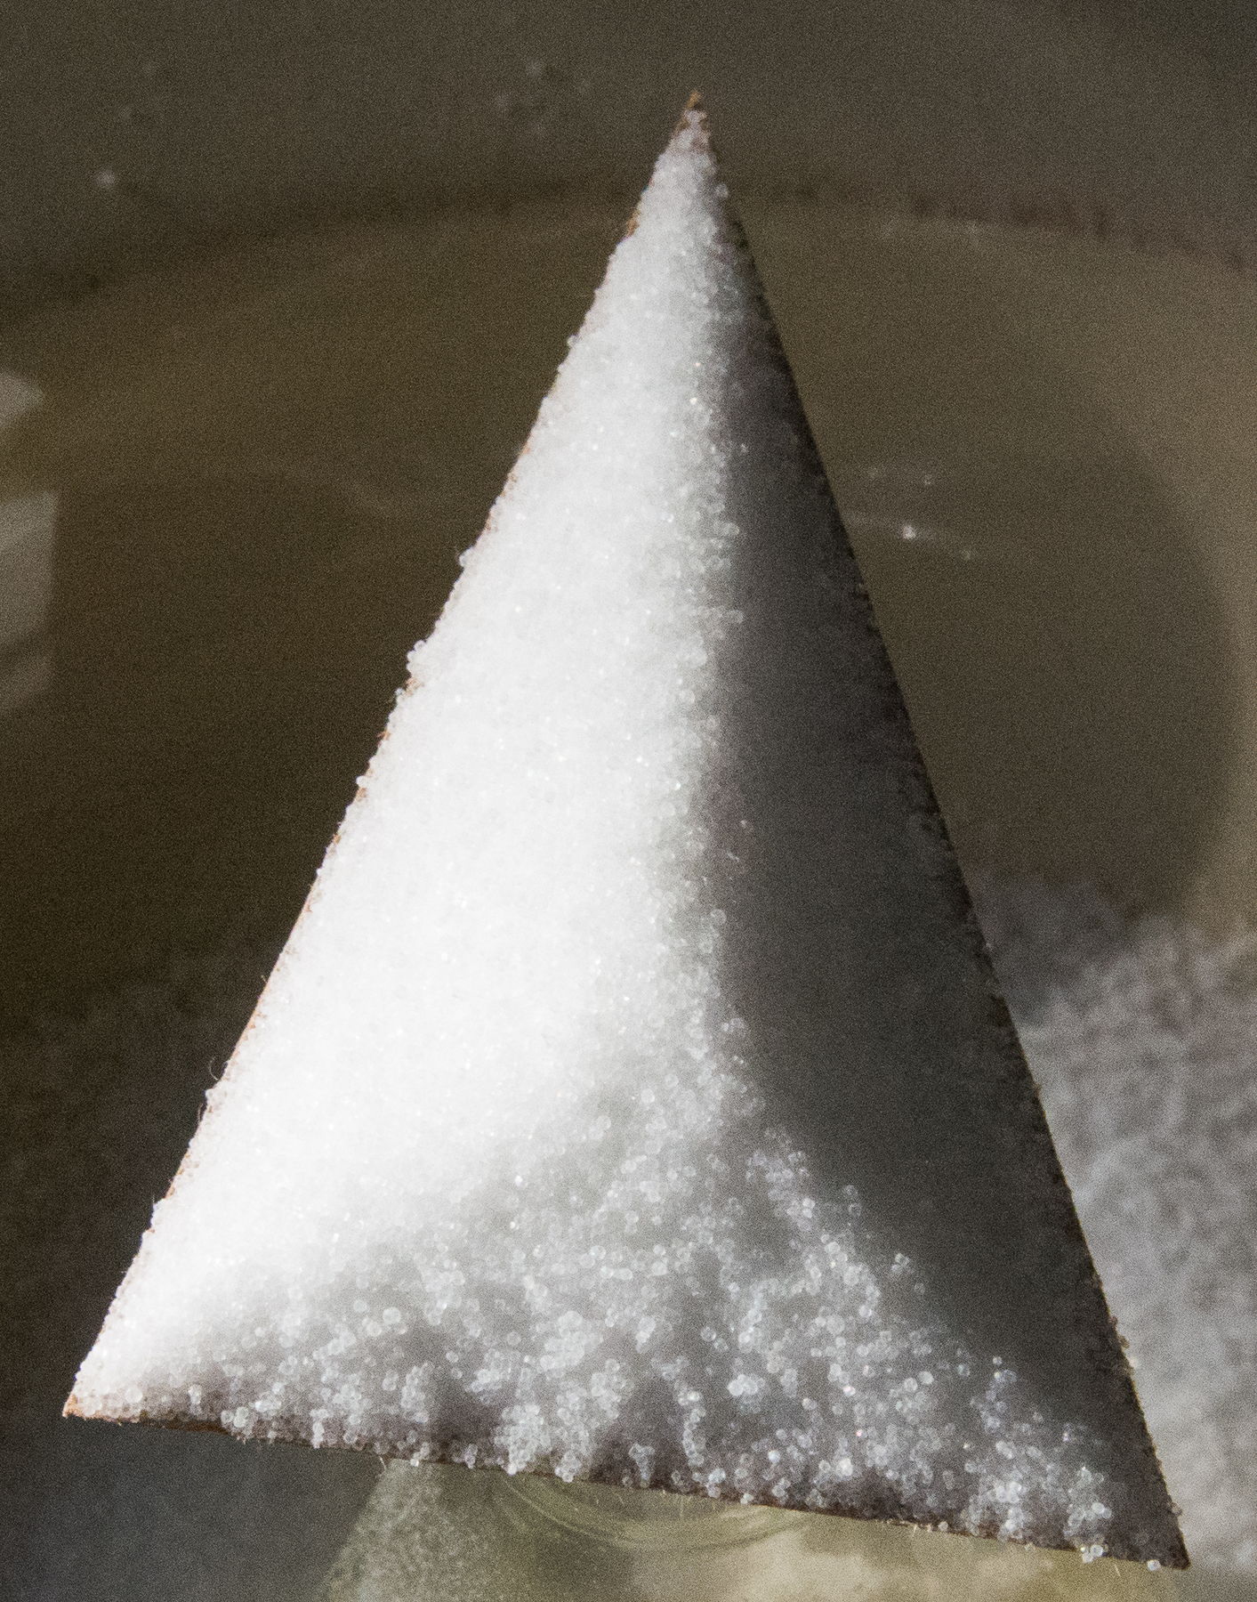
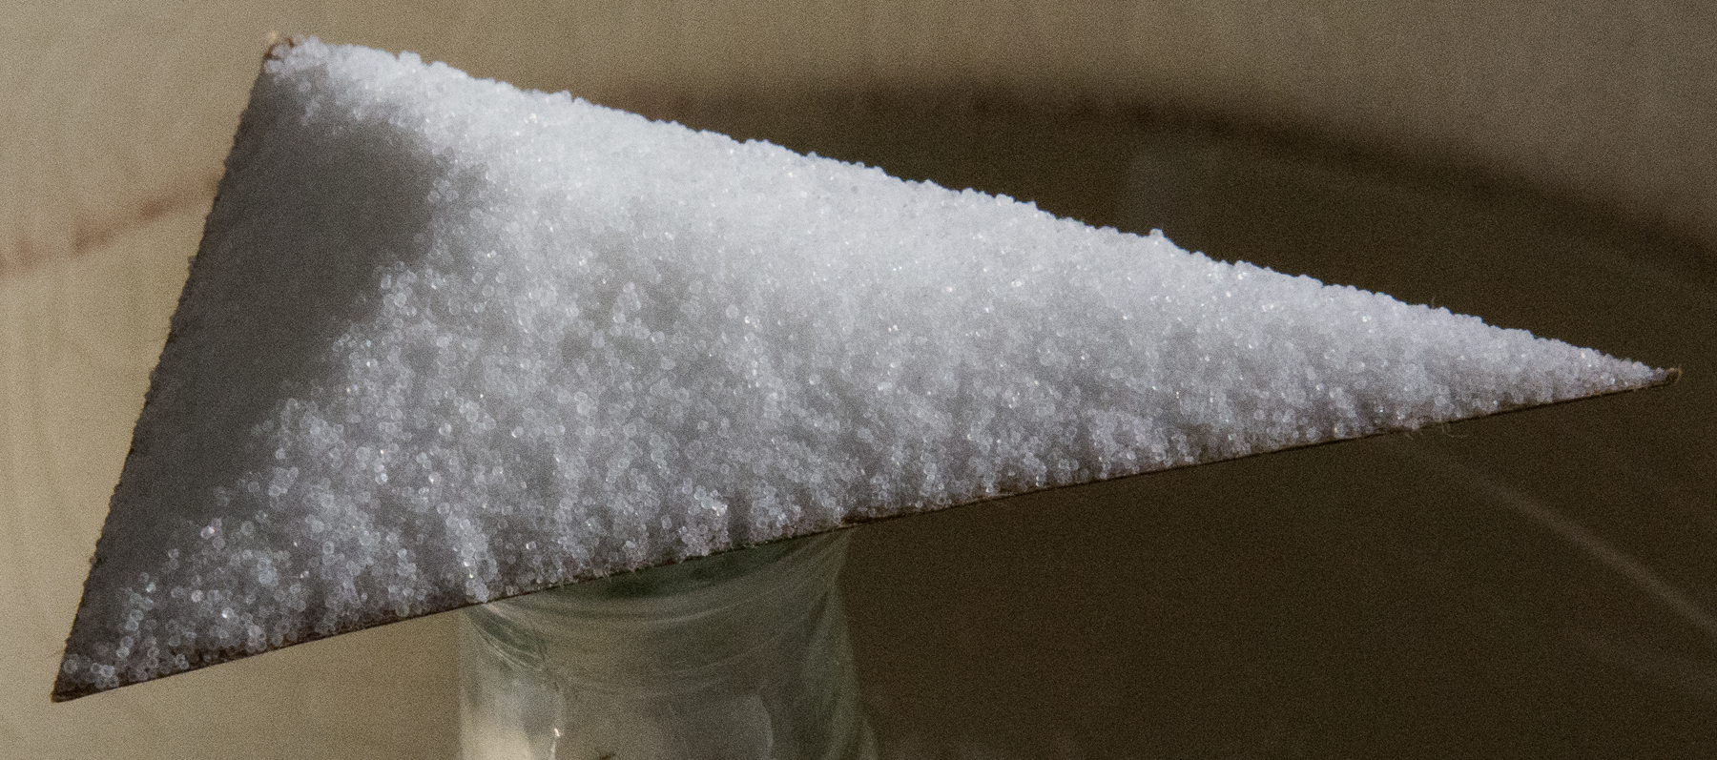

2 Point and Angle

Images for Launch
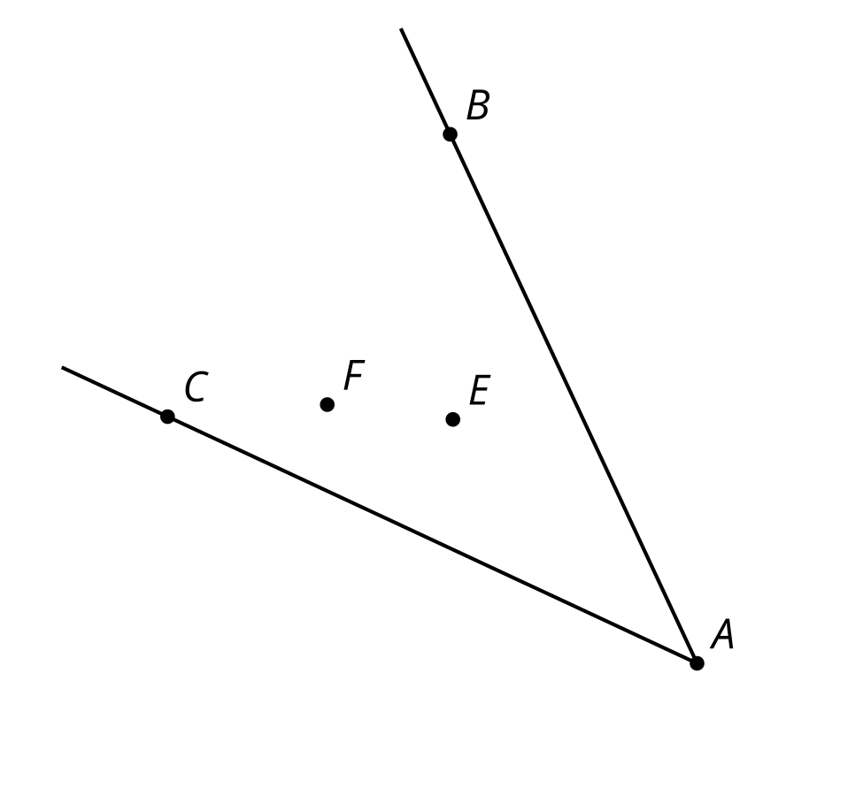

Student Task Statement
Here is an angle $BAC$ with 2 different sets of markings.
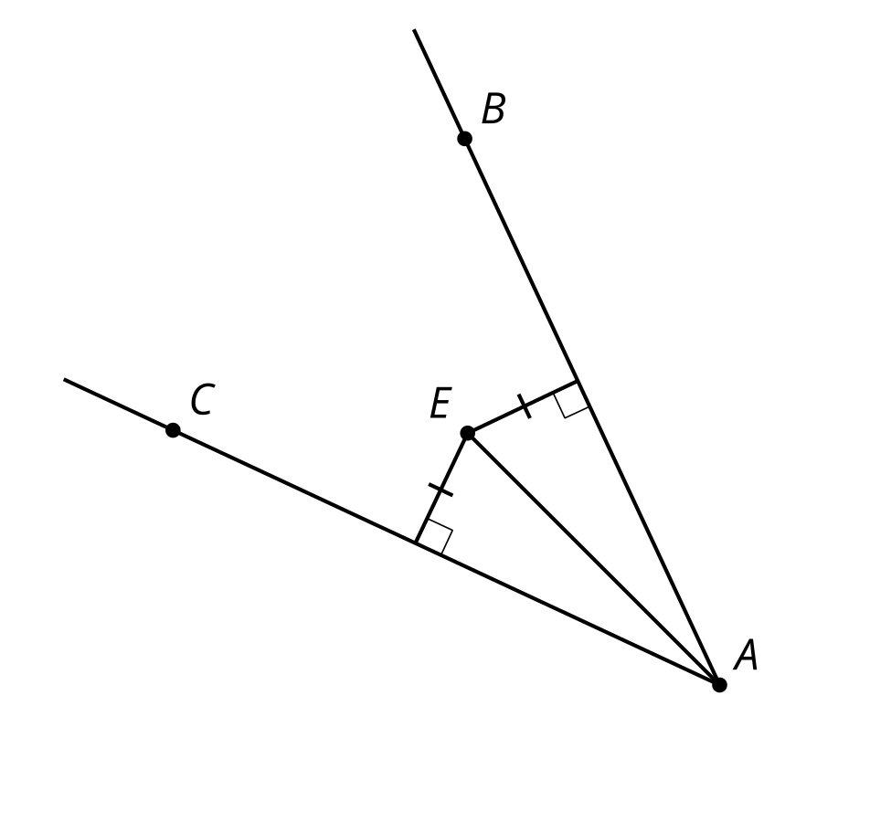
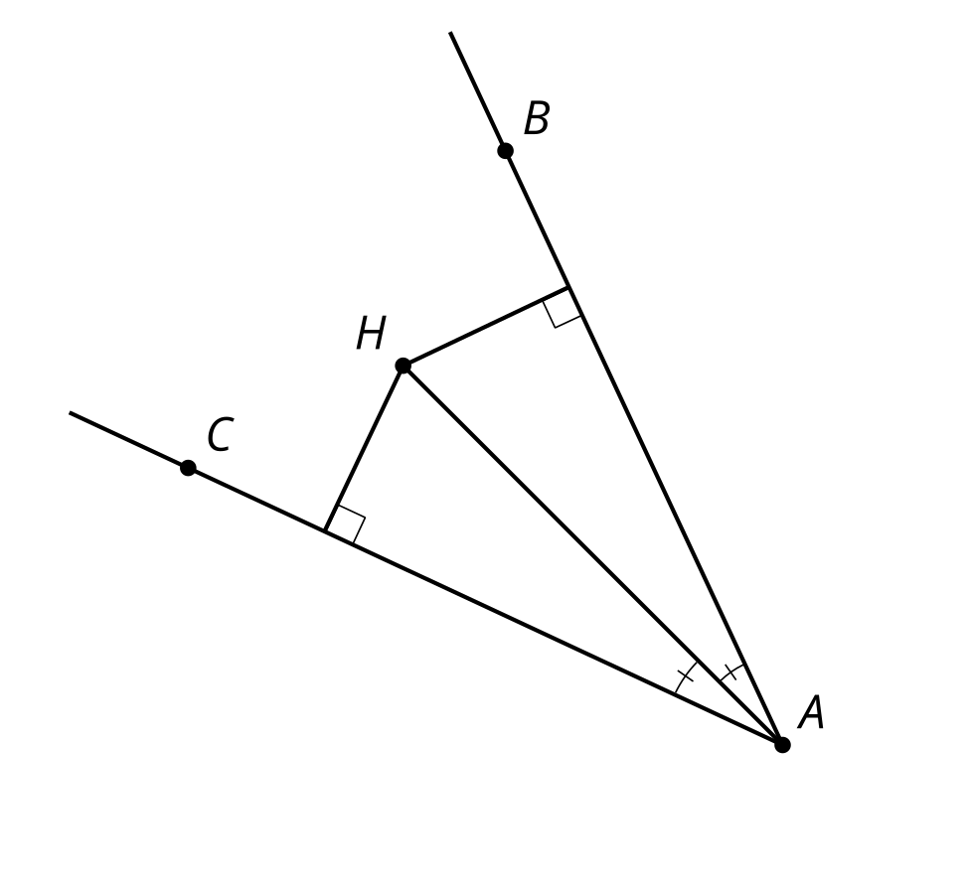
- Point $E$ is the same distance away from each of the 2 rays that form angle $BAC$. Make a conjecture about angles $EAB$ and $EAC$ and prove it.
- Point $H$ is on the angle bisector of angle $BAC$. What can you prove about the distances from $H$ to each ray?

3 What If There Are Three Sides?

Student Task Statement
Two angle bisectors have been constructed in triangle $ABC$. They intersect at point $G$.
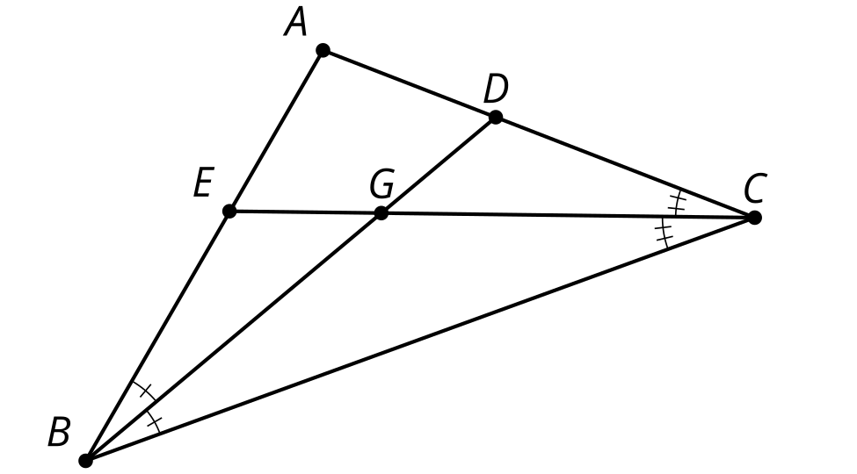
- Sketch segments that show the distances from point $G$ to each side of the triangle.
- How do the distances from point $G$ to sides $AB$ and $BC$ compare? Explain your reasoning.
- How do the distances from point $G$ to sides $AC$ and $BC$ compare? Explain your reasoning.
- Will the third angle bisector pass through point $G$? Explain your reasoning.

Activity Synthesis
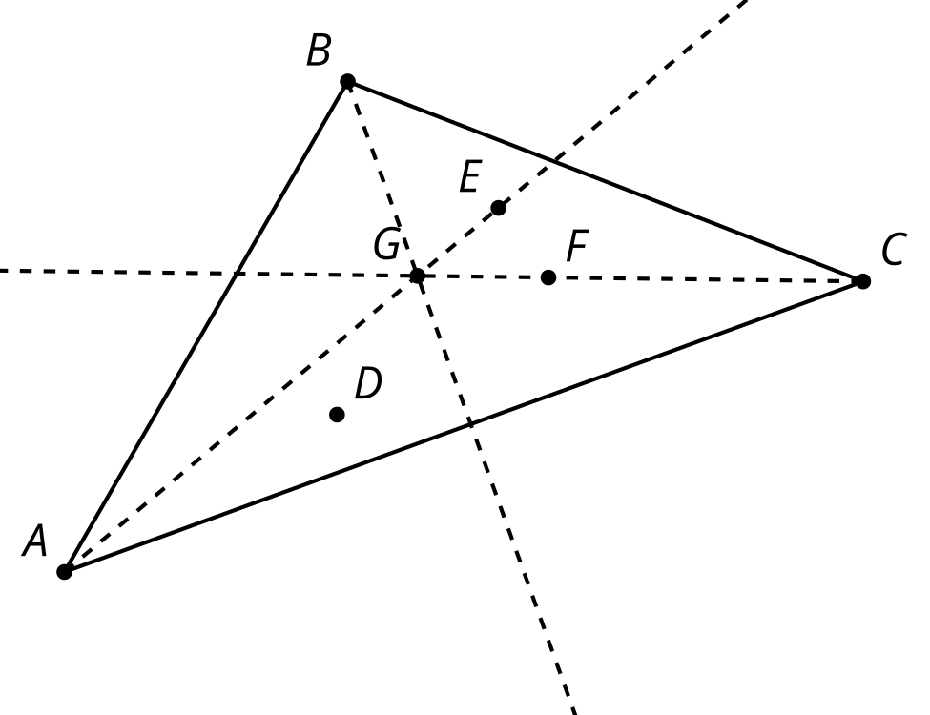

Images for Activity Synthesis
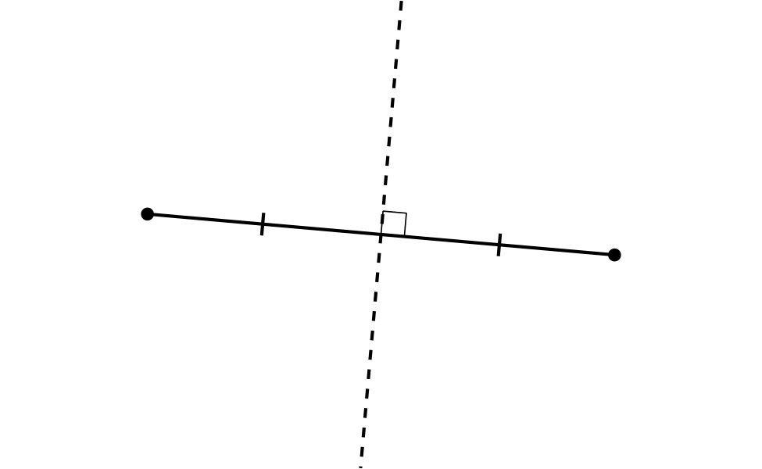
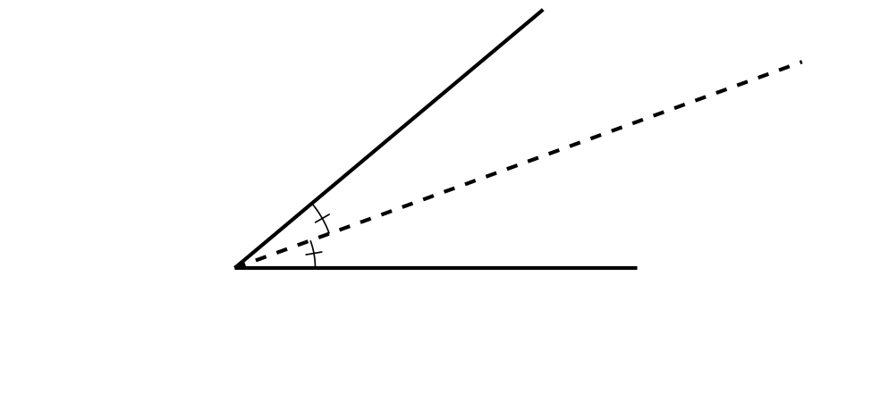
© CC BY 2019 by Illustrative Mathematics®

