Grade 2
Unit 3Lesson 2CC BY NC 2024 Illustrative Mathematics®
Unit 3, Lesson 2

Measure in Centimeters
- Let’s measure in centimeters.
Grade 2
Unit 3Lesson 2CC BY NC 2024 Illustrative Mathematics®

Warm-upNotice and Wonder: Centimeters
What do you notice? What do you wonder?
A
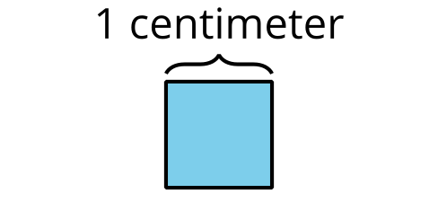
B
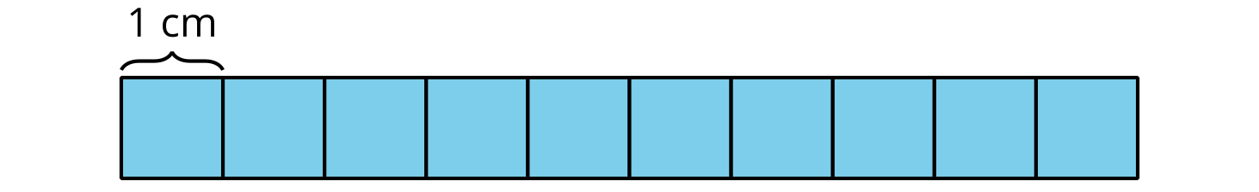
Grade 2
Unit 3Lesson 2CC BY NC 2024 Illustrative Mathematics®

Activity 1Length in Centimeters
- Measure the length of the bearded dragon using the centimeter cubes. A centimeter is a metric unit of length.
- The bearded dragon is ____________ centimeter cubes long.
- Measure the length of the bearded dragon using a 10-centimeter tool.
- The bearded dragon is ____________ 10-centimeter tools long.
- How many centimeters long is the bearded dragon?
- The bearded dragon is ____________ centimeters long.
Grade 2
Unit 3Lesson 2CC BY NC 2024 Illustrative Mathematics®

Activity 2Measure with 10-Centimeter Tools
- Measure the length of each reptile in centimeters.
  - Jaragua dwarf gecko: ____________ cm
  - blue-tongued skink: ____________ cm
  - musk turtle: ____________ cm
  - ringneck snake: ____________ cm
- Compare measurements with your partner.
- How much longer is the day gecko than the threadsnake?

