Grade 2
Unit 1Lesson 8CC BY NC 2024 Illustrative Mathematics®
Unit 1, Lesson 8

Interpret Picture Graphs
- Let’s answer questions about picture graphs.
Grade 2
Unit 1Lesson 8CC BY NC 2024 Illustrative Mathematics®

Warm-upHow Many Do You See: Dots within 10
How many do you see? How do you see them?
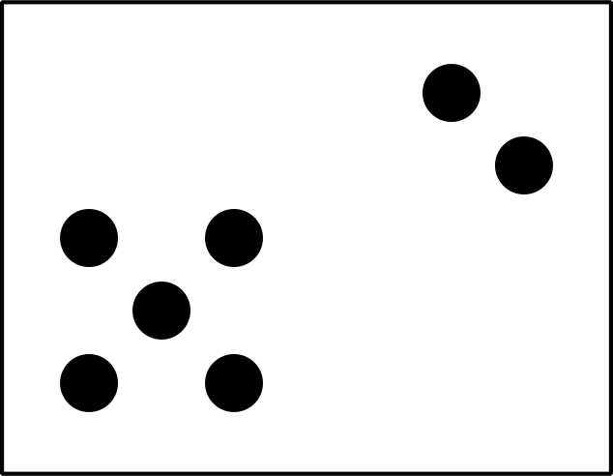
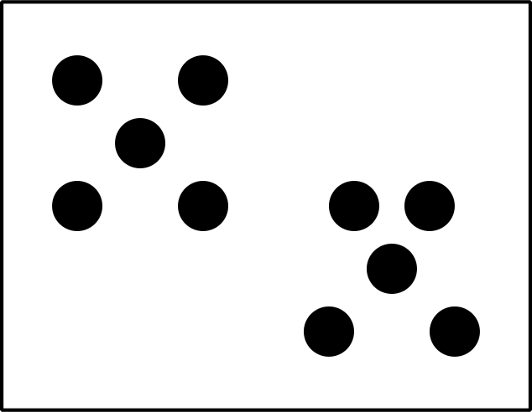
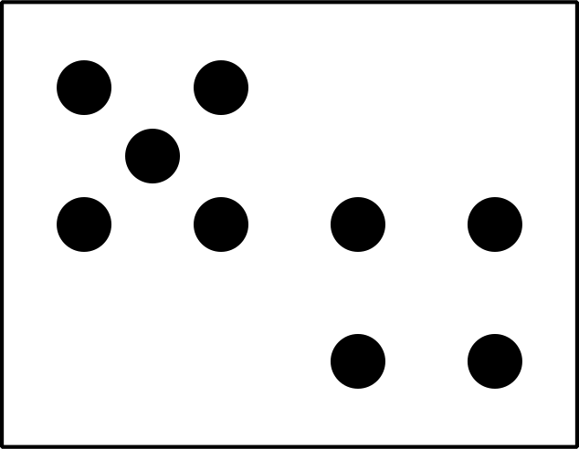
Grade 2
Unit 1Lesson 8CC BY NC 2024 Illustrative Mathematics®

Activity 1Sports People Love
Clare asked a group of children, “Which sport do you love?” Their responses are shown in this picture graph.
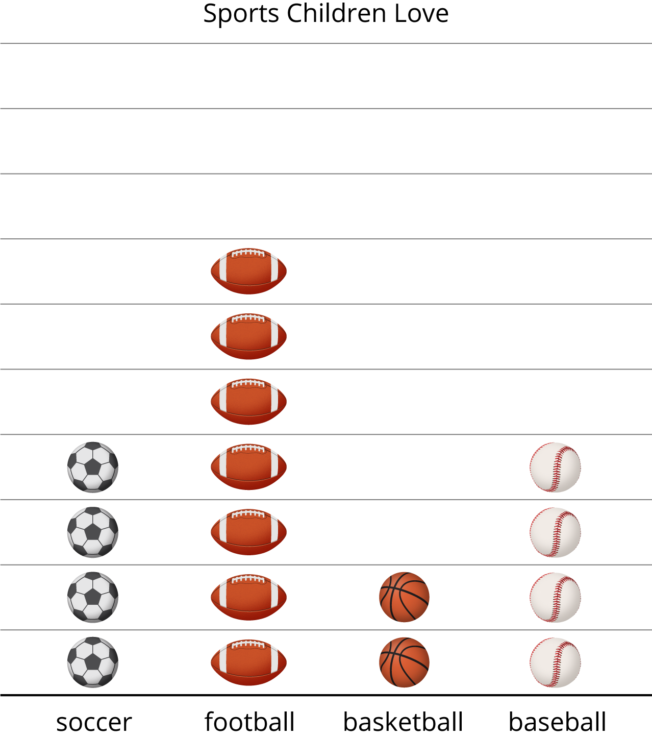
What can you learn about the sports children love from Clare’s picture graph?
A group of adults were asked, “Which sport do you love?” Their responses are shown in this picture graph.
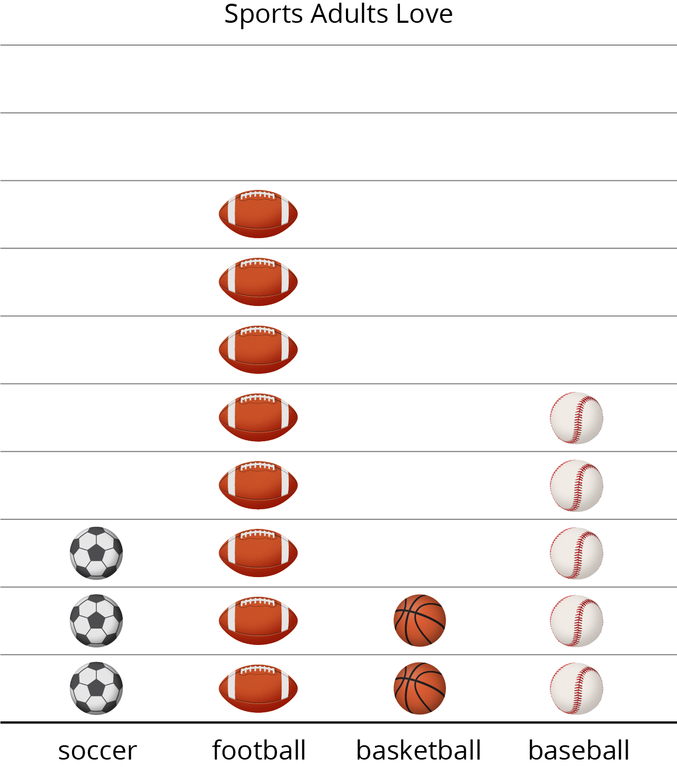
- How many adults like basketball?
- How many like football or baseball? Show your thinking using drawings, numbers, or words.
- Write 1 fact you learned about the data in the picture graph.
Grade 2
Unit 1Lesson 8CC BY NC 2024 Illustrative Mathematics®

Activity 2Answer Questions
A group of children were asked, “Which is your favorite art supply?” Their responses are shown in this picture graph.
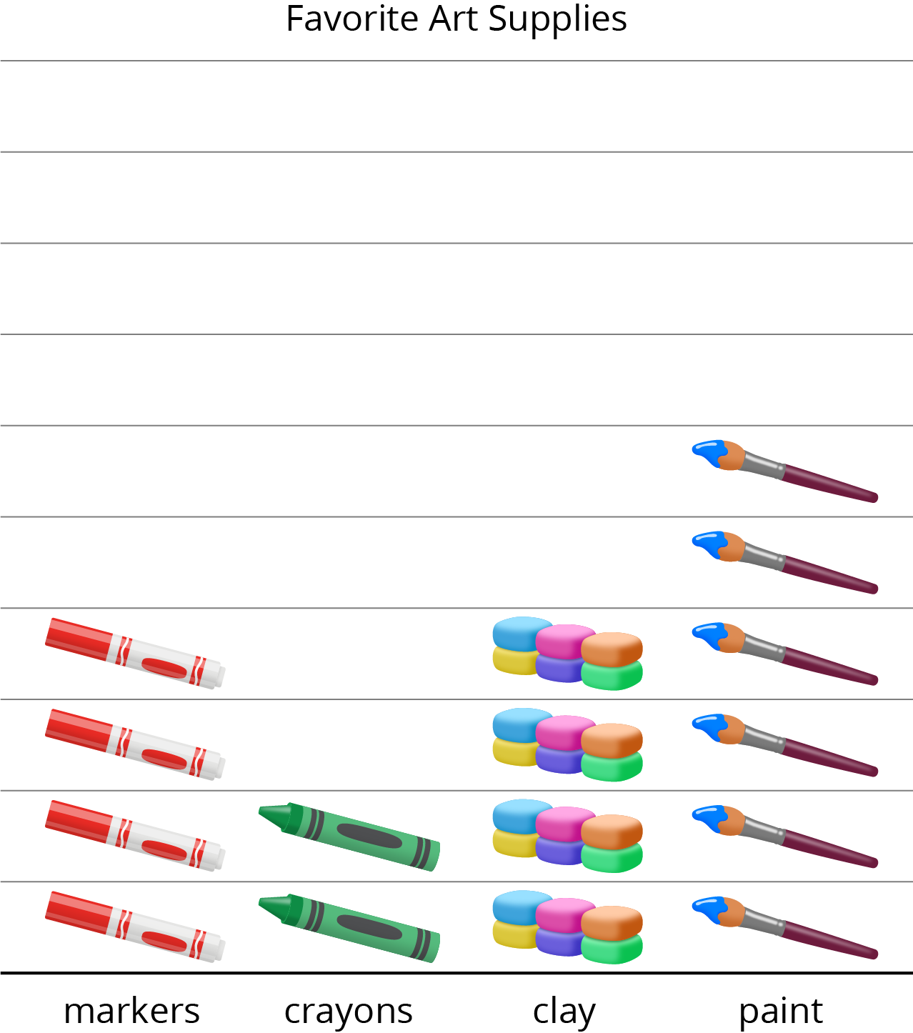
- Circle the 4 questions the graph can answer.
  - How many children chose markers?
  - How many chose crayons or clay?
  - Why did so many children choose paint?
  - How many more children chose markers than crayons?
  - What is the total number of children who chose paint or markers?
- Answer each question you circled.

